Antidiabetic Property of Aloe vera L. Juice
Chikkodi Pramod*, Patil Amol, Kengar Manohar
HOD, Nootan College of Pharmacy,kavathemahankal, Sangli (MH)*
Vice Principal, Nootan College of Pharmacy,kavathemahankal, Sangli (MH)
Assist. Professor, Nootan College of Pharmacy,kavathemahankal, Sangli (MH)

Abstract:-
In this review paper, different processing like handling, harvesting, Juice extraction of gel was described from different references. Different product prepared from Aloe vera whole leaf and gel like food products Aloe juice, Aloe health drink; Aloe desert, etc were reviewed. Even though some researchers have claimed that the polysaccharides in the leaf gel are the sole constituents and regulators for most of the metabolic activities of this plant, it appears a discouraging task to associate the distinct polysaccharides to particular healing activities. The antidiabetic and hypoglycemic properties of Aloe vera are partially mediated via its strong antioxidant effect. Aloe vera treatment is known to lower the blood glucose level through its capability of enhancing the sensitivity towards insulin. Accordingly, there is an increase in the peripheral uptake of glucose, combined with reduction in the amount of hepatic glucose produced.
Keywords: Aloe vera gel; Aloe vera gel expulsion extraction; antidiabetic aloe vera, leaf splitter method purification; stabilization.

Introduction:
Diabetes is a chronic disease marked by the higher level of blood glucose from defects in insulin production, insulin action or both [1]. Diabetes is a chronic disease marked by the higher level of blood glucose from defects in insulin production, insulin action or both [1].
Diabetes is a chronic disease marked by the higher level of blood glucose from defects in insulin production, insulin action or both ¹ The Aloe vera plant has been used for centuries for its health, beauty, medicinal and skin care properties. Aloe vera name derives from the Arabic word “Alloeh” meaning “shining bitter substance,” & “vera” in Latin means “true.” 2000 years ago, the Greek scientists regarded Aloe vera as the universal panacea. The Egyptians called Aloe “the plant of immortality.” Today, the Aloe vera plant has been used for various purposes in dermatology².
Aloe Vera is a succulent and can only be grown in hot, dry climates. It is cultivated around the world. Aloe gel is commonly used to soothe various skin conditions, including sunburn, rashes, cold sores, or dry skin. Aloe vera juice is a gooey, thick liquid made from the flesh of the aloe vera plant leaf. Aloe vera juice can help people achieve better fasting blood glucose levels, as well as reduce body fat and weight ³.
Aloe vera lowers blood glucose levels in diabetic patients. It also improves the responsiveness of the body tissues towards insulin, thereby making insulin more effective. This makes aloe vera extremely suitable for wide scale treatment to all diabetic conditions ⁴.

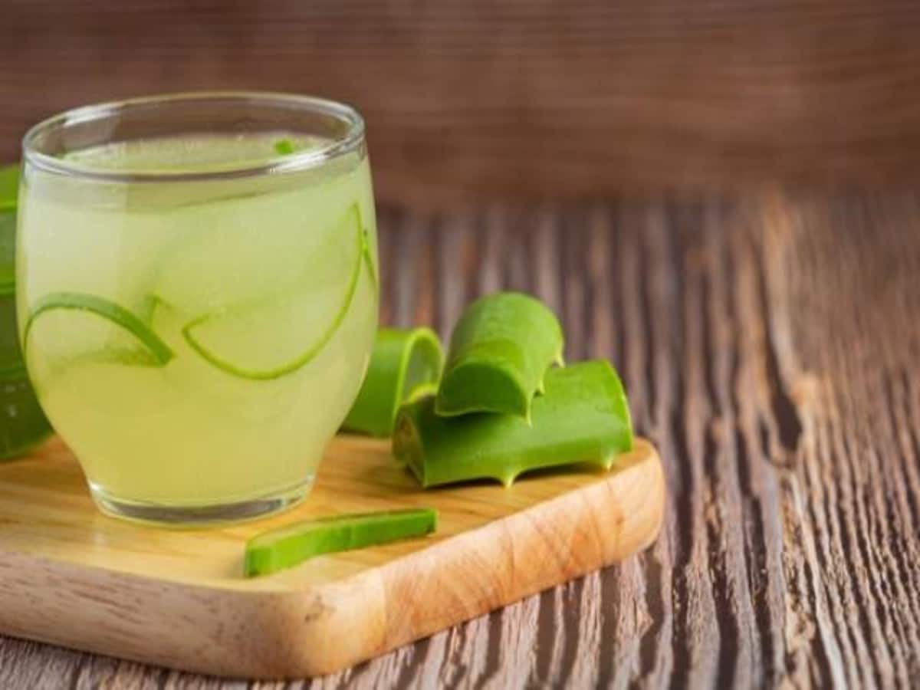
Fig.01. Aloe vera L. juice
Plant:-
The botanical name of Aloe vera is Aloe barbadensis miller. It belongs to Asphodelaceae (Liliaceae) family and pea- green color plant. It grows mainly in the dry regions of Africa, Asia, Europe and America. In India, it is found in Rajasthan, Andhra Pradesh, Gujarat, Maharashtra and Tamil Nadu.
Aloe Vera leaf characteristics:
Physical structure of Aloe vera leaf :
The Aloe Leaf consists of three layers:
A. The outer thick rind
B. A viscous, jelly like mucilage layer into which the vascular bundles, attached to the inner
surface of the rind, protrude.
C. The fillet proper, which has structural integrity consisting of hexagonal structures containing
the fillet fluid. This is the water storage area for the plant.⁽¹¹⁾

Active components with its properties:
Aloe vera contains 75 potentially active constituents: vitamins, enzymes, minerals, sugars, lignin, saponins, salicylic acids and amino acids.⁽⁵⁻⁶⁾
- Vitamins: It contains vitamins A, C and E, act as antioxidants. It also contains vitamin B12, folic acid, and choline. Antioxidant neutralizes free radicals.
- Enzymes: It contains enzymes like aliiase, alkaline phosphatase, amylase, bradykinase, carboxypeptidase, catalase, cellulase, lipase, and peroxidase. Bradykinase helps to reduce excessive inflammation when applied to the skin topically, while others help in the breakdown of sugars and fats.
- Minerals: It provides calcium, chromium, copper, selenium, magnesium, manganese, potassium, sodium and zinc. They are essential for the proper functioning of various enzyme systems in different metabolic pathways and few are antioxidants.
- Sugars: It provides monosaccharides (glucose and fructose) and polysaccharides: (glucomannans/polymannose). These are derived from the mucilage layer of the plant and are known as mucopolysaccharides. The most prominent monosaccharide is mannose-6-phosphate, and the most common polysaccharides are called glucomannans [beta-(1,4)-acetylated mannan]. Acemannan, a prominent glucomannan has also been found. Recently, a glycoprotein with antiallergic properties, called alprogen and novel anti-inflammatory compound, C-glucosyl chromone, has been isolated from Aloe vera gel.^{7,8}
- Anthraquinones: It provides 12 anthraquinones, which are phenolic compounds traditionally known as laxatives. Aloin and emodin act as analgesics, antibacterials and antivirals.
- Fatty acids: It provides 4 plant steroids; cholesterol, campesterol, β-sisosterol and lupeol. All these have anti-inflammatory action and lupeol also possesses antiseptic and analgesic properties ⁸⁻⁹
Activity of Aloe vera as antidiabetics:
Many explanations were suggested for this antidiabetic effect of aloe. The first explanation is the potent antioxidant effect of aloe extract. Aloe is long known to have antioxidant potential via suppression of free radical formation and enhancement of cellular thiol status. It is also reported to stimulate glutathione-S-transferase enzyme activity. That is, oxidative stress is involved as a causative factor in the pathogenesis of diabetes, and hence antioxidants like aloe may have a true antidiabetic effect via antioxidant potential ⁽¹⁰⁾.
Materials and Methods:
- Collection of Raw Materials:

Aloe vera was collected in May 2018, in the municipality of Armadillo, San Luis Potosí. A specimen was taken to the herbarium of the Autonomous Metropolitan University for future reference (specimen number ARC-53578).

- Processing of Aloe vera:
Three hundred grams of the whole leaf was dried and pulverized in a mechanical mill, obtaining 110 g of dry weight. The powdered material was extracted with 3 L of methanol using a Soxhlet apparatus. The extract (AVM) was filtered and concentrated by a rotary vacuum evaporator for the complete removal of solvents ⁽¹²⁾.
Conclusions:
A review from different cited reference on processing of Aloe vera leaf gel has revealed some useful information. Aloe vera plant has potential in pharmaceutical, nutritional and cosmetic industries. The leaf of Aloe vera plant contains biological active compounds, which needs careful harvesting and handling.
Reference:-
- Gupta, R., Bajpai, K. G., John, S. and Saxena, A. M.,An: overview of Indian novel traditional medicinal plants with antidiabetic potentials. African J Trod Comp Alt Med, 2008, 5 (1): 1-17.
- Amar Surjushe, Resham Vasani, and D G Saple, Aloe Vera: A Short Review, Indian J Dermatol. 2008, 53(4): 163–166.
- Misawa, E., Tanaka, M., Nomaguchi, M., Yamada, M., Toida, T., Takase, M., Iwatsuki, K. and Kawada, T., Administration of phytosterols isolated from Aloe vera gel reduce visceral fat mass and improve hyperglycemia in Zucker dabetic fatty (ZDF) rats. J Obe Res Clin Prac, 2008, 2: 239–245.
- Atherton P. Aloe vera revisited. Br J Phytother. 1998; 4:76–83.
- Shelton M. Aloe vera, its chemical and therapeutic properties. Int J Dermatol.,1991;30:679–83.
- Atherton P. The essential Aloe vera: The actions and the evidence. 2nd ed, 1997.
- Hutter JA, Salmon M, Stavinoha WB, Satsangi N, Williams RF, Streeper RT, et al. Anti-inflammatory C-glucosyl chromone from Aloe barbadensis. J Nat Prod. 1996; 59:541–3.
- Chithra R Sajithlal GB, Chandrakasan G., Influence of aloe vera on collagen characteristics in healing dermal wounds in rats. Mol Cell Biochem. 1998; 181:71–6.
- Amira Mourad Hussein Abo-Youssef, Basim Anwar Shehata Messiha, Beneficial effects of Aloe vera in treatment of diabetes: Comparative in vivo and in vitro studies, Bulletin of Faculty of Pharmacy, Cairo University, 2013, 51(1):7-11.
- V. K. Chandegara1, A. K. Varshney, Aloe vera L. processing and products: A review ,Int. J. Med. Arom. 2013,3(4): 2249 – 4340.
- Alethia Muñiz-Ramirez , Rosa M. Perez, Efren Garcia, Fabiola E. Garcia, Antidiabetic Activity of Aloe vera Leaves, Evidence-Based Complementary and Alternative Medicine,2020, Article ID 6371201.

