Beyond Abacus, Maths Curriculum and Their Extension Using Artificial Intelligence

Bhavya Diwakar
Student, Delhi Public School Indore
Indore, India
bhavyadiwakar06@gmail.com

Abstract— In today's education system, along with National Education Policy (NEP) 2020, in India, recognizing each student's aptitude for mathematics and collaborating with them to address their queries, worries, and decisions about how to approach math—not just as a subject but also as a way of comprehending, considering, and living it—will aid them in coping with the stress, anxiety, and issues that are usually connected to it. To help students identify their learning path and ultimate goal for mastering math at the school level, as well as any statistics they may wish to pursue outside of the classroom, such as data analytics, machine learning (ML), probability, etc., we are investigating the use of Artificial Intelligence (AI) to diagnose students' current math proficiency and then provide them with worksheets and carefully selected online and offline content that is all mapped with AI. This paper aims at comparing existing systems with usage of Artificial Intelligence in monitoring students for their studies and results generation. Also, it focusses on evaluating and finding out the ratio of HOTS Skills as compared with AI skillsets desired among students. Also finding the generic causes of bad / below average performance of students in maths, in traditional teaching environment.
Keywords—Artificial Intelligence (AI), Maths, GanitiyaAadhar, Beyond Abacus, Curriculum, School Education, Machine learning, Expert Systems, Conversational AI, Natural Language Processing, NEP 2020, Skillset.

Introduction
The very fundamental ability of humans, animals, and other living things to think, develop thinking, and cognition, and act or take action accordingly is referred to as general or normal (brain) intelligence. While artificial intelligence is the ability for systems, machines, or computers to work like human or animal brains or behaviours, and to emulate those behaviours in accordance.
However, maths education starts in the foundational classes, such as Nursery/Class 1, and continues through calculus engineering/management/commerce/accounts and doctoral and post-doctoral degrees. These skills include number recognition, writing, adding and subtracting single digits, and more. More generally, it can be found in the Fibonacci Series, the sum of natural numbers, and other patterns in the environment and in nature. But why is it important to understand sound theoretical ideas and the fundamentals of mathematics at a young age?
How does it support a solid foundation of knowledge for other subjects? Additionally, early learning promotes the development of the mind in numerous ways. I examine research papers, which were mostly written in the years 2020, 2021, and 2022 and try to establish theory behind them, study them from each dimension and critique, followed by conclusion and future scope, in terms of adding technological aid of Artificial Intelligence to enhance math learning among students.
Here. In this paper, I shall be discussing HOTS Skills and its linkages with Artificial Intelligence, Machine Learning Applications in School Administration, AI usage with HOTSS Skillset and other important pondering questions.
The paper is organized as follows: Section I is Introduction, Section II has Literature Review Section III has Objective of the paper Section IV has Research Methodology Section V has Results and Discussion and Section VI has Conclusion, Limitation and Future Scope.

Literature review

A. Artificial Intelligence

The goal of the interdisciplinary field of artificial intelligence (AI) is to create intelligent machines that can carry out tasks that ordinarily call for human intelligence. Natural language comprehension, pattern recognition, decision-making, and experience-based learning are some of these activities ^{[1]}. Machine learning, natural language processing, computer vision, robotics, and expert systems are some of the subfields in AI that it encompasses. Making machines that can mimic or outperform human intellect in particular fields is AI's ultimate objective ^{[1]}.
An overview of the current knowledge and research in the subject of artificial intelligence is provided through a literature review. Analysis and synthesis of pertinent academic books, journals, conference proceedings, and other reliable sources are required. The study tries to describe the state of AI research at the moment, highlight significant developments, approaches, and ideas, and suggest possible routes for the field's future work.
Historical Overview: The literature on the history of artificial intelligence (AI) offers a thorough overview of the development of the discipline. It discusses ground-breaking works including Alan Turing's notion of the "Turing machine" and the 1956 Dartmouth Conference, which launched the study of AI ^{[1]}. AI research has been significantly impacted by the writings of pioneers like John McCarthy, Marvin Minsky, and Herbert Simon.
B. Natural Language Processing (NLP): NLP researches methods to let computers comprehend and produce human language. It includes topics like question-answering systems, sentiment analysis, named entity identification, machine translation, and text categorization. Conversational AI is integral part of NLP and has huge applications such as Large Language Models (LLMs) and Chat Generative Pre trained Transformer , Chat GPT ^{[2]}
Expert system: It is an Artificial Intelligence (AI) tool that applies logic and expertise to tackle challenging issues in particular fields. It is made up of an inference engine that applies logical reasoning to draw conclusions or make judgements based on the knowledge provided and a knowledge base that maintains pertinent data and rules ^{[3]}. Expert systems can help in fields like medical, engineering, finance, and troubleshooting by mimicking the knowledge of human specialists and providing insightful analysis, suggestions, and problem-solving abilities. These systems have the ability to speed up decision-making, increase effectiveness, and deliver trustworthy knowledge across a range of disciplines ^{[3]}.

C. Machine Learning
The literature on machine learning (ML) focuses on the models and methods that give computers the ability to learn from data. It covers fundamental ideas including unsupervised learning, which focuses on finding patterns and structures in unlabeled data, and supervised learning, where models are trained using labelled samples. Another crucial topic is reinforcement learning, a subfield of machine learning that focuses on learning through interaction with the environment. ^{[4]}

D. GanitiyaAadhar
As per National Education Policy (NEP) 2020 and United Nations (UN) Sustainable Developmental Goals (SDG) 4.0, Maths learning and developing skills related to this subject is a necessary pillar of compulsory education across the world. Needless to say, it adds to workability of an employee further. This project involves creating innovative teachers as well as designing various Learning Paths, it can be that class 6th student can learn Data Visualization, or Machine Learning, Trigonometry, Calculus, etc ^{[5]}.

E. K-Means Clustering
A well-known unsupervised machine learning approach called K-means clustering is used to divide a dataset into separate groups or clusters. The within-cluster sum of squared distances, which gauges how similar data points are to one another within each cluster, is what the method seeks to minimise. The number of clusters, represented by the letter "k," must be predefined for K-means clustering to work iteratively^{[6]}.
As the initial cluster centres, K centroids, or data points, are chosen at random. Next, the algorithm uses a distance metric, usually the Euclidean distance, to assign each data point to the closest centroid. The program then recalculates each cluster's centroid by taking the mean of the data points that were first allocated to it. Until convergence, where the cluster assignments no longer noticeably vary, or until a predetermined number of iterations is reached, this procedure of reassignment and centroid recalculation is repeated^{[6]}.

objectives
Recognizing each student's arithmetic proficiency and working with them to address their questions, concerns, and choices about how to approach math—not just as a subject but also as a means of understanding, thinking about, and living it—will help them deal with the inevitable stress, anxiety, and problems that are typically associated with it. We are investigating the use of artificial intelligence (AI) to diagnose students' current math proficiency and then provide them with worksheets and carefully selected online and offline content that is all mapped with AI to help them identify their learning path and ultimate goal for mastering math at the school level, as well as any statistics they may wish to pursue beyond the classroom, such as data analytics, machine learning (ML), probability, differentiation, integration, etc. Also answering the research methodology questions.

research methodology
Here I am addressing answers to the questions below:
RQ1: Why and which techniques of Artificial Intelligence (AI) techniques are relevant in this paper?[7]
RQ2: How is K-Means clustering aligning with maths education and school management?[8]
RQ3: How does HOTS skills reflect with AI skillsets desired among students?[9]
RQ4: What changes in teaching patterns are required in order to achieve these goals of Beyond Abacus, AI, HOTS SKILLS.[10]
RQ5: Which aspects of school management does AI cover in administration?[11]
RQ1: Why and which techniques of Artificial Intelligence (AI) techniques are relevant in this paper?
Here, in this paper, AI techniques such as NLP, ML, Assessment and Progress Tracking, Curated Content, Expert Systems, play a major role in designing / creating content for students or performing research based out of this paper.
Adaptive Learning, Peer Learning and Collaboration, Visual Representation of Concepts are an extension of these concepts being practiced regularly by the followers / readers of the paper.
In paper Maths and AI parallel yet intersecting, authors have discussed reinforcement learning and its impact on education. Also, they have concluded that clinical approaches to Maths education leads to wonders in maths class final results at school level.
Contextual HyperNetworks for Novel Feature Adaptation emphasises the existence of theory classification and categorization as well as inquiry information. But what if a new category is created, or if existing data or categories have insufficient metadata? The authors look on ways to forecast categories in these situations. Therefore, they created Contextual Hyper Networks (CHNs) with Partial Variational AutoEncoders (p-VAE) to overcome the information deficit._{[12]}
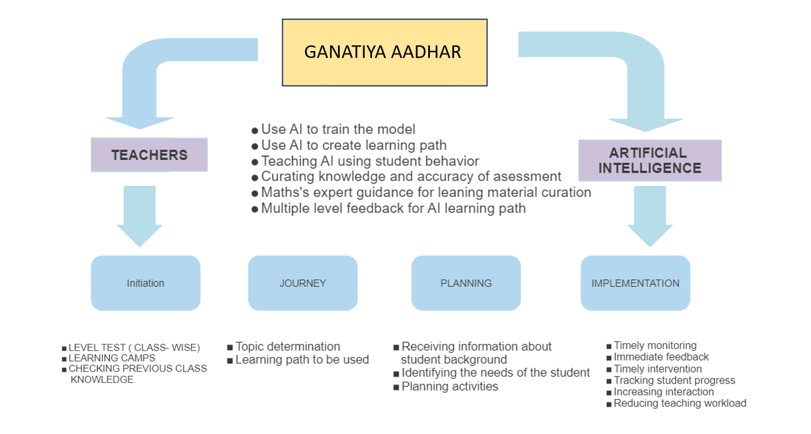
_{Fig [1]}
RQ2: How is K-Means clustering aligning with maths education and school management?
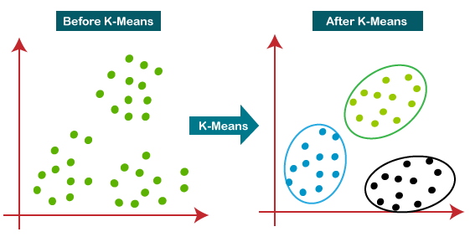
Numerous applications of K-Means clustering are found in the sphere of education. K-Means clustering is used to analyse pupils' overall performance and pinpoint individuals who are academically at risk in the context of math instruction and school administration [13]. Additionally, it is used to assign students to groups for project-based courses, enabling teachers to modify evaluations and instructional approaches to fit various learner types [14]. In order to evaluate the accessibility of the populace to educational facilities and pinpoint areas for development, K-Means clustering is also being used to analyse the school participation rate in various provinces [15]. These K-Means clustering applications show how useful they are for studying educational data and enhancing instruction and management in educational institutions. Hence, K-Means clustering is widely approached and most used machine learning technique when it comes to applying at school level basis.

Fig[2] [16]
RQ3: How does HOTS skills reflect with AI skillsets desired among students?
In order to succeed in the 21st century, one must possess Higher Order Thinking Skills (HOTS), which are developed through mathematical study. Textbooks and other instructional aids can be used to develop HOTS [17]. In order to improve students' problem-solving capabilities, the deployment of HOTS has been introduced as part of the Malaysian Education Blueprint [18]. In order to help students develop their problem-solving abilities and support the attempt to improve HOTS, Artificial Intelligence (AI) has been presented as an approach [19]. Giving students open-ended tasks that force them to think more deeply and come up with many solutions can help them develop HOTS, which focuses on thinking critically, creatively, and optimally. Therefore, HOTS competencies indicate the capacity for critical, inventive, and problem-solving thought.
Students' critical thinking and problem-solving skills can be improved through the use of Higher Order Thinking Skills (HOTS), which are crucial abilities in the field of Artificial Intelligence (AI) [20]. Investigating information, applying logic, and tying together mathematical concepts are all part of HOTS [21]. These competencies match those sought after in AI, including analytical reasoning, data analysis, and problem-solving [22]. Students can gain the key skills necessary in the workplace of the twenty-first century, such as creativity and innovation, by developing HOTS [23]. The development of skills like teamwork and project-based learning, which are essential in AI, can also benefit students from HOTS-based learning [24]. As a result, including HOTS into the classroom can help students expand their skill sets in AI, preparing them for careers in the subject in the future.
RQ4: What changes in teaching patterns are required in order to achieve these goals of Beyond Abacus, AI, HOTS SKILLS.
To accomplish the objectives of HOTS skills, changes in teaching strategies are necessary. Teachers must incorporate generative learning, learning object qualities, and the promotion of certain HOT aspects into HOTS learning design [25]. The main goals of pedagogical interventions should be to support students' interest in and proficiency in writing as well as to explicitly teach HOTS in all courses [26]. Implementing HOTS requires instructors to be competent professionals, and it's critical to address the difficulties Islamic Education teachers encounter in doing so [27]. Textbooks are important for teaching HOTS, and examining the HOTS material in maths textbooks can aid in its successful application [28]. The use of HOTS-based evaluation intends to provide students the ability to think critically, logically, reflectively, metacognitively, and creatively.
Clinical approach to intuitively include all aspects such as Artificial Intelligence, Data Visualization, etc in our teaching pedagogy, we have to use the following diagram:
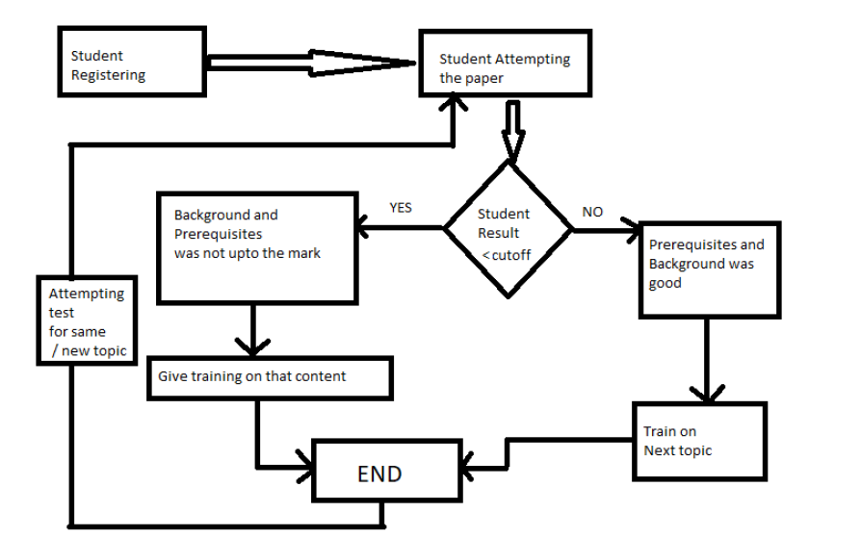
Fig[3]

Table 1. | Environment Related Problems.
Parental/other negatives
Easy going attitude
Alternates available
Easy curriculum

Table 2. | Perception problems.
Fear of unknown
Peer pressure
Initial failure / reprimand
Public insult/ scolding
mPunishment
Too much expectations
Siblings comparison

Table 3. Memory related problems. Memory related Problems | Mixing Concepts
Overlapping
Inclination towards rote the concepts
Inability to associate/ link two concepts
Too many items look alike
Not remembering formulae at right time

Table 4. Reading problems.
Teacher’s bad handwriting
Fine prints of textbooks
Own illegible handwriting
Converting thoughts to handwriting takes lots of
effort and then reading it after few months
Pace of teaching too high

Table 5. Intelligence related problems.
Lack of attention span
Low abstract thinking
Mixing symbols / models
Not able to quantify problem statement
Table 6. Teacher related problems.
What is being good at math?
Who’s best at math?
Perception of role as Math faculty in a particular class?
Lack of appreciation of individual differences?
Too much expectation from students

RQ5: Which aspects of school management does AI cover in administration?
Aspects of school management are covered by artificial intelligence in many ways. In order to improve the digital learning experience, it also analyses intelligent learning systems and incorporates expert systems into online learning environments [29]. Artificial intelligence technology can also be used in education management to improve efficiency and foster growth [30]. Additionally, the management of school buses can make use of artificial intelligence through the deployment of systems like unmanned aerial vehicles and controls for the identifying, storing, and removing of student possessions [31]. The use of artificial intelligence systems in schools has also been adopted and put into place, with frameworks being put in place to ensure success [32]. AI has an impact on how schools make decisions.
Artificial Intelligence in this paper has been referenced from the paper Maths and Artificial Intelligence, Parallel yet Intersecting in School curriculum where Microsoft has used AI in multiple ways to calculate student results in maths, diagnose it, improve it and take it further. Also, comparison of schools performance district wise has been done.
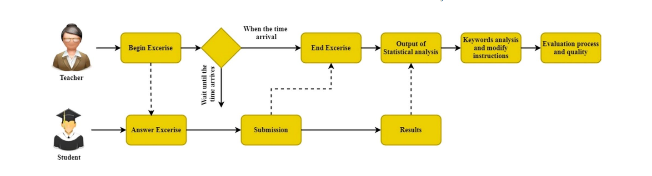

Fig [4] [33]

HOTS SKILLS
Critical Thinking | Self-regulation | Negotiation
Cooperative Mindset | Team leadership | Elaboration
Self-efficacy ICT | Technological pedagogical knowledge | Decision Making

conclusion and future scope
The research underscores the importance of understanding individual students' mathematical proficiency and engaging with them to address not only their mathematical inquiries and concerns but also their broader approach to mathematics as a concept for understanding, thinking, and living. This approach is suggested to mitigate the typical stress, anxiety, and challenges associated with math education. The study explores the utilization of AI to assess students' existing math skills. It further aims to offer personalized learning experiences by providing worksheets and thoughtfully curated online and offline resources, all guided by AI. The intention is to assist students in identifying their optimal learning trajectories and ultimate objectives in mastering math at a school level. Additionally, this approach considers potential extensions of statistical topics, like data analytics, machine learning, probability, differentiation, and integration.

The study also addresses five research questions:

RQ1: It delves into the significance of AI techniques in the context of diagnosing students' math proficiency and selecting appropriate learning strategies.
RQ2: The inquiry explores the alignment of K-Means clustering, an AI technique, with mathematical education and school management practices.
RQ3: The study investigates the intersection of Higher Order Thinking Skills (HOTS) with the skillsets sought after in the field of AI among students.
RQ4: It examines the necessary shifts in teaching methodologies required to achieve the educational objectives of advanced math, AI integration, and fostering HOTS.
RQ5: The research question explores the dimensions of school management that can be enhanced or influenced by AI.
In summary, the study underscores personalized math education facilitated by AI, addressing concerns beyond mathematical skills. The research questions delve into the relevance of AI techniques, the role of K-Means clustering in education, the connection between HOTS and AI skills, necessary pedagogical changes, and the potential impact of AI on school management aspects.

Limitations and future Scope
From NEP 2020 and applications of knowledge and school level, curriculum and syllabus available, I am limited with the scope of the same. Hence the results and reporting too.
Scope is not limited to the dynamic landscape of education shaped by the National Education Policy (NEP) 2020, the convergence of artificial intelligence, higher-order skills, school math curriculum, machine learning, and expert systems forms a compelling intersection. This junction represents an unprecedented opportunity to revolutionize how I foster learning. By leveraging AI and machine learning, we can personalize education, tailoring it to individual needs and learning styles. The infusion of higher-order skills cultivates critical thinking, problem-solving, and creativity—essential competencies for navigating the complexities of the modern world. At the heart of this endeavor, expert systems lend their expertise, offering adaptive guidance and bridging the gap between academic content and real-world applications. As I embark on this transformative journey, it is crucial to delineate a comprehensive scope that harnesses the synergy between these elements, ensuring that our educational landscape evolves in sync with the NEP's vision of holistic and future-ready learning.

References
- Verma Mudit, AI and its application with special emphasis in education
- Lund Brady, Mannurru Nishith et al, Chat GPT and New Acadedmic Reality, AI and written Academic Research and ethics of LLMs.
- Chajdegani Razieh, et al, A Review on Expert System in Medicine
- Mahesh, Batta. "Machine learning algorithms-a review." International Journal of Science and Research (IJSR).[Internet] 9.1 (2020): 381-386.
- Moghe Snehal, et al, Maths and AI Parallel yet Intersecting Approach in School Curriculum, STM Journal
- Oti, Eric U., et al. "Comprehensive review of K-Means clustering algorithms." criterion 12 (2021): 22-23
- Samar, Sharma. (2023). Integrating artificial intelligence into education. International journal of advanced academic studies, 5(6):35-39. doi: 10.33545/27068919.2023.v5.i6a.1004
- Zaenal, Mustakim., Rahmat, Kamal. (2021). K-means clustering for classifying the quality management of secondary education in Indonesia. 40(3):723-735. doi: 10.21831/CP.V40I3.40150
- Nur, Lisa, Zaharin., Sabariah, Sharif., Muralindran, Mariappan. (2018). Computational Thinking: A Strategy for Developing Problem Solving Skills and Higher Order Thinking Skills (HOTS). The International Journal of Academic Research in Business and Social Sciences, 8(10):1265-1278. doi: 10.6007/IJARBSS/V8-I10/5297
- G, S, Pratama., Heri, Retnawati. (2018). Urgency of Higher Order Thinking Skills (HOTS) Content Analysis in Mathematics Textbook. doi: 10.1088/1742-6596/1097/1/012147
- Akın, Orsdemir., Gunes, Tilki., Fahriye, Altinay. (2019). Evaluation by Teachers of “Use of Influence in Agile Management” by School Administration. International Journal of Disability Development and Education, doi: 10.1080/1034912X.2019.1634249
- Moghe, Ms & Bandhu, Kailash Chandra & Kailash, Moghe & Prakash, Moghe. (2023). Maths and Artificial Intelligence--Parallel Yet Intersecting Approach in School Curriculum.
- Gil-Vera, Victor Daniel, Isabel Cristina Puerta-Lopera, and Catalina Quintero-Lopez. "Clustering Applied to the Education: A K-means and Hierarchical Application." Rev. Eur. Stud. 12 (2020): 66.
- Goh, Yann Ling, et al. "Prediction of students' academic performance by K-means clustering." Science Proceedings Series 2.1 (2020): 1-6.
- Windarto, A. P., & Herawan, T. (2022). K-Means Algorithm with Rapidminer in Clustering School Participation Rate in Indonesia. In Recent Trends in Mechatronics Towards Industry 4.0: Selected Articles from iM3F 2020, Malaysia (pp. 779-794). Springer Singapore.
- Damodar Reddy, Prasanta K. Jana, Initialization for K-means Clustering using Voronoi Diagram, Procedia Technology, Volume 4,2012,

- Ilyas, M., and R. F. Pasandaran. "Higher order thinking skills (HOTS) first middle school of class viii students in completing the problem of polyhedron." Journal of Physics: Conference Series. Vol. 1470. No. 1. IOP Publishing, 2020.
- Ping, Owi Wei, et al. "Effectiveness of higher order thinking skills (HOTS) based i-Think map concept towards primary students." AIP Conference Proceedings. Vol. 1847. No. 1. AIP Publishing, 2017.
- Zaharin, Nur Lisa, Sabariah Sharif, and Muralindran Mariappan. "Computational thinking: A strategy for developing problem solving skills and Higher Order Thinking Skills (HOTs)." Int. J. Acad. Res. Bus. Soc. Sci 8.10 (2018).
- Hashim, Hartini, Mohd Norawi Ali, and Mohd Ali Shamsudin. "Infusing high order thinking skills (hots) through thinking based learning (tbl) during eca to enhance students interest in STEM." International Journal of Academic Research in Business and Social Sciences 7.11 (2017): 1191-1199.
- Hamdan, Nuraffefa, et al. "An Effectiveness of High Order Thinking Skills (HOTS) Self-Instructional Manual for Students' Assignment Achievement." Journal of Technical Education and Training 11.1 (2019).
- Saepuzaman, Duden, Heri Retnawati, and Edi Istiyono. "Can innovative learning affect student HOTS achievements?: A meta-analysis study." Pegem Journal of Education and Instruction 11.4 (2021): 290-305.

- Soeharto, Soeharto, and Rosmaiyadi Rosmaiyadi. "The Analysis of students’ higher order thinking skills (HOTS) in Wave and Optics Using IRT with Winstep Software." Journal of Educational Science and Technology (EST) 4.3 (2018): 145-150.

- Omar, Mohd Saifulkhair. "The relationship between attitude and higher order thinking skill
(Hots) among secondary school students." Turkish Journal of
Computer and Mathematics Education (TURCOMAT) 12.7 (2021): 82-90.
- Geraldine, D., De Mello, O. J. P., Omar, N. H., Izza, I., Esa, M., & Ariffin, K. (2021). An Analysis of Higher-Order Thinking Skills (HOTS) in Malaysian University English Test Report Writing.
- Markhamah, Naelatul. "Pengembangan soal berbasis HOTS (higher order thinking skills) pada kurikulum 2013." Nusantara: Jurnal Pendidikan Indonesia 1.2 (2021): 385-418.
- Pius, Rachel Lyne G., et al. "The Teachers’ Readiness in Integrating Higher Order Thinking Skills (Hots) In Teaching and Learning History Subject." The 2nd International Conference on Sustainable Development and Multi-Ethnic Society. Redwhite Pres, 2019.
- Akhyar, M. "Implementation of blended learning in vocational student’s to achieve hot skills (V-hots)." Universal Journal of Educational Research 8 (2020): 13-18.
- Pluzhnikova, N. N. "Technologies of artificial intelligence in educational management." 2020 International Conference on Engineering Management of Communication and Technology (EMCTECH). IEEE, 2020.
- Wang, Yashu. "Educational management system of colleges and universities based on embedded system and artificial intelligence." Microprocessors and Microsystems 82 (2021): 103884.
- Kuzior, A., Kwilinski, A., & Tkachenko, V. (2019). Sustainable development of organizations based on the combinatorial model of artificial intelligence. Entrepreneurship and Sustainability Issues, 7(2), 1353.
- Beccalli, Elena, Viktor Elliot, and Francesco Virili. "Artificial intelligence and ethics in portfolio management." Digital Business Transformation: Organizing, Managing and Controlling in the Information Age. Springer International Publishing, 2020.
- Geng, Feng, Alfred Daniel John, and Chandru Vignesh Chinnappan. "Analysis of the teaching quality using novel deep learning-based intelligent classroom teaching framework." Progress in Artificial Intelligence (2021): 1-16.

