Biochemical Pesticides a life for Kashmiri Apples
Irshad Ahmad Lone,
Assistant Professor at Department of Higher Education J&K,
Government Degree College Kulgam.
waqtkalamha@gmail.com

Abstract
Pest control agents are substances known as pesticides. A pesticide is a chemical or biological agent such as a virus, bacteria, antibiotic, or disinfectant that repels, renders ineffective, or kills pests. The terms "pesticide" and "plant protection product" are frequently used interchangeably because of how pesticides are employed. Pesticides eradicate or control agricultural pests that can harm livestock and crops and reduce farm productivity. Because of the detrimental effects on human populations and ecosystems, the widespread use of pesticides to control pests and pathogens is of significant concern in horticulture systems. The material in the current article helps understand the types of pesticides used in modern horticulture and bio-farming.
Keywords: Biochemical pesticide, Biochemical control, Kashmiri apple, Health and disease,
- Introduction
Pesticides have been used for a long time. In the past, pesticides were used to protect crops from insects and other pests. [1] Ancient Sumerians used elemental sulphur to keep insects out of their crops. Contrarily, farmers in the middle Ages experimented with poisons like lead and arsenic on common crops. The Chinese used poisons containing arsenic and mercury to get rid of insects like body lice and other pests. The Greeks and Romans used materials like oil, ash, sulphur, and other ingredients to protect themselves, their animals, and their crops against a variety of pests. [2] In contrast, research in the eighteenth century focused more on natural approaches employing compounds made from the roots of tropical plants and chrysanthemums. Due to its extraordinary efficiency, Dichloro-Diphenyl-Trichloroethane (DDT), which was initially created in 1939, is today the most commonly used pesticide worldwide. [3] Due to its biological effects and danger to humans, DDT has subsequently been banned in approximately 86 countries. [4] There are five well-known and widely used methods for controlling pests: biological control, chemical control, mechanical and physical control, cultural and sanitary controls, and the adoption of resistant types. All five of these strategies played a significant role in the continuous advancement of pest management in the 20th century. Chemicals had advantages but risks as well. Chemical pesticides are often designed to target certain pests at a specific location, but issues might develop since they are frequently hazardous to a wide range of creatures, especially the human population, and they also remain in the environment. [5]
- Some Common Apple Pests
Fire Blight
Erwinia amylovora is a kind of bacteria that causes fire blight. Sometimes entire limbs or trees, as well as blossoms and terminal twigs, are killed. Moisture during bloom and temperatures above 60° F are environmental factors that encourage infection. Infection-causing bacteria are transferred to flowers by insects and rain.
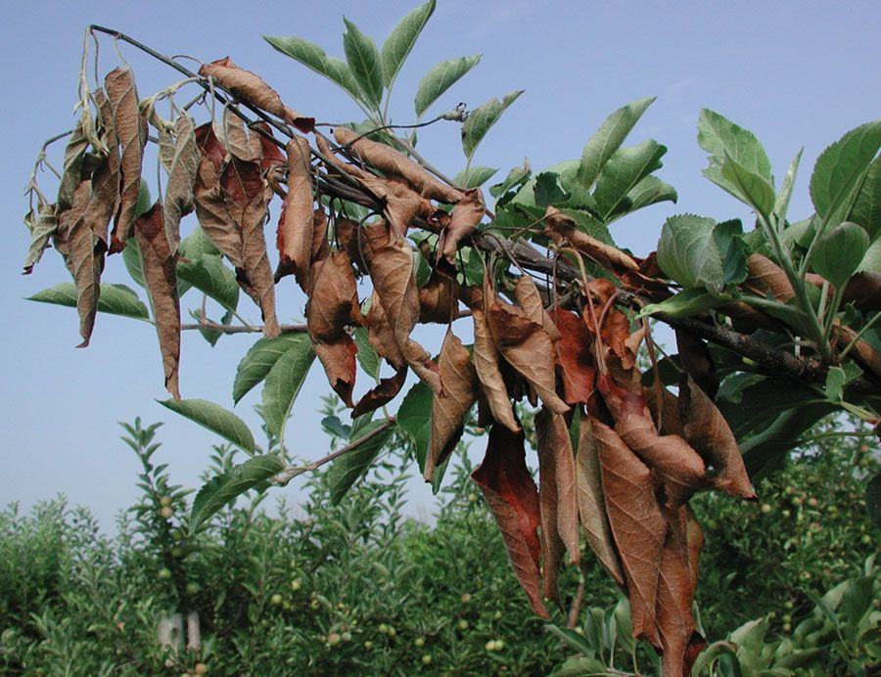

The Apple tree must first and foremost be pruned of any sick shoots or limbs as soon as they develop. Apply an antibiotic spray right before or 24 hours after it rains to guard against infection when flowers are in bloom. To avoid resistance, combine the prescribed doses of oxytetracycline and streptomycin.
Powdery Mildew
This fungus targets fruit, flowers, and foliage. Late spring is when infections start, along with warm days, cool nights, and some moisture. The wind, dew, rain, and irrigation all disseminate the spores.
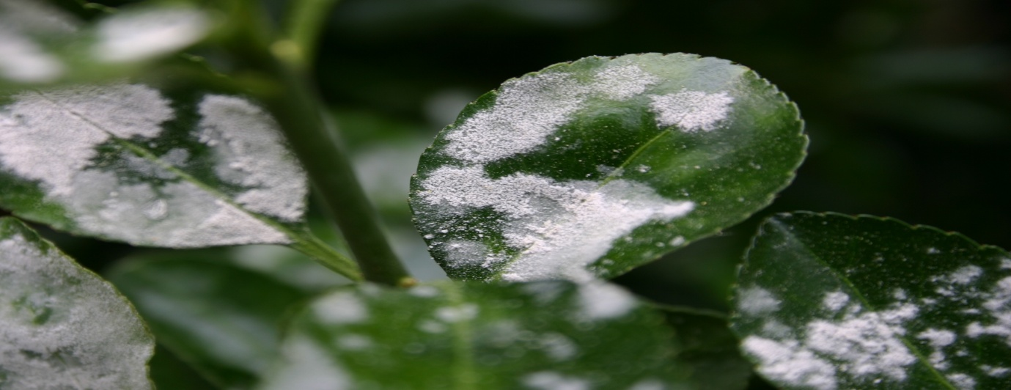

Most trees are able to withstand minor diseases. Fungicides (such as sulphur and myclobutanil) function as preventatives. It will also aid in lowering the infection levels in the area to prune afflicted twigs.
Apple Mosaic Virus
By grafting a sick scion, the rare and easily avoidable apple mosaic virus is disseminated.
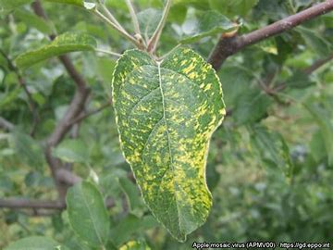

Use virus-free grafting scion and virus-free plants during planting. Although they shouldn't be cut down, diseased trees shouldn't be used to make scions.
Spider Mites
Spider mites are adults that overwinter at the foot of trees or in ground cover. In the middle and late summer, when the weather is hot and dry, they can become a nuisance because they reproduce quickly. They give the leaves a stippling look by removing the sap and chlorophyll.
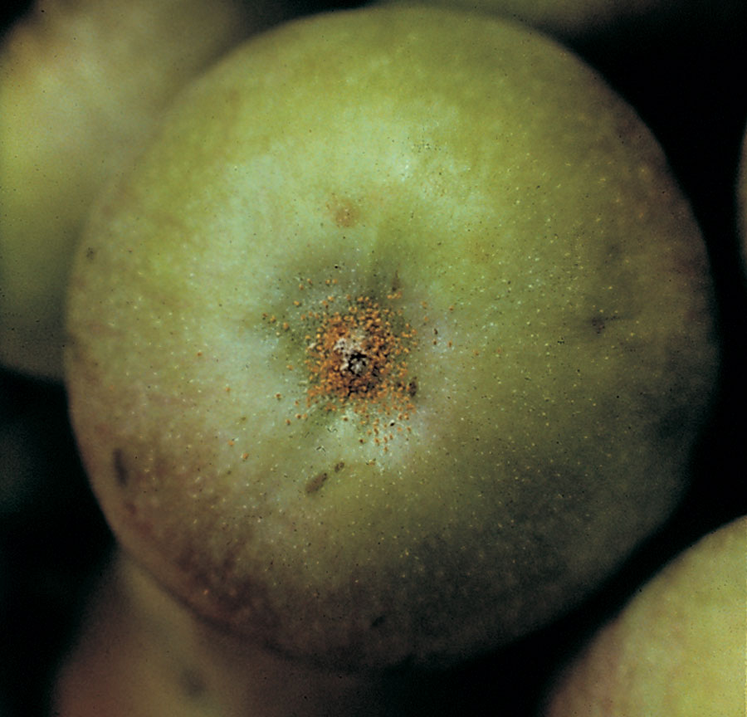

If pesticides don't kill predatory mites that eat spider mites, they can act as a reliable biological control. Low spider mite populations can be disregarded, and the predatory mites frequently keep them in check. Outbreaks of spider mites frequently occur after pesticide treatments that disturb the predator-prey balance. Applying insecticidal soap or spraying trees or plants with a forceful stream of water will help eliminate spider mite issues.
San Jose Scale
The most frequent scale insect to attack apples is the San Jose scale. Scales will consume apple fruit and bark while producing little red haloes with white centres. The insect's delicate body is concealed by an armoured shield. Females give birth to young that emerge from the

mother’s scale before settling down to eat. Late April is when the "crawlers" are most active. A tree may die if severe pests are not handled.
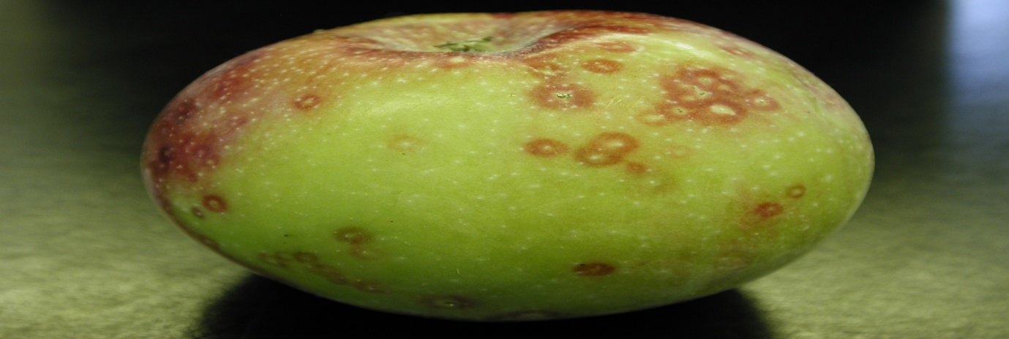

Immature scales that have overwintered will be killed by a 2% oil application at the half-inch green stage. Adults are challenging to kill. In June, use pyrethroid or carbaryl to kill crawlers. Scrub branches in the dormant season with soapy water for non-chemical pest management.
Apple Scab
A typical fungus called apple scab damages the fruit and leaves and the apples are so discolored that they are unfit for consumption. In places with a lot of rain and high humidity as well as during a warm, rainy spring, the apple scab fungus grows. Early detection and prevention are essential for its control because there is no cure for affected trees.
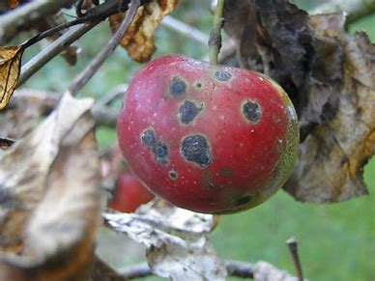

In order to stop the fungus from spreading, proper sanitation is essential. Pruning is yet another crucial step in the fight against apple scab. Only after the tree has lost the majority of its leaves for three or more straight years, it is possible to spray a fungicide on an infected tree.
- Literature Review
The environment, human health, and ecosystem services are all negatively impacted by pesticide overuse. They do not, however, provide a breakdown of the indirect, covert, or undetectable effects of pesticide use on environmental services as well as human health. Even while negative effects on human health or environmental degradation have been addressed and in-depth investigated in earlier research and studies on ecological valuation and sustainability, this is still the case. The following paper aims to present a hypothetical account of the large hidden costs related to pesticide use in the Jammu and Kashmir regions of the Indian union. [10] Pesticide application must be safe, effective, and practical. The advantages of pest control must outweigh the disadvantages to the economy, the environment, and human health. Humans should not be particularly vulnerable to insect pests, and pesticides should not harm beneficial arthropods or insect pollinators. The human food chain is impacted by pesticide residues left in crops, soil, and water. Pesticide residues have been connected to a number of health issues, including sickness, neurotoxicity, endocrine disruption, and genetic abnormalities. [11] Water bodies in Kashmir are at serious risk since a recent study found the pesticide organophosphate dimethoate in the Dal lake, which could endanger not only the use of Dal waters for human purposes but also other types of aquatic life.
- Biological Pest Control
Chemical pesticides are effective, but they also have the potential to harm both good insects and pests. They can contaminate water and soil as well. Without chemical pesticides, biological control is a way of pest management. This approach is used to manage pests like insects, rodents, and parasitic plants. Typically, this approach entails adding native predators to the habitat. [6] The advantages of biological management include effectiveness, environmental friendliness, and self-sufficiency. Biological control agents are organisms that are natural aversives, predators, and repellents in biological control.
In the biological control of pests, there are three primary approaches, each with unique stages and agents. [7] Classical biocontrol, augmentative biocontrol, and conservation biocontrol are these three methods. Importation, sometimes referred to as Classical biocontrol, is the first tactic utilized to manage pest populations naturally. This technique employs a natural predator and is utilized on exotic pests. Importation aims to locate beneficial natural pest foes, introduce them to the area, and establish them there permanently so that further human intervention is not required. Supplemental or augmentative biocontrol is a different method of biological control. When there is not enough of a predator present naturally to successfully manage pest numbers, this technique depends on increasing the population of a natural adversary. Conservation is the third and last method of biological control. [8] Conservation aims to change the environment to give pest control agents the best habitats possible so they can thrive and reduce pest numbers. Habitat control often entails providing enough resources, such as a variety of plants and nectar, to sustain the populations of the control agents. Predators, parasites, parasitoids, and even other plants can act as biocontrol agents. The sole prerequisite is that they try to increase the number of predators or eradicate a pest.
- Plants as Biocontrol Agents
The virucides, Cyanobacteria Nostoc, Virkon, Scytovirin, and Griffithsin are employed in medical studies. [9] Chrysophytes, like diatoms, are employed in hydroponics, biofarming, and the cultivation of bonsai as biopesticides and anti-chaffing agents. The Japanese beetle is managed with Bacillus popilliae, also known as Milky spore. The first bioinsecticide created for commercial use in Germany was sporine. By preventing ion transport in the midgut, sporeine kills insects. Through the use of recombinant DNA technology, the genes for some of these poisons have been extracted and transferred to hosts. Habitat manipulation includes the use of plants as biocontrol agents. It's possible for some plants to serve as spies, luring pests to them and protecting the crops. Others might offer resources to pest-eating beneficial insects. We can develop supplementary crops next to our main crops called companion plants. They offer a perfect environment for predators and improve the general health of crops. Repellent plants, as their name implies, are used to deter pests and dangerous microorganisms from the main crop by emitting chemicals into the air and producing an unpleasant odour. Barrier plants are primarily employed by farmers to prevent pests from accessing their crops, as well as to prevent plant diseases from infecting key crops. By physically enclosing the crops in barrier plants, they achieve this. By catching viruses and pests, barrier plants defend crops. To strengthen and foster a pest's natural enemies, insectary plants are used. These natural adversaries, like parasitoids, feast on plants with nectar, sap, and pollen.
- Advantages of Biocontrol Agents
In the long run, biocontrol involves little human intervention and aims to reduce pest populations in a sustainable manner, making it a cost-effective strategy. Since it doesn't utilise dangerous chemical pesticides, biocontrol is also environmentally friendly. Typically, Biopesticides are less hazardous by nature than traditional pesticides. Biopesticides frequently work in extremely small doses and frequently degrade quickly, reducing exposure levels and mainly avoiding the pollution issues brought on by conventional pesticides. Biopesticides have the potential to significantly reduce the use of traditional pesticides while maintaining excellent crop yields when utilised as a part of Integrated Pest Management (IPM) programmes.
- Conclusion
The majority of pest diseases are preventable with good hygiene, grafting, trimming, and light water scrubbing. For the entire season, a farmer will only use 2 to 3 chemical pesticide treatments if plants are used wisely as biocontrol agents. This will enable us to produce fruits without the usage of chemical pesticides. It is preferable to choose safer pest control techniques. The use of biopesticides, physical control, biological control, and, if necessary, safer chemical pesticides are some of these techniques. For purely aesthetic reasons, several municipal governments have even stopped applying pesticides on ornamental plants and lawns. Additionally, assuming fruit is safe to eat, some people are now open to accepting fruit that doesn't seem flawless and hasn't been treated with chemical pesticides.
VIII. References
[1]: Researchers use science of light to reduce pesticides used to protect crops from pests and diseases (phys.org)
[2]: Environmental Problems of the Greeks and Romans: Ecology in the Ancient Mediterranean (Ancient Society and History) (Review) - World History Encyclopedia
[3]: Dichloro-diphenyl-trichloroethane | C14H9Cl5 - PubChem (nih.gov)
[4]: Curtis, C.F. & Lines, Jo. (2000). Should DDT be Banned by International Treaty?. Parasitology today (Personal ed.). 16. 119-21. 10.1016/S0169-4758(99)01605-1.
[5]: Chemical safety: Pesticides (who.int)
[6]: Chane, Tibebu. (2018). Defense Mechanisms of Plants to Insect Pests: From Morphological to Biochemical Approach. Trends in Technical & Scientific Research. 2. 10.19080/TTSR.2018.02.555584.
[7]: Sanda, Nafiu & Sunusi, Mustapha. (2016). FUNDAMENTALS OF BIOLOGICAL CONTROL OF PESTS. 10.13140/RG.2.2.19011.20002.
[8]: Rayl, R.J., Shields, M.W., Tiwari, S., Wratten, S.D. (2018). Conservation Biological Control of Insect Pests. In: Gaba, S., Smith, B., Lichtfouse, E. (eds) Sustainable Agriculture Reviews 28. Sustainable Agriculture Reviews, vol 28. Springer, Cham. https://doi.org/10.1007/978-3-319-90309-5_3
[9]: Junaid, Jan & Dar, N.A. & Bhat, Tauseef & Bhat, Arif & Bhat, Mohammad. (2013). Commercial Biocontrol Agents and Their Mechanism of Action in the Management of Plant Pathogens. Int J Modern Plant&Anim Sci.. 1. 39-57.
[10]: Bhat, Arshad & Wani, M & Bhat, G & Mubashir, Mohammad. (2020). Pesticide use in Jammu and Kashmir: Invisible Costs and Willingness to Pay for Available Alternative Measures. 410-417. 10.37273/chesci.CS20510182.
[11]: Riyaz, Muzafar & Iqbal, Wani & Sivasankaran, Kuppusamy & Ignacimuthu, Savarimuthu. (2020). Impact on Farmers’ Health Due to the Pesticide Exposure in the Agrarian Zones of Kashmir Valley: A Review. 4. 01-07. 10.31080/ASAG.2020.04.impact-on-farmers-health-due-to-the-pesticide-exposure-in-the-agrarian-zones-of-kashmir-valley-a-review.

