Journal Title
ISSN

www.stmjournals.com

Evaluation of cytotoxic activity of Cestrum nocturnum leaves extract against A549 cell line using MTT Assay
Prachi Sharma1*
¹Amity Institute of Biotechnology, Amity University, Noida, India

Abstract
Cancer remains a major global cause of death, necessitating ongoing research for effective treatments. Traditional herbal medicine is being explored for novel anti-cancer compounds. This study investigates the cytotoxic effects of Cestrum nocturnum ethanolic extract on A549 lung cancer cells, a type of non-small cell lung cancer (NSCLC). NSCLC is a significant health concern in India, affecting even non-smokers. Cestrum nocturnum, known as Night-blooming jasmine, has shown promise in inhibiting tumor growth in mice, and its active compound, apigenin, exhibits anti-cancer properties. Apigenin modulates epigenetic mechanisms involved in cancer development and progression, including DNA methylation, histone modification, signaling pathways, cell cycle arrest, and apoptosis. The ethanolic extract demonstrated concentration-dependent cytotoxicity, indicating potential anti-cancer properties. This study underscores Cestrum nocturnum's potential as an anti-cancer agent and provides insights into apigenin's mechanisms of action, warranting further research for therapeutic applications in NSCLC treatment.

Keywords: A549, MTT assay, Cestrum nocturnum, lung cancer

*Author for Correspondence E-mail: prachi22@s.amity.edu

INTRODUCTION
Ongoing research efforts are imperative to unveil new and effective treatments, as cancer continues to persist as a prominent global cause of death. Traditional herbal medicine has gained attention as a potential source of novel anti-cancer compounds. Numerous herbs and natural products have been explored for their cytotoxic effects on cancer cells, with the aim of identifying promising candidates for further investigation and potential therapeutic development.

In India, lung cancer is the leading site in men. [1] Assessing the cytotoxic effects of herbs on the A549 cell line provides valuable insights into their potential anti-cancer properties and their viability as treatment options for NSCLC. According to recent estimates, a significant portion of lung cancer cases worldwide, specifically 15% in men and 53% in women, occurs in individuals who have never smoked.[2] However, tobacco smoking remains the predominant risk factor for lung cancer, with the likelihood of developing the disease increasing in proportion to both the number of cigarettes smoked and the duration of smoking. Tobacco smoking is responsible for over 90% of lung cancers in men and 74% to 80% of lung cancers in women. It is named "non-small cell" to distinguish it from small cell lung cancer, another major type of lung cancer. NSCLC typically originates in the tissues of the lungs and may spread to other parts of the body if not detected and treated early. NSCLC encompasses several distinct subtypes, which include adenocarcinoma, squamous cell carcinoma, and large cell carcinoma. Each subtype has distinct characteristics and may respond differently to treatment approaches. [3]

Cestrum nocturnum, commonly known as Night-blooming jasmine or Lady of the Night, is a plant that has been traditionally used for various medicinal purposes. There is limited scientific research specifically investigating its anti-cancer potential against the A549 cell line or lung cancer. Zhong, Zhen-Guo, et al. experimentally proved that extracts of CN were able to inhibit tumor growth in mice. [4] Kumar, Pradeep, et al. demonstrated the mechanism of apigenin found in leaves of CN on hepatocellular carcinoma. [5]
Apigenin is a natural compound found in various plants and has been studied for its potential anticancer properties, particularly its ability to modulate epigenetic mechanisms involved in cancer development and progression.[5] Epigenetic modifications refer to chemical changes that can impact gene expression without modifying the actual DNA sequence. They play a crucial role in regulating gene activity and can be disrupted in cancer cells, leading to abnormal gene expression patterns. [6]
Apigenin has been found to exert its anticancer effects through the following mechanisms such as DNA methylation inhibition [7], histone modification, [8] modulation of signaling pathways [9] and induction of cell cycle arrest and apoptosis.[10]

MATERIALS AND METHOD

Preparation of Cestrum nocturnum Ethanolic Extract
The dried leaves were grinded into a fine powder using a mixer. One gm of powder was submerged in 70% ethanol. After standing for 72 hours, the supernatant was filtered and collected. The supernatant was left to dry at room temperature to obtain the ethanolic extract. The extract transferred in an Eppendorf tube and DMSO was added to make a stock of 100mg/ml. The stock was stored at -20°C.

Cancer cell lines and culture conditions
The A549 cell line, derived from human lung adenocarcinoma, was obtained from ATCC. The cells were maintained in Dulbecco's Modified Eagle's Medium (DMEM, HIMEDIA) supplemented with 10% fetal bovine serum (FBS) and 1% penicillin-streptomycin in a humidified incubator at 37°C with 5% CO₂.

Cytotoxicity Assay
Cytotoxicity studies were performed using the MTT (3-[4,5-dimethylthiazole-2-yl]-2,5-diphenyltetrazolium bromide) assay. Exponentially growing A549 cells were seeded into 96-well microtiter plates at a density of 10,000 cells per well in 180 μl of DMEM medium. After 24 hours of incubation at 37°C, stock solutions of the test samples dissolved in DMEM were added to the wells at serially diluted concentrations of 250, 100, 50, 25, 10, and 1 μg/ml in culture medium. As a vehicle control, dimethyl sulfoxide (DMSO) was included at a concentration of 0.25%.

Incubation and Cell Viability Assessment
Following the addition of test samples, the plates were further incubated for 24, 48, and 72 hours, at 37°C with 5% CO2. At the end of the respective incubation period, 20 μl of MTT solution (5 mg/ml in phosphate-buffered saline) was added to each well, and the plates were incubated for an additional 3 hours. After 3 hours, the medium was removed, and the formazan crystals formed by viable cells were solubilized by adding 150 μl of dimethyl sulfoxide (DMSO) to each well. The absorbance was measured at 570 nm using a microplate reader, and the cell viability was calculated relative to the control group. The percentage cytotoxicity was calculated using the following formula, % Cytotoxicity = ((mean OD of control – mean OD of individual group)/mean OD of control
group)) *100
The percentage viability was calculated by subtracting cytotoxicity from 100.

RESULTS
The percentage viability was found to decrease in a trend from lower concentration to higher concentration. The inhibitory concentration for 24-, 48- and 72-hour incubation period was found to be 31.18 µg/ml, 24.8 µg/ml and 14.74 µg/ml respectively. Cestrum nocturnum showed % cytotoxicity in the range 23.9% - 92.8% with working concentration 1-250 µg/ml in A549 cell line.

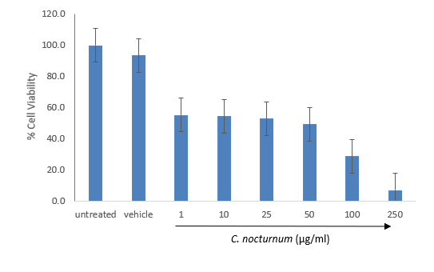

Fig. 1: Percentage of cell viability in extract treated cells after 24 hours.

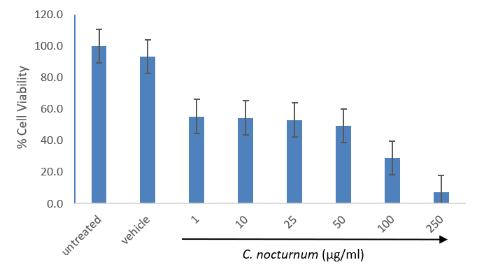

Fig. 2: Percentage of cell viability in extract treated cells after 48 hours.

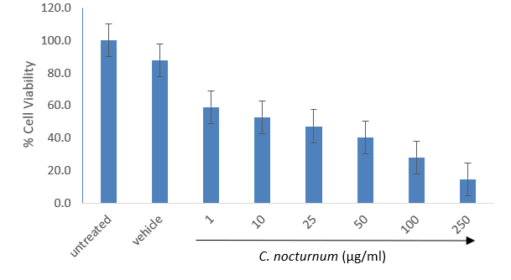

Fig. 3: Percentage of cell viability in extract treated cells after 72 hours.

CONCLUSIONS
The present study evaluated the cytotoxic effects of the ethanolic extract of Cestrum nocturnum leaves on the A549 cell line, a type of lung cancer cell, at three different time points: 24, 48, and 72 hours. The inhibitory concentration for each time point was found to be 31.18 µg/ml, 24.8 µg/ml, and 14.74 µg/ml, respectively. These findings indicate that the ethanolic extract of Cestrum nocturnum leaves possesses potential cytotoxic properties against lung cancer cells, with stronger inhibitory effects observed at longer incubation periods.

Cestrum nocturnum, commonly known as Night-blooming jasmine or Lady of the Night, has been traditionally used for various medicinal purposes. While there is limited scientific research specifically investigating its anti-cancer potential against lung cancer, previous studies have demonstrated the anti-tumour and anti-cancer effects of Cestrum nocturnum extracts. Zhong, Zhen-Guo, et al. conducted an experiment showing the inhibition of tumor growth in mice by CN extracts, supporting the notion that this plant has promising anti-cancer properties [4]. Furthermore, Kumar, Pradeep, et al. explored the mechanism of apigenin, a natural compound found in Cestrum nocturnum leaves, on hepatocellular carcinoma [5]. Apigenin has been studied extensively for its potential anticancer properties, particularly in modulating epigenetic mechanisms involved in cancer development and progression [5].

Epigenetic modifications, such as DNA methylation and histone modifications, play a crucial role in regulating gene expression and can be disrupted in cancer cells, leading to abnormal gene expression patterns [6]. Apigenin has been found to exert its anticancer effects through several mechanisms involving epigenetic regulation.

Firstly, apigenin inhibits DNA methyltransferase enzymes, which are responsible for adding methyl groups to DNA molecules. By inhibiting DNA methylation, apigenin may help restore normal gene expression patterns that could be altered in cancer cells [7]. Secondly, apigenin affects histone proteins, which play a role in packaging DNA and regulating gene expression. It inhibits histone deacetylase enzymes, leading to increased acetylation of histones. This modification can loosen the chromatin structure and promote the expression of tumor-suppressor genes, ultimately inhibiting cancer cell growth [8]. Moreover, apigenin has been shown to modulate various signaling pathways involved in cancer development and progression. For instance, it can block the PI3K/Akt pathway in breast cancer cells, thereby inhibiting metastasis [9]. These findings suggest that apigenin's effects on signaling pathways may contribute to its overall anticancer properties. Lastly, apigenin has been reported to induce cell cycle arrest and promote apoptosis in cancer cells [10]. These effects can help prevent uncontrolled cell growth and facilitate the elimination of cancer cells.

In conclusion, the findings of this study demonstrate the cytotoxic effects of the ethanolic extract of Cestrum nocturnum leaves on lung cancer cells. The inhibitory concentration of the extract was observed to decrease with longer incubation periods. This study adds to the growing body of evidence supporting the potential anti-cancer properties of Cestrum nocturnum and its active compound, apigenin. The mechanism of action of apigenin, particularly its role in modulating epigenetic processes, provides valuable insights into its anticancer effects. Further research and clinical studies are warranted to explore the full potential of Cestrum nocturnum as a promising candidate for lung cancer therapy and to elucidate the underlying molecular mechanisms involved.

ACKNOWLEDGMENTS
Special thanks to Dr. Alka Madaan and cell biology laboratory of Dabur Research Foundation for generously providing all the necessary support and resources for this research.

REFERENCES

Examples of Reference Citation
- Sathishkumar, K., Chaturvedi, M., Das, P., Stephen, S., & Mathur, P. (2022). Cancer incidence estimates for 2022 & projection for 2025: Result from National Cancer Registry Programme, India. Indian Journal of Medical Research, 156(4&5), 598-607. DOI: 10.4103/ijmr.ijmr_1821_22
- 2. Parkin, D. M., Bray, F., Ferlay, J., & Pisani, P. (2005). Global cancer statistics, 2002. CA: A Cancer Journal for Clinicians, 55(2), 74–108.
- 3. Mogi, A., & Kuwano, H. (2011). TP53 mutations in nonsmall cell lung cancer. Journal of Biomedicine & Biotechnology, 2011, 583929.
- 4. Zhong, Z. G., Zhao, S. Y., Lv, J. Y., & Li, P. (2008). Experimental study on antitumor effect of extracts from Cestrum nocturnum in vivo. Zhong yao cai= Zhongyaocai= Journal of Chinese Medicinal Materials, 31(11), 1709-1712.
- 5. Kumar, P., Singh, A. K., Verma, P., Tiwari, K. N., & Mishra, S. K. (2022). Network pharmacology-based study on apigenin present in the methanolic fraction of leaves extract of Cestrum nocturnum L. to uncover mechanism of action on hepatocellular carcinoma. Medical Oncology, 39(10), 155.
- 6. Kumar, P., Singh, A. K., Verma, P., Tiwari, K. N., & Mishra, S. K. (2022). Network pharmacology-based study on apigenin present in the methanolic fraction of leaves extract of Cestrum nocturnum L. to uncover mechanism of action on hepatocellular carcinoma. Medical Oncology, 39(10), 155.
- 7. Choi, E. J., Kim, G. H., Anti-proliferative effects of flavones on human cervical cancer cell lines. Cancer Res Treat, 2005; 37(5): 257-262.
- 8. ( Lu, W., Qin, Y., Yang, C., Li, L., Fu, Y., Deng, Y., & Yin, J. (2017). Apigenin inhibits epithelial-mesenchymal transition, migration, and invasion of prostate cancer by downregulating matrix metalloproteinase-7 expression and increasing E-cadherin expression. Oncology letters, 13(4), 2275-2280.
- 9. Tong, X., & C Pelling, J. (2013). Targeting the PI3K/Akt/mTOR axis by apigenin for cancer prevention. Anti-Cancer Agents in Medicinal Chemistry (Formerly Current Medicinal Chemistry-Anti-Cancer Agents), 13(7), 971-978.)
- 10. Shukla, S., & Gupta, S. (2010). Apigenin-induced cell cycle arrest is mediated by modulation of MAPK, PI3K/Akt, and loss of cyclin D1 associated retinoblastoma dephosphorylation in human prostate cancer cells. Cell Cycle, 9(24), 4911-4921.

Journal Title Volume, Issue, ISSN:

- Fletcher D, Wagstaff CRD. Organisational psychology in elite sport: its emergence, application and future. Psychol Sport Exerc. 2009;10(4):427–34p. doi:10.1016/j.psychsport.2009.03.009. (Electronic article – with DOI number)

Books
Author(s) – Family name and initials, Multiple authors separated by a comma. Title of Book. Edition of book if later than 1st ed. Place of Publication: Publisher Name; Year of Publication.
- Hofmeyr GJ, Neilson JP, Alfirevic Z, et al. A Cochrane Pocketbook: Pregnancy and Childbirth. Chichester, West Sussex, England: John Wiley & Sons Ltd; 2008. (Reference to a Book)
- Rowlands TE, Haine LS. Acute limb ischaemia. In: Donnelly R, London NJM, editors. ABC of Arterial and Venous Disease. 2nd Edn. West Sussex: Blackwell Publishing; 2009. (Reference to a Chapter in an Edited Book)
- Bartlett A, Breastwork: Rethinking breastfeeding [monograph online]. Sydney, NSW: University of New South Wales Press; 2005 [cited 2009 Nov 10]. Available from: NetLibrary (Electronic Book)

Conference Papers
Author(s) of paper – Family name and initials. Title of paper. In: Editor(s) Family name and initials, editor(s). Title of Conference; Date of conference; Place of conference. Place of publication: Publisher’s name; Year of publication. Page numbers.
  - Kimura J, Shibasaki H (Eds). Recent advances in clinical neurophysiology. Proceedings of the 10th International Congress of EMG and Clinical Neurophysiology; 1995 Oct 15- 19; Kyoto, Japan. Amsterdam: Elsevier; 1996. (Conference Proceedings)
  - Bengtsson S, Solheim BG. Enforcement of data protection, privacy and security in medical informatics. In: Lun KC. Degoulet P. Piemme TE, Reinhoff O, (Eds.) MEDINFO
92. Proceedings of the 7th World Congress on Medical Informatics; 1992 Sep 6-10; Geneva, Switzerland. Amsterdam: North Holland; 1992. 1561–5p. (Published Conference Paper)
  - Bowden FJ, Fairley CK. Endemic STDs in the Northern Territory: Estimations of effective rates of partner exchange. Paper presented at: The Scientific Meeting of the Royal Australian College of Physicians. Darwin, Australia. 1996 June 24-25.

(Un published Conference Paper)

Newspaper and Magazine Articles
Author(s) – family name and initials. Article title. Newspaper title (edition of paper eg. Weekend edition). Date of publication – year month (3 letter abbreviation) day: Sect. Location eg. A:12 or Business 5 (5 is the page number) column number is applicable eg. col. 1)
- Robertson J. Not married to the art. The Courier Mail (Weekend Edition). 2010 Mar 6-7:Sect. ETC:15 (Newspaper Article)
- Marano HE. Making of a perfectionist. Psychol Today. 2008 Mar-Apr;41:80-86 (Magazine Article)
- Bajak F. Why Chile dodged Haiti-style ruin. Toronto Star (Canada) [serial online]. 2010 Feb 28 [cited 2010 Mar 14]; Sect. News:A14 Available from: Australia/New Zealand Reference Centre (Electronic Newspaper or Magazine Article)
- Drivers told: Don’t use Clem7 tunnel. The Courier Mail [Internet]. 2010 Mar 16 [cited 2010 Mar 16]; Available from: http://www.couriermail.com.au/news/car-with-flat-tyre-the-first-to- cause-problems-in-clem7-tunnel/story-e6freon6-1225841179464

(Electronic Newspaper Article on the Internet)

Reports and other Government Publications
Author(s). Title of report. Place of publication: Publisher; Date of publication – year month if applicable. Total number of pages if applicable eg. 24 p. Report No.: (if applicable)

- Australia. Parliament. Senate. Select Committee on Climate Policy. Climate Policy Report.
Canberra: The Senate; 2009.
- Page E, Harney JM. Health Hazard Evaluation Report. Cincinnati (OH): National Institute for Occupational Safety and Health (US); 2001 Feb. 24 p. Report No.:HETA2000-0139-2824.

Thesis
Printed Thesis: Author. Thesis title [type of thesis]. Place of publication: Publisher; Year.
Online Thesis: Author. Thesis title [type of thesis on the internet]. Place of publication: Publisher; Year [cited date – year month day]. Available from: Name of database/web address

- Kay JG. Intracellular cytokine trafficking and phagocytosis in macrophages [PhD thesis]. St Lucia, Qld: University of Queensland; 2007. (Printed Thesis)
- Pahl KM. Preventing anxiety and promoting social and emotional strength in early childhood: an investigation of aetiological risk factors [PhD thesis]. St Lucia, Qld: University of Queensland; 2009 [cited 2010 Mar 24]. Available from: University of Queensland Library E- Reserve (Online Thesis)

