Cracks detection in Pavements Using the geomatic technique

Tariq N. Ataiwe
Lecturer, Department of Civil Eng., University of Technology-Iraq, Baghdad, Iraq
E-mail: tariq.n.ataiwe@uotechnology.edu.iq

ABSTRACT:

This scientific research aims to implement the geomatics technique especially the image processing to detect the cracks in the pavements which represent one of the main problems in the pavement. This detection can be done when the single image passes through multiple image processing filters to extract the cracks.
The cracks that are detected are clear, and the crack edge is quickly lost because digital images of pavement cracks are influenced by a lot of complicated noise, such as uneven illumination and water spots. In this research, a crack detection algorithm is suggested in the pavement image to address the issue based on the edge information.
To improve the linear characteristic of the crack, the image is first pre-processed by converting the colored digital image to a gray scale through the gray-scale transformation function and the reconstruction filter. The method of adaptive thresholding is also intended to map the crack gradient information while coarsely extracting the crack edge in accordance with the grayscale feature. The edge is then detected based on the processing of single-pixel filtering, which is optimized by exploiting the local difference between pixels in the fixed region after the filtered edge points have been acquired in accordance with the gradient information. By filling the crack edge, the entire crack is then acquired. The suggested technique can precisely identify pavement fractures and maintain edge information, according to experimental results.

Keywords: Edge detection, Pavement, Remote sensing, Image processing, Geomatics

INTRODUCTION:
Roads have a huge positive impact on society and are essential for economic growth. Having access to jobs, and social, health, and educational services are made possible by transportation networks, which also allow communication and travel.[1], The stability of the infrastructure has been assessed using a variety of technologies, including laser scanning and 3D cameras. Using a digital image to find the damage is a frequent technique. The approximate location of the road fault can be found in the pavement image based on the edge features of the road surface image. For example, thermal infrared photos and digital photographs have both been used to detect cracks.[2]. However, for modern transport management/maintenance authorities, it is getting more and harder to meet these criteria. One usual explanation is that the manual method of conducting pavement condition surveys is still the preferred method, particularly in poorer nations. Even while manual methods used by road maintenance specialists or transportation inspectors can aid in getting accurate evaluation results, they are quite labor-intensive. Therefore, traditional pavement condition surveys take a long time and involve a lot of work with data collecting and data processing. The work of eradicating the situation in time is particularly difficult due to the small number of skilled technicians/inspectors and the numerous asphalt paving techniques already in use.[3]
As a result, the last ten years have seen an increase in interest in using digital photographs to document road layers, identify and categorize asphalt fractures, and come up with acceptable fixes. For its advantages in processing enormous amounts of data, automated detection, fast speed, safety, and high accuracy, digital image processing has been used in crack detection[4] .

Image acquisition or capture
The process of obtaining an image from a source—typically one that is hardware-based—so that it can be passed through any further operations is known as image acquisition in the context of image processing. Since processing cannot be done without a picture, the image capture technique is always the first step in the workflow sequence.[5]
Since CCD self-scanning cameras represent the majority of solid-state cameras on the market today, this section will concentrate on them. The target of a solid-state CCD camera is a silicon semiconductor with an array of photocells placed at specific pixel positions. As a result, this kind of camera digitizes the image from the beginning, even if it is still a representative representation of the light intensity because of the signal amplitude.[6]
The image captured in this research was taken with Cannon EOS 500D (figure 1). And the digital image is presented in figure 2.

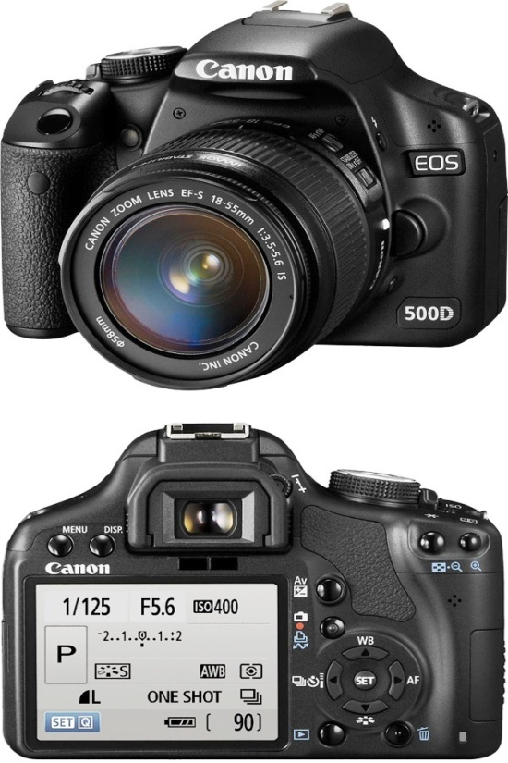
Figure 1. Digital Camera Cannon D500 EOS
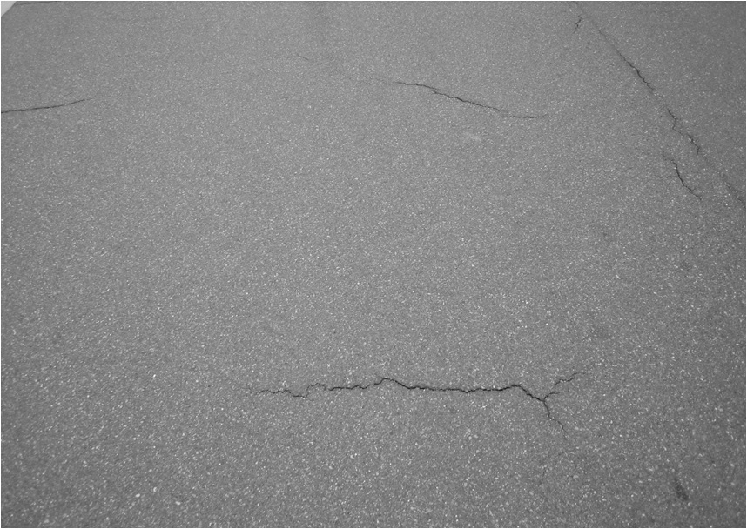
Figure (2): digital image

Image Preprocessing:
Images require picture pre-processing before being used for model training and inference. This includes, but is not restricted to, changes in size, direction, and color. Preprocessing is done to improve the image's quality so that we can analyze it more successfully. Preprocessing enables us to remove undesirable distortions and enhance particular properties required for the application we're working on. The application may alter these characteristics. In order for the program to run successfully and produce the intended results, the image must be pre-processed.[7]

Image enhancement
Image enhancement is the technique of focusing attention to specific aspects of an image while weakening or deleting any irrelevant details as needed. For instance, reducing noise, bringing out hazy details, and altering levels to draw attention to certain aspects of the image.[8]

The goal of image enhancement is to make it easier for viewers to understand or perceive information in images, or to give input to another robotic process..[9]
Image enhancement in digital image processing can be separated into two key categories:
- Spatial methods, To improve images, the spatial domain approach is applied. The input image is made clearer after image enhancement, which is used to increase performance in the following steps of the process.
- Frequency methods, It is simple to enhance images in the frequency domain. Instead of convolving in the spatial domain, we simply compute the Fourier transform of the image that needs to be enhanced, multiply the result by a filter, and then take the inverse transform to create the enhanced image. [10].

Image Filtering
Enhancing image edges and lowering image noise are two purposes of image filtering. Nearly all new digital cameras employ this technology. Although face recognition, object identification, and other computer vision tasks can be facilitated by image augmentation utilizing image filtering algorithms.
The image filtering is used to enhance or improve the data currently collected. To enhance image quality, some image alterations could be required. An image's distortion may be enhanced or fixed. Extrapolate extra diagnostic details from the collected data

Filters :
Filters are made to emphasize both low-frequency and high-frequency spatial features. The variations in spatial frequency can be explained as follows [11]:
- Zero spatial frequency:
In this filter, all image elements (pixels) will have the same image number.
- Low spatial frequency:
In this filter, the change in the gray level will change gradually.
- High spatial frequency:
In this filter, the image elements will have black and white digital numbers.

High pass filters:
The majority of sharpening techniques are built on the high-pass filter. When the contrast between adjacent areas is improved with little difference in brightness or opacity, image sharpening is increased. When applied to an image, a high-pass filter tends to keep high-frequency information while removing low-frequency information[12], figure [3].

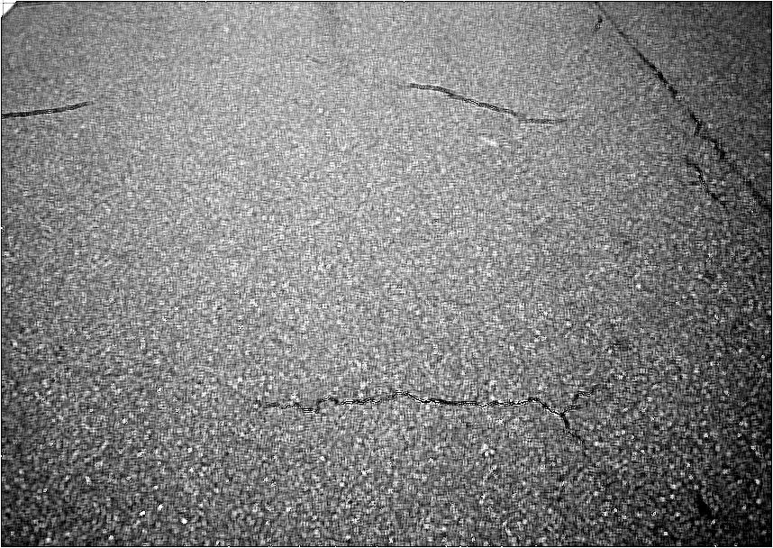
Figure (3): High-pass filters

Image Restoration
The process of restoring an image from a degraded version typically, a fuzzy and noisy image is known as image restoration. A key issue in image processing is image recovery, which also serves as a test for more widespread reversal issues[13].
The digital image needs to go through noise removal filters in order to remove noise. These filters make new digital images free of noise by removing the noise that was associated to the original image[13]., figure [4].
Figure (4): noise reduction filter resulted Image

Image Segmentation
Image segmentation is a method frequently used in digital picture processing and analysis to separate an image into various segments or areas, frequently depending on the properties of the image's pixels. The foreground and background of an image can be distinguished, or pixel sections might be grouped according to how similar they are in terms of color or shape.[14], figure [5].
Three kinds may be used to describe the image segmentation., threshold methods, edge base and region growing method.
Threshold methods: Thresholding is a straightforward, context-free technique that divides pixels into two groups based on whether some attribute measured from the image is below a threshold or whether it is equal to or greater than the threshold. For example, performing cell counts in histological images would be one application of thresholding[15].
The edge detection method: Edge detection is an image processing technique used to identify regions in a digital image with abrupt brightness changes, or, to put it another way, discontinuities. The areas along the image's margins (or boundaries) are those where the brightness varies significantly.[16]. In this study, the cracks are found using the Laplacian edge detection approach.
Region-growing methods: The region growing method for images segmentation is a well-established method. It suggests that adjacent pixels located within the same region have comparable intensity values.
The image is divided into areas using this technique, which groups nearby pixels with the same intensity levels. Then, under a predetermined criterion involving homogeneity and/or sharpness of region boundaries, adjacent regions are combined[17].

Figure (5): Final image after segmentation with the cracks

METHODOLOGY
The extraction of the cracks was done in several stages.
The process of taking an image is the first stage, and it may be done from anywhere, in any format, and in any direction.
The second stage involves numerous adjustments to the acquired image, including cropping it to the necessary dimensions and making it square as well as turning the cropped image into grayscale.
Applying various filters to the image will help remove any noise that may have been present in the second phase's output.
The the fourth stage is applying of edge detection filters. The edge detection image produced is a sample net of cracks that were discovered using Laplacian edge detection.
CONCLUSIONS:
This study shows how digital pictures and edge detection can be used to find asphalt fractures. Any digital camera or other source can be used to take a photo and create an image that looks like a map with asphalt cracks where it can be helpful to decision-makers. Asphalt cracks may be automatically extracted using the edge detection method, which can also determine the size and shape of the cracks. The main objective of the trend toward digital photos for asphalt is to lessen the image data inaccuracy learned so as to adopt the conversion methods to full auto. It is applicable to noisy digital photos with a high detection probability.

REFERENCES

[1] N. Safaei, O. Smadi, A. Masoud, B. J. I. J. o. P. R. Safaei, and Technology, "An automatic image processing algorithm based on crack pixel density for pavement crack detection and classification," vol. 15, no. 1, pp. 159-172, 2022.
[2] C. Chen, H. Seo, C. Jun, Y. J. S. Zhao, Image, and V. Processing, "A potential crack region method to detect crack using image processing of multiple thresholding," pp. 1-9, 2022.
[3] N.-D. Hoang, T.-C. Huynh, X.-L. Tran, and V.-D. J. A. i. C. E. Tran, "A Novel Approach for Detection of Pavement Crack and Sealed Crack Using Image Processing and Salp Swarm Algorithm Optimized Machine Learning," vol. 2022, 2022.
[4] G. X. Hu, B. L. Hu, Z. Yang, L. Huang, P. J. W. C. Li, and M. Computing, "Pavement crack detection method based on deep learning models," vol. 2021, 2021.
[5] D. W. Cromey, "Digital images are data: and should be treated as such," in Cell Imaging Techniques: Springer, 2012, pp. 1-27.
[6] Y. J. A. C. Talmi, "TV-Type Multichan," vol. 47, no. 7, pp. 697A-709A, 1975.
[7] S.-T. Bow, Pattern recognition and image preprocessing. CRC press, 2002.
[8] L. Fan, F. Zhang, H. Fan, C. J. V. C. f. I. Zhang, Biomedicine,, and Art, "Brief review of image denoising techniques," vol. 2, no. 1, pp. 1-12, 2019.
[9] L. Hong, Y. Wan, A. J. I. t. o. p. a. Jain, and m. intelligence, "Fingerprint image enhancement: Algorithm and performance evaluation," vol. 20, no. 8, pp. 777-789, 1998.
[10] A. C. Bovik, Handbook of image and video processing. Academic press, 2010.
[11] S. Perfetto, J. Wilder, and D. B. J. V. Walther, "Effects of spatial frequency filtering choices on the perception of filtered images," vol. 4, no. 2, p. 29, 2020.
[12] A. Makandar and B. J. I. J. o. C. A. Halalli, "Image enhancement techniques using highpass and lowpass filters," vol. 109, no. 14, pp. 12-15, 2015.
[13] X. Ma, S. Xu, F. An, F. J. W. C. Lin, and M. Computing, "A novel real-time image restoration algorithm in edge computing," vol. 2018, 2018.
[14] N. M. Zaitoun and M. J. J. P. C. S. Aqel, "Survey on image segmentation techniques," vol. 65, pp. 797-806, 2015.
[15] J. Ghaye et al., "Image thresholding techniques for localization of sub‐resolution fluorescent biomarkers," vol. 83, no. 11, pp. 1001-1016, 2013.
[16] R. Maini and H. J. I. j. o. i. p. Aggarwal, "Study and comparison of various image edge detection techniques," vol. 3, no. 1, pp. 1-11, 2009.
[17] R. M. Haralick, L. G. J. C. v. Shapiro, graphics,, and i. processing, "Image segmentation techniques," vol. 29, no. 1, pp. 100-132, 1985.

rnal, Vol.31, Part (A), No.11, 2013

