HRTEM and Current-Voltage Study of ACNT-MoS2 Nanocomposite Prepared by Hydrothermal Method
Binoy Bera, Ambar Pattanayak, Madhumita Das Sarkar Hari Sarkar, Pabitra Dey¹
Dibyaranjan Bera² Ujjwal Kumar Mondal, Rafiqul Hossain³
¹Department of computer science and engineering, West Bengal University of Technology, Kolkata – 700064, India.
²Khanayadihi P. K. Higher Secondary School, West Bengal – 721641, India.
³Jadavpur University, plot no.8, Salt Lake Bypass, LB Block, Sector III, Salt Lake City, Kolkata - 700106.
Abstract: Recently amorphous carbon nanotube and their nanocomposites are most influenced research topic in the field of nanoscience and nanotechnology. Here in this paper, amorphous carbon nanotube-molybdenum disulfide nanocomposite have been prepared by wet chemistry approach. Hexaammonium heptamolybdate tetrahydrate, thiourea and amorphous carbon nanotube were used as main material in that process. Amorphous carbon nanotube have been prepared separately by a low temperature chemical process. Finally the high resolution transmission electron microscope and current-voltage study of as prepared nanocomposite has been done.
Keywords: amorphous carbon nanotube, MoS2, hydrothermal method, nanocomposites, high resolution transmission electron microscope.

1. Introduction
Since the discovery of carbon nanotube[1] by Iijima, it is most important material in several applications for good optoelectronic[2], physical[3] and mechanical[4] properties. It has huge applications in electromagnetic wave absorber [5], supercapacitor, catalysis[6], toughening the polymers[7], introducing piezoelectricity in polymers[8-20] etc. It has also good optical properties which can be useful in optoelectronics applications. However, carbon nanotubes can be of two types: crystalline carbon nanotube[21] and amorphous carbon nanotube[22]. Crystalline carbon nanotube has crystalline in structure and amorphous carbon nanotube has no such crystallinity. Carbon nanotube can be synthesized by using various methods like arc discharge[23], laser ablation[24] and chemical vapour deposition[25] methods. Moreover the synthesis procedure is quite complicated and requires high temperature such as above 800⁰C. On the other hand, amorphous carbon nanotube can be synthesized by using very low temperature (less than 230⁰C) and it does not requires such sophisticated instruments. Furthermore, amorphous carbon nanotube can be formed into nanohybrids with other nanomaterial easily due to the defects and dangling bonds present in it. So amorphous carbon nanotube can be a good and effective replacement of crystalline carbon nanotube in numerous applications. Now a days, amorphous carbon nanotube and their hybrids are very much interesting topic in the field of nanoscience and nanotechnology. Recently, nanohybrids of amorphous carbon nanotube are very crucial topic for the researchers and scientists for their excellent chemical, physical and optoelectronic properties. Numerous nanomaterials such as MoS2, WS2, CdS, MnO2 etc are used for the preparation of amorphous carbon nanotube nanohybrids. Carbon nanotube are two types i.e. crystalline and amorphous. The preparation conditions are quite complicated and instruments used for synthesis of crystalline carbon nanotube are very complex. Several methods such as arc discharge, chemical vapour deposition, laser vapourization, pyrolysis, plasma-enhanced are used for the synthesis of crystalline carbon nanotube. These process are quite compound and costly in nature. In that case, amorphous carbon nanotube can be synthesized by a single step low temperature (225⁰C) chemical process. The walls of ACNTs are amorphous in nature and there is so many defects and dangling bonds present in it. For that it can easily react with other nanomaterial to form into nanohybrids. This nanohybrids can give tough competition to crystalline carbon nanotube in many applications. On the other hand, single layer MoS2 are very stimulating material for its fascinating optoelectronic and physical properties. MoS2 nanosheets can alter several properties of any material when it react with other nanomaterial. Here in this paper, ACNT-MoS2 nanohybrids were synthesized by using a eco-friendly method. Characterization of as prepared sample have been characterized by field emission scanning electron microscope, X-ray diffraction, high resolution microscope and fourier transformed infrared spectroscopy instrument. Recently nanocomposite of amorphous carbon nanotube become interesting topic of research for their easy synthesis procedure and amazing properties. Based on the structure, carbon nanotube are two types: crystalline and amorphous. Crystalline carbon nanotube has itself excellent physical, mechanical and electronic properties. For all these properties, it is used in numerous applications of nanoscience and nanotechnology. However, the procedure such as arc discharge method, chemical vapour deposition technique etc for synthesis of crystalline carbon nanotube are very much complicated and costly. In that sense, amorphous carbon nanotube are growing their importance in several fields of science and technology. Moreover, the presence of dangling bonds in amorphous carbon nanotube makes them suitable to form into nanocomposite by reacting easily with other nanomaterial which shows excellent electronic, physical and mechanical properties. Furthermore, amorphous carbon nanotube can be prepared by using a low temperature (225⁰C) chemical process. Several nanomaterials are present in the world which shows ecstatic electronic and physical properties. Among them, MoS2 nanomaterials has several applications in the field of Li-ion battery, supercapacitor, sensor etc for their excellent properties. Layered MoS2 which is used rapidly as lubricant and hydrogen evolution and photocatalytic material, are bounded by weak vander wall force. Bandgap of this material can be tuned by varying its number of layers and photoluminescence arising from the quantum confinement effect in d-orbitalrelated interaction in a MoS2 monolayer is strong evidence of the band-gap transition. Here in this paper, MoS2 nanosheets was concerned as a nanomaterial to form into amorphous CNT-MoS2 nanocomposite. Nanocomposite were synthesized by using a hydrothermal method. Later, HRTEM and I-V study of as prepared samples were done in briefly.
2. Material and Methods
At first, amorphous carbon nanotube have been prepared by a low temperature (225⁰C) chemical process using Ferrocene ((C₅H₅)₂Fe, Merck), ammonium chloride (NH4Cl) and hydrochloric acid (HCl) as principle material. First ferrocene and ammonium chloride were taken in 1:2 weight ratio. Then weighted material placed in a mortar and grinded very well. After that, the mixture were placed in a quartz beaker and kept it in an oven with 225⁰C for 30 minutes. Then the black product was washed with DI-water and dilute HCL repeteadly for removing the impurity present in amorphous CNT. Finally the product was kept in an oven at 45⁰C temperature for 10 hrs. Now 0.5 g of as prepared amorphous carbon nanotube, 1.24 g of Hexaammonium heptamolybdate tetrahydrate and 2.28 g of thiourea were taken in a 50ml deionized water containing glass beaker. Then it is kept in a magnetic stirrer for 40 min. with 400rpm for making a homogenous solution. Then the solutions were poured in a teflon lined autoclave and closed securely. After that the sample containing autoclave has been kept in an oven with 1800C for 16hrs. Finally, autoclave was cooled and a black product was collected. Finally the as prepared samples was vigorously washed with ethanol and di-water and black product was dried by keeping it in an oven with 60⁰C for 8hrs.
3. Characterizations and Results
Characterizations were done by high resolution transmission electron microscope. From there it is proved the formation of ACNT-MoS2 nanocomposites. I-V characteristics study under dark and UV illumination condition has also been done.
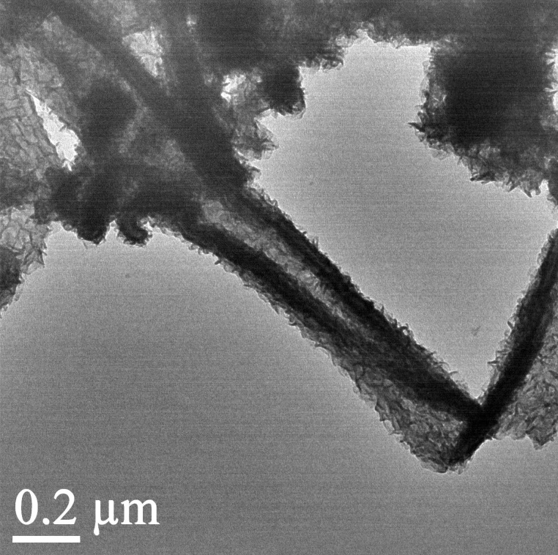
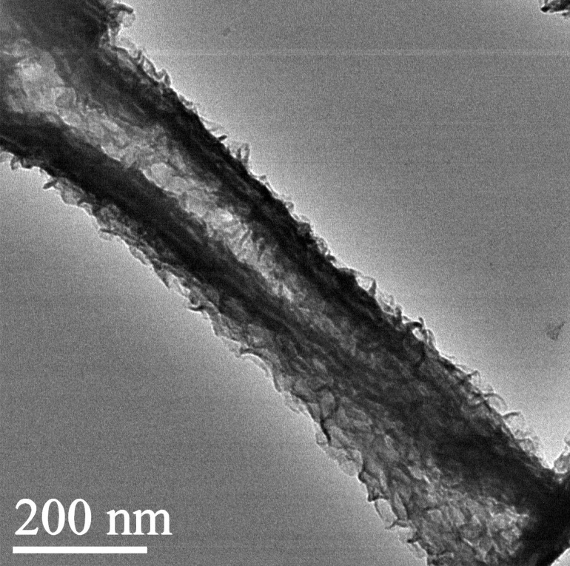
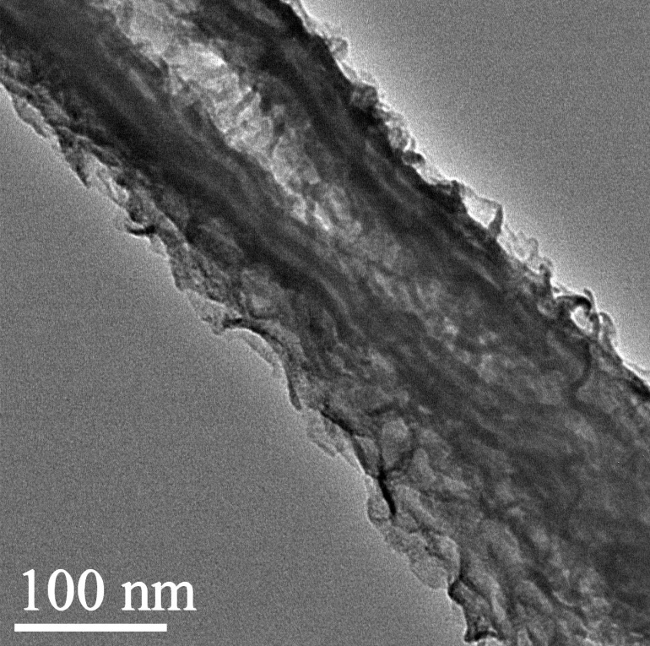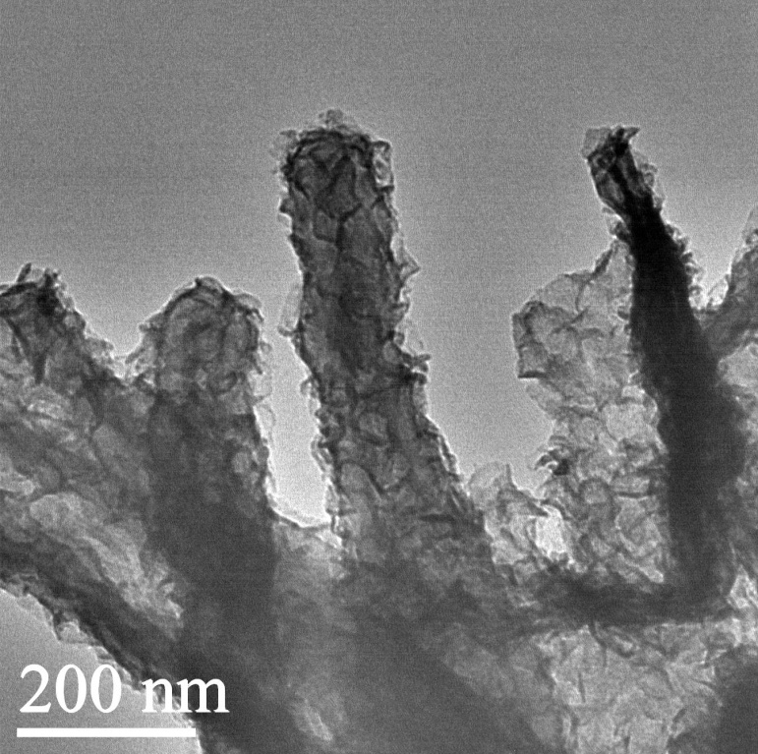

Fig. 1: (a-d) HRTEM image and (e) current-voltage study (under dark and UV illumination condition) of ACNT-MoS2 nanocomposite.
4. Conclusions
Amorphous carbon nanotube-MoS2 nanocomposite prepared by hydrothermal method were reported here. Amorphous carbon nanotube has been synthesized separately by a low temperature chemical process. HRTEM image reveals the formation of nanocomposite. Furthermore, current-voltage study (under dark and UV illumination condition) of ACNT-MoS2 nanocomposite has also been experimented.

References
- S. Iijima. Helical microtubules of graphitic carbon. Nature 354, 56 - 58.
- G. Eda, H. E. Unalan, N. Rupesinghe, G. A. J Amaratunga, and M. Chhowalla, 2008 Appl. Phys. Lett. 93, 233502 (2008).
- Y. Liu, J. Tang, X. Chen, W. Chen,G. K.H. Pang, and J.H. Xin,“A wet-chemical route for the decoration of CNTs with silver nanoparticles,” Carbon, vol. 44, no. 2, pp. 381–383, 2006.
- Z. Zanolli, R. Leghrib, A. Felten, J. Pireaux, E. Llobet, and J. Charlier, “Gas sensing with Au-decorated carbon nanotubes,”Journal of American Chemical Society, vol. 6, no. 5, pp. 4592–4599, 2011.
- T. Zhaoet al. Electromagnetic Wave Absorbing Properties of Amorphous Carbon Nanotubes. Sci. Rep. 4, 5619; DOI:10.1038/srep05619 (2014).
- D. J. Guo and H. L. Li, “Highly dispersed Ag nanoparticles on functional MWNT surfaces for methanol oxidation in alkaline solution,” Carbon, vol. 43, no. 6, pp. 1259–1264, 2005.
- B. Bera. Literature Review on Electrospinning Process (A Fascinating Fiber Fabrication Technique). Imperial Journal of Interdisciplinary Research (IJIR). Vol-2, Issue-8, 2016.

- B. Bera, Madhumita.Das Sarkar. Piezoelectricity in PVDF and PVDF Based Piezoelectric Nanogenerator: A Concept . IOSR Journal of Applied Physics (IOSR-JAP). Volume 9, Issue 3 Ver. I, PP 95-99.

- Binoy Bera, Dipankar Mandal, Madhumita Das Sarkar. Sensor Made of PVDF/graphene Electrospinning Fiber and Comparison between Electrospinning PVDF Fiber and PVDF/graphene Fiber. Imperial Journal of Interdisciplinary Research (IJIR). Vol-2, Issue-5, 2016.

- Binoy Bera, Madhumita Das Sarkar. Gold Nanoparticle Doped PVDF Nanofiber Preparation of Concurrently Harvesting Light and Mechanical Energy. IOSR Journal of Applied Physics (IOSR-JAP).Volume 9, Issue 3 Ver. III (May - June 2017), PP 05-12.

- Binoy Bera, Madhumita Das Sarkar. PVDF based Piezoelectric Nanogenerator as a new kind of device for generating power from renewable resources. IOSR Journal of Polymer and Textile Engineering (IOSR-JPTE). Volume 4, Issue 2 (Mar. - Apr. 2017), PP 01-05.

- Binoy Bera. Preparation of polymer nanofiber and its application. Asian journal of physical and chemical sciences. volume 2, issue 4, 1-4, 2017. article no. AJOPACS. 35651.

- Binoy Bera. Literature Review on Triboelectric Nanogenerator. Imperial Journal of Interdisciplinary Research(IJIR). 2(10):1263-1271·January2016.

- Binoy Bera. Preparation of MoS2 nanosheets and PVDF nanofiber. Asian journal of physical and chemical sciences. volume 2, issue 4, 1-9, 2017.article no. AJOPACS. 35176.

- Binoy Bera. Nanoporous Silicon Prepared by Vapour Phase Strain Etch and Sacrificial Technique. IJCA Proceedings on International Conference on Microelectronic Circuit and System MICRO 2015(1):42-45, December 2015.

- BinoyBera, Dipankar Mandal, Madhumita Das Sarkar. Porous Silicon and its Nanoparticle as Biomaterial: A Review. Imperial Journal of Interdisciplinary Research (IJIR). Vol-2, Issue-11, 2016. (4).

- Binoy Bera. A Review on Polymer, Graphene and Carbon Nanotube: Properties, Synthesis and Applications. Imperial Journal of Interdisciplinary Research (IJIR). Vol-3, Issue-10, 2017.

- Hari Sarkar, Binoy Bera, Sudakshina Kundu. Sleep Mode Transistor Sizing Effect of MTCMOS Inverter Circuit on Performance in Deep Submicron Technology. Global Journal of Trends in Engineering (GJTE). Vol(2)-Issue(4), 2015.

- Binoy Bera, Madhumita Das Sarkar. Piezoelectric Effect, Piezotronics and Piezophototronics: A Review. Imperial Journal of Interdisciplinary Research (IJIR). Vol-2, Issue-11, 2016.

- C. Martin (1995). "Template synthesis of electronically conductive polymer nanostructures". Acc Chem Res. 28 (2): 61–68. doi:10.1021/ar00050a002.

- D. J. Guo and H. L. Li, “Highly dispersed Ag nanoparticles on functional MWNT surfaces for methanol oxidation in alkaline solution,” Carbon, vol. 43, no. 6, pp. 1259–1264, 2005.
- K. H. Tan and R. J. Mohd, “Surface structure and optical property of amorphous carbon nanotubes hybridized with cadmium selenide quantum dots,” Journal of Nanoparticle Research, vol. 15, no. 9, article 1920, 2013.
- T. W. Ebbesen, P. M. Ajayan. Nature 1992, 358, 220.
- A. Thess, R. Lee, P. Nikolaev, H. J. Dai, P. Petit, J. Robert, C. Xu, Y. H. Lee, S. G. Kim, , A. G. Rinzler, D. T. Colbert, G. E. Scuseria, D. Tomanek, J. E. Fischer, R. E. Smalley. Science 1996, 273, 483.
- M. Endo, K. Takeuchi, S. Igarashi, K. Kobori, M. Shiraishi, H. W. Kroto. J. Phys. Chem. Solids 1993, 54, 1841.

