Infant Milk Formula: Harmonization of Standards
Geeta M¹, Priyanka S², Nidhi K³, Manjeet A⁴, R. K. Khandal^{5*}
¹Research Scholar, Department of Basic Sciences, Dr. K.N. Modi University, Newai, Rajasthan, India
² Research Scholar, Department of Basic Sciences, Dr. K.N. Modi University, Newai, Rajasthan, India
³Quality Assurance Manager, CFRA, NIFTEM, Kundli, Sonepat, Haryana, India
⁴Professor & Head, Department of Basic and Applied Sciences & CFRA, NIFTEM, Kundli, Haryana, India
⁵ Chief Mentor, Dr. K.N. Modi University, Newai, Rajasthan, India, India
*Author for Correspondence: Prof. Dr. R. K. Khandal, Email: profrakeshkhandal@gmail.com, Tel: +91-9452133590

Abstract
Harmonization of standards is the key task for regulators across the world, mainly, for processed foods. Every country has initiated the process of adopting the harmonized codes (Food Code System) for processed foods. In India, FSSAI has also been up-to-date with global trends in food industry. Capability building projects are initiated to remain in sync with emerging needs. For harmonization, FSSAI has divided processed foods in 18 categories, based on: a) origin of raw food, b) type of raw food, c) process employed for production and d) type of processed food. Category 1 to 17 are for products, well defined. All other products which could not be categorized so clearly are listed together as 18th category which is designated as category 99. The present study deals with a comparison of standards being adopted by different countries for Infant milk powder. For this, regulations of FSSAI, EU and USFDA were studied. From the study, it is evident that there remains a lot of gap areas which need to be bridged in order to ensure that the consumers across the world get quality food of same standards. Recent publications show that manufacturers of infant milk formula have been adopting practices that are not as per guidelines of WHO. The outcome of this study will be useful for all stakeholders of processed food (infant milk formula). In India, there are a large number of products of this category in the market, the manufacturers and consumers will benefit from findings of this study.
Keywords: Food Safety, Food Code System, Harmonization of Standards, Infant Milk Powder, Infant Milk Formula, Processed Food

INTRODUCTION
Harmonization of Standards involve several activities that have to be undertaken prudently by regulators, across the world. This would involve a) Categorization and Coding of processed foods as per Food Code system (FCS), b) notifying regulations for: Quality standards of processed foods; labelling, packaging of processed foods; recall and emerging food safety risks. FCS has four levels of coding process for different products: a) Level-1 states main category, b) Level-2 states subcategory under main category, c) Level-3 states sub-sub category under sub category and d) Level 4 also states sub-sub category under level 3, in order to provide clear approach for the food regulators and stakeholders. Also, FCS must categorize food products so as to club similar products under same category since food itself is so diverse and unless categorized well, it is very difficult to exchange data on foods for global markets. Regulator of each country is supposed to undertake capability building projects necessary for being able to decide minimum standards of quality of processed foods as per CODEX, after adopting FCS. It must be ensured that the set standards are harmonized so that no issues pertaining to quality as well as safety of foods arise, when foods are traded, globally [1].
All foods whether fully or partially processed must be safe for human consumption. If the product is meant for infants, special attention is given to parameters related to health safety. Not only the composition but also the contaminants and adulterants are the key concerns in this case. Parameters such as packaging and labelling requirements and nutritional values should also be decided ensuring food safety. Countries have set certain standard values for the above-mentioned requirements for infant milk formula, covering all aspects of food safety. As per FCS, foodstuffs intended for particular nutritional uses fall under the main category 13th under which a sub category 13.1 includes infant formula, follow up formula and formula for special medical purposes for infants. On further categorization of category 13.1 infant formula appears under 13.1.1 and follow up formula appears under 13.1.2. It will be in the interest of consumers as well as the manufacturers that research studies are conducted to assess whether the processed foods available in the market are in compliance with the specified standards and also that the latter are harmonized. Countries like EU, USA etc. specify the limits of food safety parameters so stringent that it becomes difficult for exporters from developing countries to comply with them. Exporters to these countries must be aware of the standards adopted regulators of importing countries. The same must be applicable when the processed foods from developed world are exported to developing countries. Thus, it becomes essential for regulators in India to have data about the quality norms and standards adopted by regulators of other countries. Present case study compares standards of US and EU with those of India for infant milk formula (IMF) to assess whether they are harmonized? [1]. This study is relevant also because of the recent publications of Lancet bringing out the areas of concern about IMF which have become a popular product, thanks to industrialization and urbanization. Manufacturers of IMF adopt practices to market their products in a manner that even the healthy mothers start feeding their infants with such substitutes rather than breast-feeding them. In spite of several findings, brought out by WHO that the breast-feeding is the best for health, growth and immunity to diseases, IMF has grown into a big industry sector.
The World Health Assembly approved [2,3] the International Code of Marketing of breast-milk substitutes. This Code defined standards made with a purpose to stop marketing of milk formula and asked for a law covering the following: a) forbidding of advertisements of milk formula to public, providing free samples to mothers and to health care workers and unsubstantiated scientific claims b) stating clearly that promotion of milk formula in health care systems not allowed and c) outlawing of scientific meetings by industries for selling Commercial Milk Formula (CMF). This Code represented an expression of the collective will of governments to ensure the protection and promotion of breast-feeding. However, only 32 countries incorporated the law and got legal measures aligned with the code, 41 countries adopted legislation somewhat aligning with the Code and 50 countries have no legal measures at all. Since the law was not followed everywhere the Code is violated without penalty.
This Code was to deal with scandals (in 1970s) by a Swiss company that aggressively marketed their product because of which women started abandoning breast-feeding, in favour of formula.
The Chinese milk scandal (2008) of adulteration of infant milk by melamine, resulting in deaths of infants. In 2016, World Health Assembly prompted all its members again to implement the law in its original form, because the same was highly significant even in present scenario. and not implemented, until date, by all. [9,10,11,12].
Recently, three papers published in Lancet highlighted that marketing strategies by manufacturers of CMF, in order to sell their products influenced the beliefs of mothers, causing reduction in practice of breastfeeding. In order to increase the sales of CMF, these industries made false claims such as increase in IQ level, enhanced sleep of infants and mothers at night, superior brain growth etc. The sales of CMF increased from US$1·5 billion in 1978, to US$55·6 billion in 2019. Less than 50% of infants are breastfed globally leading to economic losses of ~ US$350 billion each year. while CMF industry generated revenues of about $55 billion annually [4,5,6,7,8].

MATERIALS AND METHODS
Methodology: Infant milk powder samples of different brands of the product from India, EU and USA were procured for this purpose. The details given on the label were studied. The regulations of FSSAI (India), EFSA (EU), USFDA (USA) and Codex were taken from the published literature and were compared to understand the differences.
Table-1: Survey of Different Brands of each Regulation
S.No | India (FSSAI) | EU (EFSA) | USA
1 | Nan Pro-1 | Danalac Goat Organic | Baby’s Only Organic
2 | Lactogen | Meyenberg Goat Milk | Organic Premium Formula (Infant Formula with Iron Milk based powder)
3 | Enfamil Farex | Kabrita | Non-GMO Organic Sensitive Formula
4 | Dexolac Nutricia | SMA | Organic Dairy Infant Formula with iron
5 | Farex Infant Formula | Holle | Happy Baby Organic
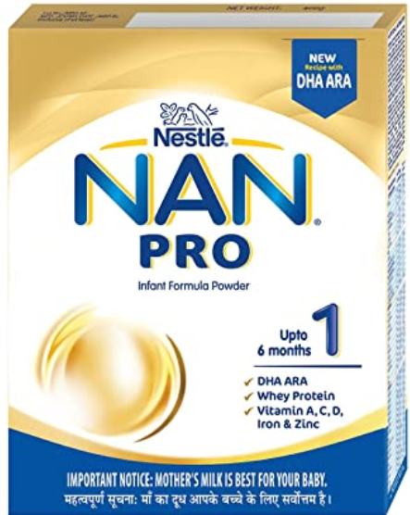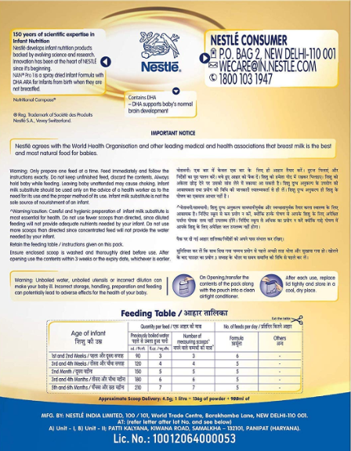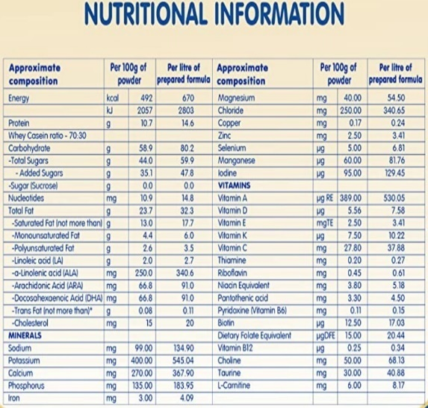
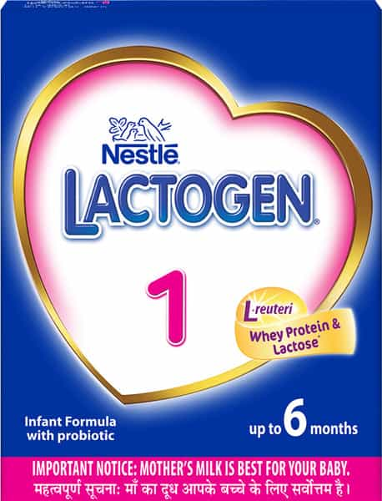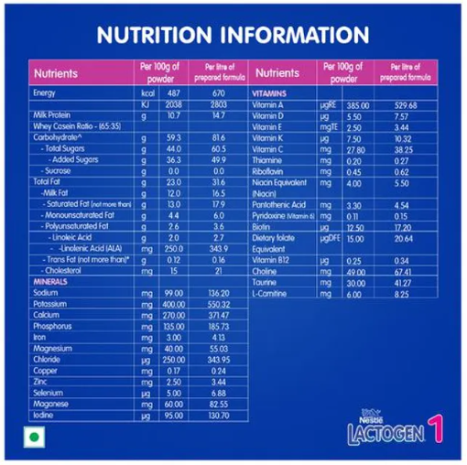
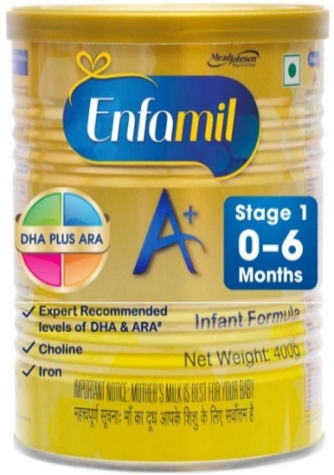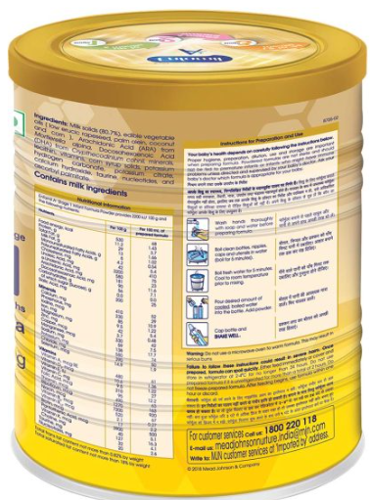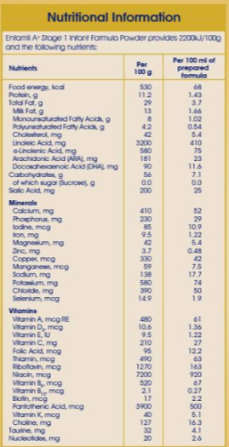
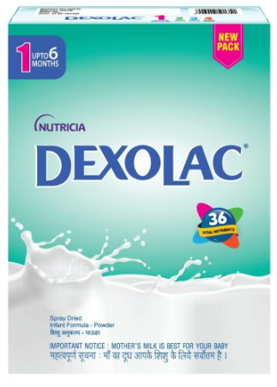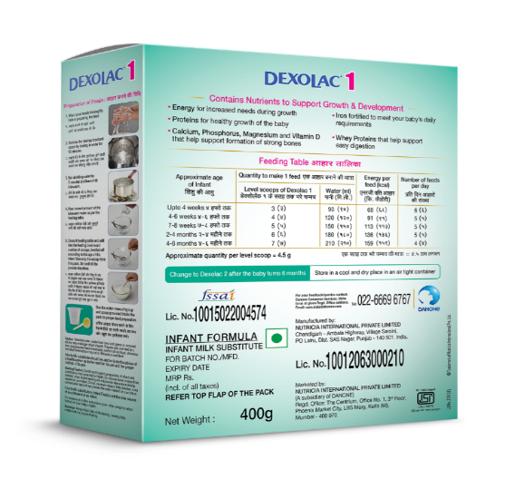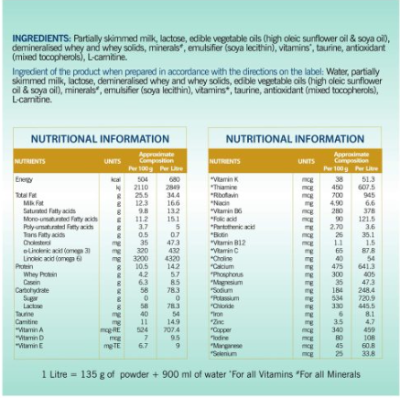
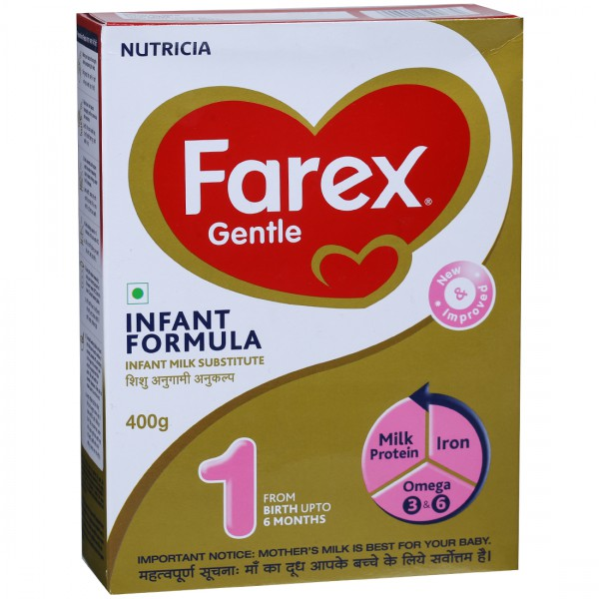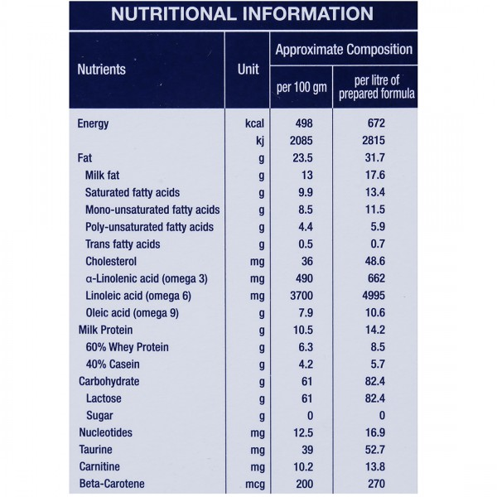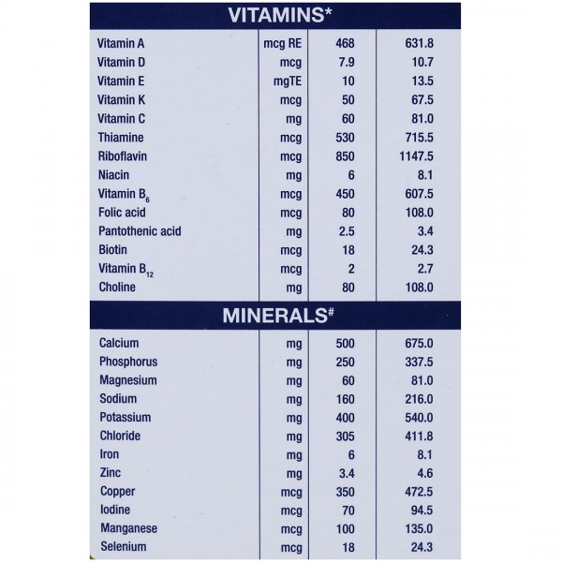
Figure 1: Pictures of Infant Formulas Samples, Manufactured in India.
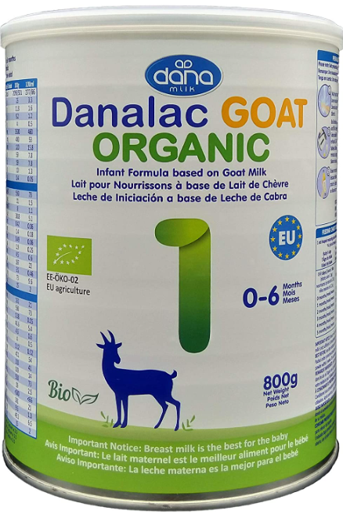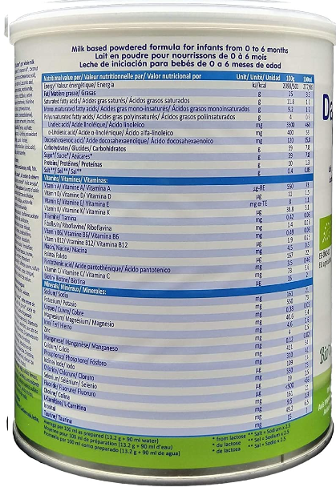
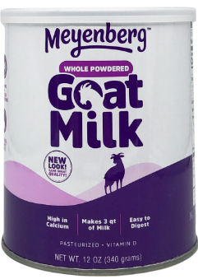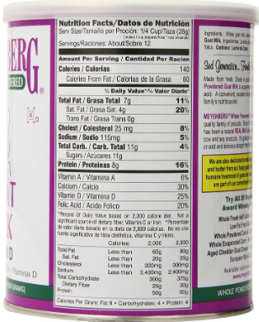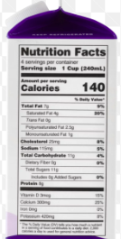
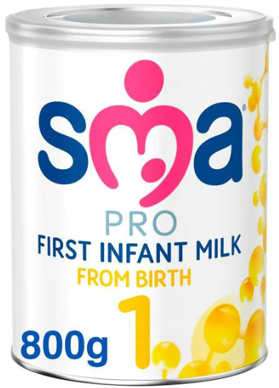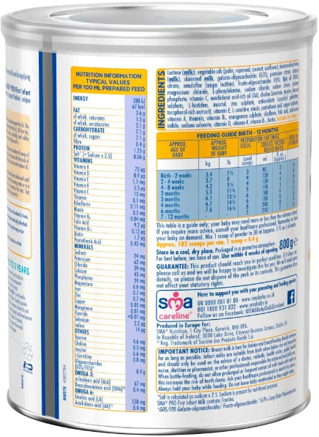
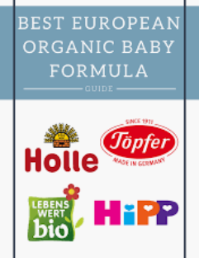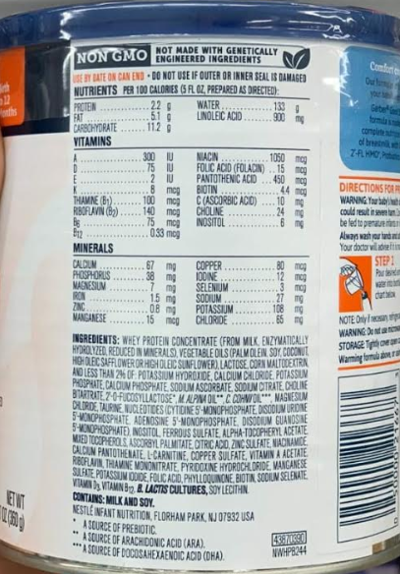
Figure 2: Pictures of Infant Formulas Samples, Manufactured in EU Countries.
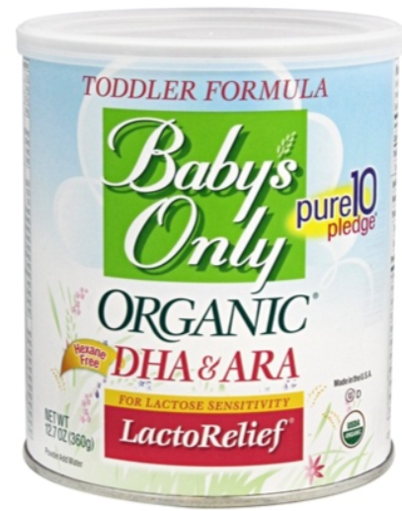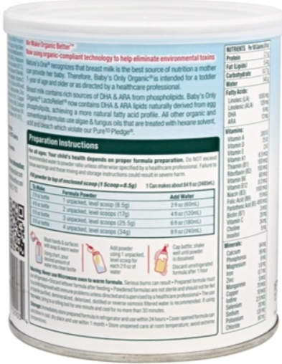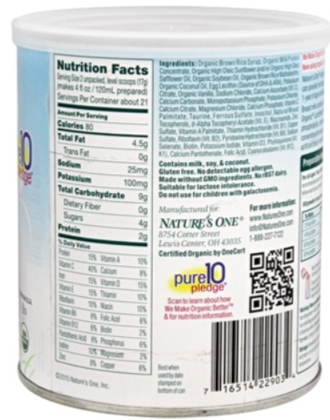
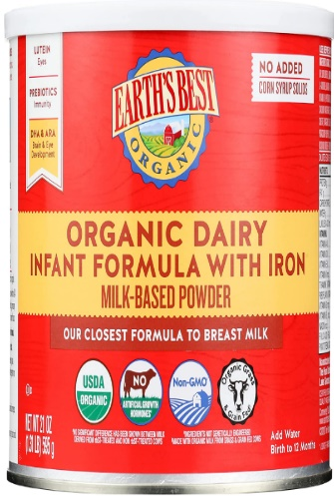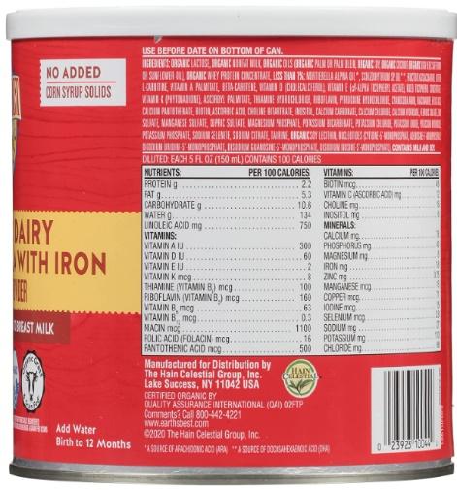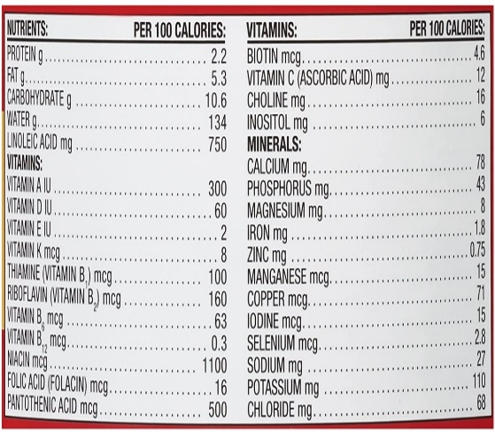
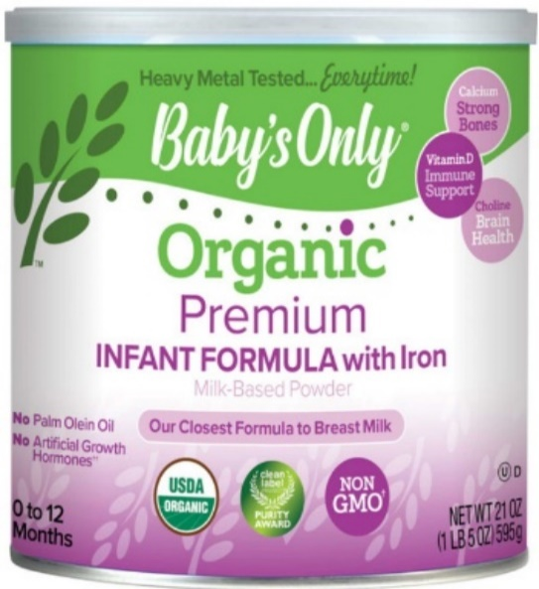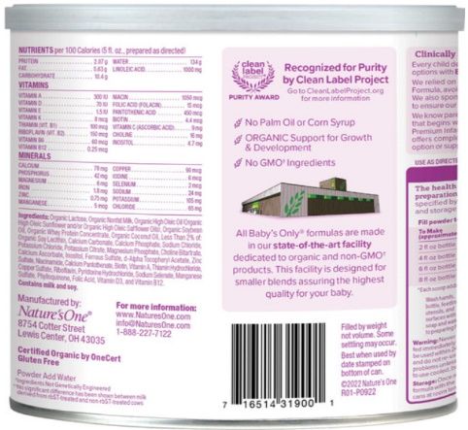
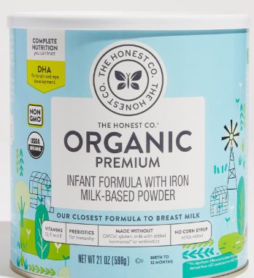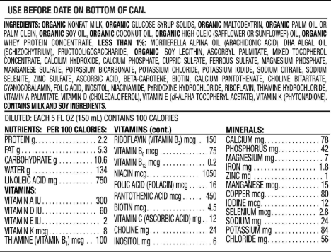
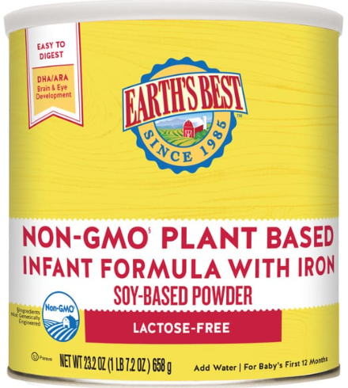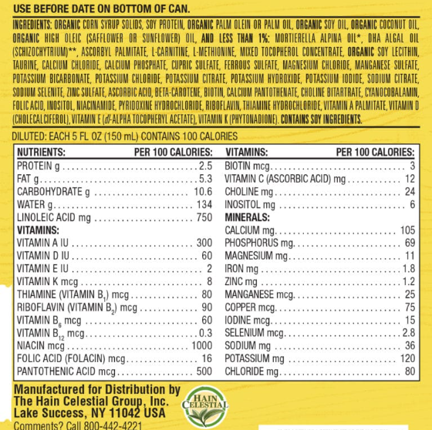
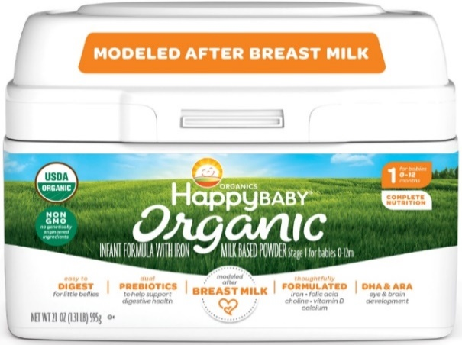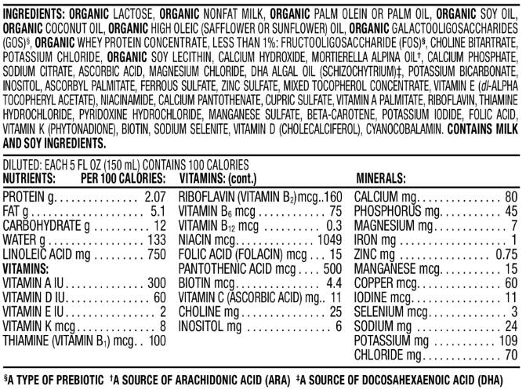
Figure 3: Pictures of Infant Formula Samples, Manufactured in United States of America.
RESULTS AND DISCUSSIONS:
Before proceeding further, let us have a look at the way the three regulatory agencies, under study, have defined an infant milk,
As per FSSAI: a) “Infant milk food” means a breast-milk substitute specially manufactured to meet the nutritional requirements of infant, b) “Infant formula” means a breast milk substitute specially manufactured product based on milk of cow or buffalo or mixture thereof and other ingredients which have been proven to be suitable for infant feeding, to meet the nutritional requirements of infant and c) “Follow-up formula” means a food intended for use as a liquid part of the complementary diet for infants when prepared in accordance with instructions for use [12].
From the definitions as per FSSAI as stated above, it is evident that: the infant milk food is a substitute for breast milk while an infant formula is a product based on milk of cow or buffalo. The follow up formula is meant to be a complementary diet. It can be said that the infant milk food and Infant formula are both either the milk or derived from milk, whereas, the follow up formula may or may not be based on or derived from milk [18,19].
As per EFSA, infant foods are only of two types unlike FSSAI having three different types. The first type known as Infant formula is defined as food intended for use by infants during the first months of life and satisfying by itself the nutritional requirements of such infants until the introduction of appropriate complementary feeding. The second type known as Follow on formula is given to infants after complimentary feeding is introduced in their diet, which includes liquids.
EFSA claims nutrition which wholly satisfies infants requirements is in processed food only before they start taking complementary food. According to EFSA Infant formula is manufactured from cow or goat milk proteins or protein hydrolysates. This is because this specific formula manufactured from protein hydrolysates reduces the risk of developing allergy to the milk proteins in infants [14].
The definition as per US FDA is as follows.
Special dietary food for infants which has all the nutrients of human milk and is a complete substitute is defined as Infant Formula.
Comparing the Salient Features Observed: Marking and Highlighting the Differences in the description of definition in the Regulation
a) FSSAI is not emphasizing this being a processed food, it says it is a product. That does not mean product can’t be a processed food but it is at the same time also leaving scope for unprocessed product whereas in the EFSA regulation, it clearly highlights and emphasize the infant formula and follow on formula to be a processed food. On the other hand, the US FDA neither talks about a product nor processed food rather it is a special dietary food used by infants.
b) As per FSSAI, milk of cow or buffalo or mixture is allowed while EFSA allows milk of cow and goat in its different infant milk formulas. On the other hand, the US FDA talks about simulant of human milk.
As per FSSAI product has been prepared based on cow milk or buffalo milk or their mixture whereas as per EFSA it is manufactured from cow or goat milk proteins or protein hydrolysates, it does not include the term milk in it. Similarly, as per US FDA whey protein is being used in the formulation.
c) FSSAI mentions the word ingredient in the regulation but EFSA doesn’t specify this term in its description. On the other hand, the US FDA defines it to be complete or partial substitute of human milk.
d) EFSA says that infant formula is the foodstuff which wholly satisfies the nutritional requirements of infants. FSSAI in its labelling regulations restricts the use of word ‘COMPLETE FOOD, HEALTH FOOD, ENERGY FOOD, FULL PROTEIN FOOD and HEALTH SUPPLEMENT’. However, the US FDA defines it as a complete or partial substitute of milk.
Now, comparing the compositional requirements as described by FSSAI, EFSA and US FDA. Table-1 describes requirement limits for various parameters of Infant Milk, Infant Formula, Follow Up and Follow on Formula as per FSSAI, EFSA and US FDA.
Table-2: Requirements or Limits of Infant Formula and Follow up formula as per FSSAI, EFSA and US FDA [12,13,14,16].
S. No | Parameter | India (FSSAI) | European Union (EFSA) | US FDA
 |  | Infant Milk; Infant formula; Follow Up formula | Infant formula and Follow On formula | Infant Formula
1. | Total ash, % by weight, NMT | 8.5 | Protein source  Cow’s milk is demineralized in the presence of enzymes (chymosin) which led to precipitation of casein to get whey protein and it consists of the following.  (a) Whey protein isolate which was free from 63% caseino glycol macro peptide, 95% of dry matter (protein content) , ash content (maximum 3%) and denatured protein (less than 70%)  (b) Whey protein concentrate (37% sweet) consisting of 87% dry matter (minimum protein content), denatured less than 70% and ash content (maximum 3.5%) | Not mentioned
2. | Protein | Infant Milk: Total milk protein  (N X 6.38): Min 2.5g/100 Kcal, Max NA  Infant formula: Total protein  (N X 6.25) 2.1 g/100 Kcal Min, 3.4 g/100 Kcal Max  Follow Up formula  3 g/100 Kcal Min, Max NA | Protein content is calculated as nitrogen content multiplied with a factor of 6.25  Manufactured from cow or goat milk proteins  1.8 g/100 Kcal Min, 2.5 g/100 Kcal Max  Manufactured from soya protein isolates alone or in a mixture with cow’s milk or goats milk protein  2.25 g/100 Kcal Min, 2.8 g/100 Kcal Max  Manufactured from protein hydrolysates  1.86 g/100 Kcal Min, 2.8 g/100 Kcal Max | Min 1.8 g/100Kcal  Max 4.5 g/100Kcal
3. | Total Fat content | Infant formula: Min 3.8 g/100 Kcal, Max 5.3 g/100 Kcal  Follow up: Min 3g/100 Kcal,  Max 6g/100 Kcal |  | Min 3.3 g/100Kcal  Max 6 g/100Kcal
a | Trans fat, % by weight, max | 3 | 3 | Not mentioned
b | Docosahexaenoic acid | Min 0.2 %, Max 0.5 % | Min 20 mg/100 Kcal, Max 50 mg/100 Kcal | Not mentioned
c | Milk fat | Infant Milk: Min 3.8 g/100 Kcal;  Infant Formula: Min 2.5 g/100Kcal | Not Mentioned | Not mentioned
d | Lipids | Not mentioned | Min 4.4 g/100 Kcal, Max 6 g/100 Kcal | Not mentioned
e | Erucic Acid | Infant Milk: NA;  Infant Formula: Max 0.2 g per 100 Kcal | NMT 1% of total fat | Not mentioned
f | Linoleic acid | Infant Milk: NA;  Infant Formula: Min 0.3 g/100 Kcal, Max 1.5 | Min 500 mg/100 Kcal,  Max 1200 mg/100 Kcal | Min 300 mg/100Kcal, Max--
g | Alpha-Linolenic acid | Infant Milk: NA;  Infant Formula: Min 53.2 mg/100 Kcal, Max NA  Follow up: NLT 300 mg/100Kcal | Min 50 mg/100 Kcal,  Max 100 mg/100 Kcal | Not mentioned
h | Sum of lauric and Myristic acid of total fatty acids | Infant Milk: NA;  Infant Formula: Max 4.25 g per  100 Kcal | Not Mentioned | Not mentioned
i | Polyunsaturated acids | Not mentioned | NMT 2% of total fat | Not mentioned
j | Archidonic acid | Not mentioned | NMT 1% of total fat | Not mentioned
k | Eicosapentaenoic acid | Not mentioned | NMT DHA content | Not mentioned
l | Phospholipids | Not mentioned | NMT 2g/L | Not mentioned
4. | Carbohydrate, g/100Kcal | Infant Milk: Min 9.6, Max 14.9  Infant formula: Min 9.6, Max 14.9  Follow up formula: The product shall contain nutritionally available carbohydrates suitable for feeding in such quantities so as to adjust the product to the energy density as 100 ml of ready to use formula as prepared according to the instructions should provide 60 to 85 Kcal of energy. | Min 9, Max 14 | Carbohydrate content = {total weight of food - (Crude protein +total fat + moisture + ash)}
5. | Energy, Kcal/100 ml | Min 60, Max 70 | Min 60, Max 70 | Not mentioned
6. | Taurine, max | Infant Milk & Infant formula: Optional ingredient  Follow up formula: 12.75 mg/100g | Optional: NMT 12 mg/100 Kcal | Not mentioned
7. | Folic acid, µg/100 Kcal | Min 3.2, Max 10.6 | Folate (µg DFE) : Min 15, Max 47.6 | Min 4, Max---
8. | Inositol, mg/100 Kcal | Optional Ingredient  Follow up formula: Max 8.5 | Infant formula: Min 4; max 40  Follow On: Not Mentioned | Min 4, Max---
9. | Minerals |  | Mineral substances (Infant formula manufactured from  cow’s milk or goat milk proteins or protein hydrolysates) | Minerals
a | Sodium, mg/100 Kcal | Min 19.10, Max 63.8 | Min 25, Max 60 | Min 20, Max 60
b | Potassium, mg/100 Kcal | Min 63.82, Max 191.48 | Min 80, Max 160 | Min 80, Max 200
c | Chloride, mg/100 Kcal | Min 53.2, Max 170.2 | Min 60, Max 160 | Min 55, Max 150
d | Calcium, mg/100 Kcal | Infant Milk: Min 53.2, Max 106.4;  Infant formula: Min 53.2, Max 148.9; Follow up formula: Min 86.2, Max 170.2 | Min 50, Max 140 | Min 60, Max -
e | Phosphorus, mg/100 Kcal | Min 26.6, Max 106.4  Follow up formula: Min 57.45, Max 106.4 | Min 25, Max 90  Min 30, Max 100 | Min 30, Max--
f | Calcium: Phosphorus Ratio | Min 1:1; Max 2:1 | Shall not be less than 1 nor greater than 2. | Shall not be less than 1.1 nor greater than 2.0
g | Iron, mg/100 Kcal | Min 0.6, Max 1 | a) If infant formula is manufactured from proteins or protein hydrosylate’s of cow’s milk or goat’s milk, the values should lie between 0.3 and 1.3  b) If it is manufactured from soya proteins isolate or mixture of cows or goats milk proteins, then the values should lie between 0.45 to 2.0  c) Similarly, if manufacture of follow on formula is from cow’s milk, goat milk proteins or protein hydrosylates then the values should lie between 0.6 and 2.0  Follow on formula manufactured from soya protein isolates alone or in mixture with cows' milk or goats' milk proteins  -Min 0.9, Max 2.5 | Min 0.15,  Max 3
h | Zinc, mg/100 Kcal | Min 0.5, Max 1 | Min 0.5, Max 1  Follow on formula manufactured from soya protein alone or in mix  Min 0.75, Max 1.25 | Min 0.5, Max-
i | Magnesium, mg/100 Kcal | Min 6.4, Max 8.5 | Min 5, Max 15 | Min 6, Max--
j | Copper, μg/100 Kcal | Min 34, Max 100 | Min 60, Max 100 | Min 60, Max--
k | Iodine, μg/100 Kcal | Min 19.10, Max 25.5 | Min 15, Max 29 | Min 5, Max 75
l | Selenium, μg/100 Kcal | Min 1, Max 3.6 | Min 3, Max 8.6 | Min 2, Max 7
m | Manganese, μg/100 Kcal | Min 1, Max 106.4  Follow up formula: Min 1, Max 10.6 | Min 1, Max 100 | Min 5, Max--
n | Molybdenum, μg/100Kcal | Optional Ingredient | Optional Ingredient:  Prepared from proteins of cow milk, goat milk or protein hydrosylates, molybdenum should be maximum 14 μg/100 Kcal. Min NA, Max 14 | Not mentioned
o | Fluoride, μg/100 Kcal | NA | Optional: Min NA, Max 100 | Not mentioned
10. | VITAMINS
a | Vitamin A (μg-RE/100 Kcal) | Min 75, Max 85 | Min 70, Max 114 | Min 75, Max 225
b | Vitamin D (μg /100 Kcal) | Min 11, Max 2.1 | Min 2, Max 3 | Min 1, Max 2.5
c | Vitamin E, mg/100 Kcal | Min 0.5, Max 1.3 | Min 0.6, Max 5 | Min 0.47, Max--
d | Vitamin K, (μg /100 Kcal) | Min 1.6, Max 3.2 | Min 1, Max 25 | Min 4, Max---
e | Thiamine, (Vitamin B1) (μg /100 Kcal) | Min 42.6, Max 63.8 | Min 40, Max 300 | Min 40, Max--
f | Riboflavin, (Vitamin B2) (μg /100 Kcal) | Min 85.1, Max 425.5 | Min 60, Max 400 | Min 60, Max --
g | Niacin, (Vitamin B3) mg /100 Kcal | Min 0.8, Max 1.2 | Min 0.4, Max 1.5 | Min 0.25, Max---
h | Pantothenic acid, (Vitamin B5) mg /100 Kcal | Min 0.4, Max 2.1 | Min 0.4, Max 2 | Min 0.3, Max--
i | Vitamin B6/Pyridoxine, (μg /100 Kcal) | Min 21.3, Max 85.1 | Min 20, Max 175 | Min 35, Max --
j | Biotin, (Vitamin H) (μg /100 Kcal) | Min 1.6, Max 10.6  Follow up formula: Min 1.6, Max 3.2 | Min 1, Max 7.5 | Min 1.5, Max--
k | Vitamin B12, (μg /100 Kcal) | Min 0.05, Max 0.1 | Min 0.1, Max 0.5 | Min 0.15, Max---
l | Vitamin C, mg /100 Kcal | Infant milk, Infant formula:  Min 5.3, Max 8.3  Follow up formula: Min 5.3, Max 8.5 | Min 4, Max 30 | Min 8, Max--
 | Others
11. | Choline, mg/100 Kcal | Min 6.8, Max NA | Infant formula: Min 25, Max 50  Follow On: NA | Min 7, Max-- (Required for non-milk based infant formulas)
12. | L-Carnitine, mg/100 Kcal | Optional Ingredient | Shall be At least 1.2 mg (Manufactured from cow milk protein goat milk protein, soya protein isolates or in mixture) | Not mentioned
13. | Essential Amino Acid, mg/100 Kcal | Follow up Formula: Min 0.19 | Amino Acid List in Table 3 | NA
Also, FSSAI mentions some ingredients as optional ingredients which can be added in Infant milk or Infant formula. Table-2 mentions all those parameters which are not given as optional ingredients in EFSA.
Table-3: Optional parameters or limits of Infant milk and Infant Formula as per FSSAI [13]
S. No | Parameter | India (FSSAI) Infant milk, Infant formula
 |  | Minimum | Maximum
1 | Carotenes, mg/100g or ml | 0.025 | NA
2 | Amino acids (L form), mg/100g or ml | 0.9 | NA
3 | Non protein nitrogen, mg/100g or ml | 17 | NA
4 | Nucleotides, mg/100g or ml | 1.17 | NA
5 | L-carnitine, mg/100g or ml | 1.13 | NA
6 | Lactalbumin, mg/100g or ml | 140 | NA
7 | Lactoferrin, mg/100g or ml | 30 | NA
8 | Lysozyme, mg/100g or ml | 80 | NA
9 | Glucosamine, mg/100g or ml | 70 | NA
10 | Inositol, mg/100g or ml | 3 | NA
11 | Citric acid, mg/100g or ml | 35 | NA
12 | Cholesterol, mg/100g or ml | 8.8 | NA
13 | Fucose, mg/100g or ml | 130 | NA
14 | Lipid phosphorus, mg/100g or ml | 0.7 | NA
15 | Prostaglandins | PGE 15, PGF 40 | NA
16 | Taurine, mg/100g or ml | NA | 60
17 | Molybdenum, μg/100 g or ml | 7.5 | 50
18 | Chromium, μg/100 g or ml | 7.5 | 50
Table-4: Indispensable and Conditionally Indispensable Amino Acids in Breast Milk as per EFSA [14]
- Infant formula and follow-on formula manufactured from cows' milk or goats' milk proteins & from soya protein isolates, alone or in a mixture with cows' milk or goats' milk proteins as per EU [15]
S. No. | Amino Acid | Requirement, mg/100Kcal
1 | Cysteine | 38
2 | Histidine | 40
3 | Isoleucine | 90
4 | Leucine | 166
5 | Lysine | 113
6 | Methionine | 23
7 | Phenylalanine | 83
8 | Threonine | 77
9 | Tryptophan | 32
10 | Tyrosine | 76
11 | Valine | 88
- Infant formula and follow-on formula manufactured from protein hydrolysates as per EU [4].
S. No | Amino Acid | Requirement, mg/100Kcal
1 | Arginine | 69
2 | Cysteine | 24
3 | Histidine | 45
4 | Isoleucine | 72
5 | Leucine | 156
6 | Lysine | 122
7 | Methionine | 29
8 | Phenylalanine | 62
9 | Threonine | 80
10 | Tryptophan | 30
11 | Tyrosine | 59
12 | Valine | 80
13 | L-carnitine | 1.2
Mentioning and highlighting the differences in the above nutritional requirements, it was observed that:
a) Taurine is an optional ingredient for Infant milk and Infant Formula in FSSAI and its max value is 60 mg/100 g, for Follow up formula its value is 12.75 mg/100g. In EU, it is also an optional parameter, its specified value for Infant Formula and Follow on Formula is 12 mg/100 Kcal. While, the US FDA doesn’t mention about this parameter.
b) Choline has a minimum limit of 6.8 mg/100 Kcal but upper limit is not mentioned in FSSAI whereas EFSA has minimum limit of 25 mg/100 Kcal and max limit as 50 mg/100 Kcal. Also, US FDA mentions its minimum value as 7 mg/100 Kcal and maximum value is not specified. It is observed that there is a wide variation in the limits of choline in these regulations.
c) Looking at the mineral values, it is observed that the value of calcium varies in three types of infant food in these regulations. The reason might be growing needs and requirements of different age groups of infants. However, calcium phosphorus ratio is found in a similar ratio in these regulations.
d) The maximum value of iron is 1 mg/100 Kcal in FSSAI whereas it is 2 mg/100 Kcal in EU. Also, it is observed that there is a wide variation in iron value when it is compared with US-FDA in terms of maximum and minimum limits (Minimum: 0.15 mg per 100 Kcal, Maximum: 3 mg/100Kcal). The reason could be the different geographical conditions, temperature variations and the nutritional requirements of different age groups of infants of these countries.
e) Fluoride is not mentioned in FSSAI and the US FDA. In EU, it is an optional parameter and its maximum value is mentioned as 100 μg/100 Kcal. The reason might be fluoride is naturally present in water and food. In countries like India, it is naturally present in drinking water, so it is not required. Also, excess of fluoride is dangerous in case of infants. According to the medical experts, excess fluoride is not advisable.
f) Also, values of iodine and selenium widely varies in FSSAI, EFSA and US FDA.
g) Molybdenum is an optional ingredient in FSSAI and defines minimum and maximum values as 7.5 and 50 μg/100 g in Infant Milk and Infant Formula but EU only mentions maximum value of 14 μg/100 Kcal in Follow on Formula while Infant formula doesn’t specify any limit.
h) EU has listed Amino acids in Annexure III. In FSSAI, Essential amino acid value for Follow Up Formula is set as 0.19 mg/ 100 Kcal. Also, in FSSAI, L form of amino acid is mentioned in optional ingredient for Infant formula which is specified as 0.9 g/100g or 100 ml. While, US FDA has not mentioned such optional ingredient.
i) In FSSAI, source for DHA and ARA is from algal and fungal oil, whereas in EU and US FDA one of the sources is fish oil other than algal and fungal oil. DHA/ARA has been found to contain in the respective formulas however it is not a labelling requirement as per USFDA while EU and FSSAI has clearly mentioned it.
j) Fat content in terms of trans-fatty acids, milk fat and total fat has not been found in harmonization or clearly distinguished with their defined limits amongst the three regulations.
Labelling and Packaging
Now, there are guidelines for packaging and labelling of infant milk products. The regulation covers the rules for packaging: packaging material, labels, font size etc. to be printed for labelling declarations. Thus, bringing into limelight some of the differences of FSSAI, EFSA and US FDA requirements of labelling packaging. Table 4 includes specific labelling requirements for infant milk food as per FSSAI, the EFSA and the US FDA.
Table 5: Specific Labelling Requirements for Infant Milk Food as per FSSAI, EU and US FDA [12,15,16,17]
India (FSSAI) | EU (EFSA) | US FDA
"IMPORTANT NOTICE"  1). a) Text shall be in Central Panel of each infant milk substitute or infant food container, letters used should not be less than 5 mm.  b) The color of the text printed or used shall be different from that of the background of the label, container as the case may be.  c) A statement that infant milk substitute or infant food should be used only on the advice of a health worker. | "IMPORTANT NOTICE"  1) A statement concerning the superiority of breast feeding;  a) A statement recommending that the product be used only on the advice of independent persons having qualifications in medicine, nutrition or pharmacy, or other professionals responsible for maternal and child care. | One of the following statements shall appear on the principal display panel  1) The statement “Infant Formula with Iron” if the product contains 1 mg or more of iron in a quantity that supplies 100 Kcal when prepared in accordance with label directions.  2)The statement “Additional Iron may be necessary” if product contains less than 1 mg  A label of “AS DIRECTED BY PHYSISIAN” is present which means parents should consult their doctors before going for this product.
d) A label “MOTHERS MILK IS BEST FOR YOUR BABY” indicates that substitutes should be given after 6 months and up to two years of age only until very much required. | Infant Formula: A statement mentions if a infant is not breastfed, substitute is available which is appropriate for nutrition purpose  Follow-on Formulae: Another statement claims above 6 months infants can use the substitutes not below that.
iv) “Warning/ Caution: Careful and hygienic preparation is most essential for health. Also, more scoops will not help as concentrated feed will not provide sufficient water. Instructions given on the label is about usage of number of scoops and dilution. It should be adequate enough to fulfil the requirements of infant, for instance, If diluted more, it will not provide adequate nutrition and if in a concentrated form, quantity of water will be less.  a warning that infant milk substitute or infant food is not the sole source of nourishment of an infant  Instruction for use of measuring scoop and the quantity per scoop (scoop to be given with pack).  The storage condition specifically stating “store in a cool and dry place in an air tight container” or after opening use the content within the period mentioned or the expiry date whichever is earlier.  The container of infant milk substitute meant for infants with allergy to cow’s /buffalo’s milk protein or soy protein or label shall indicate “HYPOALLERGENIC FORMULA” in capital letters & statement “TO BE TAKEN UNDER MEDICAL ADVICE”.  Batch No, Month and Year of its manufacture and expiry date  Declaration to be surrounded by line: There shall be a surrounding line enclosing the declaration where the words “unsuitable for babies” are required to be used.  Distance of surrounding line: The distance between any part of the words “unsuitable for babies” surrounding the line enclosing these words shall not be less than 1.5 mm  The containers of infant milk substitute meant for (premature baby (born before 37 weeks)/low birth weight infant (less than 2.5 Kg) or labels affixed thereto shall indicate the additional information, namely:  a) the words [PREMATURE BABY (BORN BEFORE 37 WEEKS) LOW BIRTH WEIGHT (LESS THAN 2.5 KG] in capital letters along with the product name in central panel  b) a statement “the low-birth-weight infant milk substitute shall be withdrawn under medical advice as soon as the mother’s milk is sufficiently available’; and  c) a statement “TO BE TAKEN UNDER MEDICAL ADVICE” in capital letters. | Instructions for appropriate preparation, storage and disposal of the product and a warning against the health hazards of inappropriate preparation and storage be mentioned. | A warning statement beneath or in close proximity to the “Directions for Preparation and use” that cautions against improper preparation or use of an infant formula, such as “THE HEALTH OF YOUR INFANT DEPENDS ON CAREFULLY FOLLOWING THE DIRECTIONS FOR PREPARTION AND USE”.  A ‘Use by __’ date, the blank to be filled in with the month and year selected by the manufacturer, packer, or distributer of the infant formula on the basis of tests or other information showing that the infant formula, until that date, under the conditions of handling, storage, preparation and use prescribed by label directions will:  a) When consumed contain not less than the quantity of each nutrient, as set forth on its label  b) Otherwise, be of an acceptable quality
(v) Approximate composition of nutrients per 100 grams of the product including its energy value in Kilo Calories/Joules  Protein efficiency ratio (PER) which shall be minimum 2.5 if the product other than infant milk substitute is claimed to have higher quality protein.  Specific name of the food additives, if permitted, shall be declared. | Average quantity of each mineral and vitamin to be mentioned and values of choline, inositol and carnitine, expressed in numerical form, per 100 ml of the product. | Nutrient Information  a) A statement of the amount supplied by 100 Kcal of nutrients.  b) In addition, the following apply  c) Biotin, choline, inositol content shall be declared except when they are not added to milk based infant formulas.  Any additional vitamin may be declared at the bottom of vitamin list and any mineral may be added between iodine and sodium.
(vi) The container of infant milk substitute for lactose intolerant infants or label shall indicate “LACTOSE-FREE or SUCROSE-FREE or LACTOSE and SUCROSE-FREE” in capital letters and statement “TO BE TAKEN UNDER MEDICAL ADVICE” and shall also bear the following statements, namely: “Lactose free Infant Milk Substitute should only be used in case of diarrhea due to lactose intolerance. The lactose free/sucrose free Infant Milk Substitute should be withdrawn if there is no improvement in symptoms of intolerance”.
(vii) Feeding chart, directions for use and instruction for discarding leftover feed should be there | Infant formulae and follow-on formulae shall be labelled in such a way that it enables consumers to make a clear distinction between such products so as to avoid any risk of confusion between infant formulae and follow-on formulae | A pictogram depicting the major steps for preparation of infant formula  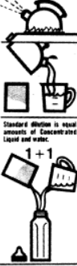  Directions for USE  Directions for Preparation and Use  a) Storage of infant formula before and after the container has been opened  b) Agitating liquid infant formula before opening the container such as “Shake Well Before Opening”  c) Sterilization of water bottle and nipples when necessary for preparing infant formula for use  d) Dilution of infant formula, when appropriate. Directions for powdered infant formula shall contain the weight an volume of infant formula to be reconstituted.
2) No containers or label referred shall have a picture of infant or women or both.  The terms “Humanized” or “Materialized” or any other similar words shall not be used. The Package and/or any other label of food shall not exhibit the words, “Full Protein Food”, “energy Food”, “Complete food” or “Health Food” | The labelling of infant formulae may not include pictures of infants, nor shall it include other pictures or text which may idealize the use of the product. It may, however, have graphic representations for easy identification of the product and for illustrating methods of preparation.  The use of the terms ‘humanized’, ‘materialized’, ‘adapted’, or similar terms are prohibited.
The product which contains neither milk
nor any milk derivative shall be labelled “contains no milk or milk product” in conspicuous manner
Highlighting some points after Observing the Labelling Requirements of India, European Union and USA:
It was also observed that some of the infant formulas imported from EU were not labelled in English language so it could mislead the information for suitable requirements due to incorrect mixing of with reference to Table 4, it was observed that there is variation in labelling pattern with reference to compliance of the regulation. Like, there is no labelling requirement of DHA/ARA, however, manufacturers are incorporating it in the respective infant formulas. Also, FSSAI says about protein efficiency ratio however other two regulations have no mention about it. Different regulation has different pattern of labelling that need to be harmonized in different context. Similar type of observation was observed by other researchers in the studies that due to non-compliance of import regulation like use of English language have not been found on label. In one of the paper’s, it was found that hypoallergenic is defined differently in Europe than in US. So, partially hydrolyzed European formula may be labelled as HYPOALLERGENIC or HA which is not appropriate for infant with CMPA (Cow Milk Protein Allergy) and may lead to improper treatment of an infant with CMPA. This difference may be misleading resulting in potential misinformation to US consumers.

CONCLUSION
It can be concluded that there is considerable difference in the values of certain parameters of regulatory bodies, the FSSAI, the EFSA and the US FDA. These regulatory authorities should aim to cover the gap areas to achieve harmonization of standards across the globe. When these products are exported, they get rejected because of so much variations in values and non-compliance of regulations. This will lead to failure of these products due to different parameters followed in different countries. Keeping this in view, these standards must be harmonized, thereby cutting the compliance costs. Also, products specially meant for infants, the most vulnerable population should necessarily have uniformity in parameters across the globe. They should aim at providing wholesome nutrition to infants in all parts of the world. Harmonization of standards will ensure common standards and enable consumers across the world to benefit from the product.
ACKNOWLEDGMENTS
The authors sincerely thank Prof. D.K. Modi, the Chancellor of Dr. K.N. Modi University for providing the facilities and Respected Prof. R.K. Khandal for his mentorship and guidance for this research work. I am highly thankful and obliged to Respected Prof. Dr. R. K. Khandal for always being available and giving his valuable time, support and knowledge whenever required. I also thank Dr Nidhi Kaushik and Ms. Priyanka for their kind support and assistance.
REFERENCES
- Indian food code, the food categorization system, 2012. Food Safety and Standard Authority of India. old.fssai.gov.in/Portals/0/Pdf/INDIAN_FOOD_CODE (25-06-2012).pdf
- World Health Organization, United Nations Children's Fund (‎UNICEF)‎ & International Baby Foods Action Network. (‎2022)‎. Marketing of breast-milk substitutes: national implementation of the international code, status report 2022. World Health Organization. WHO, 1981, International code of marketing of breast milk substitutes, Geneva. www.babymilkaction.org/archives/32584.
- Health experts call for an end to exploitative baby formula milk marketing tactics, Lancet, 7 Feb, 2023. www.cnn.com/2023/02/07/health/baby-formula-marketing/index.html.
- Unveiling the predatory tactics of the formula milk industry, The Lancet, Volume 401, Issue 10375, P409, Feb. 11, 2023. https://doi.org/10.1016/S0140-6736(23)00118-6.

Pérez-Escamilla et al. 2023. Breastfeeding: crucially important, but increasingly challenged in a market-driven world, The Lancet, Feb. 7, 2023. https://www.thelancet.com/series/Breastfeeding-2023
- Marketing of commercial milk formula, a system to capture, communities, science and policies, Lancet 2023; 401: 486–502.https://www.thelancet.com/pdfs/journals/lancet/PIIS0140-6736(22)0…
- Philip Baker et. al., 2023. The political economy of infant and young child feeding: confronting corporate power, overcoming structural barriers, and accelerating progress., Lancet 2023 Feb 11;401(10375):503-524. https://pubmed.ncbi.nlm.nih.gov/36764315.
- Christoffer van Tulleken et. al., 2023. Marketing of breastmilk substitutes during the covid -19 Pandemic, Lancet, Vol. 396, Issue 10259, E58, Oct. 24, 2020. https://doi.org/10.1016/S0140-6736(20)32119-X.
- Jill Krasny, Every Parent Should Know the Scandalous History of Infant Formula, Business Insider, Jun 26, 2012. https://www.businessinsider.com/nestles-infant-formula-scandal-2012-6
- Fran Kritz, Nestle’s Infant formula promoted in misleading aggressive ways, Global Report, 01 Mar 2022. https://www.npr.org/sections/goatsandsoda/2022/03/01/1082775961/infant...
- Céline Marie-Elise Gossner et. al. 2009. The melamine Incident: Implications of International Food and feed safety, Environ Health Perspect. Dec;117(12):1803-8. doi: 10.1289/ehp.0900949. Epub 2009 Aug 6. https://pubmed.ncbi.nlm.nih.gov/20049196.
- Business News, China probes new baby milk formula scandal Report, The economics Times, 14 May 2020. https://economictimes.indiatimes.com/news/international/business/china...
- Food Safety and Standard Authority of India., May 1, 2019, “The gazette of India “Extraordinary, Part III—Section 4, (published by Authority). https://www.fssai.gov.in/cms/food-safety-and-standards-regulations.php.
- The food safety and standards, 2011. Food Products Standards and Food Additives) fourth, amendment, Regulations, 2017, https://foodregulatory.fssai.gov.in/All Docs/Food Standards/compendium. https://www.fssai.gov.in/upload/uploadfiles/files/Compendium_Food...
- Commission Directive 2006/141/EC of 22 December 2006 on infant formulae and follow-on formulae and amending Directive 1999/21/EC Text with EEA. eur-lex.europa.eu/legal-content/en/ALL/?uri=CELEX%3A32006L0141
- FDA-CFR- Code of Federal Regulations Title-21, Volume-2, Part-107, Subpart-D, https://www.accessdata.fda.gov/scripts/cdrh/cfdocs/cfCFR/CFRSearch.cfm.
- Gazette Notification of Food Safety and Standards (Foods for Infant Nutrition) First Amendment Regulations, 2022. https://www.fssai.gov.in/notifications.php?notification=gazette-notification.
- Food and drug administration “department of health and human services”, Chapter I, “food for human consumption”, Subchapter b. https://www.ecfr.gov/current/title-21/chapter-I.
- USFDA Guidance Document, Labeling of Infant Formula Guidance for Industry, U.S. Department of Health and Human Services “Food and Drug Administration Center for Food Safety and Applied Nutrition”, September 2016. https://www.fda.gov/.../guidance-industry-labeling-infant-formula
- FDA-CFR- “Code of Federal Regulations” Title-21, Volume-2, Part-106, Subpart-D. https://www.fda.gov/.../code-federal-regulations-title-21-food-and-drugs

