Amorphous Carbon Nanotube-MoS2 Nanohybrids : A New Material in the Application of Battery, Supercapacitor and Field-emission Display Devices

Binoy Bera, Ambar Pattanayak, Madhumita Das Sarkar Hari Sarkar, Pabitra Dey1

Dibyaranjan Bera2 Ujjwal Kumar Mondal, Rafiqul Hossain3

1Department of computer science and engineering, West Bengal University of Technology, Kolkata – 700064, India.

2Khanayadihi P. K. Higher Secondary School, West Bengal – 721641, India.

3Jadavpur University, plot no.8, Salt Lake Bypass, LB Block, Sector III, Salt Lake City, Kolkata - 700106.

**Abstract:** The discovery of graphene make the researcher interested towards the other two-dimensional material which has quite similar properties like graphene. Among them, MoS2 nanosheets has extraordinary optoelectronic and physical properties. It has several applications in developing battery, sensor, optoelectronic device etc. On the other hand, amorphous carbon nanotube can be synthesized by using a low temperature chemical process. Due to the ease processing of amorphous carbon nanotube (ACNT), good optoelectronic and physical property based nanomaterial with amorphous carbon nanotube, can be a good replacement of crystalline carbon nanotube in numerous applications. Here in this paper, amorphous carbon nanotube-MoS2 nanohybrids were prepared by hydrothermal method. Beside this, ACNT has been synthesized by using a low temperature chemical process. The as prepared samples (ACNT and ACNT\_MoS2 nanohybrids) were characterized by using field emission scanning electron microscopy, X-ray diffraction method, high resolution transmission electron microscope and fourier transformed infrared spectroscopy method.

**Keywords:** amorphous carbon nanotube, MoS2 nanosheets, nanohybrids, hydrothermal method, battery, supercapacitor, field – emission display devices.

**1. Introduction**

Instead of graphene, the beautiful physical and opoelectronic property of two dimensional molybdenum di sulphide(MoS2) can be a good replacement in many applications such as electromagnetic wave absorber, supercapacitor, field-emission display devices and catalysis. Two dimensional MoS2 is a direct band gap material with band gap of 1.8 eV whereas bulk MoS2 is a indirect band gap material with band gap of 1.23 eV. Due to its direct band gap characteristics, it is hugely applicable in optoelectronic devices. Now a days, MoS2 nanosheets are also used in developing transistors and diode. Moreover, excellent high mobility, ON/OFF ratio, sensitivity makes MoS2 nanosheets as useful in fabricating field effect transistors and phototransistors. However, the researchers and scientist have discovered several methods like mechanical exfoliation, liquid phase exfoliation, chemical vapour deposition etc for synthesis of MoS2 nanosheets. On the other hand, unlike crystalline carbon nanotube, amorphous carbon nanotube can be prepared by a low temperature(2250C) process. Due to the presence of several dangling bond in amorphous carbon nanotube, it is easily react with other nanomaterial to form into nanohybrids. Instead of crystalline carbon nanotube, this nanohybrids can be applicable in numerous applications. Though ACNT-MoS2 nanohybrids can be developed by using liquid phase method, eco-friendly method and hydrothermal method. In eco-friendly method, bulk MoS2, ultra tide detergent and amorphous carbon nanotube are used as main material. In this method, a 10 g amount of bulk MoS2 are first stirred in a 50 ml of di-water (at 600C temperature) and an amount of 20 g detergent (Ultra Tide) for a fixed time and measured 400 rpm, followed by sonication using a solid probe sonicator for 3 hrs. After that, 2 g of ACNT is poured into that solutions and stirred for 30 minutes with 400 rpm. Finally the samples are filtered and washed with di-water and ethanol repeatedly. Lastly the samples are kept in an oven with a temperature of 500C for 10 hrs. In, liquid phase method, for synthesis of ACNT-MoS2 nanohybrids, MoS2 powder is used as precursor and isopropanol are used as solvent. A measured quantity of MoS2 powder is taken in a beaker which is contained previous mentioned solvent. This beaker is kept in a ultrasonicator for 30mins and then as prepared ACNT is poured into this solutions. Finally the mixed solutions are ultrasonicated for more 10 minutes. After that the samples are washed with distilled water and absolute ethanol for several time and filtered by a filter paper.

Here in this paper, amorphous carbon nanotube has been synthesized by using pre mentioned low temperature process. ACNT-MoS2 nanohybrids has been prepared by using less complicated hydrothermal method. Finally the as prepared ACNT and ACNT\_MoS2 nanohybrids were characterized by field emission scanning electron microscope, X-ray diffraction, HRTEM, FT-IR method.

**2. Materials and Method**

For the preparation of amorphous carbon nanotube, Ferrocene ((C5H5)2Fe, Merck), ammonium chloride (NH4Cl) and hydrochloric acid (HCl) are the main material used in this process. For synthesis of amorphous CNT, first ferrocene and ammonium chloride were taken in 1:2 weight ratio. Then weighted material placed in a mortar and grinded very well. After that, the mixture were placed in a quartz beaker and kept it in an oven with 2250C for 30 minutes. Then the black product was washed with DI-water and dilute HCL repeteadly for removing the impurity present in amorphous CNT. Then final product was kept in an oven with 600C for 24 hrs.

Hexaammonium heptamolybdate tetrahydrate and thiourea were used as main material in hydrothermal method. In this procedure, 1.24 g of hexaammonium heptamolybdate tetrahydrate and 2.28 g of thiourea were dissolved in 50ml deionized water under vigorous stirring for 50 min to form a homogeneous solutions. Then this solutions were transferred into a teflon-lined stainless steel  autoclave and closed securely. Next solutions containing autoclave heated with a temperature 2000C for a fixed 20h time. Furthermore the final solutions were cooled down normally and centrifuged for producing powder like sample. Samples were washed with distilled water and absolute ethanol for several time. Finally this samples were dried in vacuum at 600C for 18 h.

**3. Characterizations**

Amorphous carbon nanotube and as prepared ACNT-MoS2 nanohybrids were characterized by using field emission scanning electron microscope, X-ray diffraction (XRD, Bruker). FE-SEM is used for the surface analysis and X-ray diffraction method is used for determining the material property of as produced samples. High resolution transmission electron microscopy (HRTEM, JEOL-JEM 2100) is used for surface analysis of eco-friendly synthesized nanohybrids. Different bond measurement were done by FT-IR (Shimadzu FTIR-8400S) instrument.

**4. Results and Discussions**

**G:\me...iiest shibpur\final\working\acnt -mos2 thiorea hydrothermal\acnt\a-CNT__m003.tif**

**(a)**

Figure 1: FESEM image of amorphous carbon nanotube.

**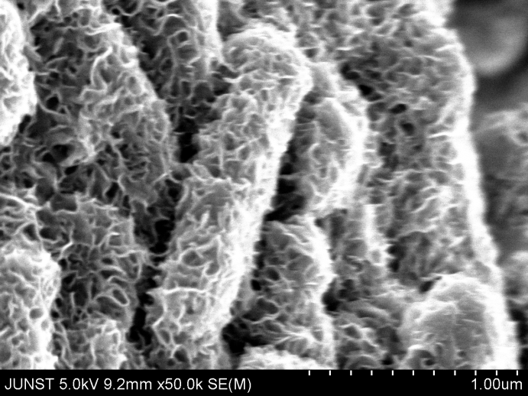**

**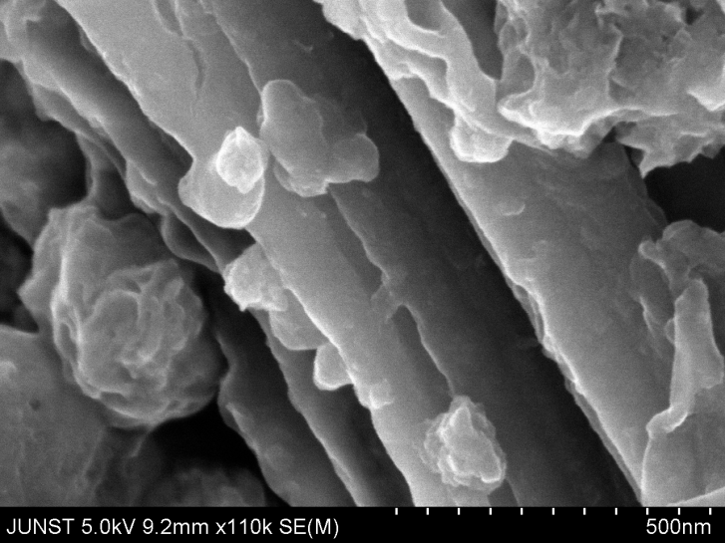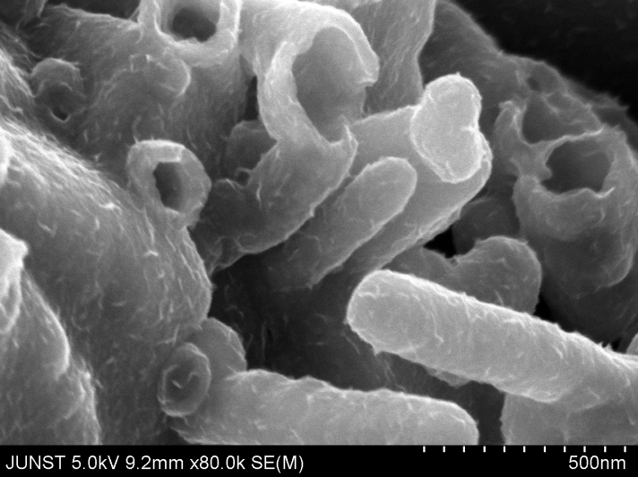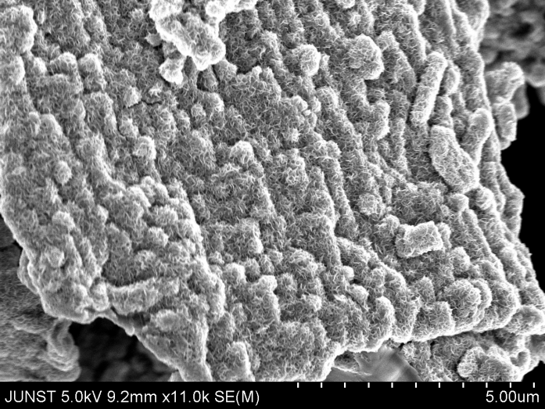**

**(b)**

**(a)**

Figure 2: FESEM image of liquid phase synthesized ACNT-MoS2 nanohybrids.

**MoS2 nanosheets**

**Amorphous Carbon Nanotube**

**(b)**

**(a)**

**110**

**(a)**

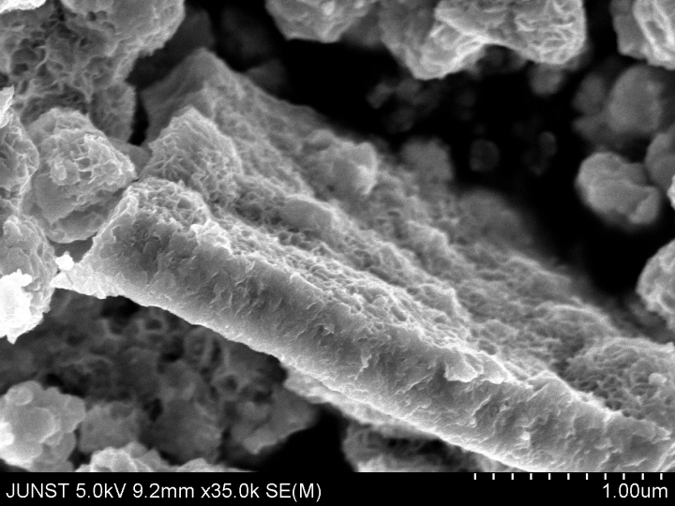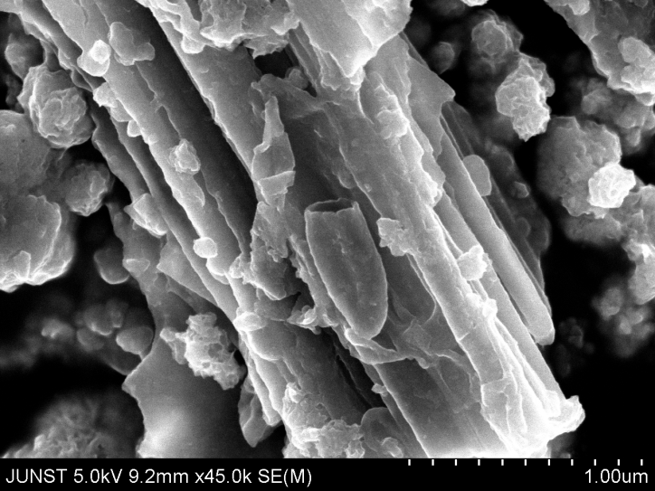

**(d)**

**(c)**

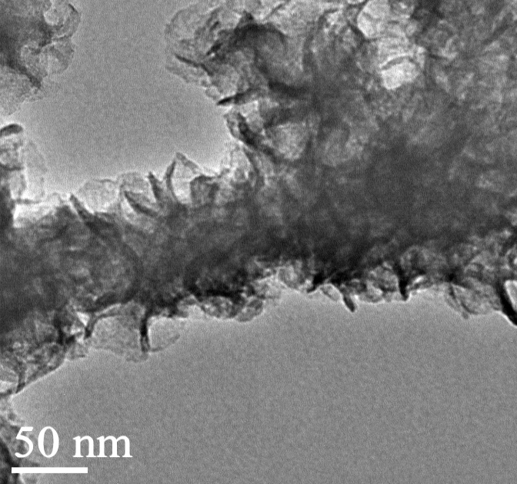

**(e)**

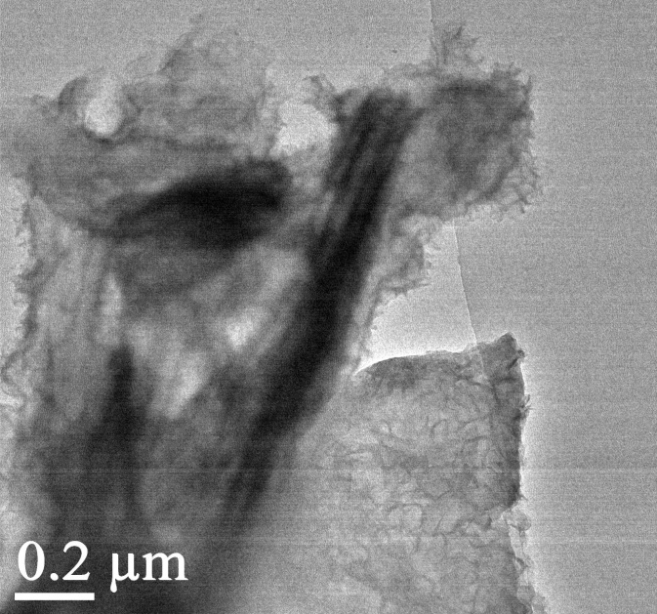

**(e)**

**(f)**

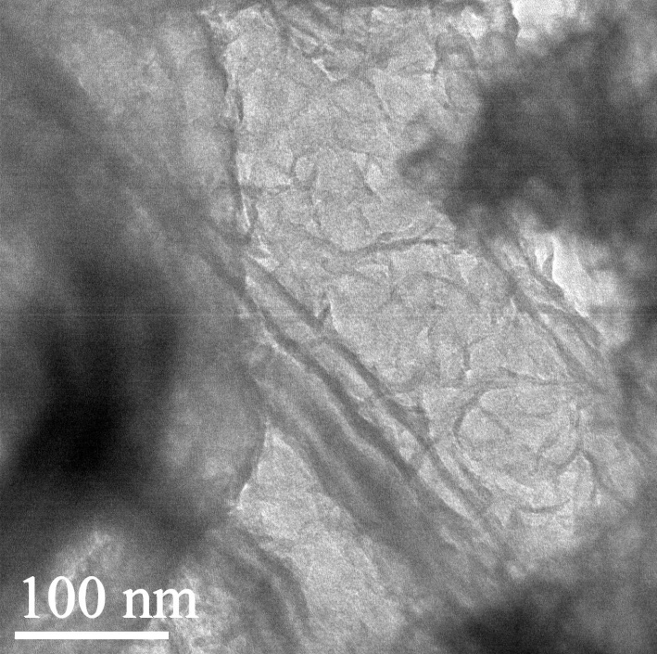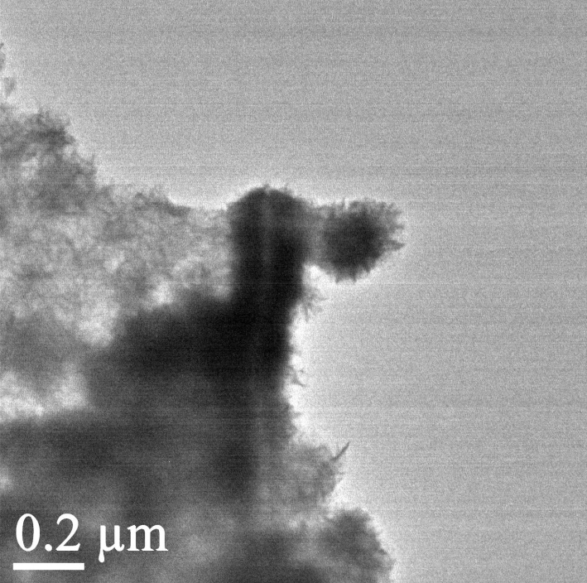

**(h)**

**(g)**

Figure 3: (a, b, c and d) FESEM, (e, f, g, h) HRTEM image of eco-friendly produced ACNT\_MoS2 nanohybrids.

Figure 1 (a and b) are showing the FE-SEM image of amorphous carbon nanotube. From FE-SEM image it is clearly observed the formation of amorphous carbon nanotube. From there, It is proved that the surface of carbon nanotube are amorphous in nature. Figure 2 (a and b) are showing the FE-SEM image of liquid phase synthesized ACNT-MoS2 nanohybrids. Amorphous carbon nanotube are wrapped by MoS2 nanosheets. XRD pattern taken using Cu Kα radiation (wavelength λ = 0.15418 nm) with normal θ-2θ scanning in the range between 5 - 650. One peak around 26.50 is occurred for the (002) plane of 2 dimensional graphitic phase of carbon. From XRD pattern, it is observed that the carbon nanotube is amorphous in structure. In figure 2, (100) and (110) peak arises due to the incorporation of MoS2 nanosheets in amorphous carbon nanotube. In eco-friendly produced nanohybrids, Surface analysis of ACNT-MoS2 nanohybrids were done from FE-SEM and HRTEM image. FE-SEM image reveals the formation of MoS2 nanosheets with amorphous carbon nanotube. High resolution transmission electron microscopy image shows the clear vision of ACNT-MoS2 samples.All planes i.e. (002), (100), (102) and (110) are corresponding to the MoS2 nanosheets. Graphitic carbon plane of amorphous carbon nanotube was suppressed by MoS2 nanosheets.

**(b)**

**(a)**





**(d)**

**(c)**



Figure 4: (a) XRD pattern of amorphous carbon nanotube, (b) liquid phase synthesized ACNT-MoS2 nanohybrids, (c and d) XRD and FT-IR pattern of eco-friendly synthesized ACNT-MoS2 nanohybrids.

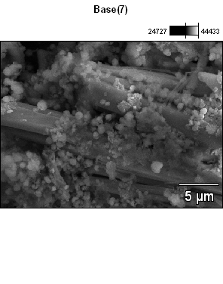

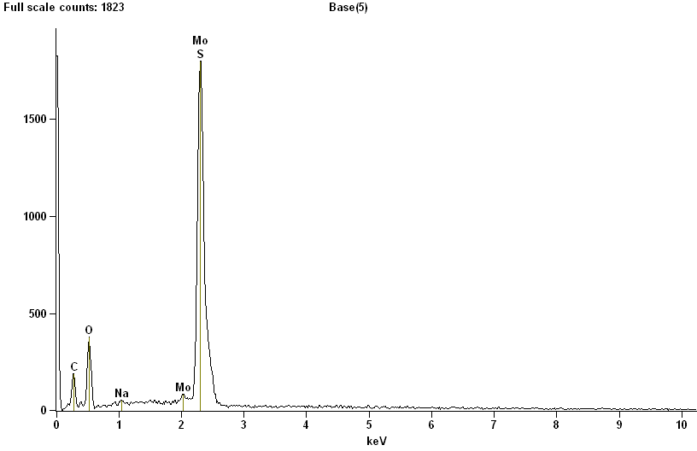

**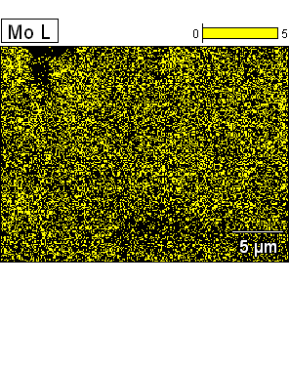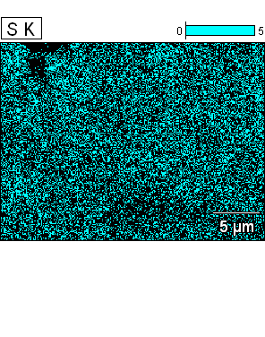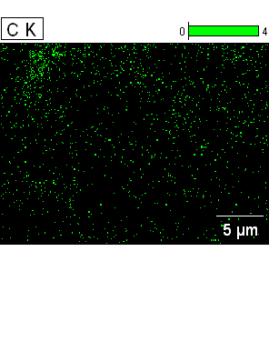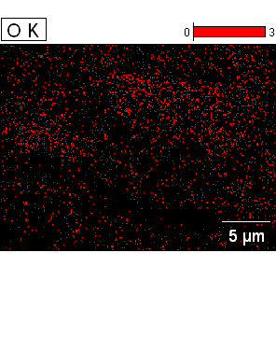**

Figure 2: EDX spectra of eco-friendly produced ACNT-MoS2 sample with corresponding elemental mapping.

**Table 1: Compositional analysis of eco-friendly produced ACNT-MoS2 sample from EDX study.**

Elemental line atom %

C K 47.91

O K 29.81

S K 14.74

Mo L 7.24

Total 100

**4. Conclusions**

Here in this paper, a simple hydrothermal method has been used for synthesis of amorphous carbon nanotube-MoS2 nanohybrids. Amorphous carbon nanotube were prepared separately by a low temperature chemical process. FE-SEM and HRTEM image proves the formation of ACNT-MoS2 nanohybrids. From there, it is also observed that the quality of samples are good in comparable with other methods of ACNT-MoS2 nanohybrids preparation. The method which has used here for synthesis of ACNT-MoS2 nanohybrids are very simple. Here amorphous carbon nanotube which was previously prepared by a low temperature chemical process are used here. In paper industry, huge amount of dye (generally toxic) and water is used. This nanohybrids can be used as toxic dye removal material in paper industry. From FE-SEM image, it is visualize that the quality of ACNT-MoS2 nanohybrids are very much good. This nanohybrids are quite interesting for developing anode material of lithium- ion battery, supercapacitor application and field emission devices.

**References**

1. S. Iijima. Helical microtubules of graphitic carbon. Nature 354, 56 - 58.
2. G. Eda, H. E. Unalan, N. Rupesinghe, G. A. J Amaratunga, and M. Chhowalla, 2008 Appl. Phys. Lett. 93, 233502 (2008).
3. Y. Liu, J. Tang, X. Chen, W. Chen,G. K.H. Pang, and J.H. Xin,“A wet-chemical route for the decoration of CNTs with silver nanoparticles,” Carbon, vol. 44, no. 2, pp. 381–383, 2006.
4. Z. Zanolli, R. Leghrib, A. Felten, J. Pireaux, E. Llobet, and J. Charlier, “Gas sensing with Au-decorated carbon nanotubes,”Journal of American Chemical Society, vol. 6, no. 5, pp. 4592–4599, 2011.
5. T. Zhaoet al. Electromagnetic Wave Absorbing Properties of Amorphous Carbon Nanotubes. Sci. Rep. 4, 5619; DOI:10.1038/srep05619 (2014).
6. D. J. Guo and H. L. Li, “Highly dispersed Ag nanoparticles on functional MWNT surfaces for methanol oxidation in alkaline solution,” *Carbon*, vol. 43, no. 6, pp. 1259–1264, 2005.
7. B. Bera. Literature Review on Electrospinning Process (A Fascinating Fiber Fabrication Technique). Imperial Journal of Interdisciplinary Research (IJIR). Vol-2, Issue-8, 2016.
8. B. Bera, Madhumita.Das Sarkar. Piezoelectricity in PVDF and PVDF Based Piezoelectric Nanogenerator: A Concept . IOSR Journal of Applied Physics (IOSR-JAP). Volume 9, Issue 3 Ver. I, PP 95-99.
9. Binoy Bera, Dipankar Mandal, Madhumita Das Sarkar. Sensor Made of PVDF/graphene Electrospinning Fiber and Comparison between Electrospinning PVDF Fiber and PVDF/graphene Fiber. Imperial Journal of Interdisciplinary Research (IJIR). Vol-2, Issue-5, 2016.
10. Binoy Bera, Madhumita Das Sarkar. Gold Nanoparticle Doped PVDF Nanofiber Preparation of Concurrently Harvesting Light and Mechanical Energy. IOSR Journal of Applied Physics (IOSR-JAP).Volume 9, Issue 3 Ver. III (May - June 2017), PP 05-12.
11. Binoy Bera, Madhumita Das Sarkar. PVDF based Piezoelectric Nanogenerator as a new kind of device for generating power from renewable resources. IOSR Journal of Polymer and Textile Engineering (IOSR-JPTE). Volume 4, Issue 2 (Mar. - Apr. 2017), PP 01-05.
12. Binoy Bera. Preparation of polymer nanofiber and its application. Asian journal of physical and chemical sciences. volume 2, issue 4, 1-4, 2017. article no. AJOPACS. 35651.
13. Binoy Bera. Literature Review on Triboelectric Nanogenerator. Imperial Journal of Interdisciplinary Research(IJIR). 2(10):1263-1271·January2016.
14. Binoy Bera. Preparation of MoS2 nanosheets and PVDF nanofiber. Asian journal of physical and chemical sciences. volume 2, issue 4, 1-9, 2017.article no. AJOPACS. 35176.
15. Binoy Bera. Nanoporous Silicon Prepared by Vapour Phase Strain Etch and Sacrificial Technique. IJCA Proceedings on International Conference on Microelectronic Circuit and System MICRO 2015(1):42-45, December 2015.
16. BinoyBera, Dipankar Mandal, Madhumita Das Sarkar. Porous Silicon and its Nanoparticle as Biomaterial: A Review. Imperial Journal of Interdisciplinary Research (IJIR). Vol-2, Issue-11, 2016. (4).
17. Binoy Bera. A Review on Polymer, Graphene and Carbon Nanotube: Properties, Synthesis and Applications. Imperial Journal of Interdisciplinary Research (IJIR). Vol-3, Issue-10, 2017.
18. Hari Sarkar, Binoy Bera, Sudakshina Kundu. Sleep Mode Transistor Sizing Effect of MTCMOS Inverter Circuit on Performance in Deep Submicron Technology. Global Journal of Trends in Engineering (GJTE). Vol(2)-Issue(4), 2015.
19. Binoy Bera, Madhumita Das Sarkar. Piezoelectric Effect, Piezotronics and Piezophototronics: A Review. Imperial Journal of Interdisciplinary Research (IJIR). Vol-2, Issue-11, 2016.
20. [BrunoF. Machado](http://pubs.rsc.org/en/results?searchtext=Author%3ABruno%20F.%20Machado)  and  [Philippe Serp](http://pubs.rsc.org/en/results?searchtext=Author%3APhilippe%20Serp). Graphene-based materials for catalysis.   
    **Catal. Sci. Technol.**, 2012,**2**, 54-75 . DOI:10.1039/C1CY00361E.
21. John R. Miller, R. A. Outlaw, B. C. Holloway. Graphene Double-Layer Capacitor with ac Line-Filtering Performance. Science  24 Sep 2010: Vol. 329, Issue 5999, pp. 1637-1639. DOI: 10.1126/science.1194372.
22. [DianaBerman,](http://www.sciencedirect.com/science/article/pii/S1369702113004574#!) [AliErdemir](http://www.sciencedirect.com/science/article/pii/S1369702113004574#!), [Anirudha V. Sumant](http://www.sciencedirect.com/science/article/pii/S1369702113004574#!). Graphene: a new emerging lubricant. Materials Today, [Volume 17, Issue 1](http://www.sciencedirect.com/science/journal/13697021/17/1), January–February 2014, Pages 31-42. <https://doi.org/10.1016/j.mattod.2013.12.003>.
23. [Mehmet Copuroglu](http://pubs.acs.org/author/Copuroglu%2C+Mehmet), [Pinar Aydogan](http://pubs.acs.org/author/Aydogan%2C+Pinar), [Emre O. Polat](http://pubs.acs.org/author/Polat%2C+Emre+O), [Coskun Kocabas](http://pubs.acs.org/author/Kocabas%2C+Coskun), and [Sefik Süzer](http://pubs.acs.org/author/S%C3%BCzer%2C+Sefik). Gate-Tunable Photoemission from Graphene Transistors. Nano Lett., 2014, 14 (5), pp 2837–2842. DOI: 10.1021/nl500842y.
24. [Hamid Ghorbani Shiraz](http://www.sciencedirect.com/science/article/pii/S136403211730271X#!), [Omid Tavakoli](http://www.sciencedirect.com/science/article/pii/S136403211730271X#!). Investigation of graphene-based systems for hydrogen storage. [Renewable and Sustainable Energy Reviews](http://www.sciencedirect.com/science/journal/13640321), [Volume 74](http://www.sciencedirect.com/science/journal/13640321/74/supp/C), July 2017, Pages 104-109. <https://doi.org/10.1016/j.rser.2017.02.052>.
25. Yi Han, Zhen Xu, Chao Gao. Ultrathin Graphene Nanofiltration Membrane for Water Purification. Advanced Functional Materials. Volume 23, Issue 29. August 7, 2013. Pages 3693–3700. DOI: 10.1002/adfm.201202601.
26. [Gonçalo da Cunha Rodrigues](https://www.nature.com/articles/ncomms8572#auth-1), [Pavel Zelenovskiy](https://www.nature.com/articles/ncomms8572#auth-2), [Konstantin Romanyuk](https://www.nature.com/articles/ncomms8572#auth-3), [Sergey Luchkin](https://www.nature.com/articles/ncomms8572#auth-4), [Yakov Kopelevich](https://www.nature.com/articles/ncomms8572#auth-5) & [Andrei Kholkin](https://www.nature.com/articles/ncomms8572#auth-6). Strong piezoelectricity in single-layer graphene deposited on SiO2 grating substrates. Nat. Commun. 7:7572 doi: 10.1038/ncomms8572 (2015).
27. Guoxing Li, Yuliang Li, Huibiao Liu, Yanbing Guo, Yongjun Li, Daoben Zhu (2010). Architecture of graphdiyne nanoscale films. [Chemical Communications](https://en.wikipedia.org/wiki/Chemical_Communications). 46 (19): 3256–3258. [doi](https://en.wikipedia.org/wiki/Digital_object_identifier):[10.1039/B922733D](https://doi.org/10.1039%2FB922733D).
28. L. Li, Y. Yu, G. J.Ye, Q. Ge, X. Ou, H. Wu, D. Feng, X. H. Chen, Y. Zhang, (2014). Black phosphorus field-effect transistors. Nature Nanotechnology. 9 (5): 372–377. [doi](https://en.wikipedia.org/wiki/Digital_object_identifier):[10.1038/nnano.2014.35](https://doi.org/10.1038%2Fnnano.2014.35).
29. Harneet Ritu (2016). Large Area Fabrication of Semiconducting Phosphorene by Langmuir-Blodgett Assembly. Sci. Rep. 6: 34095. [doi](https://en.wikipedia.org/wiki/Digital_object_identifier):[10.1038/srep34095](https://doi.org/10.1038%2Fsrep34095).
30. C. N. R. Rao, K. Gopalakrishnan (2016-10-31). ["Borocarbonitrides, BxCyNz: Synthesis, Characterization, and Properties with Potential Applications"](https://dx.doi.org/10.1021/acsami.6b08401). ACS Applied Materials & Interfaces.  [doi](https://en.wikipedia.org/wiki/Digital_object_identifier):[10.1021/acsami.6b08401](https://doi.org/10.1021%2Facsami.6b08401).
31. Yi Lin, John W. Connell. ([Advances in 2D boron nitride nanostructures: nanosheets, nanoribbons, nanomeshes, and hybrids with graphene"](http://xlink.rsc.org/?DOI=c2nr32201c). Nanoscale. 4 (22): 6908.  [doi](https://en.wikipedia.org/wiki/Digital_object_identifier):[10.1039/c2nr32201c](https://doi.org/10.1039%2Fc2nr32201c).
32. Kin Fai Mak, Changgu Lee, James Hone, Jie Shan, Tony F Heinz.  Atomically ThinMoS2: A New Direct-Gap Semiconductor". Physical Review Letters. 105 (13). . [*doi*](https://en.wikipedia.org/wiki/Digital_object_identifier):[*10.1103/physrevlett.105.136805*](https://doi.org/10.1103%2Fphysrevlett.105.136805).
33. Z. A . Piazza, H. S. Hu, W. L. Li, Y. F. Zhao, J. Li, L. S. Wang (2014). Planar hexagonal B36 as a potential basis for extended single-atom layer boron sheets". Nature Communications. 5: 3113.  [doi](https://en.wikipedia.org/wiki/Digital_object_identifier):[10.1038/ncomms4113](https://doi.org/10.1038%2Fncomms4113).
34. Q. H. Wang, K. Kalantar-Zadeh, A. Kis, J. N. Coleman, M.S. Strano. Electronics and optoelectronics of two-dimensional transition metal dichalcogenides. Nat. Nanotechnol. 2012, 7, 699–712.
35. F. H. L. Koppens, T. Mueller, P. Avouris, A.C. Ferrari, M. S. Vitiello, M. Polini. Photodetectors based on graphene, other two-dimensional materials and hybrid systems. Nat. Nanotechnol. 2014, 9, 780–793.
36. A. Castellanos-Gomez, N. Agraït, G. Rubio-Bollinger. Optical identification of atomically thin dichalcogenide crystals. Appl. Phys. Lett. 2010, 96, 213116.
37. H. Li, G. Lu, Z. Yin, Q. He, H. Li, Q. Zhang, H. Zhang. Optical Identification of Single- and Few-Layer MoS2 Sheets. Small 2012, 8, 682–686.
38. M. Buscema, G. A. Steele, H. S. J. van der Zant, A. Castellanos-Gomez. The effect of the substrate on the Raman and photoluminescence emission of single-layer MoS2. Nano Res. 2014, 7, 561–571.
39. K. Liu, J. Feng, A. Kis, & A. Radenovic. Atomically thin molybdenum disulfide nanopores with high sensitivity for DNA translocation. ACS Nano 8, 2504-2511. doi:10.1021/nn406102h (2014).
40. J.M. Tarascon, M. Armand. Issues and challenges facing rechargeable lithiumbatteries, Nature 414 (2001) 359–367.
41. A.S. Arico, P. Bruce, B. Scrosati, J.M. Tarascon, W. van Schalkwijk. Nanostructured materials for advanced energy conversion and storagedevices, Nat. Mater. 4 (2005) 366–377.
42. X. Li, Y. Feng, M. Li, W. Li, H. Wei, D. Song. Smart hybrids of Zn2GeO4nanoparticles and ultrathin g-C3N4 layers: synergistic lithium storage andexcellent electrochemical performance, Adv. Funct. Mater. 25 (2015)6858–6866.
43. M. Armand, J.M. Tarascon. Building better batteries, Nature 451 (2008)652–657.
44. B. Kang, G. Ceder. Battery materials for ultrafast charging and discharging,Nature 458 (2009) 190–193.
45. X. Li, W. Li, M. Li, P. Cui, D. Chen, T. Gengenbach, L. Chu, H. Liu, G. Song. Glucose-assisted synthesis of the hierarchical TiO2 nanowire@MoS2nanosheet nanocomposite and its synergistic lithium storage performance, J.Mater. Chem. A 3 (2015) 2762–2769.
46. D. Larcher, S. Beattie, M. Morcrette, K. Edstrom, J.-C. Jumas, J.-M. Tarascon. Recent findings and prospects in the field of pure metals as negativeelectrodes for Li-ion batteries, J. Mater. Chem. 17 (2007) 3759–3772.
47. Y. Feng, X. Li, Z. Shao, H. Wang. Morphology-dependent performance of Zn2GeO4 as a high-performance anode material for rechargeable lithium ionbatteries, J. Mater. Chem. A 3 (2015) 15274–15279.
48. L. Chu, M. Li, X. Li, Y. Wang, Z. Wan, S. Dou, D. Song, Y. Li, B. Jiang. Highperformance NiO microsphere anode assembled from porous nanosheets forlithium-ion batteries, RSC Adv. 5 (2015) 49765–49770.
49. P. Cui, B. Xie, X. Li, M. Li, Y. Li, Y. Wang, Z. Liu, X. Liu, J. Huang, D. Song, J.M.Mbengue. Anatase/TiO2-B hybrid microspheres constructed from ultrathinnanosheets: facile synthesis and application for fast lithium ion storage,CrystEngComm 17 (2015) 7930–7937.
50. T. Stephenson, Z. Li, B. Olsen, D. Mitlin. Lithium ion battery applications ofmolybdenum disulfide (MoS2) nanocomposites, Energ. Environ. Sci. 7 (2014)209–231.
51. H. Hwang, H. Kim, J. Cho. MoS2 nanoplates consisting of disorderedgraphene-like layers for high rate lithium battery anode materials, Nano Lett.11 (2011) 4826–4830.
52. R. Dominko, D. Arcon, A. Mrzel, A. Zorko, P. Cevc, P. Venturini, M. Gaberscek,M. Ramskar, D. Mihailovic. Dichalcogenide nanotube electrodes for Li-ionbatteries, ChemInform 34 (2003) 1531–1534.
53. H. Li, W. Li, L. Ma, W. Chen, J. Wang. Electrochemical lithiation/delithiationperformances of 3D flowerlike MoS2 powders prepared by ionic liquidassisted hydrothermal route, J. Alloy Compd. 471 (2009) 442–447.
54. Y. Kim, J.B. Goodenough. Lithium insertion into transition-metalmonosulfides: tuning the position of the metal 4s band, J. Phys. Chem. C 112(2008) 15060–15064.
55. X. Wang, Q. Xiang, B. Liu, L. Wang, T. Luo, D. Chen, G. Shen. TiO2 modified FeSnanostructures with enhanced electrochemical performance for lithium-ionbatteries, Sci. Rep. 3 (2013) 10454–10461.
56. L. Ji, M. Rao, H. Zheng, L. Zhang, Y. Li, W. Duan, J. Guo, E.J. Cairns, Y. Zhang. Graphene oxide as a sulfur immobilizer in high performance lithium/sulfurcells, J. Am. Chem. Soc. 133 (2011) 18522–18525.
57. Q. Fan, P.J. Chupas, M.S. Whittingham. Characterization of amorphous andcrystalline tin–cobalt anodes, Electrochem. Solid State 10 (2007).
58. T. Matsuyama, A. Hayashi, T. Ozaki, S. Mori, M. Tatsumisago. Electrochemicalproperties of all-solid-state lithium batteries with amorphous MoS3electrodes prepared by mechanical milling, J. Mater. Chem. A 3 (2015)14142–14147.
59. E. Hüger, L. Dörrer, J. Rahn, T. Panzner, J. Stahn, G. Lilienkamp, H. Schmidt. Lithium transport through nanosized amorphous silicon layers, Nano Lett. 13(2013) 1237–1244.
60. X. Li, X. Meng, J. Liu, D. Geng, Y. Zhang, M.N. Banis, Y. Li, J. Yang, R. Li, X. Sun,M. Cai, M.W. Verbrugge. Tin oxide with controlled morphology andcrystallinity by atomic layer deposition onto graphene nanosheets forenhanced lithium storage, Adv. Funct. Mater. 22 (2012) 1647–1654.
61. H. Ghassemi, M. Au, N. Chen, P.A. Heiden, R.S. Yassar. In situ electrochemicallithiation/delithiation observation of individual amorphous Si nanorods, ACSNano 5 (2011) 7805–7811.
62. Y. Jiang, D. Zhang, Y. Li, T. Yuan, N. Bahlawane, C. Liang, W. Sun, Y. Lu, M. Yan. Amorphous Fe2O3 as a high-capacity, high-rate and long-life anode materialfor lithium ion batteries, Nano Energy 4 (2014) 23–30.
63. J. Guo, Q. Liu, C. Wang, M.R. Zachariah. Interdispersed amorphousMnOx–carbon nanocomposites with superior electrochemical performance aslithium-storage material, Adv. Funct. Mater. 22 (2012) 803–811.
64. J.H. Ku, J.H. Ryu, S.H. Kim, O.H. Han, S.M. Oh. Reversible lithium storage withhigh mobility at structural defects in amorphous molybdenum dioxideelectrode, Adv. Funct. Mater. 22 (2012) 3658–3664.
65. F. Zhou, S. Xin, H.-W. Liang, L.-T. Song, S.-H. Yu. Carbon nanofibers decoratedwith molybdenum disulfide nanosheets: synergistic lithium storage andenhanced electrochemical performance, Angew. Chem. Int. Ed. 53 (2014)11552–11556.
66. D. Shujiang, C. Jun Song, X.W.D. Lou. Glucose-assisted growth of MoS2nanosheets on CNT backbone for improved lithium storage properties,Chemistry (Weinheim an der Bergstrasse, Germany) 17 (2011) 13142–13145.
67. K. Chang, W. Chen. L-Cysteine-assisted synthesis of layered MoS2/graphenecomposites with excellent electrochemical performances for lithium ionbatteries, ACS Nano 5 (2011) 4720–4728.
68. X. Zhou, Z. Wang, W. Chen, L. Ma, D. Chen, J.Y. Lee. Facile synthesis andelectrochemical properties of two dimensional layered MoS2/graphenecomposite for reversible lithium storage, J. Power Sources 251 (2014)264–268.
69. P. Seung-Keun, Y. Seung-Ho, W. Seunghee, Q. Bo, L. Dong-Chan, K.M. Kun, S.Yung-Eun, P. Yuanzhe. A simple L-cysteine-assisted method for the growth of MoS2 nanosheets on carbon nanotubes for high-performance lithium ionbatteries, Dalton Trans. 42 (2012) 2399–2405.
70. Y. Shi, Y. Wang, J.I. Wong, A.Y.S. Tan, C.-L. Hsu, L.-J. Li, Y.-C. Lu, H.Y. Yang. Self-assembly of hierarchical MoSx/CNT nanocomposites (2&lt;x&lt;3):towards high performance anode materials for lithium ion batteries, Sci. Rep.3 (2013) 2169.
71. Z. Hu, L. Wang, K. Zhang, J. Wang, F. Cheng, Z. Tao, J. Chen. MoS2 nanoflowerswith expanded interlayers as high-performance anodes for sodium-Ionbatteries, Angew. Chem. Int. Ed. 53 (2014) 12794–12798.
72. R. R. Chianelli, E. B. Prestridge, T. A. Pecoraro, and J. P. DeNeufville. *Science* **203**, 1105–1107 (1979).
73. J. L. Verble, T. J. Wietling, and P. R. Reed. Rigid-layer lattice vibrations and van der waals bonding in hexagonal MoS2. *Solid State Comm.* **11**, 941–944 (1972).
74. V. R. Surisetty, A. Tavasoli, and A. K. Dalai. Synthesis of higher alcohols from syngas over alkali promoted MoS2 catalysts supported on multi-walled carbon nanotubes. *Appl. Catal. A-Gen.* **365**, 243–251 (2009).
75. Y. Ye, J. Chen, and H. Zhou. An investigation of friction and wear performances of bonded molybdenum disulfide solid film lubricants in fretting conditions. *Wear* **266**, 859–864 (2009).
76. J. Yan, H. Zhou, P. Yu, L. Su, and L. Mao. A general electrochemical approach to deposition of metal hydroxide/oxide nanostructures onto carbon nanotubes. *Electrochem. Commun.* **10**, 761–765 (2008).
77. C. Feng, J. Ma, H. Li, R. Zeng, Z. Guo, and H. Liu. Synthesis of molybdenum disulfide (MoS2) for lithium ion battery applications. *Mater. Res. Bull.* **44**, 1811–1815 (2009).
78. N. Elizondo-Villarreal, R. Vel´azquez-Castillo, D. H. Galv´an, A. Camacho, andM. Jos´e Yacam´an. Structure and catalytic properties of molybdenum sulfide nanoplatelets. *Appl. Catal. A-Gen.* **328**, 88–97 (2007).
79. X. Zhang, B. Luster, A. Church, C. Muratore, A. A. Voevodin, P. Kohli, S. Aouadi, and S. Talapatra. Carbon Nanotube-MoS2 Composites as Solid Lubricants. *Appl. Mater. Inter.* **3**, 735–739 (2009).
80. W. Li, E. Shi, J. Ko, Z. Chen, H. Ogino, and T. Fukuda. Hydrothermal synthesis of MoS2 nanowires. *J. Cryst. Growth* **250**, 418–422 (2003).
81. K. P. Loh, H. Zhang, W. Z. Chen, and W. Ji. Templated deposition of MoS2 nanotubules using single source precursor and studies of their optical limiting properties. *J. Phys. Chem. B.* **110**, 1235–1239 (2006).
82. L. Ma, L. M. Xu, X. Y. Xu, Y. L. Luo, andW. X. Chen. Synthesis and characterization of flowerlike MoS2 microspheres by a facile hydrothermal route. *Mater. Lett.* **63**, 2022–2024 (2009).
83. G. Chu, G. Bian, Y. Fu, and Z. Zhang. Preparation and structural characterization of nano-sized amorphous powders of MoS by *γ* -irradiation method. *Mater. Lett.* **43**, 81–86 (2000).
84. Z. Wu, D. Wang, and A. Sun. PreparationofMoS2 nanoflakes by a novel mechanical activation method. *J. Cryst. Growth* **312**, 340–343 (2010).
85. M. Virˇsek, A. Jesih, I. Miloˇsevi´c, M. Damnjanovi´c, and M. Remˇskar. Raman scattering of the MoS2 and WS2 single nanotubes. *Surf. Sci.* **601**, 2868–2872 (2007).