Assessing the status of soil seed bank in Parthenium hysterophorus invaded land use types and its social aspects in Lower Hare Watershed, Southern Ethiopia
¹Tademe Minase, ^{1*}Wakshum Shiferaw, ¹Genaye Tsegaye
¹Arba Minch University, College of Agricultural Sciences, Natural Resources Management, P. O. Box 21 Arba Minch, Ethiopia
*Corresponding author: minasietademe@gmail.com
ORCID: https://orcid.org/0009-0004-6946-3975

Abstract
In Ethiopia, Parthenium hysterophorus (P. hystrophorus) is an invasive alien plant affecting various ecosystems. P. hysterophorus displaced native plant species and caused a serious threat to biodiversity. This aimed to assess soil seed bank of P. hysterophorus under major land use types and assess community perception towards the effects of P. hysterophorus on social aspects in lower Hare watershed. For this study, 210 soil samples were collected from fifteen transect lines in grassland, cropland, and forest land use types. Statistical analysis using three ways factorial ANOVA was used to analyze the difference in density of P. hysterophorus among various land uses soil depths, and sites (P < 0.05). For the perception of local communities regarding the effects of P. hysterophorus, a total of 117 respondents were used and semi-structured and close-ended questionnaires for data collection. It found that all factors: land use, site, and soil depth significantly affected the soil seed bank density in the lower Hare watershed (P < 0.05). Results indicated that mean density of seeds were the highest in croplands of other land use types. Meanwhile, the highest mean density of seeds was identified in 0-10 cm soil depth, but the lowest mean density of seeds was identified in 10-15 cm soil depth. The highest seeds were identified at Chano Cheliba, but the density of seeds the lowest in density at Kola Shera. 38.5% of households in Kola Shera, and 21.4% in Kola Cheliba, but 8.5% in Kola Doriga said that it had effects on ecosystem services such as crop yield and livestock production. There should be a need for increased awareness about the density of P. hysterophorus in various land uses and its impacts on native plant species. Seeking possible solutions such as biological and mechanical control methods are among the local people, researchers, and extension workers can use for the management of its invasion, and appropriate control measures can be designed to combat its further invasion and impacts on different land uses of the region.
Keywords/phrases: Weed density; invasive plants; Parthenium hysterophorus; social aspect; soil seed bank

Introduction
Invasive alien species are recognized as the greatest threat to ecosystem services (Shiferaw et al., 2018). They are introduced to a region outside their natural range by various human activities (Masum et al., 2013). Parthenium hysterophorus is in the Asteraceae family and it is indigenous to tropical, subtropical America, Central, and South America (Masum et al., 2022). P. hysterophorus was accidentally introduced into Kenya and Ethiopia in the early 1970s (Ojong et al., 2021). Parthenium hysterophorus was accidentally introduced to Ethiopia possibly with contaminated wheat seeds from Australia (Tamado and Milberg, 2000; Gebeyehu, 2008; Seta et al., 2013; Pratt et al., 2017). Depending on the availability of moisture, P. hysterophorus flowers throughout the year and increases its dispersal pressure. P. hystrophorus was introduced to Ethiopia probably through army vehicles during the 1976 Ethio-Somalia war or along with contaminated grain for food aid (Tamado et al., 2000; Fessehaie and Walcott, 2005). It has spread to several parts of Ethiopia at alarming rates and coverage areas through vehicles, wind, water, and urban waste. During different times and spaces, it entered agricultural fields from non-agricultural areas (Seta et al., 2013). On grazing lands, it co-existed with other plants that affected native forage cover such as natural pasture and other forage legumes in the invaded areas (Ojija and Ngimba, 2021; Ojija, 2022; Ojija and Lutambi, 2022).
In Asia, Africa, and Australia, P. hysterophorus is considered as one of the most aggressive invasive plant species affecting various ecosystems (Rubaba et al., 2017; Shabani et al., 2020). But, soil seed bank researches in relation to P. hysterophorus in Africa, Asia, and Australia are scarcer than its effects crop yield, forage production, and plant species diversity and composition. For instance, study by Karim et al. (2017) show that soil seed bank was declined down the soil depth in Batang Kali, Selangor of Malaysia. Moreover, the soil seeds varied across sites in Batang Kali, Selangor of Malaysia and in Central Queensland of Australia (Karim et al., 2017; Nguyen et al., 2017).
In India, the invasion of P. hysterophorus caused yield losses up to 40% of several crops and 90% loss in forage production (Gnanavel, 2013). In Ethiopia, the invasive alien plants displaced native plant species in different ecosystems (Wubneh, 2019) and caused a serious threat to biodiversity (Akter and Juberi, 2009). Allopathic effects of P. hysterophorus inhibited seed germination and growth of a variety of crops and pasture species (Clarence et al., 2013). Moreover, P. hystrophorus has considerable negative impact on the native grassland flora (Khatri-Chettri et al., 2022). Allelopathy is a common biological phenomenon by which one organism produces biochemicals that influence the growth, survival, development, and reproduction of other organisms (Cheng and Cheng, 2015). McConnachie et al. (2010) reported that the seeds could be transferred to urban green spaces, national parks, and other land uses and damages the landscape in urban areas, disturbed habitats such as roadsides, railway tracks, stockyards, around buildings, and fallow agricultural lands which are particularly suitable for its growth. In order to manage its invasion, P. hysterophorus can be used either as green manure or after composting. Industrially it can be used for producing various value added products (Saini et al., 2014).
In Amhara region of Ethiopia for instance, it was estimated that about 37,105 hectares of land were invaded by P. hystrophorus (Wubneh, 2019). In addition, it is well established in many districts of South, North, and Central Tigray. In Alamata district in Tigray region alone, about 10,000 hectares of land were invaded by P. hystrophorus (Birhanu and Khan, 2018). The species was also a serious problem in the Oromia region. In this region, it was spreading at an alarming rate in East Shewa, Arsi, Ziway, and Bale (Muhammad et al., 2014).
In Ethiopia, this study is particularly important for areas in which the invasion of P. hystrophorus is alarmingly increasing, for smallholder farmers that are highly vulnerable to its invasion, and their livelihoods depend heavily on the quality of natural resources (Greiner et al., 2013). In the invaded areas, intervention in management of P. hystrophorus such as manual uprooting before flowering and seed set were tried but failed. This is due to the fact that uprooting the species after seed setting led to seed dropping and hence increased the area of invasion (Kaur et al., 2014; Wubneh, 2019). Although there were some landholders that achieved success in plugging P. hystrophorus in the rosette stage before seeds, this must be followed up by sowing a crop or direct seeding the perennial pasture (Talemos et al. 2013). Talemos et al. (2013) also argued that management of P. hystrophorus was tried using various practices like manual uprooting should be handled with care and a person should make sure that protective gear such as gloves and masks are in place to prevent health hazards its invasion and had an impact on grazing, crop production, and threaten biodiversity as well as human and animal health due to severe allergic reactions like respiratory and allergies of skin (Dhileepan and Strathie, 2009; Adkins and Shabbir, 2014).
Soil seed bank studies can help to detect or map population of P. hystrophorus in the soils of land use types under investigation and for its management decisions (Rokaya et al., 2020; Costello et al., 2022). In the lower Hare watershed, the species was invading at an alarming rate which further aggravated the risk of expansion and reduced the production of crops (Arba Minch Zuria Woreda Agricultural Office Report, 2020). However, except for the effects of P. hystrophorus on plant species diversity (Gebrehiwot and Lemma, 2015); no studies were carried out about the status of P. hystrophorus in the lower Hare watershed. We hypothesized that the densities of P. hystrophorus invasion did not vary by land use type, site, and soil depths, and its effect on the density of native plant species did not vary with land use types, site, and soil depth. Therefore, this study aimed to assess the soil seed bank of P. hysterophorus under major land use types and sites and assess community perception towards the effects of P. hysterophorus on social aspects y of the study areas. The research hypotheses of this study were (1) densities of soil seed bank were not different under major land use types and (3) local community perception did not perceive the effects of P. hysterophorus on social aspects in lower Hare watershed.
Materials and Methods
Description of the study area
The study was conducted in Hare watershed, which is located between 37° 29' 00” to 37° 37' 00'' N and 6° 00' 00'' to 30° 13' 0'' E. The watershed is located in Arba Minch District, Gamo Zone of Southern Ethiopia along the Northwestern margin of the Great East African Rift Valley (Figure 1). The district town is located 454 km away from the country's capital city Addis Ababa (Arba Minch Town Transport Offices, 2021).
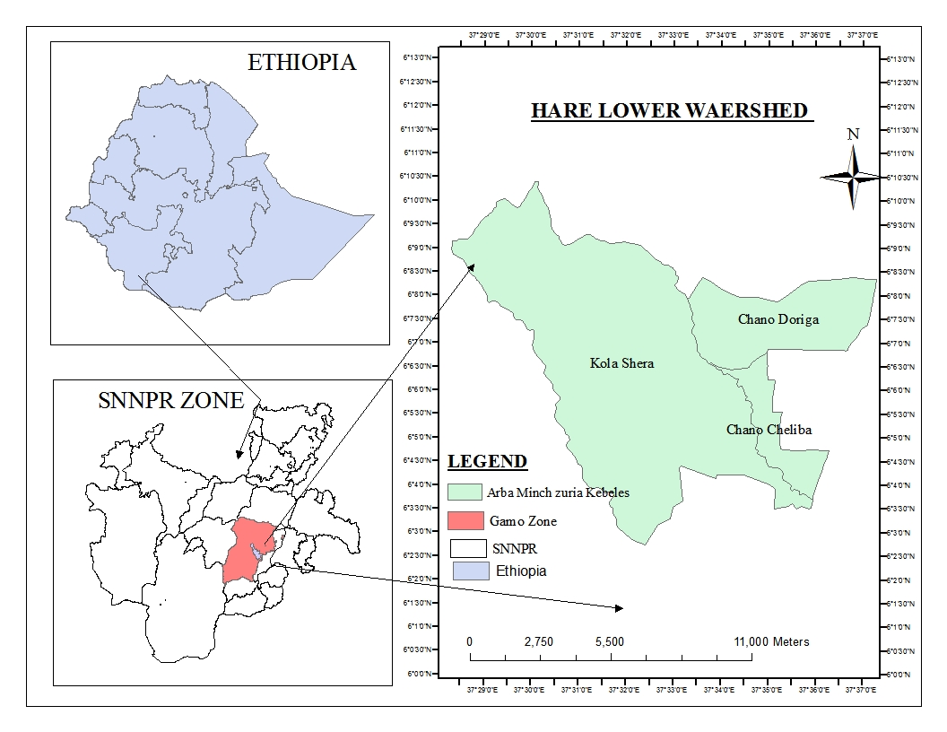
Figure 1. Map of the study area (Source: own map drawn in ArcGIS)
Climate
Hare watershed had a climatic agro-climatic zone of highland, midland, and lowland in the tropical climate. Our study area was lower part of the watershed which was the lowland agro-climate zone in which this watershed is located. The average rainfall amount of the watershed was 1540 mm and the maximum rainy season was more than 120 days. The rainfall pattern was predominantly bimodal with a long rainy season category extended from the months of March to June. The second season was extended from August to October. The agro-climatic regime of the watershed was characterized by an average length of growing period ranging from 120-240 days per year. The lower parts of Hare watershed was classified into highlands and midlands. The altitude is ranging from 1500 m to 3490 m.a.s l. (Arba Minch Zuria District Agricultural Office, 2020).
Land use and land cover and population of the watershed
A total of 25,000 people were living, of which 13100 were females and 11900 were males in the Hare watershed. In the watershed, from 2389 household heads, 201 (8%) were female-headed and the remaining 2188 (92 %) were male-headed households. Economic Activities in the area were based on mixed farming like crop production and livestock rearing (Arba Minch Zuria District Agricultural Office, 2020). The cropping system was perennial-based production with low use of external inputs and dominated only by a few crops (Arba Minch Zuria District Agricultural Office, 2020).
Section 1: Assessment of soil seed bank
Reconnaissance survey was carried out in April 2021 after a short rainy season in three sampling sites to get preliminary information in each site. These sites were chosen on the basis of the severity of invasion of P. hystrophorus and habitat heterogeneity. This study consisted of three stages for soil seed bank study namely reconnaissance, survey, site selection, and soil samplings.
A preliminary survey was conducted before the actual research work for observation of the invasion of P. hystrophorus in different sites of the study watershed. Later, a second formal survey was done to gather data by catching images such as photographs and videos about the invasion and impacts of P. hystrophorus on other plant species.
Selection of sites and land use types
The watershed was selected purposively because the area was severely invaded by P. hystrophorus. There were 10 rural kebeles in the Hare watershed of which 3 kebeles were selected purposively based on high exposure to P. hystrophorus (Ariba Minch Zuria Worda Agricultural Offices, 2019). Kola Shera, Chano Doriga, and Chano Cheliba were selected among the 10 rural kebeles (sites) in the study district. Then, in the invaded sites, cropland, grazing land and forest land use types were selected for the data collection in the watershed.
Soil sampling
For soil sample collection, major land use types mainly grassland, croplands, and forest land use types were selected. The soil samples were collected in June 2021. The sampling period was considered to represent the end of the growing season (i.e., after seed production events) for most of the species encountered in the lower Hare watershed.
For each land use type, a big plot of 1m x 1m (1 m²) was considered and the distance between the big plots was 25 m. In the 1 m² plot, small plots of 15 cm x 15 cm (225 cm²) sampling were selected. In order to cover better area cover for soil samples, zigzag soil sampling method was used in each site at three soil depths of 0–5, 5–10, and 10–15 cm. The number of soil samples taken from Chano Doriga and Kola Shera each was 90 samples (180 soil samples). That meant 30 soil samples were collected in cropland, grazing and forest land types. But, due to the lack of forest and grazing lands in Chano Cheliba site, only 30 soil samples were collected in cropland type. Then, a total of 210 soil samples were collected in the lower Hare watershed (Plate 1). The germination method was used to separate seeds from soil samples. The soil samples were taken to the lath house for germination (Plate 2). The lath house was covered with plastic that protected from the arrival of other materials or seeds on the plastic trays. All plants that were germinated in the lath house on plastic trays. At the intervals week, on each plastic tray germinated seeds were counted and recorded including P. hystrophorus. The counting and recordings of seeds were carried out for six consecutive months. The number of individual plant species in each plastic tray was important to characterize the density of P. hystrophorus and other plant species which were used to identify the status of P. hystrophorus and other native plant species within the lower Hare watershed.
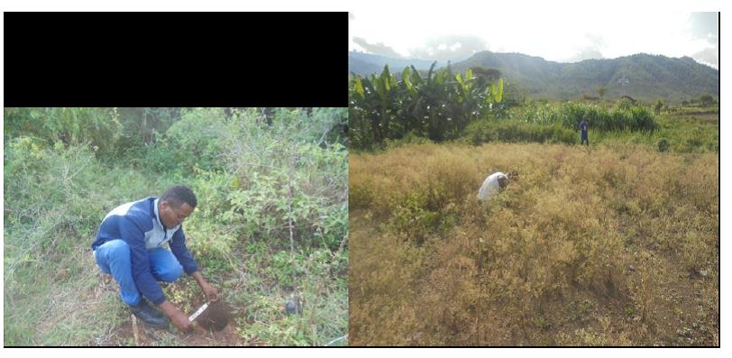
Plate 1. Photo showing soil sampling in the field
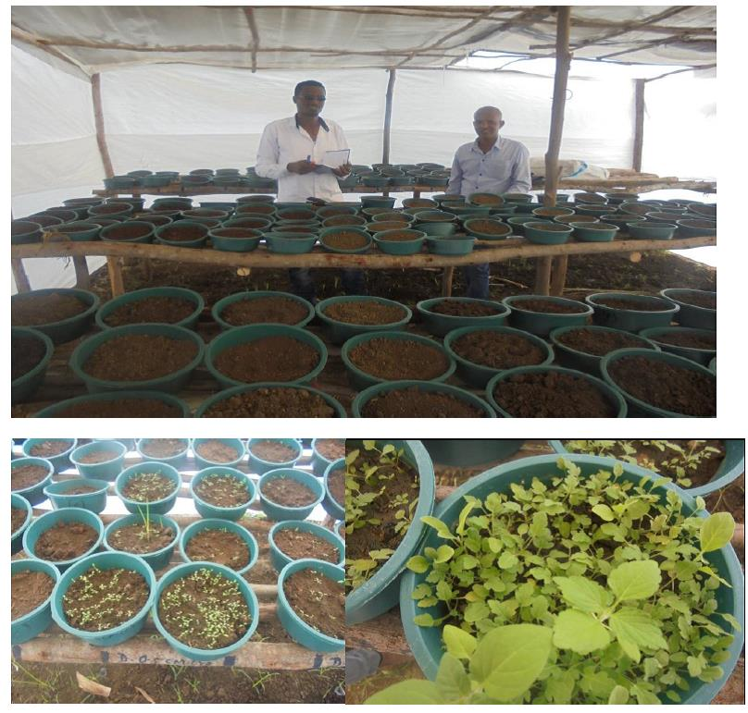
Plate 2. At the start of the trial and seeds germinated in the lath house trial for the soil seed bank
Data analysis for density of soil seed bank
The different species of plants that were counted and recorded were identified using Ethiopia and Eritrea flora books which were found in volumes 2–7. After data for both seeds and social surveys entered into Microsoft Excel, then density of species in the soil seed bank was analyzed using SAS version 9.0.
Section 2: Social survey
Out of 45,000 people, 2389 household heads were existed in the watershed of which 117 household heads were selected using stratified random sampling techniques in selected sites of Kola Shera, Chano Doriga, and Chano Cheliba as follows.
Yamane’s formula (1967) was used to determine the size of households for sample in selected kebeles.
n = N/ (1+N (e²))
Where; n = sample size
N = total number of household
e = margin of error set at 9%
Based on stratified random sampling techniques 117 household respondents were selected from the total households (N = 2389). These 117 households were selected from the lower section of the watershed (Table 1).
Table 1: Sample size of farmers from the three sections
Number | Kebeles | Total population | Sampled households
1 | Kola Shera | 1299 | 64
2 | Chano Doriga | 410 | 20
3 | Chano Cheliba | 680 | 33
Total |  | 2389 | 117

Social data analysis
Social data were analyzed with SPSS version 24. Since the data for number of seeds germinated were large in number F statistics were used for mean separation. For social surveys, descriptive statistics were used for data analysis to show simple relationships with invasion of P. hysterophorus.
Results
Composition of the soil seed bank
In the lower Hare watershed, the results revealed that in the soil seed bank, 18 plant species were identified from soil samples. This study showed that the seeds recorded in the sample plots were composed of 15 annuals, 3 perennial types, and comprised 14 herbs, 3 grass types, and sedge. About 13 families of weed species were identified, including Poaceae, Cyperaceae, Amaranthaceae, Lamiaceae, Asteraceae, Euphorbiaceae, Convolvulaceae, Polygonaceae, and Zygophyllaceae. Most of the species belong to the Asteraceae family followed by the Poaceae family. The economic use of P. hysterophorus in the local areas was compost making, biogas, and green manure (Table 2).
Table 2. Plant species taxonomical characteristics and economic uses in lower Hare watershed
Scientific name | Family name | Life form | Life cycle | Economic use
Hygrophila schulli Parmar | Acanthaceae | Herb | Annual | Medicinal purposes (Teklu et al., 2020
Amaranthus spinosus L. | Amaranthaceae | Herb | Annual | Antidepressant activity (Fariba, 2017
Bidens pilosa L. | Asteraceae | Herb | Perennial | Pharmacological potential (Kumar et al., 2017)
Galinsoga parviflora Cav. | Asteraceae | Herb | Annual | Wound healing (Studzinska-Sroka et al., 2018)
Xanthium strumarium L. | Asteraceae | Herb | Annual | Medicinal purposes (Fan et al., 2019)
Parthenium hysterophorus L. | Asteraceae | Herb | Annual | Compost, bio-gas, green manure. Health benefits (Petel, 2011).
Crassocephalum rubens Juss | Asteraceae | Herb | Annual | Anti-diabetic activity (Olajumoke et al., 2020)
Ipomea eriocarpa R.Br. | Convolvulaceae | Herb | Annual | Physicochemical use (Rajiv et al., 2011)
Cyperus rotundus L. | Cyperaceae | Siege | Perennial | pharmacological activities (Pirzada et al., 2015)
Euphorbia heterophylla L. | Euphorbiaceae | Herb | Annual | Traditional medicinal uses (Kumar et al., 2010)
Ocimum basilium L. | Lamiaceae | Herb | Annual | Treatment of headaches (Joshi, 2014)
Corchorus trilocularis L. | Malvaceae | Herb | Annual | Treatment of environmental pollution (Kabir et al., 2010)
Eragrostis cilianensis Bellardi | Poaceae | Herb | Annual | Feed of livestock and other soil and water conservation
Phalaris paradoxa L. | Poaceae | Herb | Perennial | Feed of livestock and other soil and water conservation
Digitaria abyssinica Hochst | Poaceae | Herb | Perennial | Feed of livestock and other soil and water conservation
Rumex abyssinicus Jacq. | Polygonaceae | Herb | Perennial | Antidiabetic Activity (Adugna et al., 2022)
Xanthium spinosum L. | Solanaceae | Herb | Annual | Medicinal purposes (Fan et al., 2019)
Tribulus terrestris L. | Zygophyllaceae | Herb | Annual | Prevent human nutraceutical impacts (Gunarathne et al., 2022)
The mean density of various plant species was noted in the experimental plots. During the growing periods, frequently occurring plant species were Parthenium hysterophorus, Cyperus rotundus, Ocimum basilium, Phalaris paradox, Euphorbia heterophylla. These 5 species represented 58.35% of the total plant population in the lower Hare watershed (Table 3).
Table 3. The overall plant species composition percentage and their mean seed/$m^{2}$ in lower Hare watershed
Species name | SSB (seed/m²) | %
Parthenium hysterophorus | 373.97 | 28.07
Cyperus rotundus | 125.71 | 9.43
Ocimum basilium | 94.81 | 7.12
Phalaris paradox | 91.64 | 6.88
Euphorbia heterophylla | 91.22 | 6.85
Galinsoga parviflora | 86.56 | 6.50
Rumex abyssinicus | 76.61 | 5.75
Amaranthus spinosus | 73.23 | 5.50
Bidens pilosa | 64.76 | 4.86
Tribulus terrestris | 52.06 | 3.91
Crassocephalum rubeno | 35.98 | 2.70
Eragrostis cilianensis | 32.8 | 2.46
Corchorus trilocularis | 31.32 | 2.35
Hygrophila schulli | 26.46 | 1.99
Xanthium spinosum | 26.24 | 1.97
Xanthium strumarium | 18.2 | 1.37
Ipomea eriocarpa | 15.87 | 1.19
Digitaria abyssinica | 15.03 | 1.13
Notes: Density of soil seed bank (SSB)
The density of soil seed bank
Results in Table (4) show that all factors: land use, site, and soil depth significantly affected the density of the soil seed bank in the lower Hare watershed (P < 0.05). But, the interaction effects of land use and site, and the interactions of the three factors (land use, site and soil depth) did not show effects on the densities of soil seed banks in the study areas (P > 0.05).
Table 4. ANOVA showing the effects of land use system, site, and soil depth on SSB (seed/m²) and their interactions
Source | DF | Type III SS | Mean Square | F | Pr > F
Land use | 2 | 73715.62 | 36857.81 | 4.61 | 0.01
Site | 2 | 358067.07 | 179033.53 | 22.41 | < 0.0001
Soil depth (cm) | 2 | 5822759.87 | 2911379.94 | 282.13 | < 0.0001
Land use*Site | 2 | 40425.63 | 20212.82 | 2.53 | 0.0798
Land use* Soil depth | 4 | 107985.405 | 26996.35 | 3.38 | 0.0091
Site*Land use | 4 | 246943.113 | 61735.778 | 7.73 | < 0.0001
Land use*Site*Soil depth | 4 | 25065.923 | 6266.481 | 0.78 | 0.5351
In the study sites, the highest density of seeds (78±3.9 seeds/m²) was identified under the cropland system but the lowest density of seeds (52±2.68 seeds/m²) was identified under grazing land (Figure 2).
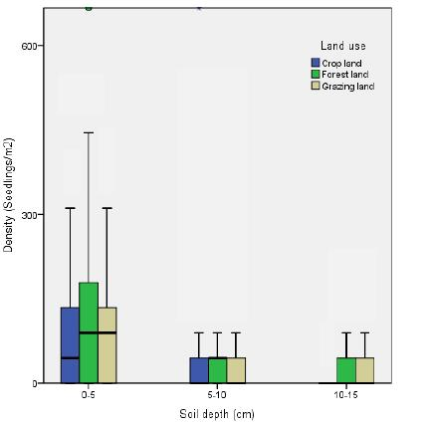
Figure 2. Density soil seed bank (seeds) by land use type in lower Hare watershed.
Meanwhile, the highest density of seeds (130±4.79 seeds/m²) was identified in 0–10 cm soil depth, but the lowest density of seeds (21.9±1.6 seeds/m²) was identified in 10–15 cm soil depth. The highest seeds (90.9±7.3 seeds/m²) were identified at Chano Cheliba, but the lowest density of seeds (52.15±2.62 seeds/m²) was identified at sites of Kola Shera (Figure 3).
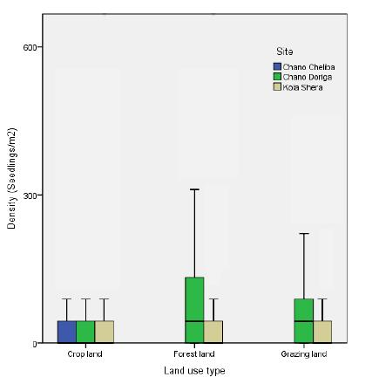
Figure 3. Density soil seed bank (seeds) in different sites in the lower Hare watershed.
In this study, the highest seeds of plant species emerged in the soil seed banks of forest land (62±3 seeds/m²), but the lowest seeds (52.9±2.8 seeds/m²) were recorded in grazing lands in the lower Hare watershed (Figure 2). Meanwhile, the highest seeds of plant species emerged in the soil seed bank at the site of Chano Doriga (65.2±2.7 seeds/m²), but the lowest seeds (45.3±2.23 seeds/m2) were recorded at Kola Shera of the lower Hare watershed (Figure 3).
Furthermore, the highest seeds of plant species emerged in the soil seed bank at a soil depth of 0-5 cm (111.9±3.8 seeds/m²), but the lowest seeds (13.9±0.8 seeds/m²) were identified in the soil depth of 10–15 cm (Figure 3).
The overall results show that Chano Doriga site and the forest land use system had the highest density of seeds/m² of plant species in the soil depth of 0–5 cm (Figure 2; Table S2). The highest densities of seeds were identified from the soil depth of 0–5 cm and in Kola Shera and Channo Chalba sites (Table S2 and Figure 2). Under a forest land use system and soil depth of 5–10 cm, P. hytrophorus was highly invaded at the site of Chano Doriga. In the grazing land use system, the invasion of P. hytrophorus was relatively low in the soil depth of 10–15 cm at Chano Doriga site (Table S2).

Perception of local people towards effects of the invasion P. hysterophorus
The majority of household respondents expressed their views on the impacts of P. hystrophorus invasion on crop production. The majority of the household heads had admitted that they were sufficiently aware of the negative effect of P. hystrophorus weed on livestock and crop production (Figure 4).
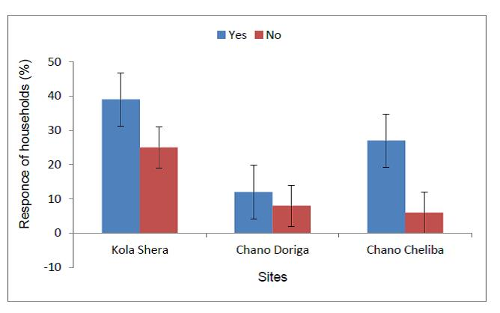
Figure 4. Percentage of the awareness of the negative effect of P. hystrophorus on agricultural productions
The majority of household respondents (68.4%) of the respondents pointed out that P. hystrophorus had no benefits and affected crop and livestock production. But, the rest of them suggested that P. hystrophorus had benefits for the ecosystem (Figure 4). Therefore, even if P. hystrophorus weed is a highly aggressive as well as invasive alien species, it had also positive impacts on the ecosystem which covers the land for soil and water conservation. For instance, 38.5% of households in Kola Shera, and 21.4% in Kola Chalba, but 8.5% in Kola Dorga said that it had effects on crop and livestock production. The anthropogenic pressures experienced in this region due to the invasion P. hysterophorus were the dispersal of its seeds through machinery, farm implements, and transport with other seeds. As a result, the densities of native plants in the soil seed bank were affected (Table S2). Results showed that it had affected very highly in Kola Shera (18.8%) and Chano Cheliba (13.7%). But, it affected the lowest in the Chano Doriga site of the lower Hare watershed (Figure 5).
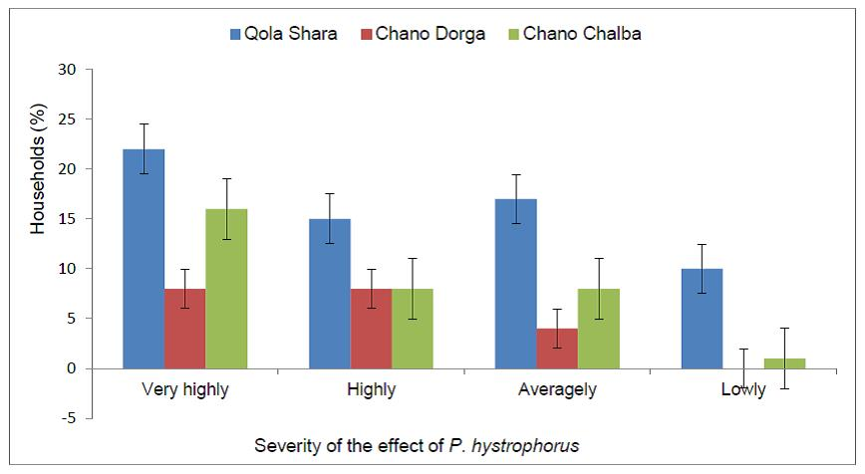
Figure 5. The severity of invasion of P. hystrophorus and its effects on crop and livestock production in the lower Hare watershed
Discussion
Composition of the soil seed bank
A total of 18 plant species belonging to 13 families were recorded in the study area. This is similar to the study of Auma (2014) who reported 25 herbaceous plants and 12 families from P. hysterophorus areas. This is due to their better establishment success of the species than their indigenous counterparts. Globally, several studies have revealed the aggressiveness of P. hysterophorus.
In Ethiopia, Ayana et al. (2011) noted that within a few years of the introduction of P. hysterophorus into Awash National Park, there was a decline of 69% in the stand density of herbaceous species. The reduction of species richness and diversity with increasing density of P. hysterophorus has been well elaborated by Kaur et al. (2014). The same author also reported that P. hysterophorus takes the form of a rosette during the early stages and requires a suitable area to establish. P. hysterophorus, Cyperus rotundus, and Ocimum basilium, Phalaris paradox, Euphorbia heterophylla were the most dominant herbaceous species as they were present in most of the sampling sites. This might be because the plants have strong competitive vigor with P. hysterophorus (Ojija, and Ngimba, 2021) and are also prolific producers of light seeds which are easily blown by the wind (Timsina, 2011).
The study also found that plant species such Corchorus trilocularis, Hygrophila schulli, Strumarium, Xanthium spinosum, Ipomea eriocarpa, and Digitaria abyssinica were less dominant in many sampling sites. This might be attributed to the negative effects of P. hysterophorus invasion as a result of its allelopathic properties and competitive replacement (Timsina, 2011; Ojija, and Ngimba, 2021). According to Shiferaw et al. (2018), the abundance of individual native threatened plant species is negatively correlated with the weed species that have invaded their habitat. The current results are in agreement with the findings of Murono et al. (2018) and Auma (2021) that reported a total habitat change in native grasslands, open woodlands, river banks, and flood plains in Kenya.
From this study, it can be postulated that an increase in P. hysterophorus invasion might lead to changes in the structure and species composition of vegetation, thereby affecting the availability of resources. When alien plant species invade, the nature of the resources that are available and the spatial and temporal patterns of resource availability can all be altered (Lachmuth, 2019). Gao et al. (2021) also reported a change in the structure and composition of the native plant communities due to the introduction of exotic plant species.
The density of P. hysterophorus under various land use types
In this study, the soil seed bank of P. hysterophorus varied from one land use type to other. This could be the completion ability of the species to various disturbance and management levels (Boja et al., 2022). The soil seed banks tell the management decision the land manager will take for managing the land types and the data in the present study is comparable to the findings of similar studies (Rokaya et al., 2020; Costello et al., 2022). The main causes of its high and fast distribution are the ability of the seed to stay for a longer period of time in the soil. In addition, its ability to outcompete native plant species, its ability to withstand drought, its ability to grow in different soil types, and its reproductive ability by producing a large number of seeds at a time. The soil seed bank study was conducted for gaining information that would assist in determining the land use type that was more vulnerable to P. hysterophorus invasion. High invasion of P. hysterophorus in different land use types was observed due to the ecological and morphological characteristics of the species, which enabled them to adapt to wide climatic and soil conditions, solar radiation insensitivity, and drought tolerance (Khan et al., 2014). In addition, P. hysterophorus produces a large number of speeds of up to 25 000, which are small and light in weight (Lorraine and Lin, 2015), thus the seeds can spread easily over long distances through moving water, wind, animal, and human dispersal (Mao, 2022). Among the three land use types, cropland had the highest seed densities in the lower Hare watershed. This could be attributed to soil disturbance due to plugging and movement of animal and human activity in the study area. High densities of P. hysterophorus along roadsides might have helped in the dispersal and spread of P. hysterophorus into other land use types in the study sites. Residential areas recorded the lowest seed bank density and this might be attributed to frequent management of the species through slashing and burning.
Parthenium hysterophorus may therefore attain the status of the most dominating weed in the watershed and the surrounding areas in the near future. This was because once it invades; the weed dominates after a few years and continues to persist as a pure stand until its managed (Murono and Abuto, 2019). Alien plant invasion could reduce the density of the seed bank of other native plants in the invaded communities (Gioria and Psek, 2016). In addition, the invasion of different land use types by an exotic P. hysterophorus was a phenomenon that could lead to permanent changes in the structure of the indigenous plant community as indicated by Osunkoya et al. (2017).
Most of the local communities responded that P. hysterophorus had negative effects on crop and livestock production. This finding was similar to the study by Boja et al. (2022) in Ginir district of Southeast Ethiopia.
Conclusions
In this study, the soil seed bank of the lower Hare watershed was different by various land uses, soil depths, and location. It was shown that soils in the lower Hare watershed were highly affected by P. hystrophorus at an alarming rate at different land uses, soil depths, and locations. These resulted in widespread distribution and invasion of the species into uncultivated areas, grazing areas (grasslands), roadsides, farmlands, and river banks, respectively, than other areas which needed for policy makers to alert natural resource managers and land managers for the control of P. hystrophorus. P. hystrophorus has been spread through wind, water, currents, vehicles, animals, and humans. P. hystrophorus weed caused significant impacts on the growth and distribution of plants. The invasion of P. hystrophorus might affect crop production; livestock feed, health of animals and their production, and plant species diversity in the study areas. Thus, long-term and wider research should be conducted on the impacts of P. hystrophorus on crop yield and the diversity of above-ground native plant species. In addition, research should be done on how to combat this invasive species and reduce its distribution and impacts. Appropriate discussions should also be conducted among the stakeholders to provide solutions to control the current distribution of P. hystrophorus in the study sites. The basic finding of this study will inform policy for management decisions of P. hystrophorus in the region and in similar agro-ecologies.
References
Adkins S and Shabbir A. Biology, Ecology and Management of the Invasive Parthenium Weed (Parthenium hysterophorus L.). Pest Management Science (2014) 70:1023-1029, https://doi.org/10.1002/ps.3708.
Adugna YB , Adinew MG , Getahun AK , Gurmu EA, Berhie A, Awoke A, Desta TG (2022). Evaluation of the Antidiabetic Activity of Hydromethanolic Roots Extracts of Rumex abyssinicus Jacq: (Polygonaceae) in Swiss Albino Mice. Evid Based Complement Alternat Med, doi: 10.1155/2022/5193250.
Anita, S., Neeraj, K., Anuja, S.H., Manpreet, K., Anita, Y. (2014). Utility Potential of Parthenium hysterophorus for its Strategic Management, 16.
Auma, D.M. (2014). Distribution of Parthenium hystrophorus L. and its impacts on biodiversity and agricultural productivity in Nyndo Sub County, Kisumu County, Kenya. A Thesis Submitted in Partial Fulfillment of the Requirement MSc Thesis, Kenyatta University.
Ayana, E., Ensermu, K. Teshome, S. Impact of Parthenium hysterophorus L .(Asteracea) on Herbaceous plant biodiversity of Awashe natinal park (ANP). Manag. Biolog. Invasions (2011) 2:69-80.
Birhanu A, Khan RP. The distribution, status and mitigation methods of Parthenium hysterophorus L. in Ethiopia: A review. JMPS (2018) 6(4): 05-10.
Boja M, Girma Z, Dalle G. Impacts of Parthenium hysterophorus L. on Plant Species Diversity in Ginir District, Southeastern Ethiopia. Diversity (2022) 14(8):675. https://doi.org/10.3390/d1408067.
Cheng F and Cheng Z Research Progress on the use of Plant Allelopathy in Agriculture and the Physiological and Ecological Mechanisms of Allelopathy. Front. Plant Sci. (2015) 6:1020. doi: 10.3389/fpls.2015.01020.
Clarence J. Msafiri, Mokiti T. Tarimo, Patrick A. Ndakidemi. Allelopathic effects of Parthenium hysterophorus on seed germination, seedling growth, fresh and dry mass production of Alysicurpus glumaceae and Chloris gayana. American Journal of Research Communication (2013) 1(11): 190-205.
Costello B, Osunkoya OO, Sandino J, Marinic W, Trotter P, Shi B, Gonzalez F, Dhileepan K. Detection of Parthenium Weed (Parthenium hysterophorus L.) and Its Growth Stages Using Artificial Intelligence. Agriculture (2022) 12(11):1838. https://doi.org/10.3390/agriculture12111838.
Dhileepan, K., Strathie, L. . Parthenium hysterophorus L. (Asteraceae). In: Muniappan R, Reddy DVP and Raman A (Eds.), Biological Control of Tropical Weeds Using Arthropods (2009) 274-318.
Fan W, Fan L, Peng C, Zhang Q, Wang L, Li L, Wang J, Zhang D, Peng W, Wu C (2019). Traditional Uses, Botany, Phytochemistry, Pharmacology, Pharmacokinetics and Toxicology of Xanthium strumarium L.: A Review. Molecules , 24: 359. https://doi.org/10.3390/molecules24020359.
Fariba HM. An Observation of an Unusual Therapeutic Use of Amaranthus spinosus L. (Amaranthaceae) by the Garo Tribe of Bangladesh. Ethnopharmacological (2017) 1(1):19-21.
Fessehaie, A., Walcott, R. R. Biological Control to Protect Watermelon Blossoms and Seed from Infection by Acidovorax avenae subsp. citrulli. Biological Control (2005) 95(4): 413-419, https://doi.org/10.1094/PHYTO-95-0413.

Gao, F.L., He, Q.S., Zhang, Y.D., Hou, J.H., Yu, F.H. Effects of Soil Nutrient Heterogeneity on the Growth and Invasion Success of Alien Plants: A Multi-Species Study. Front. Ecol. Evol. (2021) 8:619861. doi: 10.3389/fevo.2020.619861.
Garima Singh1, Ajit Kumar Passsari1, Pratibha Singh, Vincent Vineeth Leo, Sarathbabu Subbarayan, watershed of Rajouri Forest Range. International Journal of Scientific Research (2013) 2.
Gebrehiwot, N., Lemma, B. Impacts of Parthenium hystrophorus on species diversity in Gamo Gofa, Ethiopia. Journal of Agricultural Science (2015) 5(7): 226-231.
Gioria, M. Psyek, P. The legacy of plant invasions: changes in the soil seed bank of invaded plant communities. Bioscience, (2016) 66(1):40-53
Gnanavel, I. Parthenium hysterophorus L.: a major threat to natural and agro eco-systems in India. Science International (2013) 1(5): 124-131.
Gunarathne R, Anni NH, Jinyao L, Zhang B, Ying T, Lu J (2022). Potential Nutraceutical Use of Tribulus terrestris L. in Human Health.
Food Reviews International, /doi/full/10.1080/87559129.2022.2067172.
Joshi KR (2014). Chemical composition and antimicrobial activity of the essential oil of Ocimum basilicum L. (sweet basil) from Western Ghats of North West Karnataka, India. Anc Sci Life. 2014 Jan-Mar; 33(3): 151–156. doi: 10.4103/0257-7941.144618.

Kabir M., Iqbal ZM, Farooqi RZ, Shafiq M. Vegetation pattern and soil characteristics of the Polluted Industrial area of Karachi. Pak. J. Bot. (2010) 42(1): 661-678.
Karim SMR, Nurzafirah Z, Norhafizah Md Zain. Weed seed bank of parthenium weed (Parthenium hysterophorus L.) in Batang Kali, Selangor, Malaysia. Pertanika Journal of Tropical Agricultural Science (2017) 40(4):565-576.
Kaur, M, Aggarwal, K.N., Kumar, V., Dhiman, R. Effects and Management of Parthenium hysterophorus: A Weed of Global Significance. International Scholarly Research Notices (2014) 368647: 1-12, http://dx.doi.org/10.1155/2014/368647.
Khatri-Chettri J, MB Rokaya and BB Shrestha. Impact of parthenium weed invasion on plants and their soil seedbank in a subtropical grassland, central Nepal. Journal of Ecology and Environment (2022) 46:2. https://doi.org/10.5141/jee.21.00083.
Khan, H., Khan, B.M., Hassan, G. and Muhammad, A.K. Socio-economic impacts of Parthenium (Parthenium hysterophorus L.) in Peshawar valley. Pakistan (2013).19: 275-293.
Kumar B, Singh PB, lalhlenmawia H, Kumar SN (2017). Pharmacological potential of Bidens pilosa L. and determination of bioactive compounds using UHPLC-QqQLIT-MS/MS and GC/MS. BMC Complementary and Alternative Medicine, 17:492.
Kumar S, Malhotra R, Kumar D (2010). Euphorbia hirta: Its chemistry, traditional and medicinal uses, and pharmacological activities. Pharmacognosy Reviews 4(7): 58-61, DOI: 10.4103/0973-7847.65327.

Lachmuth, S. Eco-evolutionary processes in natural populations at the opposing extremes of demographic success: Invasive and declining plant species in the era of anthropogenic global change. Plant Biology (2019). https://doi.org/10.25673/14092.
Lorraine, S. and Lin, B. ( 2015). Agricultural Research Council-Plant Protection Research Institute (ARC-PPRI) fact sheets on invasive alien plants and their control in South Africa.
Mao, R., Osunkoya, O.O., Campbell, S., Adkins, W.S. Wind dispersal of seeds of Parthenium hysterophorus L. (Asteraceae) contributes to its steady invasion and spread. Austral Ecology (2022).https://doi.org/10.1111/aec.13159.
Masum, S., Hasanuzzaman, M. Ali M. Threats of Parthenium hysterophorus on agro-ecosystems and its management: a review (2013) 6(11), 684-697.
Masum, S.M.; Halim, A.; Mandal, M.S.H., Asaduzzaman, M.; Adkins, S. Predicting Current and Future Potential Distributions of Parthenium hysterophorus in Bangladesh Using Maximum Entropy Ecological Niche Modelling. Agronomy (2022) 12, 1592.
Mcconnachie, A.J, Strathie, L.W., Mersie, W., Gebrehiwot, L., Zewdie, K., Abdurehim, A., Abreha, T. Current and potential geographical distribution of the invasive plant Parthenium hysterophorus in east and southern Africa (2010) 51, 71-84.
Murono, A.D., Abuto, O.J. Parthenium hysterophorus Linn: Soil Seed Bank Analysis and Impact on Agricultural Production in Nyando SubCounty, Kisumu County, Kenya. European Academic Research (2019) 7(5): 2888-2910.
Murono, A.D., Wabuyele, E., Muoria, K.P., Abuto, O.J. Distribution of Parthenium hysterophorus L. and its Impacts on Biodiversity in Nyando Sub-County, Kisumu County, Kenya. European Academic Research (2018) 5(4): 1600-1621.
Ojija, F and Ngimba C. Suppressive abilities of legume fodder plants against the invasive weed Parthenium hysterophorus (Asteraceae). Environmental and Sustainability Indicators (2021) 10: 100111. https://doi.org/10.1016/j.indic.2021.100111.
Ojija, F. Eco-friendly management of Parthenium hysterophorus. Science Progress (2022) 105 (3): 1-15. DOI: 10.1177/00368504221118234.
Ojija, F., Lutambi, L.P. An Invasive Plant Parthenium hysterophorus Reduces Native Forage Cover. East African Journal of Environment and Natural Resources (2022) 5 (1): 318 326. https://doi.org/10.37284/eajenr.5.1.862.
Ojong, P.M.K., Alvarez, M., Ihli, J.H., Becker, M., He, T. Action on Invasive Species: Control Strategies of Parthenium hysterophorus L. on Smallholder Farms in in Kenya. Environmental Management (2021) 69:861–870.
Osunkoya, O., Akinsanmi, O., Dhileepan, D. Parthenium hysterophorus L. (Asteraceae) invasion had limited impact on major soil nutrients and enzyme activity: Is the null effect real or reflects data insensitivity? Plant and Soil (2017) 420(1-2):177-194, DOI: 10.1007/s11104-017-3375-x.

Oyebode AO., Erukainure LO, Sanni O, Islam SM (2020). Crassocephalum rubens (Juss. Ex Jacq.) S. Moore improves pancreatic histology, insulin secretion, liver and kidney functions and ameliorates oxidative stress in fructose-streptozotocin induced type 2 diabetic rats.
Drug and Chemical Toxicology, 45 (2), doi/pdf/10.1080/01480545.2020.1716783.

Patel S (2011). Harmful and beneficial aspects of Parthenium hysterophorus: an update. Biotech, 1(1):1-9, doi: 10.1007/s13205-011-0007-7.
Pirzada, M.A, Ali, H.H., Naeem M, Latiif , Bukhari HA, Tanveer A Cyperus rotundus L.: Traditional uses, phytochemistry, and pharmacological activities. J Ethnopharmacol (2015) 4 (174):540-60. doi: 10.1016/j.jep.2015.08.012.
Rajiv K, Mona R. K , Ajay K. S. Preliminary Pharmacognosnostic and Physicochemical Evaluation of Aerial Parts of Ipomoea eriocarpa R.Br. Research J. Pharmacognosy and Phytochemistry (2011) 3(6): 275-277.
Rokaya MB, J Khatri-Chettri, Ghimire SR, Shrestha BB. Vegetation and soil seedbank dynamics in Parthenium hysterophorus L. invaded subtropical grassland in Nepal. Tropical Ecology (2020) 61:238–247.
Rubaba, O., Chimbari, M., Mukaratirwa, S. Scope of research on Parthenium hysterophorus in Africa, South African Journal of Plant and Soil (2017) 34:5, 323-332.
Saini A, Aggarwal KN, Sharma A, Kaur M, Yadav A. Utility potential of Parthenium hysterophorus for its atrategic management. Advances in Agriculture (2014) 381859, 1-16,http://dx.doi.org/10.1155/2014/381859.
Seta, T., Assefa, A., Mesfin, F., Balcha, A. Distribution status and the impact of Parthenium weed (Parthenium hysterophorus L.) at Gedeo Zone (Southern Ethiopia). African Journal of Agricultural Research (2013) 8(4):386-397.
Shabani, F., Ahmadi, M., Kumar, L., Solhjouy-fard, S., Shafapour Tehrany, M., Shabani, F.,Kalantar, B., Esmaeili, A. Invasive weed species threats to global biodiversity future scenarios of changes in the number of invasive species in a changing climate, (2020). 116(106436).
Shiferaw, W., Demissew, S., Bekele, T. Invasive alien plant species in Ethiopia: ecological impacts on biodiversity a review paper, Int J Mol Biol. (2018) 3(4):171‒178, Doi: 10.15406/ijmboa.2018.03.00072.
Studzi ´nska-Sroka E, Dudek-Makuch M, Chanaj-Kaczmarek J, Czepulis N, Korybalska K, Rutkowski R , Łuczak J, Grabowska K, Bylka W, Witowski J. 2Anti-inflammatory Activity and Phytochemical Profile of Galinsoga Parviflora Cav. Molecules, 23, 2133; doi: 10.3390/molecules23092133.
Tamado, T., Schütz, W., Milberg, P. Germination ecology of the weed Parthenium hysterophorus, Eastern Ethiopia. Annals Applied Biology (2002) 140:263- 270.
Teklu HG, Desta A, Gebrelibanos M, Hiben GM, Araya ME (2020). Anti-Nociceptive and Anti-Inflammatory Activity of Hygrophila schulli Leaves. Journal of Inflammation Research, 13: 497–505.
Timsina, B., Shrestha, B.B., Rokaya, M.B., Munzbergova, Z. Impact of Parthenium hysterophorus L. invasion on plant species composition and soil properties of grassland communities. Flora (2011) 206(3):233-240.
Wubneh, Y.W. Parthenium hystrophorus in Ethiopia: Distribution, Impact, and Management - A Review. World Scientific News (2019) 130: 127-136.
Yamane, T. (1967).Statistics; An Introductory Analysis, 2nd Ed, New York: Harper and Row.

Appendices
Table S1. Status of the density of seedlings/m² by land use type, site, and soil depth (seedling densities of P. hytrophorus are included in data analysis).
Independent factor*soil seed bank
Land use | N | Mean ± SE
Crop land | 1598 | 78.2±3.93ª
Grazing land | 1136 | 52±2.68^{b}
Forest land | 1046 | 68.4±3.29^{c}
Null hypothesis (P < 0.05) |  | **
Soil depth
0-5 cm | 1260 | 130.3±4.79ª
5-10 cm | 1260 | 51.6±2.90^{b}
10-15 cm | 1260 | 21.9±1.64^{c}
Null hypothesis (P < 0.05) |  | **
Site
Kola Shara | 1620 | 52.15±2.62ª
Chano Dorga | 1620 | 76.08±3.25^{b}
Chano Chalba | 540 | 90.9±7.29^{c}
Null hypothesis (P < 0.05) |  | **
Table S2. Effect of P. hytrophorus on soil seed banks of native plant species (seedlings/m²) (seedling densities of P. hytrophorus are excluded from data analysis).
Independent factor*Soil seed bank
Land use | N | Mean ± SE
Crop land | 1530 | 54.9±2.7ª
Grazing land | 1020 | 52.9±2.8^{b}
Forest land | 1020 | 62.4±3.1^{c}
Null hypothesis (P < 0.05) |  | **
Soil depth
0-5 cm | 1190 | 111.9±3.8ª
5-10 cm | 1190 | 43.4±2.3^{b}
10-15 cm | 1190 | 13.9±0.8^{c}
Null hypothesis (P < 0.05) |  | **
Site
Kola Shara | 1530 | 45.3±2.23ª
Chano Dorga | 1530 | 65.2±2.7^{b}
Chano Chalba | 510 | 63.4±4.9^{c}
Null hypothesis (P < 0.05) |  | **

