Numerical and Experimental Comparison of Aerodynamic Characteristics on Finite Wing with NACA 2415 Airfoil scaled model

T J Prasanna Kumar¹, Y Ayyappa^{2a}, M Kiran Kumar^{2b}, Sk Roshan^{2c}, P Tarun kumar^{2d}

^{1*}Assistant Professor, Department of Mechanical Engineering, PVP Siddhartha Institute of Technology, Kanuru, Vijayawada, AP, India-520007
^{2abcd} UG Students, Department of Mechanical Engineering, PVP Siddhartha Institute of Technology, Kanuru, Vijayawada, AP, India-520007

*Corresponding Author Email: tjpk.mech@gmail.com
Abstract

The aerodynamic force is the force exerted on a body by the air in which the body is immersed, and is due to the relative motion between the body and the air. The aerodynamic force arises from two causes namely, the normal force due to the pressure on the surface of the body and the shear force due to the viscosity of the air, also known as skin friction.
Pressure acts locally, normal to the surface, and shear force acts locally, parallel to the surface. The net aerodynamic force over the body is due to the pressure and shear forces integrated over the total exposed area of the body. The purpose of the aircraft flow manipulation, as Gad-el-Hak [1] explains as: increasing lift, reducing drag and enhancing the mixing of mass, momentum and energy. In order to meet these objectives: 1) The laminar-to-turbulent transition has to be postponed or provoked, [2], 2) The flow separation has to be avoided or initiated, 3) The flow turbulence has to be prevented or encouraged. All these seemingly contradictory goals are interrelated.
The separation location has a great effect on the performance of the device. For instance, a separation delay can increase the circulation around an airfoil at a high angle-of-attack and increase the lift. It also contributes to reducing the pressure drag of a bluff body and improving the pressure recovery. Experimental studies show that the flow separation control over a lifting surface greatly influences the aerodynamic properties and consequently the device’s optimum performance. In the airplane design process, it is important to evaluate performance, including a stall, by considering the airfoil lift and drag coefficients. These are fundamental quantities rather than conveniently defined expressions [3].
At fixed free stream Mach numbers (the ratio of the flow velocity to the speed of sound) and the Reynolds numbers (the ratio of the inertia forces to the viscous forces), the lift coefficient C_{L} and the drag coefficient C_{D} are only functions of the angle-of-attack α.
the ultimate goal of this investigation is to improve aircraft lift and the lift-to-drag ratio while maintaining its simplistic nature and minimizing drawbacks. It is beneficial to delay separation, since a later stall increases lift and decreases form drag. Obviously, this yields a larger lift-to-drag ratio [4], [5] as the angle-of-attack increases. It has been proven that early transition to turbulence helps avoid, or delay, the separation, but it also has some disadvantages. In present work Ansys fluent software is used to analyze the flow over an airfoil (4-digit series) NACA 2415. The results will be compared with experimental results. For experimentation a low subsonic wind tunnel is utilized C_{L} to C_{D} ratios are tabulated for airfoil at specified angles of attack where the flow velocity is kept constant for all testing. With the obtained plots, the finite wing with NACA 2415 airfoil design can be optimized. Also, from this analysis an optimized angle of attack with better aerodynamic characteristics can be predicted.
Keywords: Airfoil, coefficient of lift, coefficient of drag, NACA 2415,

1. INTRODUCTION
1.1 Airfoil
An Airfoil shaped body moved through a fluid produces an aerodynamic force. The component of this force perpendicular to the direction of motion is called lift. The component parallel to the direction of motion is called drag. Subsonic flight airfoils have a characteristic shape with a rounded leading edge, followed by a sharp trailing edge, often with a symmetric curvature of upper and lower surfaces. Foils of similar function designed with water as the working fluid are called hydrofoils

1.2 Airfoil Terminology

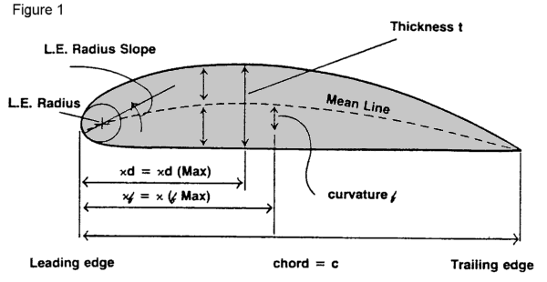

Figure -1: Airfoil Terminology

The various terms related to airfoils are defined below:
- The suction surface (a.k.a. upper surface) is generally associated with higher velocity and lower static pressure.
- The pressure surface (a.k.a. lower surface) has a comparatively higher static pressure than the suction surface. The pressure gradient between these two surfaces contributes to the lift force generated for a given airfoil.
- The geometry of the airfoil is described with a variety of terms:
- The leading edge is the point at the front of the airfoil that has maximum curvature (minimum radius).
- The trailing edge is defined similarly as the point of maximum curvature at the rear of the airfoil.
- The chord line is the straight line connecting leading and trailing edges. The chord length, or simply chord, is the length of the chord line. That is the reference dimension of the airfoil section.
The shape of the airfoil is defined using the following geometrical parameters.
The mean camber line or mean line is the locus of points midway between the upper and lower surfaces. Its shape depends on the thickness distribution along the chord;
- The thickness of an airfoil varies along the chord. It may be measured in either of two ways:
  - Thickness measured perpendicular to the camber line. This is sometimes described as the "American convention
  - Thickness measured perpendicular to the chord line. This is sometimes described as the "British convention".
Some important parameters to describe an airfoil's shape are its camber and its thickness. For example, an airfoil of the NACA 4-digit series such as the NACA 2415 (to be read as 2 - 4 - 15) describes an airfoil with a camber of 0.02 chord located à 0.40 chord, with 0.15 chord of maximum thickness.
Finally, important concepts used to describe the airfoil's behavior when moving through a fluid are:
- The aerodynamic center, which is the chord-wise length about which the pitching moment is independent of the lift coefficient and the angle of attack.
- The center of pressure, which is the chord-wise location about which the pitching moment, is zero.

1.3 BASIC AIRFOILS

1.3.1 NACA 4 digit airfoil specification

This NACA airfoil series is controlled by 4 digits e.g. NACA 2415, which designate the camber, position of the maximum camber and thickness. If an airfoil number is NACA MPXX
e.g. NACA 2415
- M is the maximum camber divided by 100. In the example M=2 so the camber is 0.02 or 2% of the chord
- P is the position of the maximum camber divided by 10. In the example P=4 so the maximum camber is at 0.4 or 40% of the chord.
- XX is the thickness divided by 100. In the example XX=15 so the thickness is 0.15 or 15% of the chord.

1.3.2 NACA 5 digit airfoil specification

The NACA 5 digit airfoils use the same thickness envelope as the 4 series but with a different camber line and numbering system. NACALPQXX . e.g. NACA 23012

Table 1.1: Description of NACA-5 Digit

Digits | Letter | Example | Description
1 | L | 2 | This digit controls the camber. It indicates the designed coefficient of lift (Cl) multiplied by 3/20. In the example L=2 so Cl=0.3
2 | P | 3 | The position of maximum camber divided by 20. In the example P=3 so maximum camber is at 0.15 or 15% chord
3 | Q | 0 | 0 = normal camber line, 1 = reflex camber line
4& 5 | XX | 12 | The maximum thickness as percentage. In the example XX=12 so the maximum thickness is 0.12 or 12% chord

1.3.3 NACA 6 digit airfoil Specification

An improvement over 1-series airfoils with emphasis on maximizing laminar flow. The airfoil is described using six digits in the following sequence:
- The number "6" indicating the series.
- One digit describing the distance of the minimum pressure area in tens of percent of chord.
- The subscript digit gives the range of lift coefficient in tenths above and below the design lift coefficient in which favorable pressure gradients exist on both surfaces
- A hyphen.
- One digit describing the design lift coefficient in tenths.
- Two digits describing the maximum thickness as percent of chord.
For example, the NACA 61₂-315 a=0.5 has the area of minimum pressure 10% of the chord back, maintains low drag 0.2 above and below the lift coefficient of 0.3, has a maximum thickness of 15% of the chord, and maintains laminar flow over 50% of the chord.

1.4 Airfoil specification

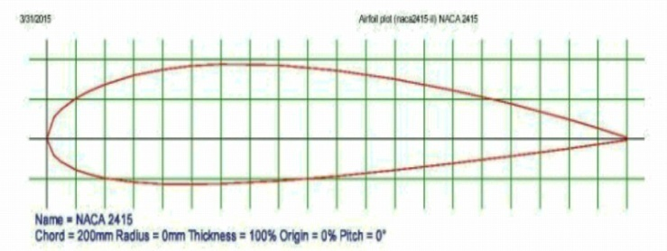

Figure 2: NACA 2415 2D details

2. Wind tunnel test procedure for NACA 2415 Airfoil

Wind tunnel testing is a crucial step in the design of a wing. It can give quite accurate information on the performance of a wing or a section of an aircraft by taking data on a scale model. This can save enormous amounts of money by testing models instead of prototypes [8,7]. It is also much safer to test in a wind tunnel than out in the open. The following section covers the theory of the wind tunnels and procedures for testing the NACA 2415 airfoil.

2.1 Theory of Wind Tunnels

All wind tunnels can be divided into one of two types: open circuit (also called “straight through”) or closed circuit (also called “return flow”). Open circuit wind tunnels pull the air from the environment into the tunnel and release the air back into the environment, whereas the closed circuit continually circulates the same air throughout the tunnel. [11]. The wind tunnel used for this investigation is a single return flow wind tunnel, shown in Figure (put our wind tunnel image). Closed circuit wind tunnels are advantageous over open circuit wind tunnels for the following reasons: the quality of the flow can be easily controlled with screens and corner turning vanes; less energy is required to create an air flow of a given size and velocity [12]; the wind tunnel runs more quietly. The disadvantages are the initial expense of building and need to change the air if it is significantly heated or polluted with smoke from smoke testing or engines. Fortunately, neither of the disadvantages affected us.

2.2 Procedures of Testing the NACA 2415 Airfoil
The objective of this work is to find the coefficients of lift and drag, C_{L} and C_{D}, respectively. These coefficients are defined as follows:
$$C_{L}=\frac{2L}{\frac{1}{2}ρ_{∞}V_{∞}^{2}SC}$$

$$C_{D}=\frac{2D}{\frac{1}{2}ρ_{∞}V_{∞}^{2}SC}$$

Where L is the lift force in N, D [5] is the drag force also in N, d is the density of the air in kg/m³, V is the velocity of the air in m/s, and A is the horizontal area of the wing in m².
For testing, The area of the wing is taken as the chord length (20 cm) multiplied by the length of the section (25 cm), giving a total area of 500 square centimeter. The density of air is 1.255kg/m³ at room temperature (288.16). By using above equations, C_{L} and C_{D} were calculated. The Lift and Drag data are displayed digitally as shown below and shown.

2.3 ANSYS Finite Element Analysis Tool

ANSYS [8] is a general-purpose software, used to simulate interactions of all disciplines of physics, structural, vibration, fluid dynamics, heat transfer and electromagnetic for engineers. So ANSYS, which enables to simulate tests or working conditions, enables to test in virtual environment before manufacturing prototypes of products. Furthermore, determining and improving weak points, computing life and foreseeing probable problems are possible by 3D simulations in virtual environment. ANSYS software with its modular structure as seen in the table below gives an opportunity for taking only needed features. ANSYS can work integrated with other used engineering software on desktop by adding CAD and FEA connection modules.

ANSYS can import CAD data and also enables to build geometry with its "preprocessing" abilities. Similarly in the same preprocessor, finite element model (a.k.a. mesh) which is required for computation is generated. After defining loadings and carrying out analyses, results can be viewed as numerical and graphical. ANSYS can carry out advanced engineering analyses quickly, safely and practically by its variety of contact algorithms, time-based loading features and nonlinear material models. ANSYS Workbench is a platform which integrate simulation technologies and parametric CAD systems with unique automation and performance. The power of ANSYS Workbench comes from ANSYS solver algorithms with years of experience. Furthermore, the object of ANSYS Workbench is verification and improving of the product in virtual environment [9]. ANSYS Workbench, which is written for high level compatibility with especially PC, is more than an interface and anybody who has an ANSYS license can work with ANSYS Workbench. As same as ANSYS interface, capacities of ANSYS Workbench are limited due to possessed license [10].

2.4 Experimental Data Obtained from Wind Tunnel Testing on Scaled model

The geometry of the wing and dimensions are taken from literature. By using this configuration, a finite wing scaled model is designed later it is tested in wind tunnel.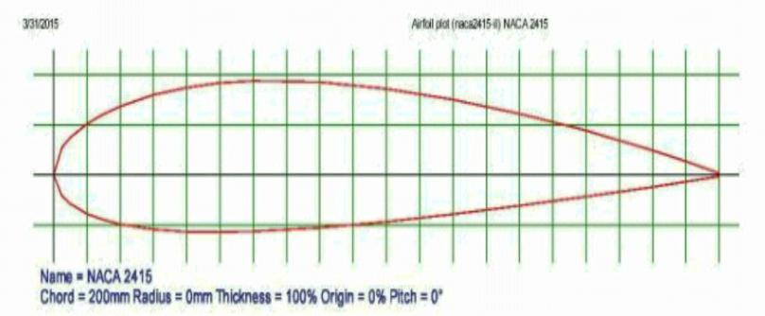
Figure 3: NACA 2415 Airfoil profile

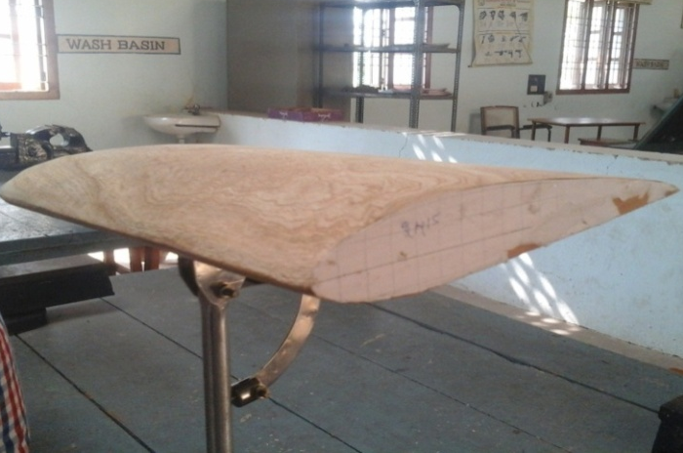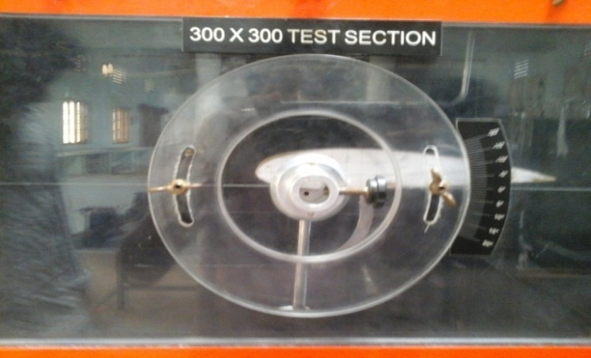

Figure 4: Finite Wing model erected in test section

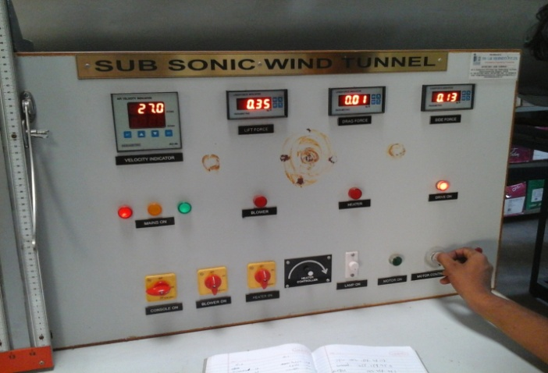
Figure-5: Wind tunnel digital control panel board

2.4.1 Lift and Drag values obtained at an Angle of Attack, α=-14°,
Table 2.1: Experimental results at α=-14°
α | L | D
-14 | -2.73 | 0.05

2.4.2 Lift and Drag values obtained at an Angle of Attack = -7°,
Table 2.2: Experimental results at α=-7°
α | L | D
-7 | -0.97 | 0.02

2.4.3 Lift and Drag values obtained at an Angle of Attack =0°,
Table 2.3: Experimental results at α=0°
α | L | D
0 | 0.69 | 0.02

2.4.4 Lift and Drag values obtained at an Angle of Attack =7°,
Table 2.4: Experimental results at α=7°
α | L | D
70 | 1.98 | 0.03

2.4.5 Lift and Drag values obtained at an Angle of Attack =14°,

Table 2.5: Experimental results at α=14°
α | L | D
14 | 3.34 | 0.035

Table 2.6: Tabulation Of Experimental Results
Angle Of Attack | L | D | L/D | C_{l} | C_{d} | C_{l}/C_{d}
-14 | -2.73 | 0.05 | -54.6 | -2.228 | 0.0408 | -54.607
-7 | -0.97 | 0.02 | -48.53 | -0.791 | 0.0163 | -48.576
0 | 0.69 | 0.02 | 34.5 | 0.543 | 0.0163 | 33.312
7 | 1.98 | 0.03 | 66 | 1.616 | 0.0244 | 66.229
14 | 3.34 | 0.035 | 95.42 | 2.7265 | 0.02857 | 95.4322

Graph-2.1: Experimental results of Lift force obtained for different angle of attack

Graph-2.2: Experimental results of Drag force obtained for different angle of attack
Graph-2.3: C_{l} Vs C_{d} plot obtained from Experimental Data

3. Computational Analysis

Creating a wing whose geometry and dimensions are taken from the airfoil data and finite wing from literature.
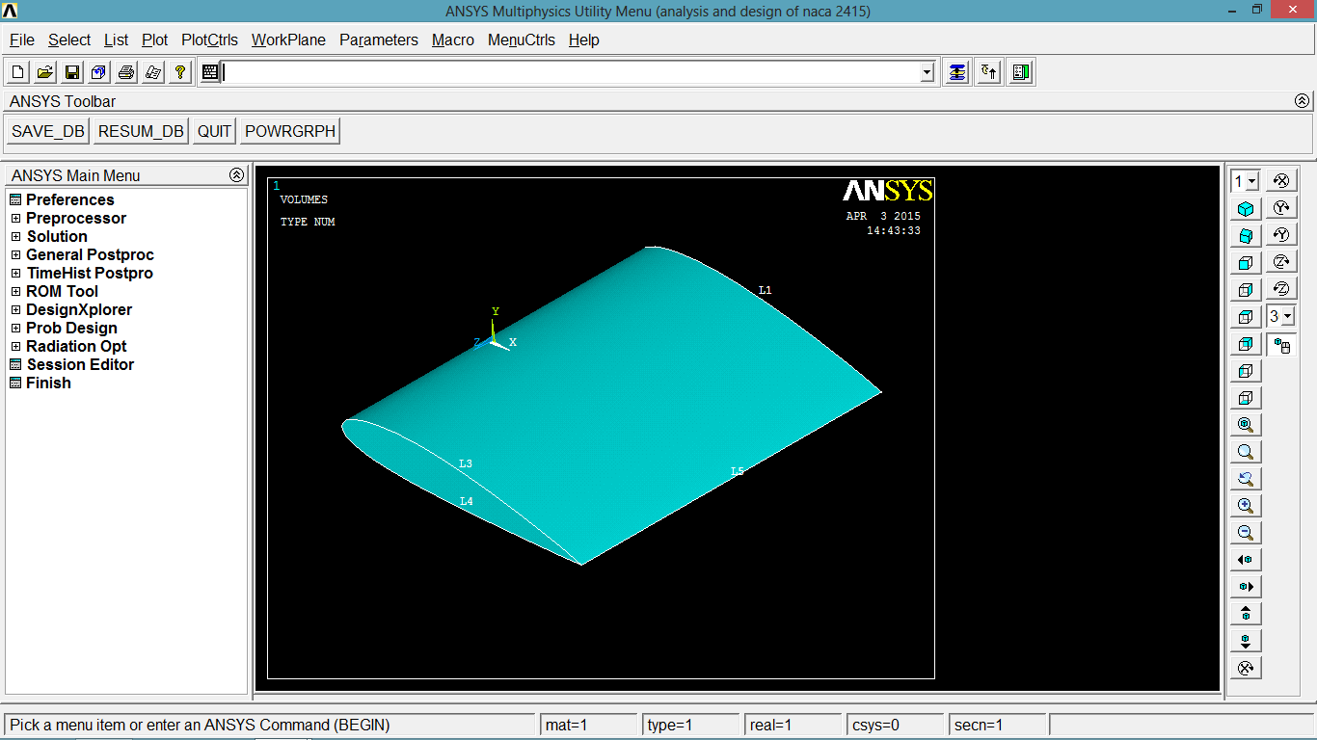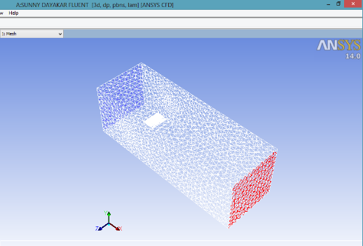
Figure-6 (a): Wing generated in ANSYS
Figure-(6b): Wing placed in control volume in ANSYS Workbench

3.1 Results and contour plots obtained from Computational Analysis

3.1.1 coefficient of Lift and coefficient of drag at angle of attack, α= -14°,

Table 3.1: Computational Results obtained at α=-14°

Α | C_{l} | C_{d}
-14 | -7.4397 | 0.096132

Figure 7(a): C_{l} variation with iteration at α = -14°
Figure 7(b): C_{d} variation with iteration at α = - 14°
Figure 8(a): contour plot of flow over airfoil with No slip condition at α = - 14°
Figure 8(b): contour plot for Velocity variation at α = - 14°
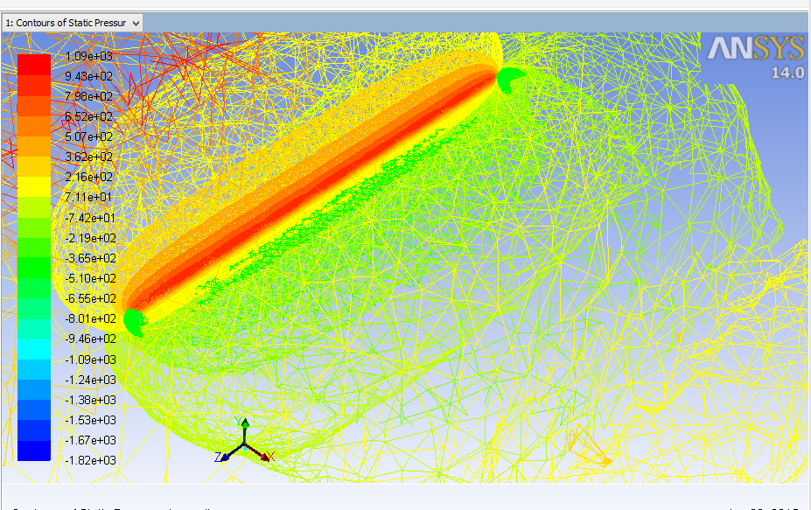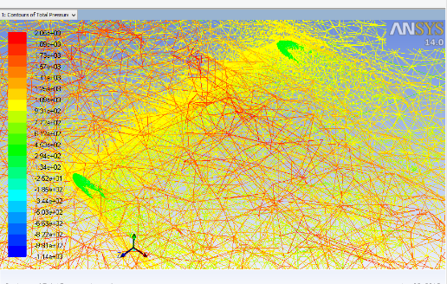

Figure 9(a): contour plot for Static Pressure Variation at α = - 14°
Figure 9(b): contour plot for Total Pressure Variation α=-14°

3.1.2 coefficient of Lift and coefficient of drag at angle of attack, α= -7°,
Table 3.2: Computational results obtained at α=-7°

α | C_{l} | C_{d}
-7 | 7.4646 | 0.096887
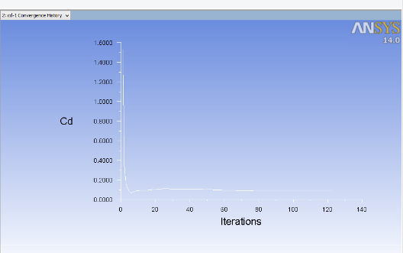
Figure 10(a): C_{l} variation at α = - 7°
Figure 10(b): C_{d} variation at α = - 7°
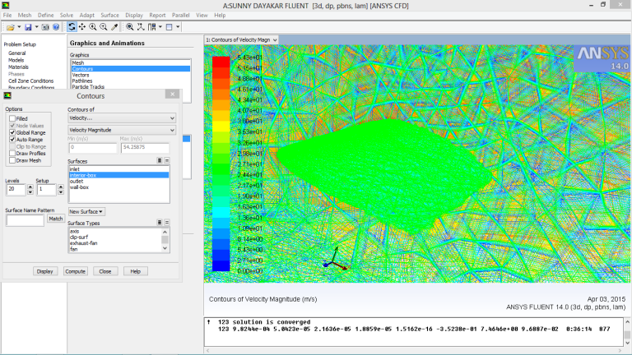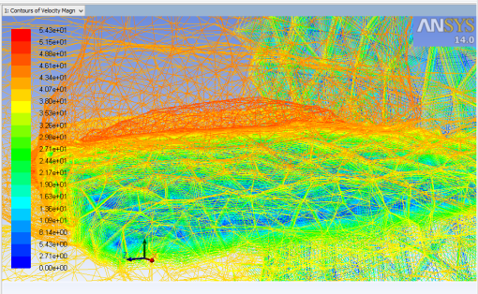
Figure 11 (a): contour plot for the flow over finite wing with No slip condition at α = - 7°
Figure 11 (b): contour plot for Velocity distribution at α=-7°
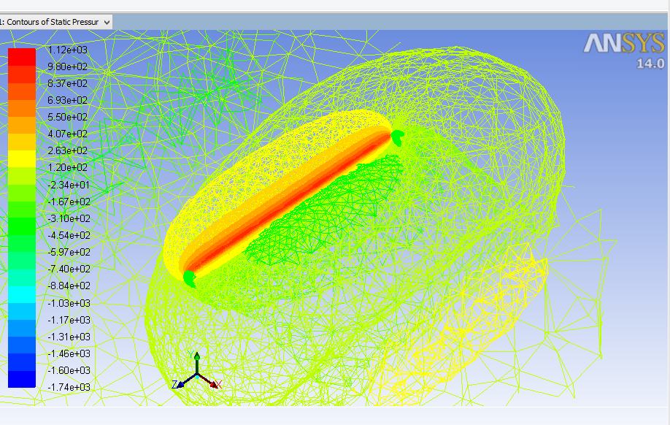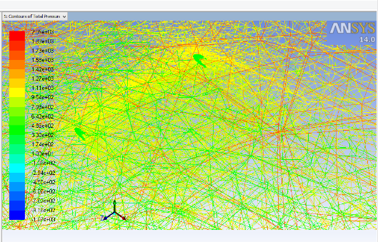
Figure 11(a): contour plot for Static Pressure Variation at α = - 7°
Figure 11(b): contour plot for Total Pressure Variation at α = - 7°

3.1.3 coefficient of Lift and coefficient of drag at angle of attack, α= 0°
Table 3.3: Computational solution at α = 0°
Α | C_{l} | C_{d}
0 | 0.024055 | 0.10253
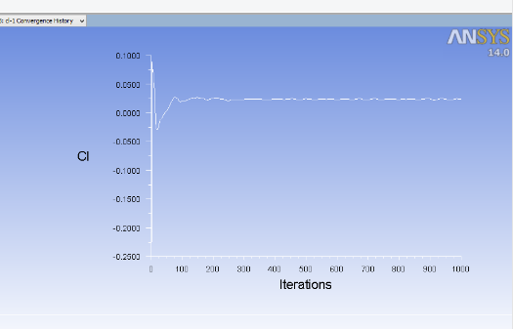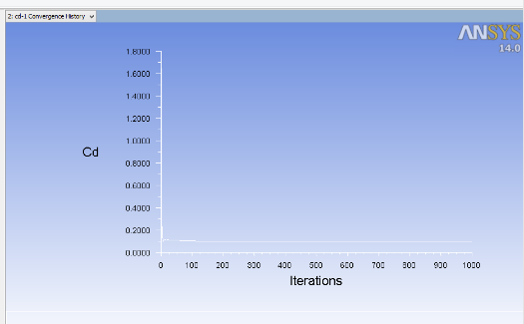
Figure 12(a): C_{l} Variation at α = 0°
Figure 12(b): C_{d} Variation at α = 0°

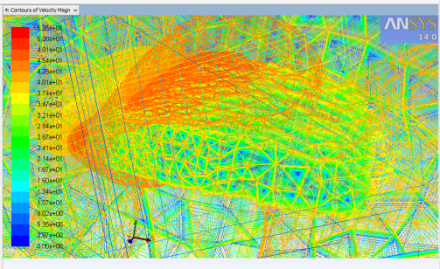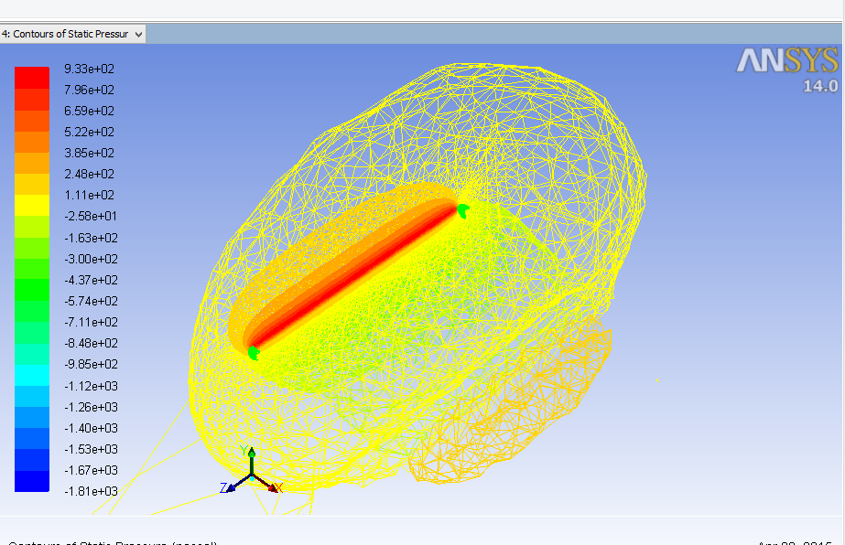
Figure 13(a): contour plot for Velocity Variation at α = 0°
Figure 13(b): contour plot for Static pressure Variation at α = 0°
Figure 13(c): Total Pressure Variation at α = 0°

3.1.4 coefficient of Lift and coefficient of drag at angle of attack, α= 7°

Table 3.4: Computational solution At α = 7°
α | C_{l} | C_{d}
7 | 3.8491 | 0.10111

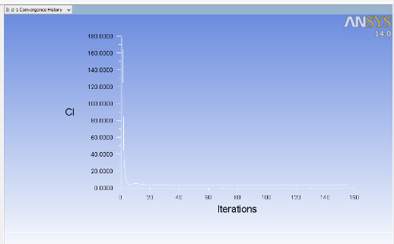
Figure 14(a): C_{l} Variation with iteration at α = 7°
Figure 14(b): C_{d} Variation with iteration at α = 7°
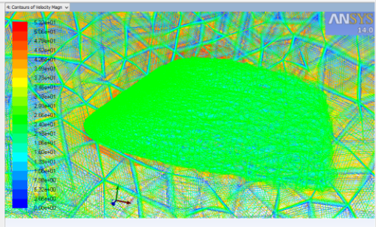
Figure 15(a): contour plot for the flow over airfoil with No slip condition at α = 7°
Figure 15(b): contour plot for Velocity Variation at α = 7°
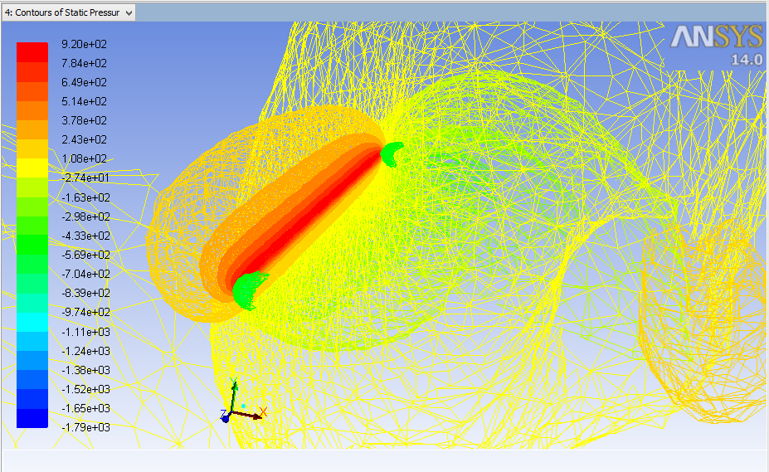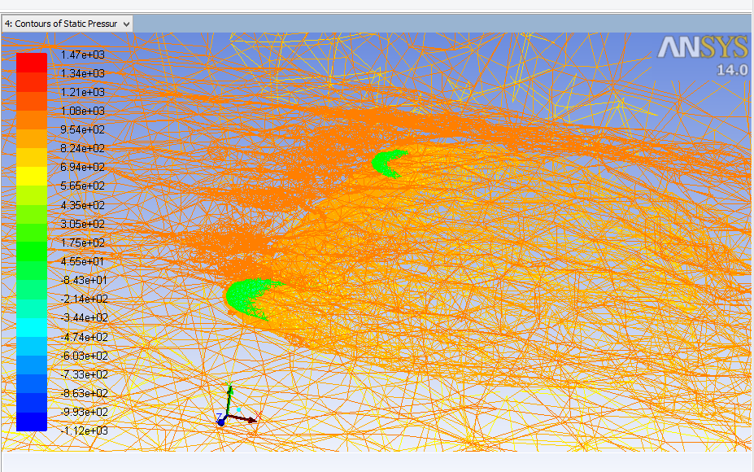
Figure 16(a): contour plot for Static Pressure Variation at α = 7°
Figure 16(b): contour plot for Total Pressure Variation at α = 7°

3.1.5 coefficient of Lift and coefficient of drag at angle of attack, α= 14°,

Table 3.5: Computational solution At α = 14°
α | C_{l} | C_{d}
14 | -3.8013 | 0.10016

Figure 17(a): C_{d} Variation with Iteration at α =14°
Figure 17(b): Cl Variation with iteration at α =14°
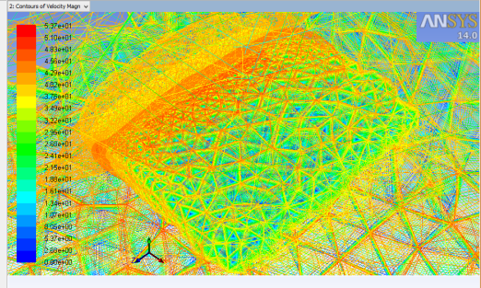
Figure 18(a): contour plot for the flow over airfoil with No slip condition at α =14°
Figure 18(b): contour plot for Velocity Variation at α =14°
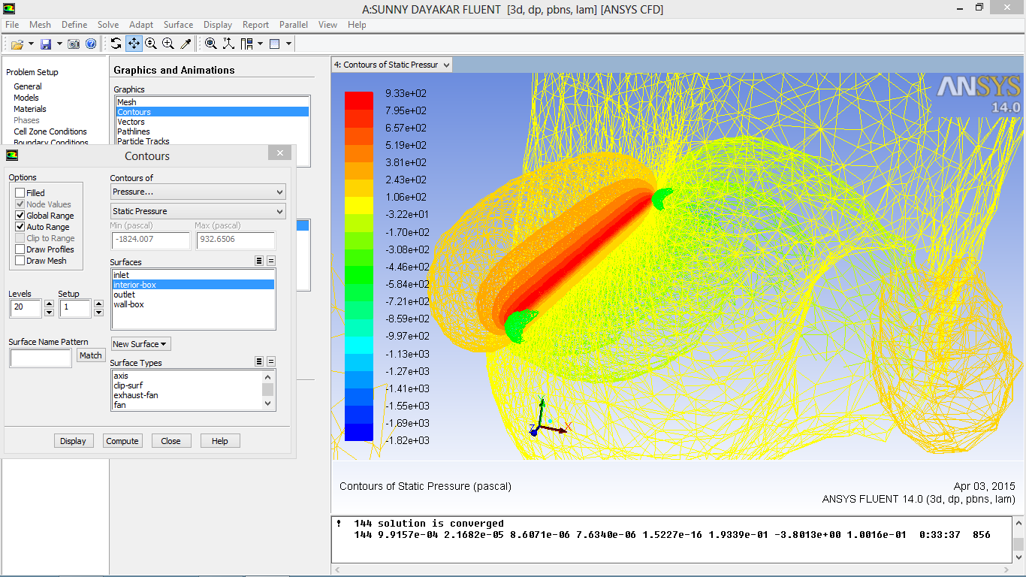
Figure 4.5.5: contour plot for Static Pressure Variation at α =14°
Figure 4.5.6: contour plot for Total Pressure Variation at α = 14°

4. Comparison between Experimental and Computational Results

In this work, a comparison between both experimental and Computational results were presented. And Aerodynamic characteristic curves were plotted
Table 4.1: Computational results of Cl and Cd for at different angles of attack
Angle of attack | C_{l} | C_{d} | C_{l}/C_{d}
-14 | -7.4397 | 0.096132 | -77.3904
-7 | 7.4646 | 0.096887 | 77.04439
0 | 0.024055 | 0.10253 | 0.23461
7 | 3.8491 | 0.10111 | 38.0684
14 | -3.8013 | 0.10016 | -37.9522

Table 4.2: Experimental results of Cl and Cd for at different angles of attack

Angle Of Attack (α) | Lift ForceL | Drag Force, D | L/D | C_{l} | C_{d} | C_{l}/C_{d}
-14 | -2.73 | 0.05 | -54.6 | -2.22 | 0.040 | -54.60
-7 | -0.97 | 0.02 | -48.53 | -0.79 | 0.016 | -48.57
0 | 0.69 | 0.02 | 34.5 | 0.56 | 0.016 | 33.31
7 | 1.98 | 0.03 | 66 | 1.61 | 0.024 | 66.22
14 | 3.34 | 0.035 | 95.42 | 2.72 | 0.028 | 95.43

Graph 4.1: C_{l} Vs C_{d} plotted for computational (Ansys) results

Graph 4.2: C_{l} Vs C_{d} plotted for Experimental (Wind tunnel) Results

Graph 4.3: C_{l} Vs α plotted from computational results

Graph 4.4: C_{l} Vs α plotted from experimental results

Graph 4.5: Cd V_{S} α plotted for computational results

Graph 4.6: Cd V_{S} α plotted for experimental results

5.CONCLUSION
On wing, lift is caused by an upward force that is resulted from the difference in pressure between its top and the bottom surface. This difference in pressure is due to the special shape of the airfoil, and the amount of this lift is dependent upon the angle at which the wing is inclined. To find the maximum performance of the wing, it should be tested in a wind tunnel at different angles of attack. From testing the NACA 2415 it is determined that the optimum angle of attack is between 7 to 14 degrees for this scaled model. Unfortunately, excessive drag is generated by the inaccuracies in the construction of the wing and the errors in the experiment. In order to decrease this drag, fiberglass can be used to cover the wing to decrease the friction between air and the wing surface. Also, there are a few concavities on the surface of the wing that resulted from the dissolution of foam by the resin. To avoid these concavities a few layers of plastic paint could be applied to the surface of the wing before covering it with the fiberglass. As it can be observed from the left graphs, the NACA 2415 airfoil has superior lift versus drag characteristics suitable for the Radio-Controlled Vertical Takeoff and Land Aircraft. The results from testing the existing wing section are close to the theoretical results from the National Airfoil Database; however, as mentioned before, excess drag is generated.
On the other hand, by understanding the significance of lift and drag on an aircraft, model of wing is designed.at different angle of attacks the lift, drag, lift to drag ratios are calculated by using practical and analytical (ANSYS) approaches. The corresponding solutions are compared with the practical solutions.

FUTURE SCOPE

Since the results presented in this work for lift (L), drag (D) and dependence of lift to drag ratio on angle of attack are through basic formulas which only depend on the wing area, a flow analysis could be done in order to determine the lift-off performance, vortex reduction, drag reduction. The pressure distribution can be done by using the pressure tapings. Moreover, applying a composite material to wing and optimizing the drag could be performed. Ribs and spars would be designed for each winglet and finite element analysis could be performed to calculate structural integrity using FEA tools like ANSYS

6. REFERENCES
[1] M. Gad-el-Hak, Flow Control Passive: Active and Reactive Flow Management, First ed., Cambridge University Press, 2000.
[2] D. J. Butter, "Recent Progress on Development and Understanding of High Lift Systems," in Improvement of Aerodynamic Performance Through Boundary Layer Control and High Lift Systems, Brussels, Belgium, pp. 1.1-1.26, 1984.
[3] J. D. Anderson, Fundamentals of Aerodynamics, McGraw Hill Series, Third Edition, pp. 41- 47, 2001.
[4]Aircraft excrescence Drag. AGARD 1981.
[5]Aircraft Drag Prediction, AGARD-R-723, 1985.
[6]http://www.aa.washington.edu/courses/aa101/aa101_07.pdf
[7]http://www.allstar.fiu.edu/aerojava/airflylvl3.htm
[8]http://www.allstar.fiu.edu/aerojava/Wing31.htm
[9]http://www.allstar.fiu.edu/aerojava/Wing31.htm
[10]http://www.lerc.nasa.gov/WWW/K-12/airplane/incline.html
[11]William Rea and Alan Pope, Low Speed Wind Tunnel Testing, John Wiley and Sons, Toronto, 1984

