**TiO2-ZrO2 supported nickel oxide catalysts for hydrogenation of levulinic acid to γ-valerolcatone**

**Ramu Kunaa, Putrakumar Ballab,*, Pethan Rajan Na , Umesh Kumar Utkoorc, V R Chary Komandura,\***

a Catalysis Division, CSIR-Indian Institute of Chemical Technology, Hyderabad, Telangana 500007, India

b Department of Energy & Environmental Engineering, Coal & Gas Division, CSIR-Indian Institute of Chemical Technology, Uppal Road, Hyderabad, Telangana-500 007, India

c Department of Chemistry, University College of Science, Osmania University, Hyderabad, Telangana- 500 007, India

|  |
| --- |
| * Corresponding authors:  Dr. Komandur V. R. Chary; E-mail: [charykvr@gmail.com](mailto:charykvr@gmail.com)  Dr Putrakumar Balla; E-mail: bputrakumar@yahoo.com |

**Abstract:**

The Titania-Zirconia (TZ) mixed oxide sample (50:50 wt.% percent) was prepared by a simple co-precipitation method and used as a support for the nickel catalyst. The various loadings of nickel content from 1 to 20 wt.% were synthesized for the production of γ-valerolactone (GVL) from levulinic acid (LA). Among all the tested samples, the 5 wt.% Ni/TZ sample exhibited the 98% conversion of LA and 96% selectivity to GVL and the stability of the catalyst was also constant up to TOS of 15 h under the optimized reaction conditions i.e., 260 °C,10 wt.% of LA and 1atm H2 pressure. The results of XRD and UV-DRS reveal that uniform and small nickel oxide particles are uniformly distributed on the catalyst surface at low nickel loadings and high nickel loadings it exists as agglomerated nickel oxide particles. The hydrogen chemisorption analysis result also confirms the above findings.

**Keywords:**

Titania-Zirconia (TZ) support, Co-precipitation method, nickel oxide, Levulinic acid, γ- Valerolactone,

**Introduction:**

Levulinic acid (LA) is one of the important chemical platforms and promising sustainable intermediates for producing various high value-added products [1-2]. Levulinic acid molecule possesses carbonyl, carboxyl functional group with alpha hydrogen; hence it can be easily converted into other valuable compounds by various organic transformation processes such as hydrogenation, esterification, oxidative dehydrogenation etc.. As a result, several compounds can be obtained such as gamma-valerolactone (GVL), levulinate esters, methyl tetrahydrofuran (MTHF) etc., [3].

Among all of them, gamma-valerolactone (GVL) is an important intermediate in chemical industries and also possesses many usages such as a green solvent for many chemical reactions, as a flavoring agent, as a food additive, gasoline additive and precursor for many chemical compounds [4-7]. This can be synthesized from levulinic acid through the hydrogenation process with the use of various metal-supported catalysts such as Ru, Rh, Pt, Ni etc., [8-9]. Using supported nickel catalysts has many advantages, such as low cost that can be applied for the largescale production in industries.

In the case of supported catalysts, support plays a detrimental role in catalytic performance and stability. The various supports were employed to get the highest yields and stability of gamma valerolactone (GVL). In general, the supports provide a high surface area for the better dispersion of the surface-active Ni sites and suitable metal support interaction that is useful for hydrogenation. They should also contain appropriate acidic and basic sites for the dehydration reaction during the conversion [10-11].

Among the binary oxides, TiO2-ZrO2 (TZ) showed excellent catalytic activity. A charge imbalance based on Ti–O–Zr formation has also created high surface acidity in the TZ binary oxides. [12, 13]. According to previous research, TZ is also an active catalyst for dehydrocyclization of n-paraffins to aromatics, hydrogenation of carboxylic acids to alcohols, and photocatalytic oxidation of acetone [14]. As a result, mixed TZ oxide has lately gained popularity as a catalyst that may be used in various applications. NiO-TZ catalysts have received far less attention than other supported nickel oxide catalysts [14].

In this section, the structural characteristics of nickel catalysts supported on TZ with variable Ni loading were investigated and characterized using BET surface area, BJH for pore size distribution, XRD, SEM, UV-DRS spectroscopy, TPR-H2, and TPD-CO2 analysis. The the catalytic for the hydrogenation of LA to GVL were evaluated.

**Experimental:**

The co-precipitation approach was used to create the Titania-Zirconia (TZ) mixed oxide (1:1 w.%) support. The appropriate volumes of titanium isopropoxide in 2-propanol, zirconium (IV) propoxide in n-propanol, and aqueous NH3 were continuously mixed at room temperature for 6 hours while maintaining the solution pH at 9, and the precipitation was accomplished after 4-5 hours. The residue was obtained through filtration and rinsed numerous times with distilled water until it was clear of the base. The filtrate was dried overnight at 110℃ and calcined for 5 hours at 500℃ in the air. A range of nickel oxide catalysts with Ni loadings ranging from 1.0 to 20 wt.% was synthesized by impregnating Ni(NO3)2.6H2O on the support TZ (BET specific surface area 206 m2/g). The catalysts were dried for 16 hours at 110℃ and then calcined in air for 5 hours at 500℃. The samples are labeled as XNiO/TZ. X tends to wt.% of Ni loading.

**Catalyst Characterization:**

X-ray diffraction (XRD) patterns were recorded on Rigaku miniflex diffractometer using graphite filtered Cu Kα (K = 0.15406 nm) radiation. The surface area measurements were done at -196 °C by the BET method taking 0.0162 nm2 as its cross-sectional area using Autosorb 1C instrument. The UV-Vis diffused reflectance spectra were obtained in the air at room temperature using the GBC UV-Visible cintra 10e spectrometer. The morphology of the samples was investigated by scanning electron microscopy (SEM) using Hitachi S-520 SEM instrument.

The pulse H2 chemisorption experiments were also conducted at 400 °C on Auto Chem 2910 instrument (Micromeritics, USA) to determine the dispersion, particle size and metal surface area of various nickel-loaded TZ catalysts. Prior to the H2 chemisorption experiment, the sample was reduced in hydrogen flow (50 mL/min) at 450 °C for 2 h and then flushed with pure He flow for 1 h at the same temperature. The H2 uptake was determined by injecting pulses of pure H2 from a calibrated online sampling valve onto a He stream passing over a reduced sample at 450 °C. The adsorption was completed after at least three successive peaks showed a similar peak area. The dispersion of nickel, metal surface area and the average particle size of various Ni-TZ catalysts are calculated from the hydrogen chemisorption measurements using the following equation

Metal area of Ni = (Metal area of catalyst / wt.% of Ni) X 100

Metal area of catalyst = (Volume of H2 uptake X Avagadro number) / (22414 X Ni atoms/m2)

Avarage particle size (nm) = 6000 / (Ni metal area of gram Ni X Ni density)

Dispersion (%) = (Volume of H2 uptake x S.F X M.W of Ni) / (22414 X C)

Where, C = (M.W of Ni X wt% of Ni) / 100

M.W of Ni = Molecular weight of nickel

**Catalytic activity studies:**

At ambient pressure and temperatures ranging from 250-325 °C, the hydrogenation of LA was examined in a downflow fixed-bed quartz reactor (i.d. 12 mm, length 42 cm) with varied loadings of TZ supported nickel catalysts. Around 0.3 g of the catalyst was mixed with an equal amount of quartz beads and kept between the quartz wool beds in the center of the reactor. The ceramic beads were placed above the catalyst bed for complete evaporation of the reactants. An aqueous solution of 10 wt% LA was fed into the reactor by a micropump along with H2 flow (30 mL/min) at the WHSV of 0.534 h-1. Before the reaction, the catalyst was reduced under H2 flow at 450 °C for 2 h. The reaction products were condensed in an ice-water trap and analyzed on a gas chromatograph HP-6890 equipped with an HP-1 capillary column (0.25 mm i.d., 15 m long) and a flame ionization detector.

**Results & Discussion:**

**X-ray diffraction:**



**Figure 1: XRD patterns of pure TZ and various NiO/TZ catalysts**

Figure.1 shows the powder XRD patterns of several calcined TZ supported nickel catalysts. The XRD pattern of TZ (1:1) catalysts revealed no diffraction lines owing to TiO2, ZrO2 and zirconium titanate (ZrTiO4), indicating that the TZ phase is an amorphous or weakly crystalline in all samples [14].

The XRD patterns show that the nickel oxide species exists in a highly dispersed state in the sample with a nickel loading of 5 wt% nickel. And in these samples, the nickel oxide species could exist as tiny crystallites with size less than 4 nm that are undetected by XRD method. Interestingly, 10 wt% Ni/TiO2–ZrO2 samples show a small XRD reflection peak at 2theta of 43.3, and 62.9. The existence of these XRD peaks in the profile reflects the formation of small nickel oxide crystallites with a size greater than 4 nm. With further increase of nickel loadings (15wt% NiO/TZ), XRD reflections due to crystalline NiO are clearly visible at 2θ = 37.3, 43.3, and 62.9, corresponding d values 2.36, 2.08, 1.40. However, the intensities of these reflections appear to rise sharply for the samples with 20wt% Ni loading (exposed with closed circles in Figure. 1) [15, 16]. However, due to the creation of any mixed oxide phase between NiO and the TZ support, no additional diffraction peaks are visible in the XRD pattern (Figure 1).

**UV-DRS analysis:**

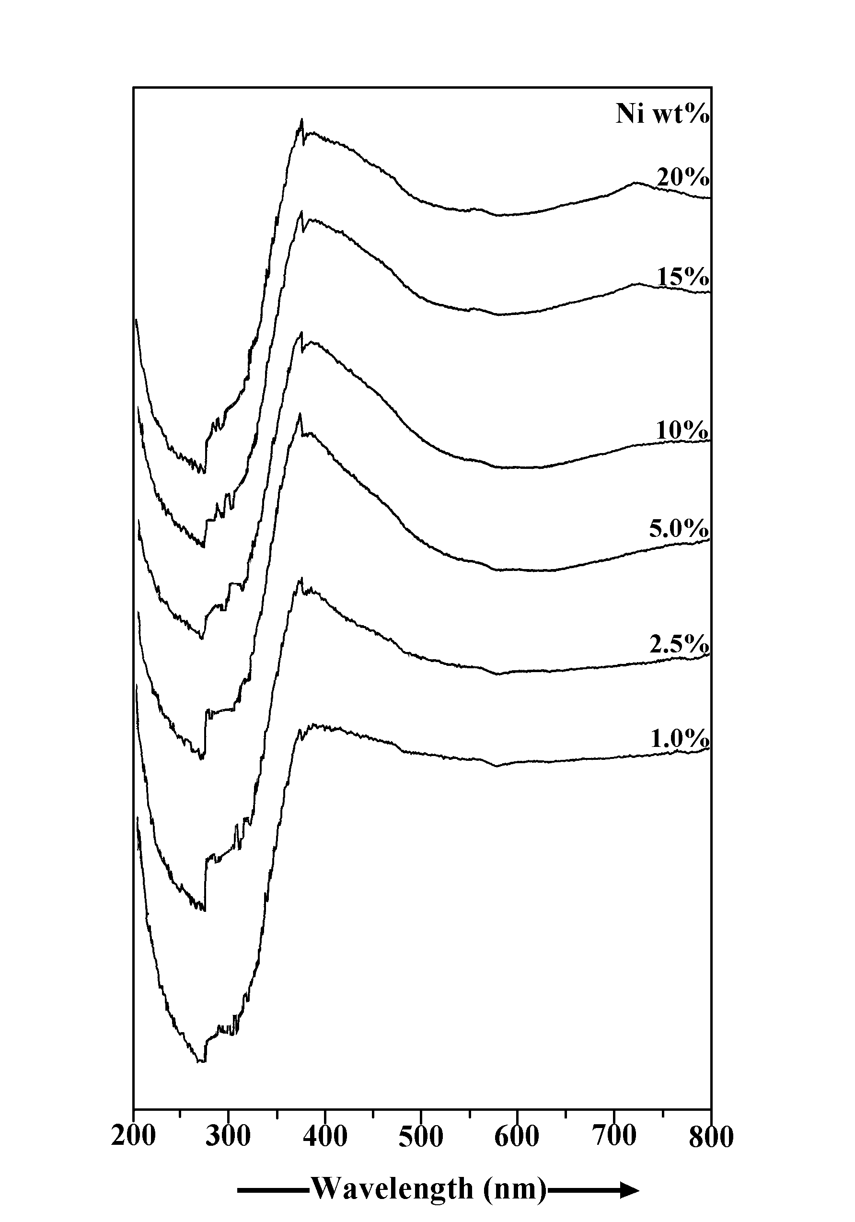

**Figure 2: UVDRS spectra of pure TZ and various NiO/TZ catalysts**

Figure 2 shows the UV-DR Spectra of pure TZ and NiO-TZ calcined materials.When Ni is present as octahedrally coupled Ni2+ species, the NiO species exhibits an absorption band at 380 nm and 720 nm [17]. Significant absorption lines at 380 nm are visible in the UVDRS spectra of NiO-TZ catalysts, indicating the presence of Ni2+ species in an octahedral environment at NiO lattices over the TiO2-ZrO2 support [17]. As the nickel loading rises, so does the strength of the absorption band. Surprisingly, strong absorption bands at 710-720 nm may be seen in the UV-DRS spectra of samples with nickel loadings of 10% and more. In the distorted octahedral symmetry, this peak is attributed to Ni2+ transitions [17]. As Ni loading increases, the intensity of the wide absorption band between 710 and 720 nm increases, implying that crystalline and bulk NiO formation. The intensity of the absorption band increases as the increase of nickel content. The intensity of the broad absorption band between 710 and 720 nm increases as Ni loading increases, implying crystalline and bulk NiO formation.

**BET Surface Area and ICP analysis:**

Table 1 displays the BET surface areas measured by nitrogen sorption for all samples. Pure TZ support seemed to have a specific surface area of 206 m2/g. BET surface area reduces due to nickel loading on TZ. It could be due to nickel oxide crystallites clogging the pores of the support, as demonstrated by XRD and pore size distribution measurements (Table. 1). The Ni content was determined via ICP AES analysis, and the resulting nickel loadings in terms of wt.% were nearly identical to the theoretical values employed in the synthesis of the catalyst

**Table 1: BET surface area and ICP AES results of pure TZ and various NiO/TZ catalysts**

|  |  |  |  |
| --- | --- | --- | --- |
| S.No | Samplesa  Ni loadings (wt%) | Ni loadingb  (Wt.%) | BET surface area  (m2/g) |
| 1 | 0.0 | - | 206 |
| 2 | 1.0 | - | 189 |
| 3 | 2.5 | 2.0 | 183 |
| 4 | 5.0 | 4.93 | 160 |
| 5 | 10 | 9.41 | 151 |
| 6 | 15 | 14.47 | 141 |
| 7 | 20 | 19.21 | 135 |

a- Theoretical Nickel loadings in wt%

b- Measeured Ni loadings (wt%) from ICP AES analysis.

**Hydrogen chemisorption analysis:**

The dispersion of nickel across the Titania-Zirconia (TZ) support was determined using hydrogen chemisorption analysis, and the findings are reported in Table 2. The particle size of nickel increases with the increase of the nickel content over the TZ support. However, the difference in nickel particle size between the TZ supported 2.5 wt% Ni and 5 wt% Ni was negligible. As the increase of nickel loading further, i.e, from 5 to 10 wt%, the particle size difference was significant, which means that the Ni crystallites were formed. The same can be confirmed from the results of nickel surface area too. With a further increase in nickel loading, the same trend was observed due to the formation of bulky nickel crystallites. The hydrogen consumption in terms of mmol is increasing with the increase of nickel loading as expected. Interestingly, the amount of hydrogen consumption of 20wt% nickel loaded sample is lower than the 15 wt% nickel loaded sample in Table 2, indicating that highly agglomerated NiO species formed in the high nickel content sample. This can be evidenced by the nickel particle size results shown in Table 2. Hence, from Ni surface area and Ni particle size value, one can conclude that the agglomeration nickel particle appeared over TZ support for the 10 wt% and above nickel loaded samples.

**Table 2: Hydrogen chemisorptions analysis results of pure TZ and various NiO/TZ**

**catalysts**

|  |  |  |  |  |
| --- | --- | --- | --- | --- |
| S.No | Catalyst  Ni loadings (wt%) | H2 uptake  (mmol) | Ni surface area  (m2/gNi) | Ni particle size  (nm) |
| 1 | 1.0 | - | - | - |
| 2 | 2.5 | 0.088 | 172.8 | 3.9 |
| 3 | 5.0 | 0.207 | 164.4 | 4.1 |
| 4 | 10 | 0.274 | 114.2 | 5.9 |
| 5 | 15 | 0.351 | 94.9 | 7.1 |
| 6 | 20 | 0.341 | 69.5 | 9.7 |

**SEM analysis:**

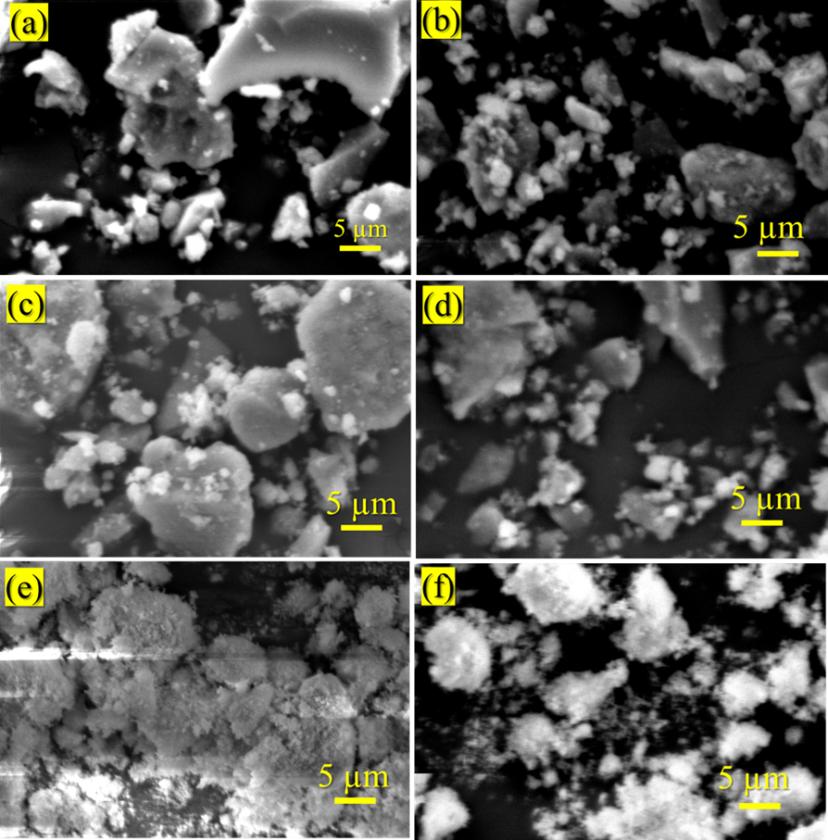

**Figure 3: SEM analysis of pure TZ and various NiO/TZ catalysts**

**Catalytic-performance:”**

**Effect of Ni loading:**

The vapor phase hydrogenation of LA at ambient pressure was investigated using TZ-supported nickel catalysts with various Ni loadings. The catalytic activity of various loadings of Ni catalysts supported on TZ is shown in Fig. 4. The conversion of levulinic acid improved from 18 to 98% as nickel loadings increased from 1 wt.% to 5 wt.% over the TZ support, as shown in Fig. 4. The conversion of LA reduced from 98% to 61% when the nickel loading increased from 5 to 20%. GVL selectivity increases from 52 to 96% with an increase of nickel loadings from 1 to 5 wt.% over the TZ support and decreases further with the increase of nickel loadings. Thus, the 5NiO/TZ catalyst showed the maximum conversion (98%) and 96% selectivity towards GVL with 2% of angelica lactone and valeric acid (VA) each. The pure TZ support alone gave 9% LA conversion with 100% angelica lactone as the main product. This result implies that the conversion of LA and the selectivity of GVL hang on the exposed surface nickel species. However, the conversion of LA and selectivity of GVL decreases at high nickel loadings (higher than 5wt% Ni content

Interestingly, at 20 wt.% Ni loaded samples, the decline in LA conversion is very sharp due to a drop in primary sites, i.e., surface nickel species, caused by the nickel metal's maximum coverage of TZ [20]. As a result, the TZ-supported nickel catalyst with a nickel loading of 5% proved to be an active catalyst for the hydrogenation of LA to GVL.

According to the mechanism reported in the literature, the GVL formation takes place through two pathways. In the pathway 1, the hydrogenation of the carbonyl bond in the levulinic acid takes place first to form the hydroxyl valeric acid, followed by intramolecular dehydration to form GVL. In pathway 2, the enolization of the carbonyl group takes place over the acidic or basic sites of the catalysts, followed by dehydration leads to the formation of angelica lactone. Then, the hydrogenation of angelica lactone leads to the formation of GVL [18-19]. As a result, the presence of acidic sites on the support might explain the synthesis of angelica lactone as the major product in the bare TZ support. Furthermore, the TZ assisted nickel catalysts were used to carry out reaction pathway 2, which may be explained by the creation of angelica lactone as a byproduct [20].

“



**Figure 4:** Catalyticresults of TZ and NiO/TZ catalystswith various Ni loadings

**Reaction conditions**: 10 wt% aqueous LA, 0.3g of Catalyst, 260℃, H2 flow: 30 mL/min”

**Effect**-**of reaction**-**temperature:**

The influence of reaction temperature was tested using a 5NiO/TZ catalyst in the temperature range of 220 °C-320 °C under similar reaction conditions and the findings are shown in Fig. 5. These findings indicate that the temperature change significantly affected the LA conversion and product selectivity. It can be understood from Fig. 5 that the LA conversion remained 22% at 220 °C and reached a maximum (98 %) at 260 °C. After that, no change in the conversion of LA with the rise of temperature from 260 - 320 °C was noticed. The selectivity of GVL follows the same pattern, increasing as the temperature rises from 220 to 260 ° C. With the increase in temperature from 280 °C to 320 °C, the selectivity of GVL decreased from 96 to 72 % due to the rise in valeric acid selectivity at higher temperatures. As a result, higher temperatures facilitate ring-opening, which is followed by a drop in GVL. Based on these findings, we determined that 260°C is the best temperature for the hydrogenation of LA to GVL reaction for the further study. 

**Figure 5:** Effect-of reaction-temperature over 5NiO/TZ catalyst

**Reaction conditions**: Catalyst: 0.3 g, Reaction-temperature: 220 – 320 °C H2 flow: 30 mL/min

**Effect of LA loading:**

The effect of LA concentration (10%, 20%, 40%, 60%, 80%, and 100%) was considered over 5NiO/TZ under the optimum conditions, i.e., at reaction temperature 260 °C, ambient pressure, and 30 mL/min H2 flow. From Fig. 6, it is spotted that the conversion of LA lessened with a rise in the concentration of LA. Henceforth, the rise of LA concentration presented a negative impact on the catalytic activity. This might be due to the adsorption of a higher amount of LA molecule over the active catalyst's surface. Hence, all the LA molecules could not be able to convert into products. In the case of-GVL selectivity, it is declined with an increase in the concentration of LA as a result, the angelica lactone selectivity increased. This could be due to the involvement of the TZ surface in the LA conversion.



**Figure 6:** Effect of LA concentration over 5NiO/TZ catalyst

**Reaction conditions**: Catalyst: 0.3 g, 260 °C, H2 flow: 30 mL/min

**Time on stream study (TOS)**:

The-catalyst-constancy-was-predicted by testing for a longer duration (25 h) over 5NiO/TZ under optimal conditions, i.e., at reaction temperature 260 °C, ambient pressure, 30 mL/min H2 flow, and 10wt% LA loading, shown in Fig. 7. Surprisingly, up to TOS 16 h of reaction time, the conversion of levulinic acid remains constant, and the selectivity of GVL falls in line throughout the investigation. According to the TOS studies, the 5Ni/TZ sample is relatively stable.



**Figure 7:** Time-on-stream study over-5NiTZ catalyst

**Reaction conditions**: Catalyst: 0.3 g, Temperature: 260 °C, H2 flow: 30 mL/min, LA loading: 10wt%

Conclusion:

In summary, various TZ supported nickel loaded materials were synthesized and evaluated for the vapor phase hydrogenation of levulinic acid into gamma valerolactone under various reaction conditions. All of the synthesized catalysts were active in the conversion of LA to GVL, with the 5 wt% Ni/TZ sample exhibiting the highest yield of 98 % when the reaction temperature is 260 °C and the Levulinic acid loading is 10 wt%. Under the optimum reaction conditions, the catalyst's stability was also good up to a TOS of 25 hours. The finding of catalytic and characetization results reveals that the better dispersion of nickel over the TZ support at 5 wt% is the reason for obtaining high yield γ-valerolactone.

**Acknowledgements**:

R.K acknowledges the Council of Scientific and Industrial Research (CSIR), New Delhi, India, for the financial support.

**Conflicts of Interest:** The authors declare no conflict of interest

**Reference:**

[1] Balla P, Seelam Prem Kumar, Ginjupalli Srinivasarao, Karthikeyan Rajan, Mitta Harishekar, Keiski Riitta, Tong Xiang Liang, A comparison of structure-activity of Cu-modified over different mesoporous silica supports for catalytic conversion of levulinic acid

Waste and Biomass Valorization (2022) 13, 67–79, https://doi.org/10.1007/s12649-021-01485-z

[2] Putrakumar Balla, Prem Kumar Seelam, Ravi Balaga, Vijayanand Perupogu,

Tong Xiang Liang, Immobilized highly dispersed Ni nanoparticles over porous carbon as an efficient catalyst for selective hydrogenation of furfural and levulinic acid, Journal of Environmental Chemical Engineering 2 (2021) 109530, https://doi.org/10.1016/j.jece.2021.106530

[3] Luo MT, Zhao C, Huang C, Chen XF, Huang QL, Qi GX et al., Efficient using durian shell hydrolysate as low-cost substrate for bacterial cellulose production by gluconacetobacter xylinus. Indian J Microbiol 57 (2017)393–399. https://doi.org/10.1007/s12088-017-0681-1

**[4]** Yan K, Yang Y, Chai J, Lu Y. Catalytic reactions of gamma-valerolactone: a platform to fuels and value-added chemicals. Appl Catal B Environ 179 (2015) 292–304. https://doi.org/10.1016/j.apcatb.2015.04.030

[5] I. T. Horváth, H. Mehdi, V. Fábos, L. Boda, L. T. Mika, γ-Valerolactone- A sustainable

liquid for energy and carbon-based chemicals, Green Chem. 10 (2008) 238–242.

[6] Á. Bereczky, K. Lukács, M. Farkas, S. Dóbé, Effect of γ-Valerolactone blending on engine performance, combustion characteristics and exhaust emissions in a diesel engine, Nat. Resour. 05 (2014) 177–191.https://doi.org/10.1039/B712863K

[7] H. Mehdi, R. Tuba, L.T. Mika, A. Bodor, K. Torkos, I.T. Horvath, Catalytic conversion of carbohydrates to oxygenates, in: P. Fornasiero, M. Graziani (Eds), Renewable Resources

and Renewable Energy: A Global Challenge, CRC Press, (2006) 55-60. https://doi.org/10.1201/9781420020861

[8] Manzer LE. Catalytic synthesis of α-methylene-γ-valerolactone: a biomass-derived

acrylic monomer. Appl Catal A Gen 272 (2004) 249–56. https://doi.org/10.1016/j.apcata.2004.05.048

[9] Yan Z, Lin L, Liu S. Synthesis of γ-valerolactone by hydrogenation of biomassderived

levulinic acid over Ru/C catalyst. Energy Fuels 23 (2009) 3853–8. https://doi.org/10.1021/ef900259h

[10] Ramu Kuna, Putrakumar Balla, N PethanRajan, Bhanuchander Ponnala, Hussain SK, V.R. Chary Komandur.Highly dispersed and ultra-small Ni nanoparticles over hydroxyapatite for hydrogenation of levulinic acid, Reaction kinetics mechanisms and catalysis (2022) 135, 183–199 , https://doi.org/10.1007/s11144-021-02113-6

[11] Gundeboina, R., Velisoju, V.K., Gutta, N. *et al.* Influence of surface Lewis acid sites for the selective hydrogenation of levulinic acid to γ-valerolactone over Ni–Cu–Al mixed oxide catalyst. *Reac Kinet Mech Cat* 127 (2019)601–616. <https://doi.org/10.1007/s11144-019-01577-x>

[12] Wu B, Yuan R, Fu X Structural characterization and photocatalytic activity of hollow binary ZrO2/TiO2 oxide fibers. J Solid State Chem 182, 3 (2009) 560–565 https://doi.org/10.1016/j.jssc.2008.11.030

[13] Reddy BM, Chowdhury B, Smirniotis PG An XPS study of the dispersion of MoO3 on TiO2–ZrO2, TiO2–SiO2, TiO2–Al2O3, SiO2–ZrO2, and SiO2–TiO2–ZrO2 mixed oxides. Appl Catal A 211 (2001) 19–30. https://doi.org/10.1016/S0926-860X(00)00834-6

[14] Benjaram M. Reddy and Ataullah Khan, Recent Advances on TiO2-ZrO2 Mixed Oxides as Catalysts and Catalyst Supports, Catalysis Reviews, 47 (2005) 257–296, https://doi.org/10.1081/CR-200057488

[15] Fabien Ocampo, Benoit Louis, Anne-Cecile Roger, Methanation of carbon dioxide over nickel-based Ce0.72Zr0.28O2 mixed oxide catalysts prepared by sol–gel method Applied Catalysis A: General 369 (2009) 90–96. https://doi.org/10.1016/j.apcata.2009.09.005

[16] Chalachew Mebrahtu, Salvatore Abate, Siglinda Perathoner, Shiming Chen, Gabriele Centi, CO2 methanation over Ni catalysts based on ternary and quaternary mixed oxide: a comparison and analysis of the structure-activity relationships, Catalysis Today 304 (2018) 181-189. https://doi.org/10.1016/j.cattod.2017.08.060

[17] Rubén López-Fonseca, Cristina Jiménez-González, Beatriz de Rivas, José I. Gutiérrez-Ortiz Partial oxidation of methane to syngas on bulk NiAl2O4 catalyst. Comparison with alumina supported nickel, platinum and rhodium catalysts Applied Catalysis A: General 437– 438 (2012) 53– 62. https://doi.org/10.1016/j.apcata.2012.06.014

[18] Sun D, Takahashi Y, Yamada Y, Sato S. Efficient formation of angelica lactones in a vapor-phase conversion of levulinic acid. Appl Catal A Gen 526(2016)62–69. https://doi.org/10.1016/j.apcata.2016.07.025

[19] Putrakumar B, Nagaraju N, Kumar VP, Chary KVR. Hydrogenation of levulinic acid to γ-valerolactone over copper catalysts supported on γ-Al2O3. Catal Today 250 (20105) 209–217. https://doi.org/10.1016/j.cattod.2014.07.014

[20] K. Hengst, M. Schubert, H.W.P. Carvalho, C. Lu, W. Kleist, J.-D. Grunwaldt, Synthesis of γ-valerolactone by hydrogenation of levulinic acid over supported nickel catalysts, Appl

Catal A: Gen. 502 (2015) 18–26. https://doi.org/10.1016/j.apcata.2015.05.007.