Finite element analysis using Staad-Pro for irregular L-shape Building by Time History Analysis
Mr. Sadhu B. Nagargoje Mr. Mahesh R. More Mr. Ajinkyaraj S. Bhumare
Department of Civil Engineering, CSMSS College of Polytechnic, Chhatrapati Sambhajinagar, Maharashtra,
India.
ABSTRACT
To perform well in an earthquake, a building should possess four main attributes, namely simple and regular configuration, and adequate lateral strength, stiffness and ductility. Buildings having simple regular geometry and uniformly distributed mass and stiffness in planes well as in elevation, suffer much less damage than buildings with irregular configurations. Impairment can be in the form of loss of non-structural element, damage to structural components, and collapse of structural element leading to progressive failure of section or whole building. This failure usually happens in a domino effect and leads to a progressive collapse failure in the construction.
The Linear Static Analysis is carried out by using STAAD-PRO software. From the results obtained, it is observed that the vulnerability of a multi-storey structure is least for a low intensity blast generated at a comfortably longer standoff distance.
Keywords: Alternative load path method, Time history analysis, collapse resistance, finite element method, nonlinear static analysis.
*Author for Correspondence E-mail: sadhu.bn12@gmail.com
INTRODUCTION
Progressive collapse is a chain reaction failure, which causes the initial impairment of the constructions. The Progressive collapse is defined by ASCE 7-05 as “the spread of an initial local failure from element to element, eventually resulting in the collapse of the entire structure or a disproportionately large part of it” [1]. The progressive collapse of building structures is initiated when one or more vertical load carrying members (typically columns) is removed. Once a column is removed due to a vehicle impact, fire, earthquake, or other man-made or natural hazards, the buildings weight i.e. gravity load transfers to neighbouring columns in the structure. Such cases would include abnormal loads such as gas explosions, vehicular collisions, sabotage, and structural actions due to severe fires. The most publicized incidents of progressive collapse are the Ronan Point collapse of 1968 and the bombing of the Alfred P. Murrah building in Oklahoma City in 1995.
Removed Columns For frame structures, the guidelines specify that a single column is to be removed, and that the joints at the column ends remain intact. Rules are included for the column locations and apply for removing wall segments. The rules are the same as those in the (DoD 2001) guidelines. Analysis Methods The “Nonlinear Static Analysis, Remove Column First” method is allowed, and apply Gravity Load First” method. Loads The basic gravity load is (1.2DL+0.5LL). This is more conservative than the GSA 2003 guidelines, which use (DL+0.25LL), and the (DoD 2001) guidelines, which use (1.0DL+0.5LL). Strength Capacities Nominal strengths are calculated from the formulas in the ACI, AISC, etc. design codes. Material over-strength (Ω) factors are specified, typically 1.25 for reinforced concrete. Strength reduction (ɸ) factors are the ACI and AISC values (typically 0.9 or 0.85). The (DoD 2001) guidelines used Ω=1.1.
ALTERNATE PATH METHOD
Alternative path analysis is useful for checking the potential of a structure to progressive collapse. Most of the designers often choose static procedures, which tend to be simpler and less labour demanding. For the analysis of progressive collapse of structures, the load cases for the static procedures require the use of factors to account for inertial and nonlinear effects. A number of inconsistencies have been identified in the way the existing guidelines applied dynamic and nonlinear load factors. To update the existing guidelines, this study looked into the behaviour of a variety of reinforced-concrete and steel moment-frame buildings. This helps to investigate the magnitude and variation of the dynamic and nonlinear load increase factors. The study concluded that the factors in the existing guidelines tend to yield overly conservative results. Those are often translated into expensive designs and retrofits. This study identified new load increase factors and proposed a new approach to utilize these factors when performing alternative path analyses for progressive collapse.
General Service Administration (GSA)
• Linear Elastic Static Analysis,
• Linear Elastic Dynamic Analysis, and
• Nonlinear Dynamic Analysis.
GSA GUIDELINES
The GSA guidelines consider four analysis methods: linear static analysis, nonlinear static analysis, linear elastic dynamic analysis, and nonlinear dynamic analysis. Both the GSA and FEMA guidelines limit the applicability of linear elastic static analysis procedures. The GSA guidelines allow certain structures to be exempted from progressive collapse analysis on the basis of their occupancy and functional use. The guidelines include a comprehensive flow chart for deciding whether a construction is exempt. The General Service Administration (GSA) progressive collapse guideline provides a detailed methodology and performance measures required to measure the vulnerability of new and existing buildings to progressive collapse.
STRUCTURAL FRAMING SYSTEM
The proposed structure is a G+10 storey hotel RCC building. Eccentricity provided for bracing is 0.3mm Details of super structure are described below,
Location : Seismic zone IV
Zone factor : 0.24
Importance factor : 1.2
Type of structure : RCC
Type of occupancy : Hotel
Height of structure : 33 m
Typical storey height : 3 m
Depth of foundation : 1.5 m
Type of soil : Mediu
MATERIAL PROPERTIES
The strength of structure depends upon strength of material from which it is made-
Unit weight of masonry: : 20 kN /m³
Unit weight of R.C.C : 25k kN /m³
Unit weight of steel : 79 kN /m³
Grade of concrete for R.C.C : M20
Grade of steel : HYSD bars for reinforcement Fe 415
Modulus of Elasticity for R.C.C. : 5000 X √fck N /mm³
Modulus of Elasticity for Steel : 2.1 x 105 N/ mm³
Load combination
Load combination are as per IS 1893:2016 and 875:1987
a. 1.7DL + LL
b. 1.7DL +/- EQ
c. 1.7DL +/- WL
d. 1.3DL + LL +/- EQ
e. 1.3DL + LL +/- WL
f. 0.9DL +/- 1.7EQ
g. 0.9DL +/- 1.7WL
h. 1.7*DL+/- Time History
i. 1.3*DL + LL +/- Time History
Dimensions consideration for design:
Beam size: 250mm X 350 mm
Column size at G.L.:250mm X 400 mm
Plinth RCC column: 0.3m X 0.3m
Time History
Time history includes live load, super impose load, for lateral load ground motion UTTARKASHI 1991 ground motion is used.
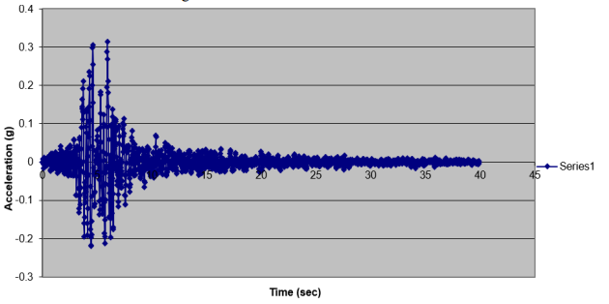
Figure. Acceleration Vs Time
For irregular building changes are Slab thickness is 150mm including floor finish. Wall load is considered as 4.2KN/m^2 the thickness of brick is 200x240x650mm.
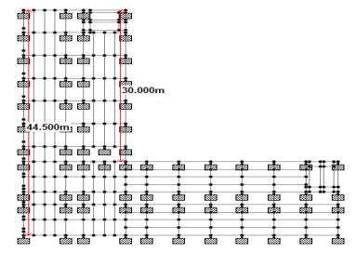
Figure. Plan view of model

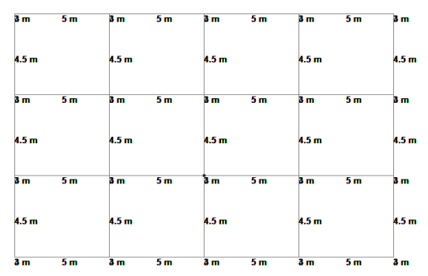
Plan of low rise Building
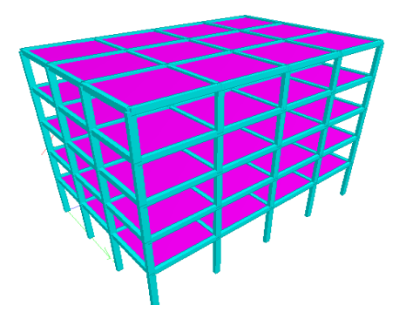
3D Model of low rise building
Performance analysis:
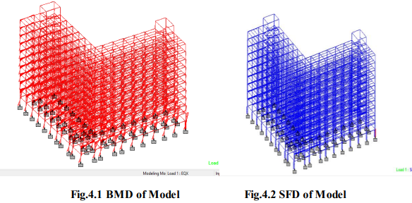
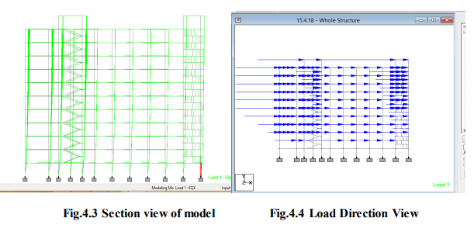
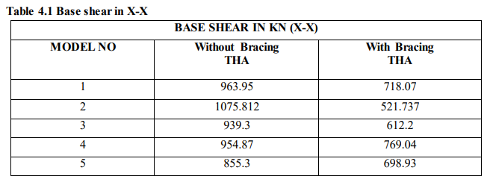
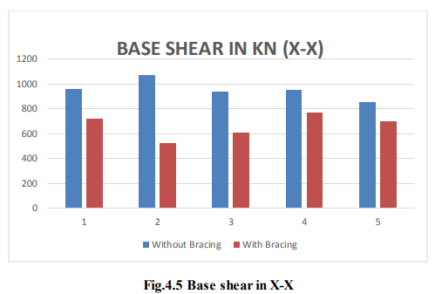
It is observed that from above graph base shear value of model 1, 2, 3, 4, 5 is decreased by 25.50%, 51.50%, 34.82%, 19.46%, 18.28% resp. in model 6, 7, 8, 9, 10. Model6, 7, 8, 9, and 10 are the same model 1, 2, 3, 4, 5 but they are provided with eccentric bracing. The results are obtained from time history analysis method.
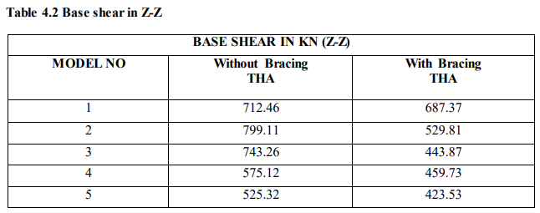
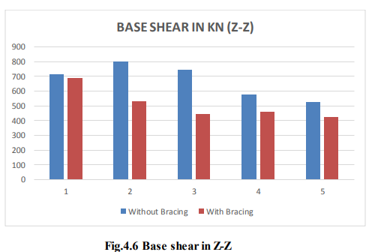
It is observed that from above base shear value of model 1, 2, 3, 4, 5 is decreased by 17.56%, 33.69%, 40.28%, 20.06%, 19.37% resp. in model6, 7, 8, 9, 10. Model 6, 7, 8, 9, and 10 are the same model 1, 2, 3, 4, 5 but they are provided with eccentric bracing. The results are obtained from time history analysis method.
Validation of analysis of low rise building in staad-pro
Given data:
Thickness of slab: 130mm
Beam size: 250mm X 350 mm
Column size at G.L.:250mm X 400 mm
Thickness of outer wall including plaster: 250 mm
Thickness of partition wall including plaster: 175 mm
Load due to roof finish: 2kN/m2
Load due to floor finish: 1kN/m2
Imposed load: 4kN/m2
Type of foundation: Isolated footing
Soil Condition: Hard Murum available at depth of 1.5m below G.L.
Zone-III

CONCLUSIONS
In this project modeling of multistoried building with plan irregularity is done. In accordance with IS1893-2016 for simulation purpose finite element analysis Staad-Pro is used following conclusions are formed after studying L-shape Building with and without bracing with variation of mass along height.
• BASE SHEAR
It is concluded that increase in mass increases the base shear compared to other models but base shear gets decreased when eccentric bracing is provided to the normal building without mass irregularity in X and Z direction for THA analysis.
REFERENCES
1. Nonika. N, Gargi Danda De, ''Seismic analysis of vertical irregular multistoried building'' IJRET: International Journal of Research in Engineering and Technology, Volume: 04 Issue: 09, September-2015, Available @ http://www.ijret.org
2. Robert Tremblay and Laure Poncet, “Seismic Performance of Concentrically Braced Steel Frames in Multistory Buildings with Mass Irregularity“ Journal Of Structural Engineering © ASCE, September 2005
3. Elena MOLA, Paolo NEGRO, Artur V. PINTO “Evaluation Of Current Approaches For The Analysis And Design Of Multi-Storey Torsionally Unbalanced Frames”13th World Conference on Earthquake Engineering Vancouver, B.C., Canada, August 1-6, 2004, Paper No. 3304
4. Prof. M.R.Wakchaure, Anantwad Shirish and Rohit Nikam “Study Of Plan Irregularity On High-Rise Structures” International Journal Of Innovative Research & Development, Vol 1, Issue 8, October, 2012
5. Rucha S. Banginwar, M. R. Vyawahare and P. O. Modani “Effect of Plans Configurations on the Seismic Behaviour of the Structure By Response Spectrum Method” International Journal of Engineering Research and Applications (IJERA), Vol. 2, Issue 3, May-Jun 2012, pp.1439-1443
6. Kien Le-Trung , Kihak Lee and Do-Hyung Lee, “Seismic Behavior And Evaluation Of Steel Smf Buildings With Vertical Irregularities” The 14 th World Conference on Earthquake Engineering, October 12-17, 2008, Beijing, China
7. Poncet, L.1 and Tremblay, R. “Influence Of Mass Irregularity On The Seismic Design And Performance Of Multi-Storey Braced Steel Frames” 13th World Conference on Earthquake Engineering Vancouver, B.C., Canada August 1-6, 2004 Paper No. 2896
8. Thi Thi Hein Lwin and Kyaw Llin Htat, ''Study On Effect Of High Rise Steel Building With Different Masses'' International Journals of Science, Engineering and Technology Reaserch, Volume 4, Issue 7, July 2015
9. T.L. Karavasilis, N. Bazeos, D.E. Beskos “Seismic response of plane steel MRF with setbacks: Estimation of inelastic deformation demands” Journal of Constructional Steel Research, 8 December 2007, Page No.644–654 10. Komal R. Bele, S. B. Borghate, ''Dynamic Analysis Of Building With Plan Irregularity'' Journal of Civil Engineering and Environment Technology, Vol. 2, No. 11, Pp. 23-30, 2015.

