2D LiDAR Based Obstacle Detection System for Obstacle Avoidance in 3D Space
Rajesh Sangalge, Nahas Pareekutty, Sreenath Ravi, Rajeeva S, Sundaresan Poovalingam*
Infosys Limited, India
and
Timothy Ochmann, Sathish Kumar Ranganathan
Prysmian Group, USA
Abstract: Obstacle detection is an important feature in autonomous systems to enhance safety and to improve reliability of the operations in the unknown environment. Various techniques are adopted to detect the obstacle using passive and/or active sensors. Fusion of active and passive sensor techniques are also considered in some cases for better detection of obstacles and improve the accuracy of the detection with safe distance especially in an unmanned aerial robotic system. In this paper, robust method of detecting the obstacle in 3D space using 2D LiDAR system is presented. The experiments conducted indoor in lab environment and outdoor showed excellent results in detecting the obstacle within the safe distance predefined based on the speed of the autonomous systems.
Keywords: Robots, Obstacle Detection, Obstacle Avoidance, Sensor, Transmission Line
* Author for Correspondence, Email: - Sundaresan_p@infosys.com

Introduction
Robot usage is becoming more popular in 3D environments, namely dull, dirty, and dangerous where human intervention needs to be minimal or to protect them from exposure to hazardous environments and enhance the productivity. Today, the power utilities are facing many issues in modernizing the aging grid and its sustainability towards the carbon neutralization. Robotics and autonomous systems are the key to address the labor shortage and get prepared for the future of grid enhancements. The transmission lines of these grids get accumulated with ice during winter and cause major outage due to sag or breakage and intrusion into the vegetation can cause forest fires. Also, the heavy dirt and pollution cause large deposits over a period on these transmission line which increases the power loss and elevated temperature of conductors causing additional sag. Modern robots are employed [1-8] for the replacement of insulators, spacers, de-icing, maintenance, and repair of the grid with remote inspection to protect them from outage with improved industry safety and ensure continuous power supply to their end customers. Drones, helicopters or UAVs [9-10] can also be used for reducing the regular inspection risks and to reduce the cost of certified and heavily insured crews working on the powerlines.
The robots run most of the time on the transmission lines autonomously or with minimum ground control. The transmission line overhead conductors can be single, double or bundle with spacers in between for transmitting the power from the generation points to the distribution points. The robots need to maneuver between the poles as shown in Figure 1 while doing inspection, maintenance, repair, or any other operations it is supposed to perform. The conductor between the poles might have the splice joints as part of conductor joints. The conductors are also equipped with vibration dampers, bird diverters, air flow spoilers and suspension cushion pads to protect the grid from oscillation due to wind, preventing ice buildup and collision of birds as per forest authority guidelines. Various obstacles installed in the transmission lines is as shown in Figure 2.
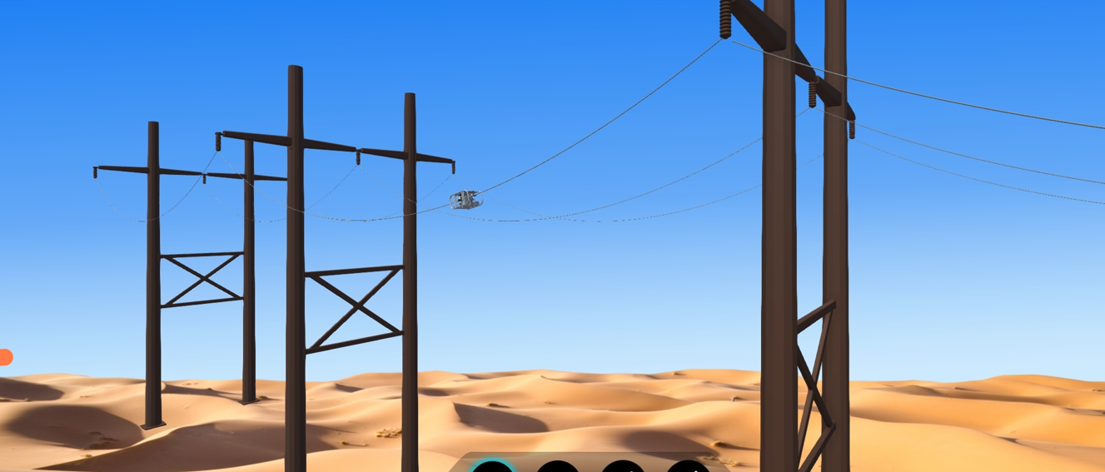
Figure 1: Schematic Showing Robot Operation Between Poles
Due to system level design constraints, it is difficult for robots to cross this kind of obstacle. Therefore, real time obstacle detection and recognition plays a crucial role in robot navigation and behavior planning without compromising on the power grid safety. Hence, it is required to provide safety systems to create an alarm or stop when the robots come across these obstacles on the way.
Obstacle sensors are mostly used in the robots, drones, and any autonomous vehicles very commonly to avoid the obstacles on its path. There is good amount of literature available on various sensors [12-13] and technologies used in the obstacle detection and its avoidance [14-17]. This paper mainly focusses on the methodology developed to identify the obstacles using 2D LiDAR from Sick in 3D space. The method developed here is validated for the stationary and mobile environment of autonomous robots.
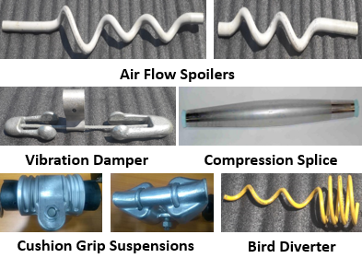
Figure 2: Obstacles Installed on the Transmission Lines

Obstacle Detection Sensors
As mentioned earlier, the obstacle sensors should have the ability to detect the obstacles in advance and avoid them or maneuver over them or stop the robots at a safe distance without damaging them. The temperature rise due to ambient sunlight and power transmission leads to sag in the overhead conductors. The temperature variation is diurnal and in addition the sag will increase with the dynamic movement of robot from start pole to the end pole due to its weight. The slope of the conductor will be almost zero at mid span whereas near the poles it can be reach 30-60 degrees. The obstacle sensor selected should be able to take care of this and should not detect the conductor itself as an obstacle which is a key to the success of the robot operating safely without disturbing the live grid. Another requirement is that it should be able to operate in dust and smoke without getting deposited over them and obstructing the vision or detection of obstacle. Overhead conductor obstacles can be detected using various sensors such as Ultrasound sensors [18], RPLiDAR [19], 2D LiDAR sensor [20], HD Cameras equipped with machine learning algorithms [21]. Each of these sensors have advantages / disadvantage to detect overhead transmission line obstacles.
Obstacle Detection Using Ultrasound Sensors:
Ultrasonic sensor (Figure 3) is a low-cost sensor and most suitable for obstacle detection. They work in any critical conditions such as dirt and dust. The ultrasonic sensor can detect the obstacles like rocks, iron rods and soil on search environment. The ultrasonic sensor transducer is used for alternate transmission and reception of sound waves with very good accuracy. The sonic waves emitted by the transducer are reflected by an object and received back in the transducer. The distance of the object from the sensor is directly proportional to the time taken between the emission and reception of signal at transducer. They offer excellent non-contact detection range of 2cms to 4meters. The ultrasound transducers can be mounted on the robots to detect the obstacles on conductor and interfaced with robot embedded pc to take corrective action to avoid the obstacle.
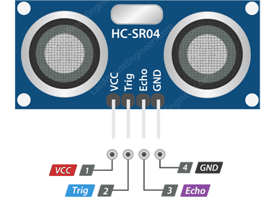
Figure 3: Ultrasound Sensor
Compared to other Time-of-Flight (ToF) sensors like LiDAR, the beam emitted by the ultrasonic sensor transmitter has greater divergence which can be influenced by power of transmission and distance to obstacle. This increases the chances of false positives.
Ultrasound sensor is the best solution to detect obstacle on overhead conductor if the conductor is in straight line. The sag angle is an issue with ultrasound transducer as it keeps detecting the conductor as an obstacle and the robot will keep stopping at every 10 or 15 seconds affecting the autonomous operation of robot and reduce the productivity.
Obstacle Detection Using Camera:
High-definition camera is another option for obstacle detection. The image streaming from camera can be trained using suitable ML algorithms to detect the obstacles. To avoid the effect of external ambient light or to remove reflected glare from the conductor, polarized lens needs to be fixed in front of camera lens. Following are the challenges faced during the camera usage that need to be addressed adequately to get fairly accurate results.
- Conductor shine in bright ambient light will give rise to distorted images
- External illumination in cloudy environment
- Shadow effect due to illumination
- ML models need lot of training for various obstacles and need to train for all type of obstacles, different illumination conditions, and different sag angles of conductor for up and down slopes
- Image processing needs high end processor that consume good amount of power which is not recommended for onboard battery system
- Expensive solution due to high cost of computing power.
- Dust accumulation over lens requires continuous lens cleaning
Obstacle detection using LIDARs:
Similar to ultrasonic sensors, (Light Detection And Ranging) LiDAR sensors use ToF algorithms to calculate distances by calculating the time taken for a laser pulse to be reflected by an object. While a single laser transmitter-receiver pair can detect linear distances, mounting the sensor on a rotating platform extends the detection to a 2D plane, creating a 2D LiDAR. Further, 3D LiDARs consisting of multiple 1-D sensors on a rotating platform can detect objects in 3D space. Use of laser pulses instead of ultrasonic waves provide the benefits of higher accuracy due to significantly lower beam divergence.
LiDAR solutions are available for wide range of applications. The laser measurement solution technology is available for indoor and outdoor environments such as collision avoidance in autonomous vehicles, position evaluation in navigation, classification in traffic and detection in building automation. 3D sensors are useful to detect nearly gap free environment whether the objects are stationary or moving. They are used in collision protection of fast-moving autonomous vehicle system. It is very expensive compared to the 2D sensors. On the other hand, 2D sensors are very useful in performing detection of objects and calculating its range on surfaces from the sensor irrespective of the angle of sensor installation.
RPLIDAR:
RPLIDAR shown in Figure 4 is a 2D LiDAR that uses laser triangulation ranging principle, high-speed vision acquisition technique and processing hardware developed by SLAMTEC. It measures distance data 2000 times per second and provides high resolution distance output. RPLIDAR emits the modulated infrared laser signal which is then reflected by the object to be detected as an obstacle. The returning signal is sampled by vision acquisition system of RPLIDAR. DSP fixed within the RPLIDAR processes the reflected data and outputs the distance & angle value between the object and the RPLIDAR using the communication interface available in the robots. It can perform 360⁰ scan of objects in 6 – 12 M range.
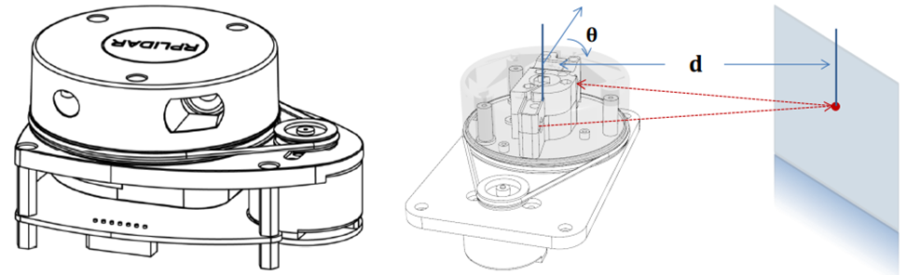
Figure 4: RPLiDAR and Working Schematics
RPLIDAR is best suited for indoor application as the Lidar measurements can be adversely affected by sunlight contamination during the daytime due to the saturation of scattered sunlight with enormous power. Since the robot operations are mostly outdoor on bright sunlight during daytime, this sensor is not suitable. Exposed belts from the drive need to be replaced after certain time of usage
SICK 2D LiDAR:
In this paper, usage of 2D sensors from SICK AG, Germany is explored for detecting obstacles in 3D space of overhead transmission line installations which will have sag and oscillations due to wind. The sensor is characterized by high scanning frequency and resolution, which are instrumental to safe and error-free detection of obstacles
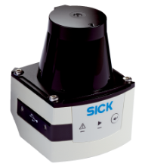
Figure 5: Outdoor 2D LiDAR Sensor

The methodology developed to predict the obstacles on the overhead conductor in 3D space is demonstrated in the following sections.

Obstacle Detection Methodology for Overhead Conductors
The obstacle detection methodology for the overhead conductor is derived for various conductor sizes as the transmission line diameter will be different based on the voltage (say 220 kV to 500kV) or the power it transmits. The methodology is based on the number of laser beam points that is getting reflected from the conductor. The number of reflection points are calculated based on the resolution of the sensor. The diameter of the conductor can range from 0.5” to 2” and the method developed should be able to cater to these variations. If the number of points reflected is more than the number of expected reflections from the conductor, then it shows that there is an obstacle present. Hence it is necessary to calculate the resolution of the sensor and thereby calculate the number of points for each conductor size. The resolution of the sensor is calculated based on the angular resolution (α) of the LiDAR and the distance (L) between the LiDAR and the obstacle.
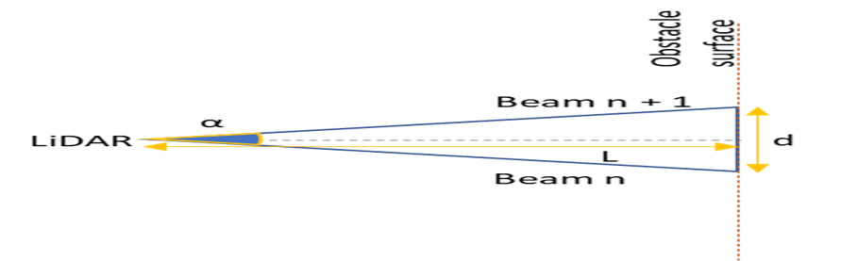
Figure 6a: Resolution of LiDAR Sensor
From Figure 6 the resolution of the Lidar “d” can be calculated using the following equation
$d=2\tan{\frac{α}{2} L}$ (1)
Alternatively, the resolution of LiDAR sensor can be calculated as below.
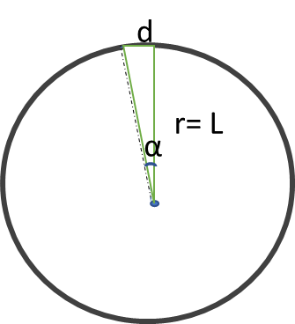
Figure 6b: Resolution of LiDAR Sensor – Alternate Method
$d=\frac{2 π L α}{360}$ (2)
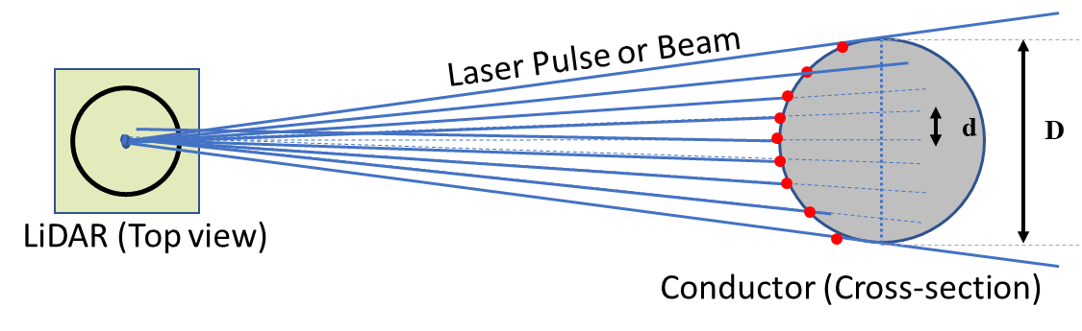
Figure 7: Laser Reflection Points on Arbitrary Conductor
Assume that the LiDAR is kept at a distance “L” from the obstacle and the laser pulse fired from the LiDAR sensor is reflected by the conductor with diameter “D” and if the resolution as calculated from equation (1) and (2) is “d” then the number of points reflected by the conductor can be calculated as below:
Number of LiDAR reflection points = $n= \frac{D}{d}$ (3)
Number of these reflection points may be calculated for the type of conductor on which the robots will be run, and database shall be created for different conductor diameter versus number of reflection points. Whenever the number of reflected points is more than the expected number of reflection points for a particular conductor, it can be understood that there is an obstacle on the conductor and alarm can be created to stop the robot or avoid any collision with the obstacle.
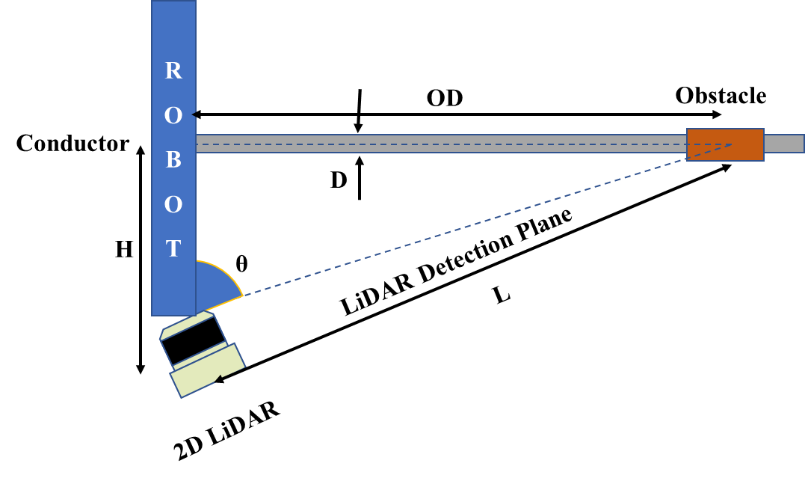
Figure 8: Schematic Showing Safe Obstacle Stopping Distance
It should be noted here that the “OD” is the safe Obstacle Distance before which the robot needs to be stopped and not the distance “L” which the Obstacle distance from LiDAR. The OD can be calculated from the equation shown below:
$L= \sqrt{H^{2}+{OD}^{2}}$ (4)
This safe Obstacle Distance can be decided based on the speed of the robot and set as a desirable value to avoid collision based on the feedback response time for applying the brakes of the running motors with ramp down speed. In the current study the value of L is selected as 1 meter so that the safe Obstacle Distance can be at least around 500 mm including the sag angle of conductors that varies with temperature on the conductor.

Method to Avoid False Obstacle Detection Using Imaginary Cuboid
In the field robot operations, one need to ensure that the sensors do not detect false obstacles in the nearby vicinity but not in the path of the robot itself. Installed overhead transmission lines have 4 conductor lines (R, Y, B and Neutral line) and optical fiber lines for internet running in parallel between two poles as illustrated in figure 1. Distance between two consecutive lines is roughly one meter apart from each other. In case of wire bundles, the distance between the conductors can be as low as 18-24” based on the power transmission line capacity.
2D LiDAR sensors are capable to detect obstacles up to 10 to 14 meters range and has aperture angle of 270 degrees. LiDAR sensors for obstacle detection may detect the adjacent conductor or obstacle on adjacent conductor as obstacle or also it can detect conductor itself as an obstacle due to the sag of installed conductors. To avoid false obstacle sensing need to limit the scanning range and angle, this can be achieved through LiDAR settings. In addition, to avoid false obstacle sensing need to neglect false detections caused by obstacle placed at distance greater than the width of the Robots under consideration.
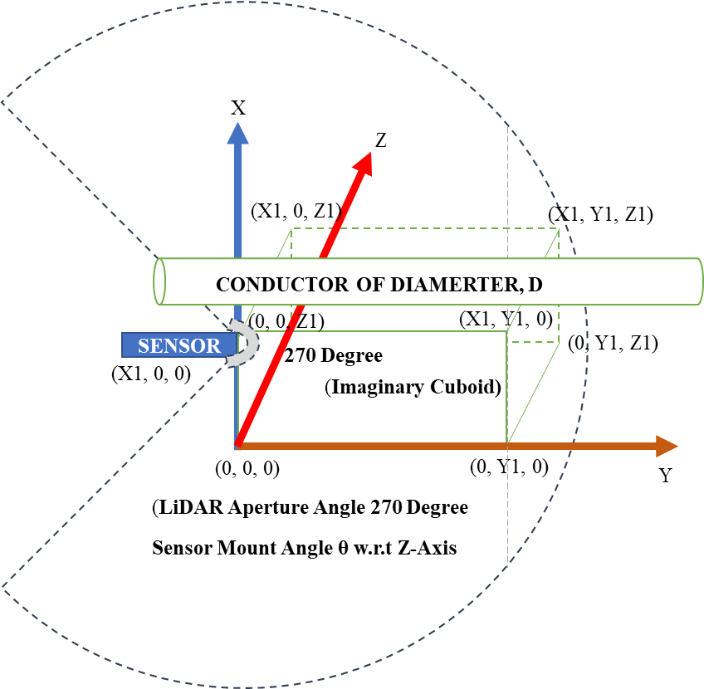
Figure 9: False Obstacle Detection Avoidance Methodology using 2D LiDAR
Following obstacle detection algorithm as shown in figure 10 will solve the problem of false obstacle detection around the conductor.
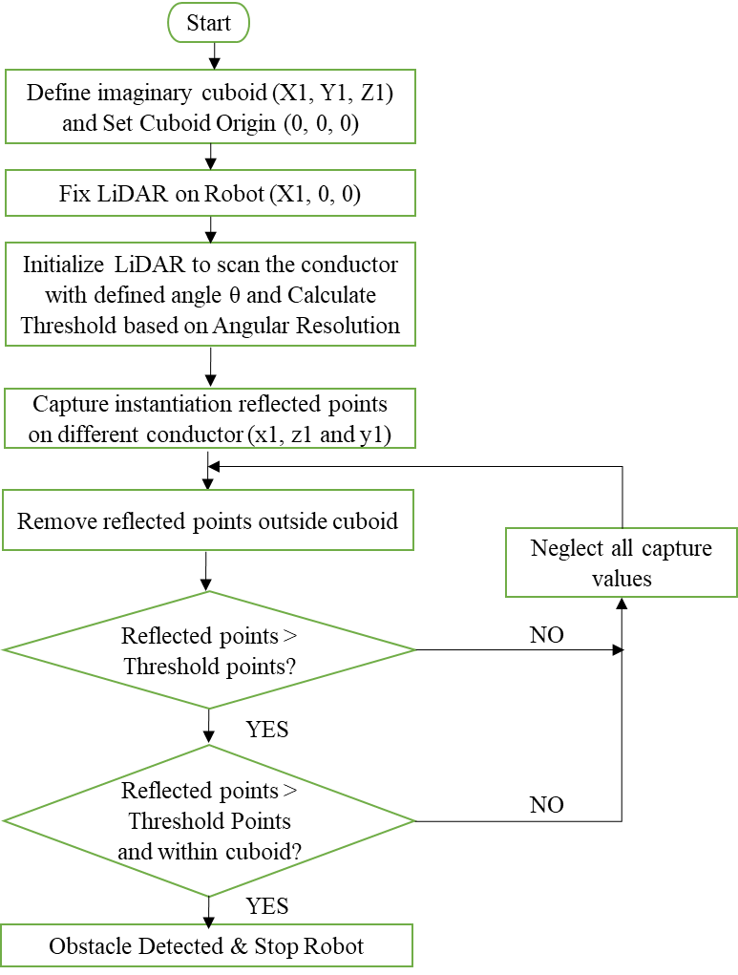
Figure 10: Obstacle Detection Algorithm Flowchart
- Consider the imaginary cuboid around the conductor ahead of robot of following size with origin (0,0,0) at the bottom corner of the robot as shown in figure 9.
- Consider sensor placed on robot on x-axis (X1, 0, 0) coordinate
- Width (Z1) = Robot Width
- Height (X1) = Robot Height
- Length (Y1) = Safe Obstacle Distance from the Robot (Usually assumed value for stopping the robot safely without any damage based on its speed)
- LiDAR provides instantaneous X & Z coordinate from reflection point and Y coordinate of reflected points are constant as the robot runs along the conductor axis
- Select the size of Cuboid (X1, Y1, Z1) based on the obstacle size (Typically start with 2D of conductor)
- Perform lab experiments on various conductor type/size and arrive at the number of reflection points from conductor (threshold value for each conductor)
- Remove reflected points outside the imaginary cuboid
- If number of reflected points are less than that of the threshold value based on conductor type/size indicates only the presence of conductor alone
- If number of points reflected from the obstacle is greater than that of the threshold value based on conductor type/size but within the imaginary cuboid coordinates indicates the presence of the obstacle on the conductor (top/bottom or left/right)
- If number of reflected points are greater than the threshold value and also outside the imaginary cuboid indicates that the obstacle is beyond the point of interest and hence to avoid detection of false obstacles

Experimental Setup, Results and Discussion
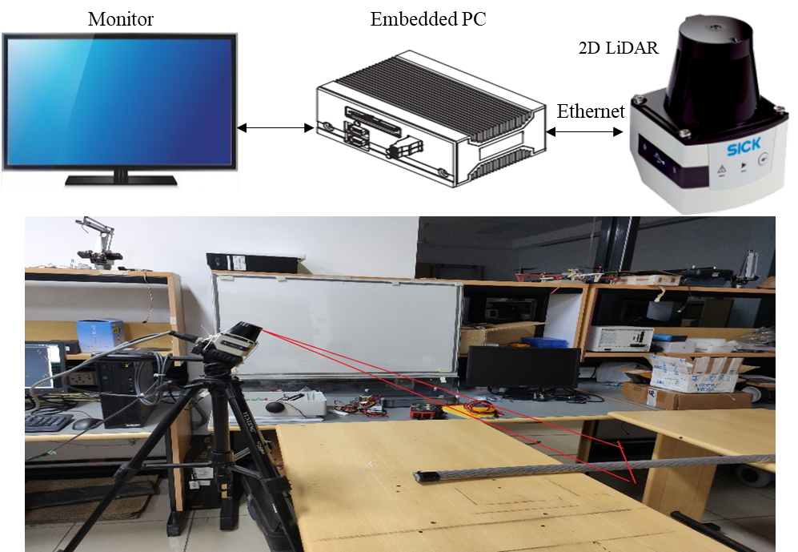
The experimental setup as shown in the Figure 11 is considered for capturing the number of threshold reflection points from the conductor to the sensor with the pre-set angle. In the lab
Figure 11: Lab Set-up for 2D LiDAR Sensor Scanning of Conductor
setup, the 2D Lidar sensor is mounted on to the tripod and kept stationary. The conductor was placed on top of the table and the object was moved manually to get detected by the sensor at the desired safe distance from the sensor. Various conductors are scanned with the sensor to arrive at the threshold points.
Table 1: Threshold Values for Different Overhead Conductor Types
No | Conductor Type | Conductor diameter (mm) | H (mm) | O (mm) | L (mm) | Resolution  d (mm) | Threshold Points
1 | Arbutus | 26.0604 | 240 | 850 | 883 | 5 | 5
2 | Drake | 28.1178 | 240 | 850 | 883 | 5 | 6
3 | Bluejay | 31.9786 | 240 | 850 | 883 | 5 | 6
4 | Bluebird | 46.03 | 240 | 850 | 883 | 5 | 9

In the lab setup, the distance (H) of the sensor from the conductor axis is kept as 240 mm and the safe distance (O) is considered as 850 mm as shown in Figure 8. The sensor was trained by scanning it on various conductor diameters to arrive at the number of reflection points called Threshold points as shown in Table 1. The points are fed into the algorithm to detect the obstacle based on the no of reflection points received at the sensor after reflection of conductor and obstacle together. The sensor is kept at an angle to the conductor so that it can detect the obstacle on top or bottom and on left or right side of it.
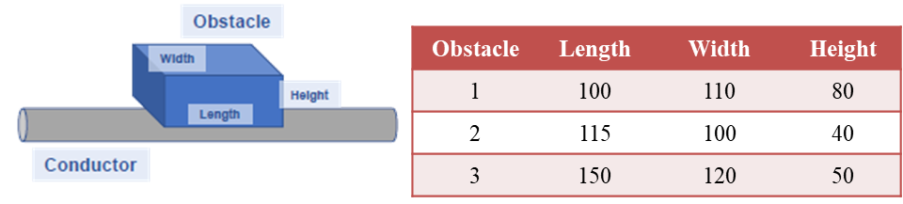
Figure 12: Obstacles for 2D LiDAR Sensor Scanning with Conductor
Various size of obstacles as shown in Figure 12 with different shapes are considered in lab environment to train the sensor. The reflected points detected by sensor are listed as shown in Table 2.
Table 2: Laser Scan of Obstacles with Reflected Points
No | Object | Min Points | Max Points
1 | Conductor Alone | 6 | 9
2 | Conductor + Obstacle 1 | 21 | 24
3 | Conductor + Obstacle 2 | 18 | 22
4 | Conductor + Obstacle 3 | 21 | 26
The obstacle detection algorithm is written as per the flow chart in Figure 10 to detect the obstacle and provide the alarm on the monitor connected to the embedded PC as shown in Figure 13.
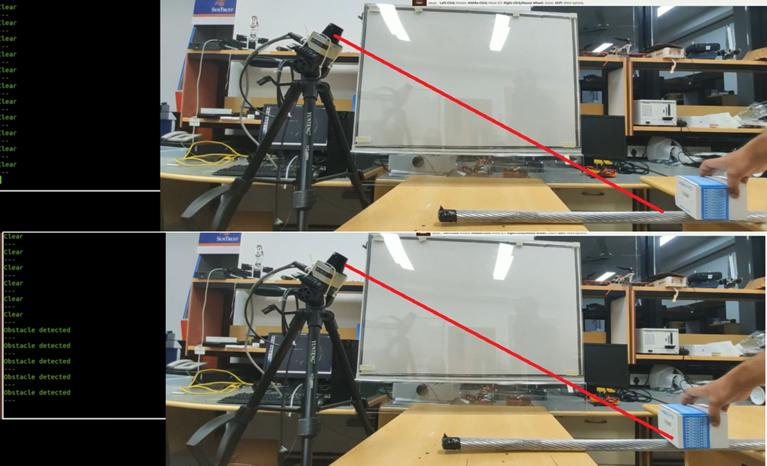
Figure 13: LiDAR Scan for Obstacle Detection – Go/NoGo Conditions
The lab setup is 2D environment without any sag angle. However, in the actual scenario the robots will be running on the conductor with sag and create a 3D environment with dynamic environment of robot movement together with the LiDAR mounted on it. Hence it is required to take care of the robot speed and the resolution of the sensor also into account to set the alarm to stop the robot at desired safe distance to avoid any damage to the robot.

Obstacle Detection on an Overhead Conductor in 3D Space
The LiDAR sensor was mounted on to a robot and made to run between the poles with sag angle of 2% of span as shown in Figure 1. The experiments are conducted on various installed obstacles (Figure 2) on the conductor. The safe stopping distance of the robot for various obstacles with different traction speed of the robot are listed in Table 3.
The test results are repeated multiple times to ensure the reliability of the stopping distance and the average distances are listed in the table for brevity. The stopping distance is a function of the location of the obstacle within the span (up/down slope), speed of robot, shape and size of the obstacles. It may be noted from the test results that the stopping distance reduces with increase in speed and sag of the conductor. Hence, proper care to be taken to set the alarm accordingly to stop the robot during the field operation where unknown obstacles like birds sitting on the conductor may also be expected.

Table 3: Obstacle Avoidance – Robot Stopping Distance
Trial No | Obstacle Type | Traction Speed, ft/min | Stopping Distance, mm
1 | Suspension Cushion Pad | 30 | 899
2 |  | 27 | 918
3 |  | 15 | 1163
1 | Bird Diverter | 30 | 718
2 |  | 27 | 843
3 |  | 15 | 860
1 | Air Flow Spoiler (Big) | 30 | 803
2 |  | 27 | 742
3 |  | 15 | 852
1 | Air Flow Spoiler (Small) | 30 | 435
2 |  | 27 | 472
3 |  | 15 | 507
1 | Vibration Damper | 30 | 715
2 |  | 27 | 933
3 |  | 15 | 970

Conclusion
Obstacle detection and avoidance is an important requirement in the field of autonomous operations of vehicles and robots. It is more pronounced in the dynamic operation environment where speed of operation is an important parameter to the stopping distance. Vibration dampers, Suspension cushion pad, Bird Diverter, Air Flow Spoiler and Splices are used on overhead conductors. Robots used for various operations such as inspection, repair and maintenance of the overhead conductor needs to detect these kinds of obstacles and stop the operation to inform wirelessly to the ground crews in remote location and to ensure the safety of the live grid. Operators will take corrective action either by removing these obstacles or allowing robots to override the obstacles under their supervision.
Various sensors used for obstacle detection are discussed together with the challenges that need to be addressed while selecting the sensors like ambient light, dust, rain, snow, sag of conductors, obstacles from nearby transmission lines and the end poles. The SICK 2D LiDAR sensor selected for obstacle detection in 3D space for overhead transmission lines is demonstrated with very good detection capability and the reliability. Considering the accuracy, speed, economy, and other requirements of the application, 2D LiDAR is the most suitable to detect all types of obstacles on the overhead conductors while overcoming known system level challenges.

ACKNOWLEDGEMENT
Authors wish to thank Gopikrishnan Konnanath, SVP-Service Offering Head, Engineering Unit and Dr G.V.V Ravi Kumar, VP and Head-Advanced Engineering Group for the constant support, guidance, motivation, and encouragement throughout the work at Advanced Engineering Group, Infosys Limited. The authors extend their sincere thanks to Dr Srinivas Siripurapu - Chief Innovation and R&D officer, Garcia Valeria – Chief Engineer, R&D Head, and Luca De Rai – VP, R&D Energy Business, Prysmian Group for their sponsorship of the fundamental research activities at Infosys Limited, India.
References:
- Binhai Wang, Lei Han, and Bingqiang Li, The Specific Requirements of Applied Robots for the Power Utility, 1st International Conference on Applied Robotics for the Power Industry, Delta Centre-Ville, Montréal, Canada, October 5-7, 2010.
- Janos Toth, Nicolas Pouliot, and Serge Montambault, Field Experiences Using LineScout Technology on Large BC Transmission Crossings, 1st International Conference on Applied Robotics for the Power Industry, Delta Centre-Ville, Montréal, Canada, October 5-7, 2010.
- Paulo Debenest, Member, IEEE, and Michele Guarnieri, Expliner - From Prototype Towards a Practical Robot for Inspection of High-Voltage Lines, 1st International Conference on Applied Robotics for the Power Industry, Delta Centre-Ville, Montréal, Canada, October 5-7, 2010.
- Serge Montambault, and Nicolas Pouliot, Field Experience with LineScout Technology for Live-Line Robotic Inspection and Maintenance of Overhead Transmission Networks, 1st International Conference on Applied Robotics for the Power Industry, Delta Centre-Ville, Montréal, Canada, October 5-7, 2010.
- Jinlong Zhao, Rui Guo, Lei Cao and Feng Zhang, Improvement of LineROVer: A mobile Robot for De-icing of Transmission Lines, 1st International Conference on Applied Robotics for the Power Industry, Delta Centre-Ville, Montréal, Canada, October 5-7, 2010.
- David Elizondo Thomas Gentile Hans Candia Greggory Bell, Overview of Robotic Applications for Energized Transmission Line Work –Technologies, Field Projects and Future Developments, 1st International Conference on Applied Robotics for the Power Industry, Delta Centre-Ville, Montréal, Canada, October 5-7, 2010.
- Gongping Wu, Hua Xiao, Xiaohui Xiao, Zhenglie Huang, and Yingsong Li, Transmission Line Inspection Robot and Deicing Robot: Key Technologies, Prototypes and Applications, 1st International Conference on Applied Robotics for the Power Industry, Delta Centre-Ville, Montréal, Canada, October 5-7, 2010.
- Oswaldo Menendez, Fernando Auat Chee In, Marcelo Perez, and Samir Kouro, Robotics in Power Systems, IEEE industrial electronics magazine, Jun 2017, 22-34p.
- Binhai Wang, Member, IEEE, Xiguang Chen, Qian Wang, Liang Liu, Hailong Zhang and Bingqiang Li, Power Line Inspection with A Flying Robot, 1st International Conference on Applied Robotics for the Power Industry, Delta Centre-Ville, Montréal, Canada, October 5-7, 2010.
- Janos Toth, and Adelana Gilpin-Jackson, Smart View for a Smart Grid – Unmanned Aerial Vehicles for Transmission Lines, 1st International Conference on Applied Robotics for the Power Industry, Delta Centre-Ville, Montréal, Canada, October 5-7, 2010.
- Sachin Lalar, Obstacle Detection Sensors: A Survey, International Journal of Current Engineering and Technology, Vol. 3, No. 5, December 2013, 2138-2142p.
- Anca Discant, Alexandrina Rogozan, Corneliu Rusu and Abdelaziz Bensrhair, Sensors for Obstacle Detection A Survey, 30th International Spring Seminar on Electronics Technology (ISSE), IEEE Conference, 2007, 100-105p.
- C. Giannìa, M. Balsia, S. Espositob and P. Fallavollita, Obstacle Detection System Involving Fusion of Multiple Sensor Technologies, International Conference on Unmanned Aerial Vehicles in Geomatics, 4–7 September 2017, Bonn, Germany, https://doi.org/10.5194/isprs-archives-XLII-2-W6-127-2017, 127-134p.
- Jonathan Henrique Efigˆenio de Oliveira, and Walter Fetter Lages, Robotized Inspection of Power Lines with Infrared Vision, 1st International Conference on Applied Robotics for the Power Industry, Delta Centre-Ville, Montréal, Canada, October 5-7, 2010.
- Dnyaneshwar V. Nimse and S. B. Abhang, Obstacle Detection and Collision Avoidance System, International Research Journal of Engineering and Technology (IRJET), Volume: 05 Issue: 01, Jan-2018, pp 1297-1302p.
- K. Kamalakannan, S. Prashanth, Shriram K. Vasudevan, A. Balachandran and T. Boobalan, An innovative and inexpensive method for Obstacle Detection and Avoidance, Information Technology Journal, 12(11), 2013, 2241-2245p.
- Greeshma G, and Lalithamani Nithyanandham, Obstacle Detection of Vehicles under Fog, International Journal of Simulation Systems, Science & Technology (IJSSST), DOI 10.5013/IJSSST.a.20.01.27
- Product User’s Manual – HCSR04 Ultrasonic Sensor, V1.0, May 2013.
- Introduction and Datasheet, RPLIDAR Model A1M8, Shanghai Slamtec Company Limited, Rev 1.0, Jul 2017.
- 2D LIDAR sensors, TiM561-9950101S01, Product Datasheet, 2020-09-11 10:09:50, SICK AG, Waldkirch, Germany.
- 2MP 1080P USB Camera AD-BHC7350U, Product datasheet, Aidevision Technology Co., Ltd, Shenzhen, China.

