A Study on Strength and Durability of Fly Ash–Metakaolin Blended Geo-Polymer Concrete
Shoaib Hussain Syed ¹, *Mohd Nazim Raza², Mohammed Samiullah Jabeer³
¹ High School Student, Hyderabad Public School, Hyderabad, India
² Assistant Professor, Department of Civil Engineering, MJCET, Hyderabad, India
³ PG Student, Structural Engineering, MJCET, Hyderabad, India
Abstract:
Production of cement causes 8% of the total carbon-dioxide emissions in the World. Finding a right alternative to cement is the need of the hour, to eliminate environmental pollution caused by cement production. One of the potential materials to substitute for conventional concrete by fully replacing cement with an industrial by-product like flyash, metakaolin (MK) is geopolymer concrete (GPC). The current investigation presents the effect of metakaolin (MK), a by-product of kaolinite on class F fly ash based GPC. External exposure curing has been adopted, Influence of molarity on compressive and tensile strength and water absorption and sorptivity tests of GPC is tested for 8M, 10M and 12M. Fly ash in GPC has been replaced with metakaolin at the 0%,10%,20%,30%,40%,and 50% for improvement of early age properties of concrete.Tests on fresh concrete like slump cone test is performed.Compressive strength was found at the age of 28 days on hardened concrete. At 28 days there has been a 11%, 15%, 20%, 38% increase in strength for 10%, 20%, 30%, 40% and 50% inclusion of metakaolin compared to the control specimen of 0% MK inclusion. But for upto 30% replacement of MK the 28 day characteristic strength was observed to be higher than what it is designed for. The water absorption and sorptivity of fly ash based geopolymer concrete shows higher water absorption and sorptivity at 10% replacement with metakaolin. There after the water absorption and sorptivity deacreases.

Key words: Extenal exposure curing, Geopolymer concrete, flyash , metakaolin, water absorption
*Author for Correspondence E-mail: mohammednazimraza@gmail.com
1.0 INTRODUCTION
The world's cement industry accounts for about 7% of global carbon dioxide production (and is still rising). The construction industry is one of the leaders leading to environmental degradation through the consumption of resources, energy or waste. Emissions from cement production are one of the main causes of global warming and climate change. Using fly ash and alkali instead of OPC as a binder, geopolymer concrete is becoming a new and sustainable environmentally friendly building material. The process uses fly ash (raw material) itself as a by-product of coal-fired power stations, and activates it with highly alkaline liquids to produce a polymer gel that combines and solidifies non-reactive components (crude Pellets and fines).
Researchers have developed geopolymer adhesives using different raw materials. These include natural minerals such as kaolinite, albite, feldspar and amphibole; treated minerals such as metakaolin; and by-products such as blast furnace slag and fly ash. In theory, any source of amorphous silica and aluminum can be used to make geopolymer adhesives (Hardjito & Rangan 2005b). Davidovits (1999a) used metakaolin as a source of silica and aluminum to produce geopolymer slurries. The combined use of two raw materials has also been reported, such as ground blast furnace slag and fly ash, kaolinite and sphalerite, grade C fly ash and blast furnace slag powder, metakaolin and grade F fly ash, metakaolin and Calcium hydroxide, etc.

1.1 Fly ash

It is a coal combustion product composed of fine particles (fine particles of burning fuel) that are discharged from the coal-fired boiler together with coal flue gas. The ash that falls on the bottom of the boiler combustion chamber (commonly called the combustion chamber) is called bottom ash. In modern coal-fired power plants, fly ash is usually captured by electrostatic precipitators or other particulate filtering equipment before the flue gas reaches the chimney.
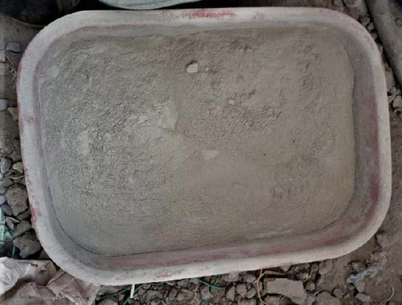
Fig.1 Fly Ash
1.2 Metakaolin

Metakaolin is a pozzolan, probably the most effective pozzolanic material for use in concrete. It is a product that is manufactured for use rather than a by-product and is formed when china clay, the mineral kaolin, is heated to a temperature between 600 and 800ºC.

1.3 Alkaline Liquids

The most common alkaline liquid used for geological polymerization is a combination of sodium hydroxide (NaOH) or potassium hydroxide (KOH) and sodium silicate or potassium silicate. Some researchers have reported the use of a single alkaline activator. Palomo et al. (1999) concluded that the type of alkaline liquid plays an important role in the polymerization process. When the alkaline liquid contains soluble silicate (sodium silicate or potassium silicate), the reaction occurs at a higher rate than when only alkali metal hydroxide is used. The researchers confirmed that the addition of sodium silicate solution to the alkaline liquid sodium hydroxide solution can enhance the reaction between the raw material and the solution.

1.4 Sodium hydroxide (NaOH)

Since geopolymer concrete used in this study is homogeneous material and its main process to activate the sodium silicate Pellet Sodium Hydroxide is recommended to use the lowest cost i.e. up to 94% to 96 % purity.

1.5 Sodium silicate

In present investigation sodium silicate 2.0 (ratio between Na₂O to SiO₂) is used. A per the manufacture, silicate were supplied to the detergent company and textile industry as bonding agent. Same sodium silicate is used for the making of geo-polymer concrete.
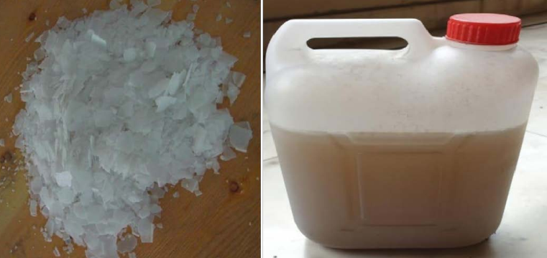
b
a
Fig.2 (a) NaOH flakes (b) Sodium Silicate Solution

2.0 NEED FOR STUDY

Geopolymer concrete uses flyash which is a by-product of coal-fired power stations instead of Ordinary Portland Cement. Currently, ordinary Portland cement based concrete is the leading construction material all across the world, with the cement usage being 4.0 billion tons per annum and growth rate being 4% per annum (USGS, 2014). The major problems associated with the Portland cement are its production, which is energy consuming and more significantly it releases very high volume of carbon dioxide in to the atmosphere. At the same time the disposal of industrial wastes such as fly ash, ground granulated blast furnace slag, mine waste, red mud etc., has become a big problem, it requires large areas of useful land and also has huge impact on the environment.
3.0 LITERATURE REVIEW
3.1 General
Amer Hassan et al (2019) reported that the compressive strength and splitting tensile strength of geo-polymer concrete cured by hot oven are much higher than that of environmentally cured concrete. In environmental curing, the compressive strength and split tensile strength increase with the increase of concrete age. As the temperature of the heating furnace increases and reaches the optimal ^{80oC} within 24 hours, the compressive strength of the geo-polymer will increase. It reaches the required strength of up to 44.84 MPa at 80ºC.Above this temperature, the compressive strength of the soil polymer decreases. As the temperature of the hot oven increases and reaches the optimal 80ºC within 24 hours, the splitting tensile strength of the geo-polymer will increase. The required strength of 4.81 MPa was reached at 80ºC. In addition to this, the tensile strength decreases.

Dibyendu Adak, and Saroj Mandal, et al (2019) studied that the process of modification (heat activation of fly ash and alkaline fluid), the modified geo-polymer concrete shows a significant enhancement in mechanical strength (compressive, split tensile, flexural, and bond strength) and durability (water absorption, acid attack resistance, and rapid chloride permeability test) compared with conventional geo-polymer concrete (heat activation after casting) and the control concrete. Low-calcium fly ash-based process modified geo-polymer Concrete after curing at ambient temperature (GPC I) display the mechanical strength and durability are higher than conventional thermal curing geo-polymer concrete (GPC II) and OPC concrete of The amorphous phase of fly ash is transformed into a crystalline phase in the geo-polymer matrix. Energy saving is also an important criterion Used for processing modified geo-polymer (GPC I) mixture In practical applications.

Habeeb Lateef Muttashar, Mohd Azreen et al. (2018) used GGBS as a raw material to evaluate the ability of different content (0-100%) of waste garnet as a sand substitute to achieve self-compacting geo-polymer concrete (SCGPC). The replacement level of waste garnet is 25%, showing the best performance in terms of fluidity and mechanical properties. The study showed the compressive strength upto 78 MPa was obtained at 28 days. Garnet replacement level of 25% revealed the optimum performance regarding both flow ability and mechanical properties.

P.Pavithra, et al (2016) developed a hybrid design method for geo-polymer concrete, which is mainly focused on achieving an economical way of achieving better results for different alkaline activator solutions with binder ratios (i.e. 0.4, 0.5, 0.6, 0.7 and 0.8). Compressive strength. The concrete cubes were cured in an oven at a temperature of 60 degrees for 24 hours, and then air-dried at atmospheric temperature until the day of the test. The relationship between the ratio of AAS to adhesive and 28-day compressive strength has been studied, and the conceptual hybrid design method of GPC has been proposed in a reasonable manner.

3.2 Critical Appraisal

Early researchers have conducted research aimed at improving the greenness of geo-polymers by using environmental curing, thereby increasing their strength. Some researchers study the effect of alkaline solutions by changing the molar concentration of NaOH and the ratio of sodium silicate solution to sodium hydroxide solution. The difference between fly ash and alkaline solution is different. Some researchers have compared the strength of geo-polymeric concrete between room temperature curing and sunlight curing. There are few studies on the use of metakaolin as a partial replacement of fly ash in GPC. In this study, attempts have been made to incorporate metakaolin into GPC as an alternative to fly ash under external exposure solidification that represents casting conditions on site.
4.0 OBJECTIVES OF THE WORK

- To study the compressive and tensile strength of the following on geopolymer concrete
under external exposure curing :
(a) Molarity of alkaline activator solution.
(b) Metakaolin as partial replacement to flyash.
- To study the effect of water absorption and sorptivity performance of flyash and
metakaolin blended geopolymer concrete under external exposure curing.

5.0 METHODOLOGY
The experimental procedure is to determine the percentage of metakaolin replaced by fly ash in polymer concrete based on fly ash and its effect on the strength and durability of external exposure and curing.
The procedure is carried out in two stages. After correctly determining the various properties of the materials involved, the design procedure for mixing fly ash and geopolymer concrete in the Cleaner Production Magazine (May 2016) was adopted.
- The Compressive and tensile strength is examined for the mixes of varying molarities of Sodium Hydroxide i.e. 8M, 10M and 12M
- Fly ash is replaced by metakaolin by 0%, 10%, 20%, 30%, 40% and 50% by weight and casting was done.
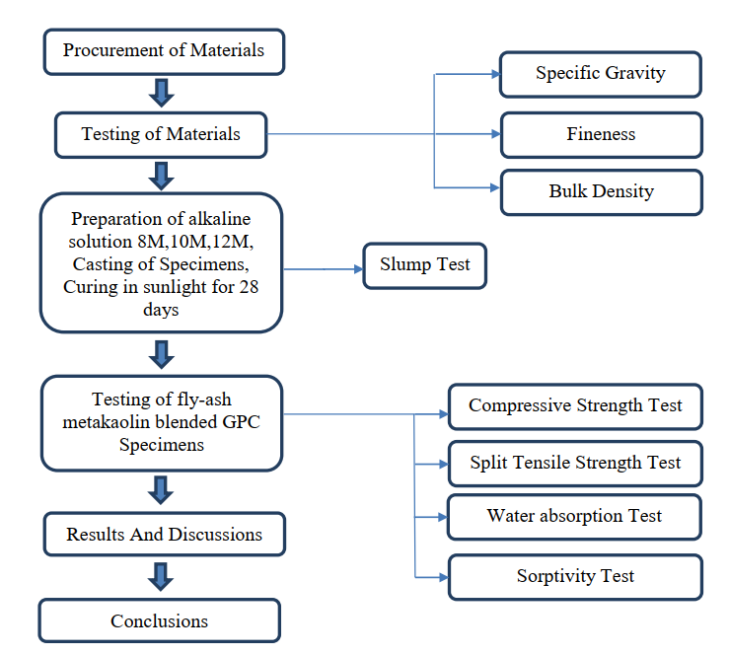
Fig.3 Flow Chart of Experimental Program

Table No.1 Constituent materials for GPC
Constituent materials for 1 m³ of GPC
Fly ash | 400 kg
NaOH | 57.14 kg
Na2SiO3 | 142.8 kg
Fine aggregate | 513.26 kg
Coarse aggregate | 1220.46 kg
Super Plasticizer | 4 liters

5.1 Mix Proportions:
Table No.2 Mix proportions of geopolymer concrete
Stage I
Mix | FlyAsh kg | Coarse Aggregate kg | Fine Aggregate kg | Sodium Silicate | Sodium Hydroxide | Water  Litres | Water Geopolymer solids ratio
GPM2 (8M) | 400 | 1220.46 | 513.26 | 142.8 | 57.14 | 114.4 | 0.24
GPM3 (10M) | 400 | 1220.46 | 513.26 | 142.8 | 57.14 | 112.22 | 0.23
GPM4 (12M) | 400 | 1220.46 | 513.26 | 142.8 | 57.14 | 109.76 | 0.22
Stage II
Mix | FlyAsh kg | Metakaolin  kg | Coarse Aggregate kg | Fine Aggregate kg | Sodium Silicate | NaOH | Super  plasticizer  Litres
GP M0 (0%) | 400 | 0 | 1220.46 | 513.26 | 142.8 | 57.14 | 6
GP M1 (10%) | 360 | 40 | 1220.46 | 513.26 | 142.8 | 57.14 | 6
GP M2 (20%) | 320 | 80 | 1220.46 | 513.26 | 142.8 | 57.14 | 6
GP M3 (30%) | 280 | 120 | 1220.46 | 513.26 | 142.8 | 57.14 | 6
GP M4 (40%) | 240 | 160 | 1220.46 | 513.26 | 142.8 | 57.14 | 6
GP M5 (50%) | 200 | 200 | 1220.46 | 513.26 | 142.8 | 57.14 | 6
GP M0 | 400 | 0 | 1220.46 | 513.26 | 142.8 | 57.14 | 6

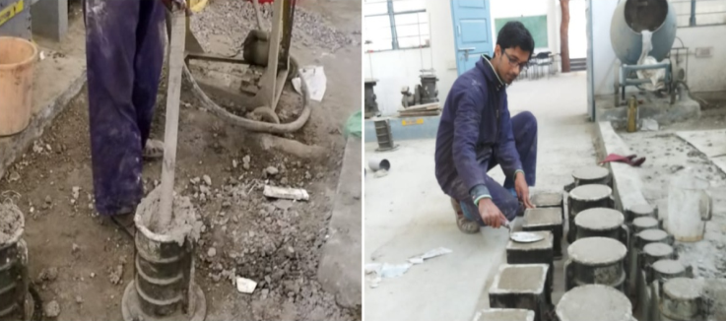

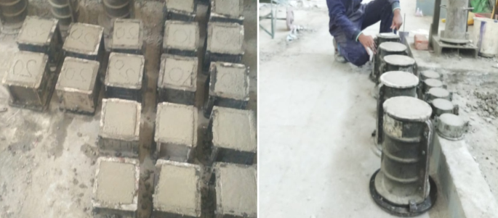
d
c
b
a

Fig.4 (a) Compaction of geopolymer concrete (b) Finishing Geopolymer concrete
(c) Cube Specimens cast for Compressive Strength
(d) Cylindrical Specimens for Split Tensile Test.
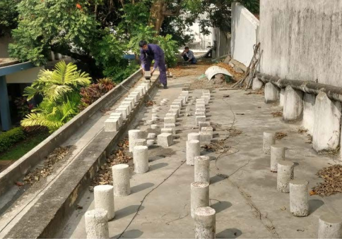
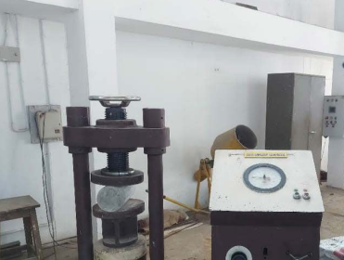
Fig.5 (a) Compressive Testing Machine (b) Specimens under sunlight curing
a
b
6.0 RESULTS AND DISCUSSIONS
As previously mentioned during the experimental procedure, three different classes of mixtures were prepared for the concentration of sodium hydroxide solution: 8M, 10M and 12M. The main purpose of this test is to study the effect of sodium hydroxide solution on the compressive and strength of fly ash base polymer concrete under sunlight curing. The molar concentration of the geopolymer mixture giving best results is considered in the next stage of experimental program.

Table 3 Compressive strength for varying (8M). MK at 28 day

S.No | Specimen | Metakaolin % | Average ultimate compressive load (KN) | Average cube compressive strength (MPa)
1 | GPM0 | 0% | 490 | 21.77
2 | GPM10 | 10% | 520 | 23.85
3 | GPM20 | 20% | 590 | 27.11
4 | GPM30 | 30% | 670 | 31.04
5 | GPM40 | 40% | 790 | 38.07
6 | GPM50 | 50% | 830 | 41.03

Table 4 Compressive strength for varying MK at 28 days (10M).
S.No | Specimen | Metakaolin % | Average ultimate compressive load (KN) | Average cube compressive strength (MPa)
1 | GPM0 | 0% | 550 | 24.44
2 | GPM10 | 10% | 570 | 27.7
3 | GPM20 | 20% | 600 | 31.25
4 | GPM30 | 30% | 640 | 38.36
5 | GPM40 | 40% | 690 | 41.03
6 | GPM50 | 50% | 730 | 45.02

Table 5 Compressive strength for varying MK at 28 days (12M).
S. No | Specimen | Metakaolin % | Average ultimate compressive load (KN) | Average cube compressive strength (MPa)
1 | GPM0 | 0% | 700 | 24.44
2 | GPM10 | 10% | 770 | 27.7
3 | GPM20 | 20% | 840 | 31.25
4 | GPM30 | 30% | 910 | 38.36
5 | GPM40 | 40% | 970 | 41.03
6 | GPM50 | 50% | 1320 | 45.02

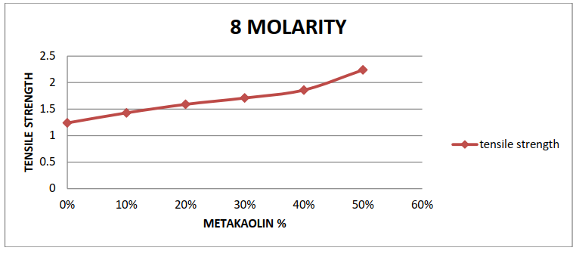
6.1 Effect of alkali activator concentration on split tensile strength

Fig.6 Graph showing variation of tensile strength vs various percentages of metakaolin for
8 molarity geopolymer concrete
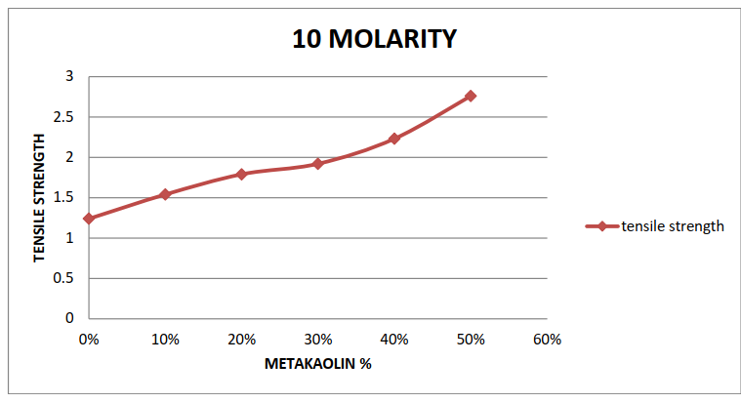
Fig.7 Graph showing variation of tensile strength vs various percentages of metakaolin for
10 molarity geopolymer concrete
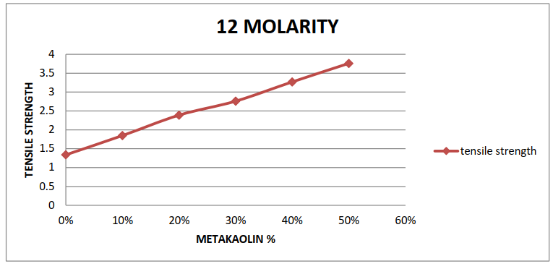
Fig.8 Graph showing variation of tensile strength vs various percentages of metakaolin for
12 molarity geopolymer concrete

6.1 Water absorption test
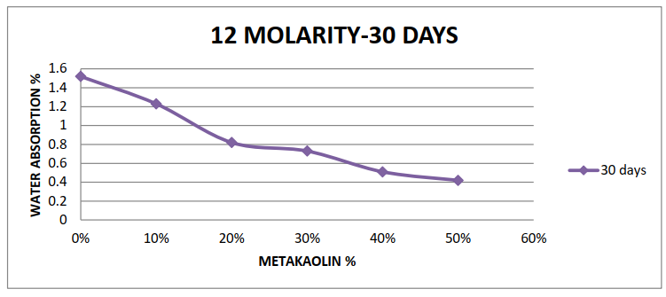
The 150mm dia x 50 mm height cylinder after casting were immersed in water for 28 days of sunlight curing. These specimens were then oven dried for 24 hours at the temperature 110°C until the mass became constant and again weighed. This weight was noted as the dry weight (W1) of the cylinder. After that the specimen was kept in hot water at 85°c for 3.5 hours.
Fig.8 Graph showing variation of water absorption with percentage metakaolin
6.2 Sorptivity test :
The sorptivity can be determined by the measurement of the capillary rise absorption rate on reasonably homogeneous material. Water was used of the test fluid. The cylinders after casting were put under sunlight curing for 30 days. Sorptivity (S) is a material property which characterizes the tendency of a porous material to absorb and transmit water by capillarity.
Table 6 Sorptivity (mm/min^{0.5}) at 28 days for 12M of GPC Varying metakaolin %

Concrete Mix | % replacement of metakaolin | Sorptivity coefficient in 10⁻⁵ mm/min^{0.5}
 |  | 30 mins | 60 mins | 90 mins | 120 mins
GPM0 | 0% | 3.2 | 3.4 | 3.6 | 4.8
GPM10 | 10% | 3 | 3.3 | 3.5 | 4.1
GPM20 | 20% | 2.8 | 3 | 3.3 | 3.5
GPM30 | 30% | 2.5 | 2.7 | 2.8 | 3
GPM40 | 40% | 1.5 | 1.7 | 1.9 | 2
GPM50 | 50% | 0.9 | 1.3 | 1.5 | 1.7
7.0 CONCLUSIONS :

- The molarity was changed from 8M to 10M, the compressive strength observed at 28 days increased by 15.7%, while the change from 10M to 12M was 23.3%.

- The molarity was changed from 8M to 10M, the tensile strength observed at 28 days increases by 7.3%, and when the number of moles is changed from 10M to 12M, only 13.4% is observed.

- For GPC mix with 8M concentration of NaOH solution, flyash can be replaced with 20% metakaolin at which maximum increase in strength by 22.5% compared to control mix is obtained.

- The split tensile strength of geopolymer concrete increase with increased in molaritity. It achieved desired strength up to 2.76 MPa.

- For 30 days 10% of metakaolin replacement with flyash GP-M10 decrease in water absorption is found to be 1.23% for GP-M20 is 0.82% and 0.73% for GP-M30 and sorptivity is found to be 3.2 mm/min^{0.5} for GP-M0 and 1.39 mm/min^{0.5} for GP-M50 with respect to control mix.

- The water absorption and sorptivity of fly ash based geopolymer concrete shows higher water absorption and sorptivity at 10% replacement with metakaolin. There after the water absorption and sorptivity deacreases.

8.0 REFERENCES

- Habeeb Lateef Muttashar, Mohd Azreen Mohd Ariffin, Shafiq Bin Ishq “SelfCompacting geopolymer concrete with spent garnet as sand replacement”. Elsevier, Journal of Building Engineering.Malaysia. (2018)
- Parveen, Dhirendra Singhal et al “ Mechanical and microstructural properties of fly ash based geopolymer concrete incorporating alccofine at ambient curing”. Elsevier, Construction and Building Materials (2018) 180.
- Bhikshma and T Naveen Kumar September “Mechanical properties of fly ash based geopolymer concrete with addition of GGBS”. The Indian concrete journal. (2016)
- P. Pavithra, M. Srinivasula Reddy, P. Dinakar Et Al “A mix design procedure for geopolymer concrete with flyash”. Elsevier, Journal of Cleaner Production (2016). IIT, Bhubaneswar.
- Muhd Fadhil Nuruddin, Ridho Bayuaji, H.Fansuri et al at Universiti Teknologi Petronas, Malaysia “Mechanical properties of MIHRA-Fly ash Geopolymer Concrete. Materials science forum (2015) vol.803.
- Pradip Nath, Prabir Kumar Sarker, Vijaya B Rangan “ Early age properties of lowcalcium fly ash geopolymer concrete suitable for ambient curing”. Department of civil engineering, Curtain University, Perth, Australia. Sicience direct (2015), Elsevier, Procedia engineering.
- B. Vijaya Rangan “Geopolymer concrete for environmental protection”. The Indian Concrete Journal (2014) – Special issue – Future Concrete.
- Kiatsuda Somna, Chai Jaturapitakkul et al “NaOH- activated ground fly ash geoploymer cured at ambient temperature”. University of Technology Thonburi, Bangkok, Thailand. Elsevier, Journal- Fuel (2011).

- Khatib J M, Baig S, Bougara A and Booth C Foundry Sand Utilization in Concrete Production, in: J. Zachar, P. Claisse, T.R. Naik, E. Ganjian (Eds.) Proc: Second International Conference on Sustainable Construction Materials and Technologies, (2010) :8. doi:ISBN 978-1-4507-1490-7.
- V. Bhikshma, M. Koti Reddy and T. Srinivas Rao “An experimental investigation on properties of geopolymer concrete ( no cement concrete )”. Asian Journal Of Civil Engineering (2010) (Building and Housing) VOL. 13, No.6.
- IS: 456-2000, “Plain and Reinforced Concrete - Code of Practice”, Bureau of Indian Standards.
- IS: 10262-2009, “Concrete mix proportioning-Guideline”, Bureau of Indian Standards.
- IS 516 -1959, “ Method of Tests for Strength of Concrete”, Bureau of Indian Standards.
- IS 4031-1988, “Methods of physical tests for hydraulic cement”, Bureau of Indian Standards.
- IS 383 -197, “Specification for Coarse and Fine Aggregates”, Bureau of Indian Standards.
- IS 2386- 1963,“Methods of test for aggregates forconcrete”, Bureau of Indian Standards.
- IS 1786-2008,“High strength deformed steel bars and wiresfor concrete reinforcement” , Bureau of Indian Standards.

