Multi-Response Optimization of Electro Chemical Discharge Machining Performances during Micro-Machining Operation of Silicon-wafer.

Ravindra Naik^{1*} Sathisha N²
¹Research scholar, Visvesvaraya Technological University, Belagavi, Karnataka, INDIA,
and Faculty, Department of Mechanical Engineering, Yenepoya Institute of Technology, Moodabidri, Mangaluru, Karnataka,INDIA-574225.
² Professor, Department of Mechanical Engineering, Yenepoya Institute of Technology, Moodabidri, Mangaluru, Karnataka,INDIA-574225.

*Corresponding Author: rhnayak77@gmail.com

Abstract
Silicon-wafer (Si-wafer) plays a vital role due to its semi-conducting nature. Parametric effects on Tool Wear Rate (TWR), Heat Affected Zone (HAZ) and Surface Roughness (SR) has been illustrated using NaOH + KOH with same percentage (%) in solution, altering Inter Electrode Gap (IEG) (mm), Duty Ratio, Electrolyte Concentration (wt.%), Voltage (V) and pulse on time (µs), during micro-machining of Silicon-wafer using WC micro-tool. Analysis of variances has been tested and mathematical models co-efficient are shown to analyze the fitness of experimental results and multi objective optimization has been propagated to minimize TWR, HAZ and SR using desirability analysis using Response Surface Methodology (RSM). The Scanning Electronic Microscopic analysis has been done to analyze the quality of Si-wafer micro-channel. It is found that multi-response optimization parametric combinations are 50.70V/48.23µs/40mm IEG/0.49 duty ratio/30wt% of NaOH and KOH of 1:1.
Keywords: µ-ECDM, SR, TWR, HAZ, Silicon-wafer, Tungsten carbide, Desirability Function, Mixed electrolyte.
1. INTRODUCTION
Electrochemical discharge micro-machining process is involved to cut micro-profile and channel on ceramics, quartz, composites, silicon carbide, silicon-wafer and various types of glass. Many more researchers did their works to full fill their targets and used various optimization techniques to reach their goals. Use of Neural Network (NN) based optimization by Evolutionary Algorithms (OEAs) is a demandable algorithm to the researchers as well as to the industrialist. Skrabalak et al. [1] proposed a model of fuzzy-logic control during ECDM process. Peng and Liao [2] found that when applied voltage was larger than the changeover voltage then material was removed. Wüthrich et al. [3] stated that ECDM had capability to cut several electrically non-conducting materials. Kim et al. [4] drilled glass wafers by electro chemical discharge machining (ECDM) process. Yang et al. [5] showed that difficult to cut brittle and high hardness materials by traditional machining (TM). Sarkar et al. [6] showed application of ECDM for micro-drilling of silicon nitride. Bhondwe et al. [7] studied the material removal mechanism of electro-chemical spark machining (ECSM). Han et al. [8] conducted experiments using tungsten carbide (WC) tool of diameter of 200 µm at 30% electrolyte concentration and 35Volt. Chak and Rao [9] fabricated holes on aluminium oxide (Al₂O₃) by ECDM. Furutani and Maeda [10] showed that the tool electrode wear rate could decrease by increasing of the rotation speed of micro-tool. Jain and Adhikari [11] showed that overcut and surface roughness become larger when reverse polarity was used. Wuthrich et al. [12] fabricated threads on non-conducting materials by ECDM. Liu et al. [13] proposed that high current reduced MRR and quality of micro-channel. Cao et al. [14] achieved good surface microstructures and higher machining depth during ECDM process. Liu et al. [15] first time cut reinforced metal matrix composite by ECDM. Wüthrich and Allagui [16] stated that high heat was generated during micro-machining operation by ECDM. Yang et al. [17] stated that the tool electrode (200mm) was fabricated by wire electrical discharge grinding (WEDG). Khas and Manna [18] used EDM and ECM sequentially for machining of aluminium-oxide (Al₂O₃). Cheng et al. [19] showed that quality of gas film was an important factor for good surface quality. Wei et al. [20] evaluated the dressing performance of ECDD in terms of surface morphology of the tool. Yang et al. [21] reported that spherical tool reduced the contact area between the tool and the job specimen. Mochimaru et al. [22] fabricated the smallest diameter of micro hole of 12μm diameter. Jawalkar et al. [23] presented that the applied voltage had dominating power in both MR and TWR. Jana et al. [24] demonstrated that the machining depth decreased when the speed was increased. Mallick et. al. [25] used different electrolyte and different shapes of tool to improved machining rate of micro-ECDM process. Mallick et al. also [26-31] used various optimization techniques like RSM, GA, and RSM-GA.
But most of the work is based on quartz or ceramics, glass, but till date very few are working using silicon-wafer which is a semi-conducting material.

2. EXPERIMENTAL µ-ECDM SETUP and METHODOLOGY
To investigate the objectives of present research work and to control the process parameters such as machining voltage, inter electrode gap, pulse on time, duty ratio and electrolyte concentrations etc., an experimental µ-ECDM micro-set-up was used for micro-machining operation for semi-conducting material like silicon-wafer. Figure 1 shows the schematic diagram of µ-ECDM experimental set-up which consists of X,Y and Z axis tool movement and fixing with automated spring feed mechanism along vertical axis.
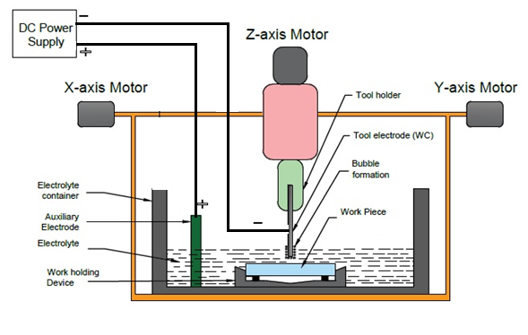
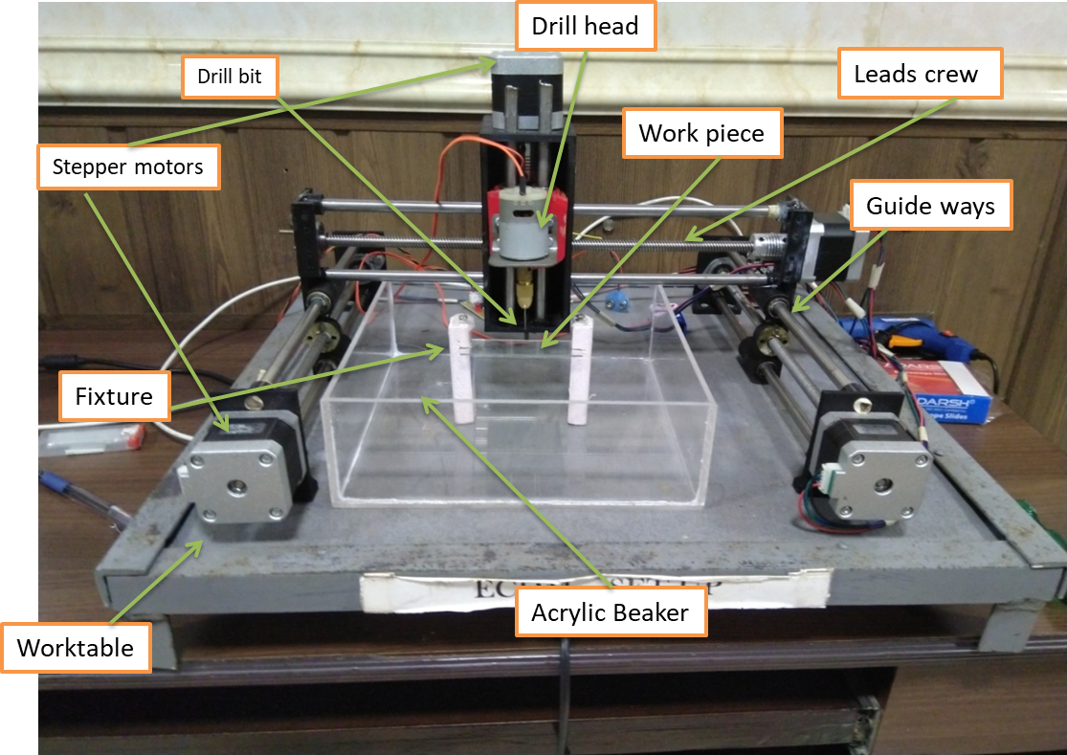
Fig.1(a). Schematic diagram of µ-ECDM Experimental set-up

Fig.1(b) µ-ECDM Experimental set up
The input parameters are applied voltage (50-60V), pulse on time (45-55µs), inter-electrode gap (IEG) (30-40mm), duty ratio (0.45-0.55) and electrolyte concentration (20-30wt. %). Stand-off distance (0.5mm fixed) and Pulse frequency is kept fixed 200Hz.Trial and Error methods have been followed to choose the range of process parameters. Design of experiments (DOE) has been done using response surface methodology (RSM), face centred design of experiments for desirability function analysis -1, 0, +1 is chosen for the level of process parameters.
3. EXPERIMENTAL RESULTS ANALYSIS
Table.1 Shows the experimental design and test results.
 | Input parameters |  |  |  |  | Out responses
Run  Order | VOLTAGE  (V) | PULSE ON TIME  (µs) | IEG  (mm) | DUTY RATIO | ELECTROLYTECON. (wt%) | SURFACE ROUGHNESS  (R_{a}) (µm) | TWR  (mg/hr) | HAZ  (µm²) x 10³
1 | 50 | 45 | 30 | 0.45 | 30 | 1.15 | 0.030 | 210.210
2 | 60 | 45 | 30 | 0.45 | 20 | 2.16 | 0.039 | 293.250
3 | 50 | 55 | 30 | 0.45 | 20 | 1.46 | 0.038 | 282.040
4 | 60 | 55 | 30 | 0.45 | 30 | 2.61 | 0.042 | 362.110
5 | 50 | 45 | 40 | 0.45 | 20 | 1.6 | 0.033 | 237.700
6 | 60 | 45 | 40 | 0.45 | 30 | 2.06 | 0.033 | 234.320
7 | 50 | 55 | 40 | 0.45 | 30 | 1.15 | 0.031 | 219.400
8 | 60 | 55 | 40 | 0.45 | 20 | 1.86 | 0.033 | 235.770
9 | 50 | 45 | 30 | 0.55 | 20 | 1.09 | 0.017 | 277.730
10 | 60 | 45 | 30 | 0.55 | 30 | 1.85 | 0.039 | 302.230
11 | 50 | 55 | 30 | 0.55 | 30 | 1.01 | 0.038 | 292.230
12 | 60 | 55 | 30 | 0.55 | 20 | 2.7 | 0.033 | 232.700
13 | 50 | 45 | 40 | 0.55 | 30 | 1.14 | 0.031 | 221.600
14 | 60 | 45 | 40 | 0.55 | 20 | 1.87 | 0.033 | 241.110
15 | 50 | 55 | 40 | 0.55 | 20 | 1.85 | 0.030 | 201.800
16 | 60 | 55 | 40 | 0.55 | 30 | 2.97 | 0.039 | 305.110
17 | 50 | 50 | 35 | 0.50 | 25 | 1.06 | 0.033 | 237.250
18 | 60 | 50 | 35 | 0.50 | 25 | 2.15 | 0.037 | 302.210
19 | 55 | 45 | 35 | 0.50 | 25 | 1.98 | 0.028 | 192.110
20 | 55 | 55 | 35 | 0.50 | 25 | 2.35 | 0.036 | 271.640
21 | 55 | 50 | 30 | 0.50 | 25 | 1.30 | 0.023 | 132.150
22 | 55 | 50 | 40 | 0.50 | 25 | 1.68 | 0.019 | 98.695
23 | 55 | 50 | 35 | 0.45 | 25 | 2.08 | 0.037 | 286.560
24 | 55 | 50 | 35 | 0.55 | 25 | 2.29 | 0.038 | 276.210
25 | 55 | 50 | 35 | 0.50 | 20 | 2.04 | 0.025 | 150.720
26 | 55 | 50 | 35 | 0.50 | 30 | 2.07 | 0.026 | 180.520
27 | 55 | 50 | 35 | 0.50 | 25 | 2.02 | 0.026 | 179.110
28 | 55 | 50 | 35 | 0.50 | 25 | 2.00 | 0.027 | 173.820
29 | 55 | 50 | 35 | 0.50 | 25 | 2.01 | 0.027 | 175.160
30 | 55 | 50 | 35 | 0.50 | 25 | 2.02 | 0.027 | 173.820
31 | 55 | 50 | 35 | 0.50 | 25 | 2.01 | 0.027 | 175.330
32 | 55 | 50 | 35 | 0.50 | 25 | 2.02 | 0.027 | 174.120

3.1 Empirical Modelling Co-efficient and ANOVA Performances of SR, TWR and HAZ
Estimated regression co-efficient of SR, TWR and HAZ are performed and also analyzed based on their observations of table 2 to 7 and obviously clear that findings results are indicates the fitness of experimental results. An ANOVA of P value and F-ratio test as well as R² and Adj.R² were analysed to certify the actual fitness of the experimental results of TWR, HAZ and surface roughness. Standard P value (0.5) which depends on degree of freedom of lack of error for TWR, HAZ and surface roughness, and 95% confidence level with degrees of freedom (DOF 5) indicates the desirability level of 0.95 that also indicates the better solution of the conducted experiments.

Table.2 Shows the Estimated Regression Coefficients for Surface roughness (R_{a}) (µm)
Term | Coef | SE Coef | T | P
Constant | 1.97044 | 0.02627 | 75.003 | 0.000
Voltage(V) | 0.48444 | 0.02167 | 22.358 | 0.000
Pulse on time(µs) | 0.17000 | 0.02167 | 7.846 | 0.000
IEG(Mm) | 0.04722 | 0.02167 | 2.179 | 0.052
Duty Ratio | 0.03556 | 0.02167 | 1.641 | 0.129
Electrolyte Con.(Wt%) | -0.03444 | 0.02167 | -1.590 | 0.140
Voltage(V)*Voltage(V) | -0.33327 | 0.05860 | -5.687 | 0.000
Pulse on time(µs)*Pulse on time(µs) | 0.22673 | 0.05860 | 3.869 | 0.003
IEG(Mm)*IEG(Mm) | -0.44827 | 0.05860 | -7.649 | 0.000
Duty Ratio*Duty Ratio | 0.24673 | 0.05860 | 4.210 | 0.001
Electrolyte Con.(Wt%)*  Electrolyte Con.(Wt%) | 0.11673 | 0.05860 | 1.992 | 0.072
Voltage(V)*Pulse on time(µs) | 0.10688 | 0.02298 | 4.650 | 0.001
Voltage(V)*IEG(Mm) | -0.09938 | 0.02298 | -4.324 | 0.001
Voltage(V)*Duty Ratio | 0.06062 | 0.02298 | 2.638 | 0.023
Voltage (V)*Electrolyte Con.(Wt%) | 0.15313 | 0.02298 | 6.663 | 0.000
Pulse on time(µs)*IEG(Mm) | -0.02312 | 0.02298 | -1.006 | 0.336
Pulse on time(µs)*Duty Ratio | 0.15437 | 0.02298 | 6.717 | 0.000
Pulse on time(µs)*  Electrolyte Con.(Wt%) | 0.02438 | 0.02298 | 1.061 | 0.312
IEG(Mm)*Duty Ratio | 0.11812 | 0.02298 | 5.140 | 0.000
IEG(Mm)*Electrolyte Con.(Wt%) | 0.05813 | 0.02298 | 2.529 | 0.028
Duty Ratio*Electrolyte Con.(Wt%) | -0.02687 | 0.02298 | -1.169 | 0.267

S = 0.0919277 PRESS = 6.79073
R-Sq = 98.76% R-Sq(pred) = 9.16% R-Sq(adj) = 96.50%

Table.3 Shows Analysis of Variance for Surface Roughness (R_{a}) (µm)

Source | DF | Seq SS | Adj SS | Adj MS | F | P
Regression | 20 | 7.38269 | 7.38269 | 0.36913 | 43.68 | 0.000
Linear | 5 | 4.82881 | 4.82881 | 0.96576 | 114.28 | 0.000
VOLTAGE(V) | 1 | 4.22436 | 4.22436 | 4.22436 | 499.88 | 0.000
PULSE ON TIME(µS) | 1 | 0.52020 | 0.52020 | 0.52020 | 61.56 | 0.000
IEG(MM) | 1 | 0.04014 | 0.04014 | 0.04014 | 4.75 | 0.052
DUTY RATIO | 1 | 0.02276 | 0.02276 | 0.02276 | 2.69 | 0.129
ELECTROLYTE CON.(WT%) | 1 | 0.02136 | 0.02136 | 0.02136 | 2.53 | 0.140
Square | 5 | 1.09092 | 1.09092 | 0.21818 | 25.82 | 0.000
VOLTAGE(V)*VOLTAGE(V) | 1 | 0.40715 | 0.27331 | 0.27331 | 32.34 | 0.000
PULSE ON TIME(µS)*PULSE ON TIME(µS) | 1 | 0.12673 | 0.12650 | 0.12650 | 14.97 | 0.003
IEG(MM)*IEG(MM) | 1 | 0.32894 | 0.49448 | 0.49448 | 58.51 | 0.000
DUTY RATIO*DUTY RATIO | 1 | 0.19457 | 0.14981 | 0.14981 | 17.73 | 0.001
ELECTROLYTE CON.(WT%)*  ELECTROLYTE CON.(WT%) | 1 | 0.03353 | 0.03353 | 0.03353 | 3.97 | 0.072
Interaction | 10 | 1.46296 | 1.46296 | 0.14630 | 17.31 | 0.000
VOLTAGE(V)*PULSE ON TIME(µS) | 1 | 0.18276 | 0.18276 | 0.18276 | 21.63 | 0.001
VOLTAGE(V)*IEG(MM) | 1 | 0.15801 | 0.15801 | 0.15801 | 18.70 | 0.001
VOLTAGE(V)*DUTY RATIO | 1 | 0.05881 | 0.05881 | 0.05881 | 6.96 | 0.023
VOLTAGE (V)*ELECTROLYTE CON.(WT%) | 1 | 0.37516 | 0.37516 | 0.37516 | 44.39 | 0.000
PULSE ON TIME(µS)*IEG(MM) | 1 | 0.00856 | 0.00856 | 0.00856 | 1.01 | 0.336
PULSE ON TIME(µS)*DUTY RATIO | 1 | 0.38131 | 0.38131 | 0.38131 | 45.12 | 0.000
PULSE ON TIME (µS) * ELECTROLYTE CON.(WT%) | 1 | 0.00951 | 0.00951 | 0.00951 | 1.12 | 0.312
IEG(MM)*DUTY RATIO | 1 | 0.22326 | 0.22326 | 0.22326 | 26.42 | 0.000
IEG(MM)*ELECTROLYTE CON.(WT%) | 1 | 0.05406 | 0.05406 | 0.05406 | 6.40 | 0.028
DUTY RATIO*ELECTROLYTE CON. (WT%) | 1 | 0.01156 | 0.01156 | 0.01156 | 1.37 | 0.267
Residual Error | 11 | 0.09296 | 0.09296 | 0.00845 | 231.56 | 0.000
Lack-Of-Fit | 6 | 0.09262 | 0.09262 | 0.01544
Pure Error | 5 | 0.00033 | 0.00033 | 0.00007
Total | 31 | 7.47565

Table.4 Shows Estimated Regression Coefficients for TWR (mg/hr)

Term | Coef | SE Coef | T | P
Constant | 0.028106 | 0.000540 | 52.029 | 0.000
VOLTAGE(V) | 0.002611 | 0.000446 | 5.861 | 0.000
PULSE ON TIME(µs) | 0.002056 | 0.000446 | 4.614 | 0.001
IEG(mm) | -0.000944 | 0.000446 | -2.120 | 0.058
DUTY RATIO | -0.001000 | 0.000446 | -2.245 | 0.046
ELECTROLYTE CON.(wt%) | 0.001556 | 0.000446 | 3.492 | 0.005
VOLTAGE(V)*VOLTAGE(V) | 0.005940 | 0.001205 | 4.930 | 0.000
PULSE ON TIME(µs)*PULSE ON TIME(µs) | 0.002940 | 0.001205 | 2.440 | 0.033
IEG(mm)*IEG(mm) | -0.008060 | 0.001205 | -6.689 | 0.000
DUTY RATIO*DUTY RATIO | 0.008440 | 0.001205 | 7.005 | 0.000
ELECTROLYTE CON.(wt%)*  ELECTROLYTE CON.(wt%) | -0.003560 | 0.001205 | -2.954 | 0.013
VOLTAGE(V)*PULSE ON TIME(µs) | -0.001437 | 0.000473 | -3.042 | 0.011
VOLTAGE(V)*IEG(mm) | -0.001063 | 0.000473 | -2.248 | 0.046
VOLTAGE(V)*DUTY RATIO | 0.000812 | 0.000473 | 1.719 | 0.114
VOLTAGE(V)*ELECTROLYTE CON.(wt%) | 0.000188 | 0.000473 | 0.397 | 0.699
PULSE ON TIME(µs)*IEG(mm) | -0.001438 | 0.000473 | -3.042 | 0.011
PULSE ON TIME(µs)*DUTY RATIO | 0.000687 | 0.000473 | 1.455 | 0.174
PULSE ON TIME(µs)*  ELECTROLYTE CON.(wt%) | 0.000313 | 0.000473 | 0.661 | 0.522
IEG(mm)*DUTY RATIO | 0.001562 | 0.000473 | 3.307 | 0.007
IEG(mm)*ELECTROLYTE CON.(wt%) | -0.001063 | 0.000473 | -2.248 | 0.046
DUTY RATIO*ELECTROLYTE CON.(wt%) | 0.002562 | 0.000473 | 5.423 | 0.000

S = 0.00189019 PRESS = 0.00201773

R-Sq = 96.61% R-Sq(pred) = 0.00% R-Sq(adj) = 90.44%

Table.5 Shows Analysis of Variance for TWR (mg/hr)
Source | DF | Seq SS | Adj SS | Adj MS | F | P
Regression | 20 | 0.001120 | 0.001120 | 0.000056 | 15.67 | 0.000
Linear | 5 | 0.000276 | 0.000276 | 0.000055 | 15.47 | 0.000
VOLTAGE(V) | 1 | 0.000123 | 0.000123 | 0.000123 | 34.35 | 0.000
PULSE ON TIME(µs) | 1 | 0.000076 | 0.000076 | 0.000076 | 21.29 | 0.001
IEG(mm) | 1 | 0.000016 | 0.000016 | 0.000016 | 4.49 | 0.058
DUTY RATIO | 1 | 0.000018 | 0.000018 | 0.000018 | 5.04 | 0.046
ELECTROLYTE CON.(wt%) | 1 | 0.000044 | 0.000044 | 0.000044 | 12.19 | 0.005
Square | 5 | 0.000577 | 0.000577 | 0.000115 | 32.27 | 0.000
VOLTAGE(V)*VOLTAGE(V) | 1 | 0.000261 | 0.000087 | 0.000087 | 24.30 | 0.000
PULSE ON TIME(µs)*PULSE ON TIME(µs) | 1 | 0.000009 | 0.000021 | 0.000021 | 5.95 | 0.033
IEG(mm)*IEG(mm) | 1 | 0.000124 | 0.000160 | 0.000160 | 44.74 | 0.000
DUTY RATIO*DUTY RATIO | 1 | 0.000151 | 0.000175 | 0.000175 | 49.07 | 0.000
ELECTROLYTE CON.(wt%)*  ELECTROLYTE CON.(wt%) | 1 | 0.000031 | 0.000031 | 0.000031 | 8.73 | 0.013
Interaction | 10 | 0.000267 | 0.000267 | 0.000027 | 7.46 | 0.001
VOLTAGE(V)*PULSE ON TIME(µs) | 1 | 0.000033 | 0.000033 | 0.000033 | 9.25 | 0.011
VOLTAGE(V)*IEG(mm) | 1 | 0.000018 | 0.000018 | 0.000018 | 5.06 | 0.046
VOLTAGE(V)*DUTY RATIO | 1 | 0.000011 | 0.000011 | 0.000011 | 2.96 | 0.114
VOLTAGE(V)*ELECTROLYTE CON.(wt%) | 1 | 0.000001 | 0.000001 | 0.000001 | 0.16 | 0.699
PULSE ON TIME(µs)*IEG(mm) | 1 | 0.000033 | 0.000033 | 0.000033 | 9.25 | 0.011
PULSE ON TIME(µs)*DUTY RATIO | 1 | 0.000008 | 0.000008 | 0.000008 | 2.12 | 0.174
PULSE ON TIME(µs)*  ELECTROLYTE CON.(wt%) | 1 | 0.000002 | 0.000002 | 0.000002 | 0.44 | 0.522
IEG(mm)*DUTY RATIO | 1 | 0.000039 | 0.000039 | 0.000039 | 10.93 | 0.007
IEG(mm)*ELECTROLYTE CON.(wt%) | 1 | 0.000018 | 0.000018 | 0.000018 | 5.06 | 0.046
DUTY RATIO*ELECTROLYTE CON.(wt%) | 1 | 0.000105 | 0.000105 | 0.000105 | 29.41 | 0.000
Residual Error | 11 | 0.000039 | 0.000039 | 0.000004 | - | -
Lack-of-Fit | 6 | 0.000038 | 0.000038 | 0.000006 | 38.47 | 0.001
Pure Error | 5 | 0.000001 | 0.000001 | 0.000000
Total | 31 | 0.001159

Table.6 Estimated Regression Coefficients for HAZ (µm²)

Term | Coef | SE Coef | T | P
Constant | 188.459 | 5.843 | 32.256 | 0.000
VOLTAGE(V) | 18.269 | 4.819 | 3.791 | 0.003
PULSE ON TIME(µs) | 10.697 | 4.819 | 2.220 | 0.048
IEG(mm) | -21.619 | 4.819 | -4.486 | 0.001
DUTY RATIO | -0.591 | 4.819 | -0.123 | 0.905
ELECTROLYTE CON.(wt%) | 9.717 | 4.819 | 2.017 | 0.069
VOLTAGE(V)*VOLTAGE(V) | 71.346 | 13.033 | 5.474 | 0.000
PULSE ON TIME(µs)*PULSE ON TIME(µs) | 33.491 | 13.033 | 2.570 | 0.026
IEG(mm)*IEG(mm) | -82.961 | 13.033 | -6.366 | 0.000
DUTY RATIO*DUTY RATIO | 83.001 | 13.033 | 6.369 | 0.000
ELECTROLYTE CON.(wt%)*  ELECTROLYTE CON.(wt%) | -32.764 | 13.033 | -2.514 | 0.029
VOLTAGE(V)*PULSE ON TIME(µs) | 1.034 | 5.111 | 0.202 | 0.843
VOLTAGE(V)*IEG(mm) | 0.483 | 5.111 | 0.095 | 0.926
VOLTAGE(V)*DUTY RATIO | -5.519 | 5.111 | -1.080 | 0.303
VOLTAGE(V)*ELECTROLYTE CON.(wt%) | 16.048 | 5.111 | 3.140 | 0.009
PULSE ON TIME(µs)*IEG(mm) | -3.644 | 5.111 | -0.713 | 0.491
PULSE ON TIME(µs)*DUTY RATIO | -8.417 | 5.111 | -1.647 | 0.128
PULSE ON TIME(µs)*  ELECTROLYTE CON.(wt%) | 19.248 | 5.111 | 3.766 | 0.003
IEG(mm)*DUTY RATIO | 5.322 | 5.111 | 1.041 | 0.320
IEG(mm)*ELECTROLYTE CON.(wt%) | -1.063 | 5.111 | -0.208 | 0.839
DUTY RATIO*ELECTROLYTE CON.(wt%) | 11.909 | 5.111 | 2.330 | 0.040

S = 20.4441 PRESS = 256448
R-Sq = 95.82% R-Sq(pred) = 0.00% R-Sq(adj) = 88.23%

Table.7 Shows Analysis of Variance for HAZ (µm²)

Source | DF | Seq SS | Adj SS | Adj MS | F | P
Regression | 20 | 105496 | 105496 | 5274.8 | 12.62 | 0.000
Linear | 5 | 18186 | 18186 | 3637.3 | 8.70 | 0.001
VOLTAGE(V) | 1 | 6008 | 6008 | 6007.9 | 14.37 | 0.003
PULSE ON TIME(µs) | 1 | 2060 | 2060 | 2059.5 | 4.93 | 0.048
IEG(mm) | 1 | 8413 | 8413 | 8413.0 | 20.13 | 0.001
DUTY RATIO | 1 | 6 | 6 | 6.3 | 0.02 | 0.905
ELECTROLYTE CON.(wt%) | 1 | 1700 | 1700 | 1699.6 | 4.07 | 0.069
Square | 5 | 72666 | 72666 | 14533.2 | 34.77 | 0.000
VOLTAGE(V)*VOLTAGE(V) | 1 | 40731 | 12526 | 12526.1 | 29.97 | 0.000
PULSE ON TIME(µs)*PULSE ON TIME(µs) | 1 | 1329 | 2760 | 2760.2 | 6.60 | 0.026
IEG(mm)*IEG(mm) | 1 | 13169 | 16937 | 16936.6 | 40.52 | 0.000
DUTY RATIO*DUTY RATIO | 1 | 14795 | 16953 | 16952.8 | 40.56 | 0.000
ELECTROLYTE CON.(wt%)*ELECTROLYTE CON.(wt%) | 1 | 2642 | 2642 | 2641.6 | 6.32 | 0.029
Interaction | 10 | 14643 | 14643 | 1464.3 | 3.50 | 0.026
VOLTAGE(V)*PULSE ON TIME(µs) | 1 | 17 | 17 | 17.1 | 0.04 | 0.843
VOLTAGE(V)*IEG(mm) | 1 | 4 | 4 | 3.7 | 0.01 | 0.926
VOLTAGE(V)*DUTY RATIO | 1 | 487 | 487 | 487.4 | 1.17 | 0.303
VOLTAGE(V)*ELECTROLYTE CON.(wt%) | 1 | 4121 | 4121 | 4120.7 | 9.86 | 0.009
PULSE ON TIME(µs)*IEG(mm) | 1 | 213 | 213 | 212.5 | 0.51 | 0.491
PULSE ON TIME(µs)*DUTY RATIO | 1 | 1134 | 1134 | 1133.5 | 2.71 | 0.128
PULSE ON TIME(µs)*ELECTROLYTE CON.(wt%) | 1 | 5928 | 5928 | 5927.8 | 14.18 | 0.003
IEG(mm)*DUTY RATIO | 1 | 453 | 453 | 453.2 | 1.08 | 0.320
IEG(mm)*ELECTROLYTE CON.(wt%) | 1 | 18 | 18 | 18.1 | 0.04 | 0.839
DUTY RATIO*ELECTROLYTE CON.(wt%) | 1 | 2269 | 2269 | 2269.3 | 5.43 | 0.040
Residual Error | 11 | 4598 | 4598 | 418.0 | - | -
Lack-of-Fit | 6 | 4577 | 4577 | 762.9 | 188.11 | 0.000
Pure Error | 5 | 20 | 20 | 4.1
Total | 31 | 110093

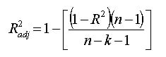 ------------------------------------------- (1)
Where n = Number of points
& k= Number of variables in models.
  - Parametric Influences on SR, TWR and HAZ

Figures 2(a) - (e), 3(a) - (e), 4(a) - (e), present the parametric analysis plot of electrolyte concentration, applied voltage, duty ratio inter electrode gap and pulse on time, on TWR, HAZ and surface roughness respectively. From the Figures 2(a)-(e) it is found that SR become higher due to raise of duty ratio, pulse on time, applied voltage as well as electrolyte concentration and becomes less if inter electrode gap is amplified. For analysis the parametric influences on machining criteria, two parameters are altered and others are remaining constant on the middle value and also all fixed parameters are reserved constant. From the Figures 3(a)-(e) it is predicted that TWR becomes higher due to raise of pulse-on time, duty ratio, applied voltage as well as electrolyte concentration and becomes less if inter-electrode gap (IEG) is increased because the rate of discharge becomes less. If IEG is enlarged, side sparking occurs and HAZ is greater than before. From the Figures 4(a)-(e) it is noticeable that more HAZ creates due to increase of electrolyte concentration, pulse-on time, duty ratio and applied voltage and HAZ becomes less if IEG is near about 40mm as sparking rate become continuous and side sparking rate decreases.
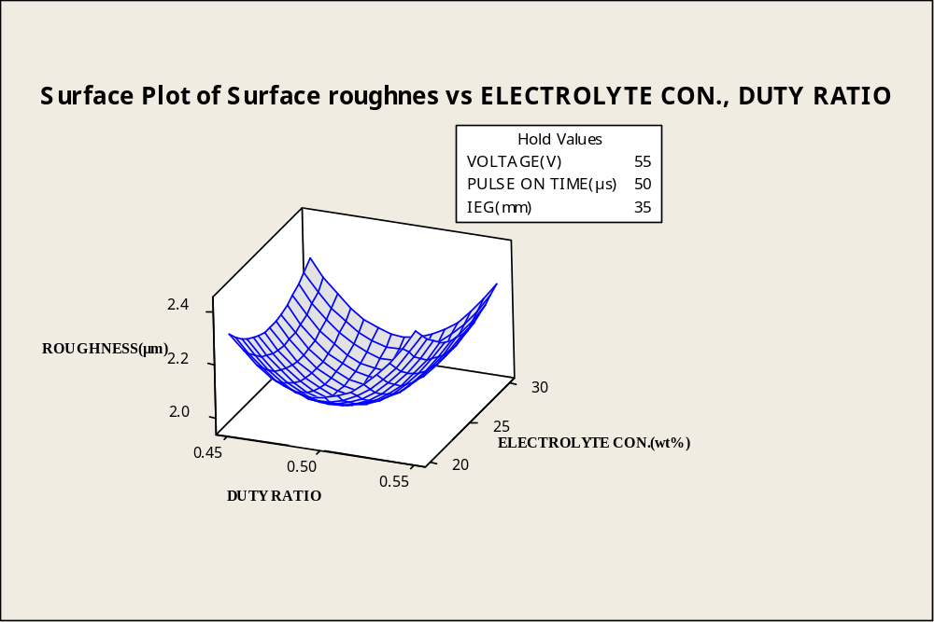
(a) Effect of Electrolyte Concentration and Duty Ratio on Surface Roughness
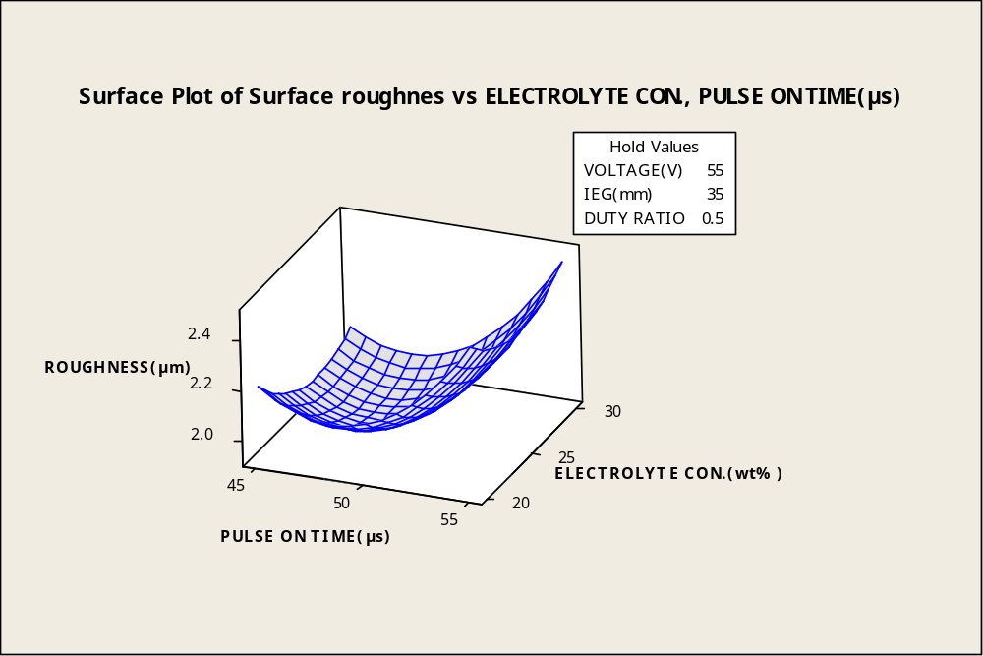(b) Effect of Electrolyte Concentration and Pulse-on Time on Surface Roughness

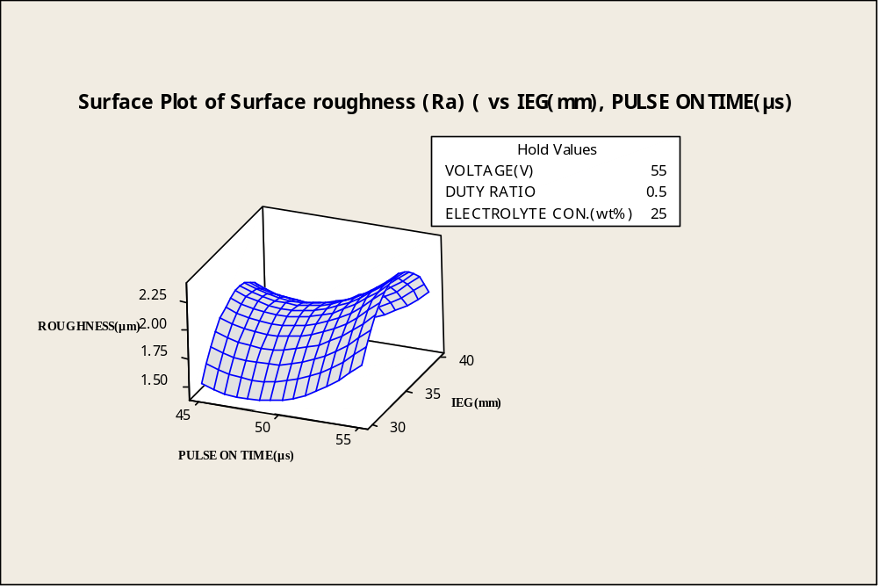
(c) Effect of Inter Electrode gap and Pulse-on time on Surface Roughness
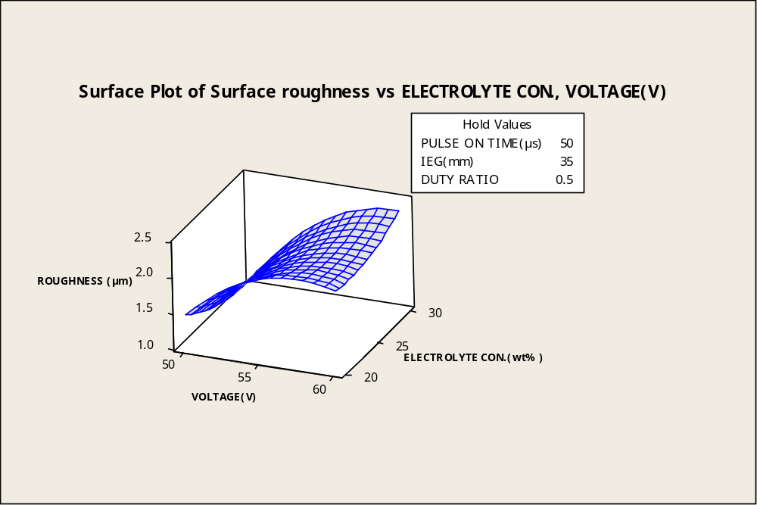
(d) Effect of Electrolyte Concentration and Applied Voltage on Surface Roughness
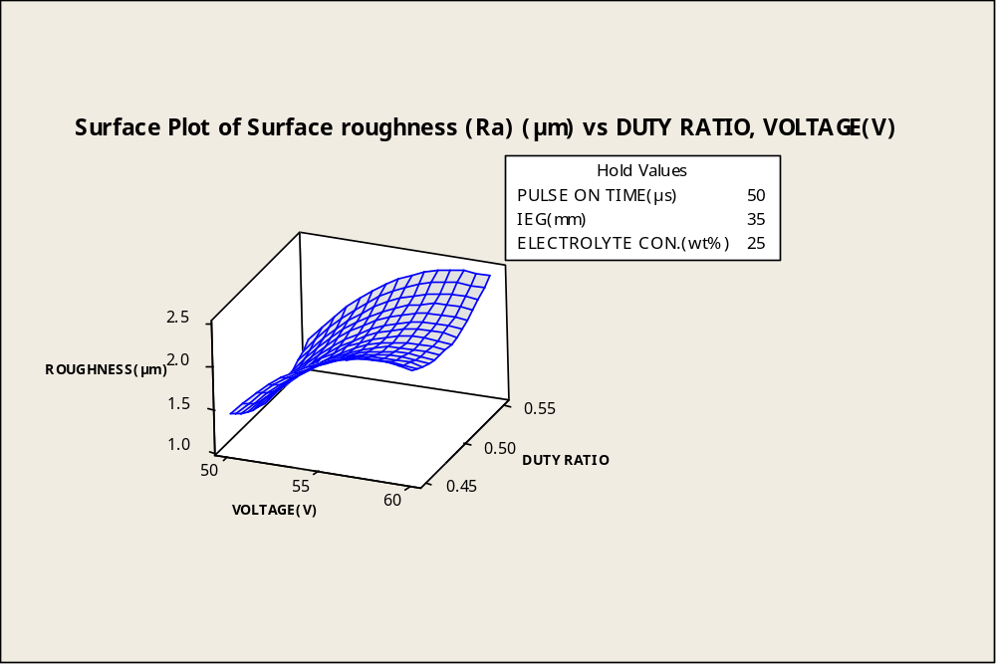
(e) Effect of Duty Ratio and Applied Voltage on Surface Roughness
Fig. 2 (a) - (e) Effect of Electrolyte Concentration, Duty Ratio Pulse on time, Applied Voltage, , Inter Electrode Gap (IEG) and on Surface Roughness

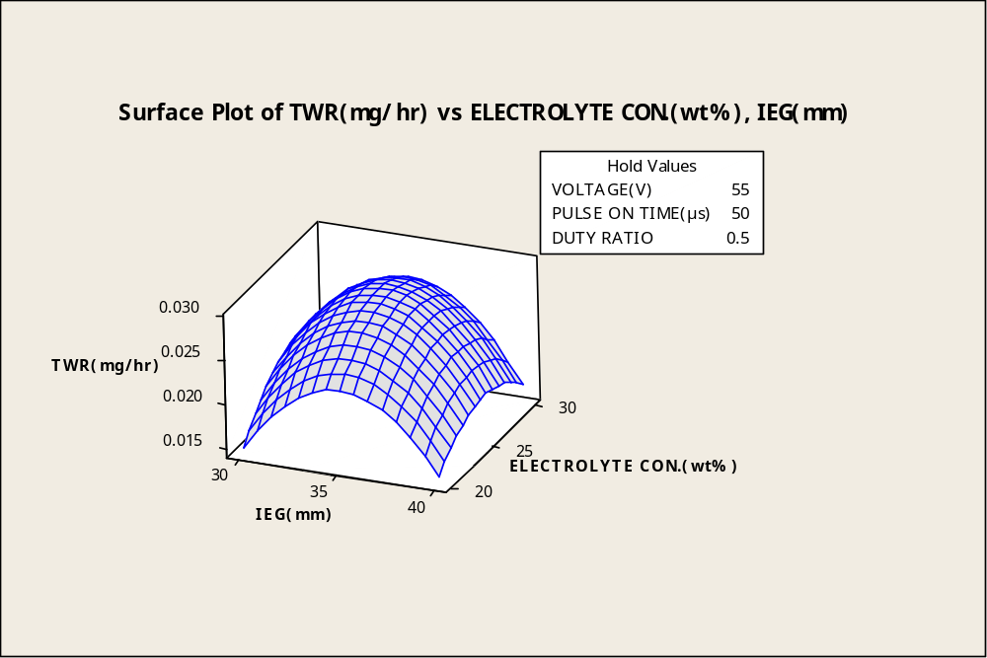
- Effect of Electrolyte Concentration and IEG on TWR
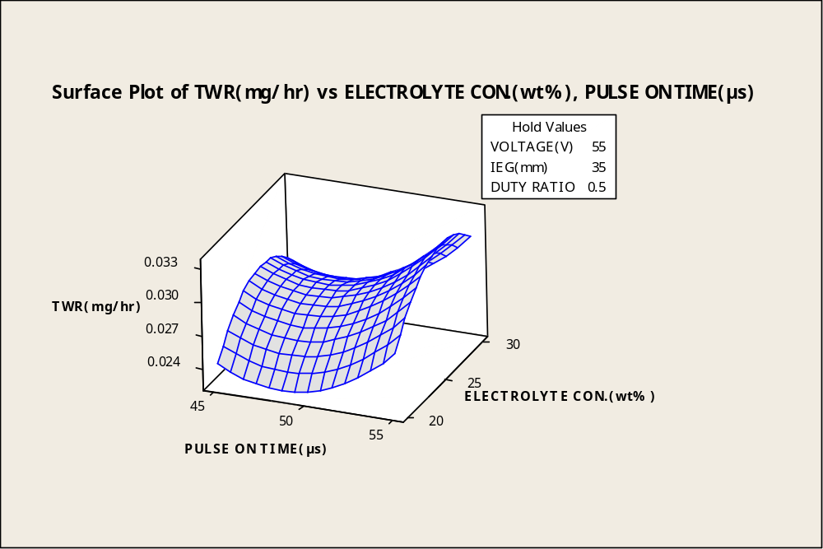
- Effect of Electrolyte concentration and Pulse-on time on TWR

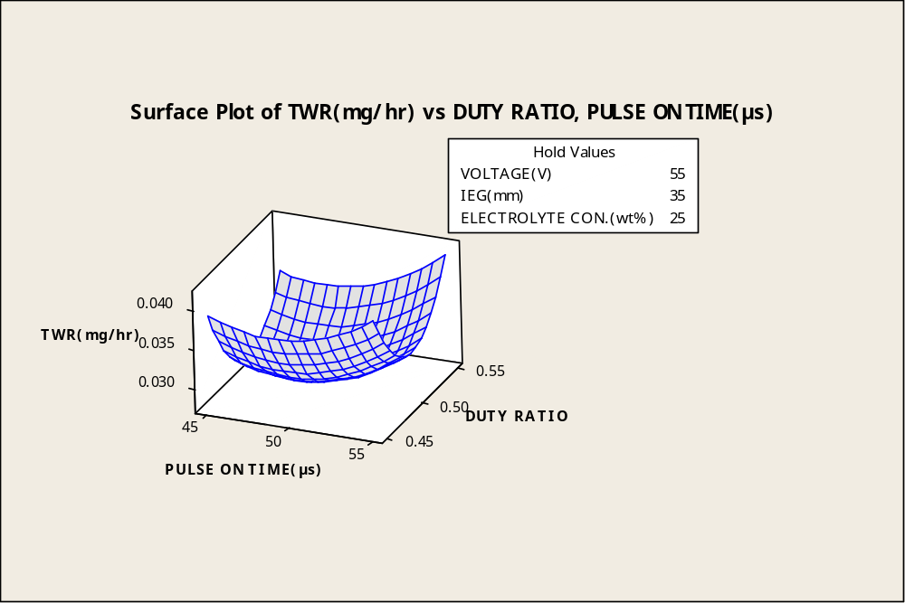
- Effect of Duty Ratio and Pulse on time on TWR
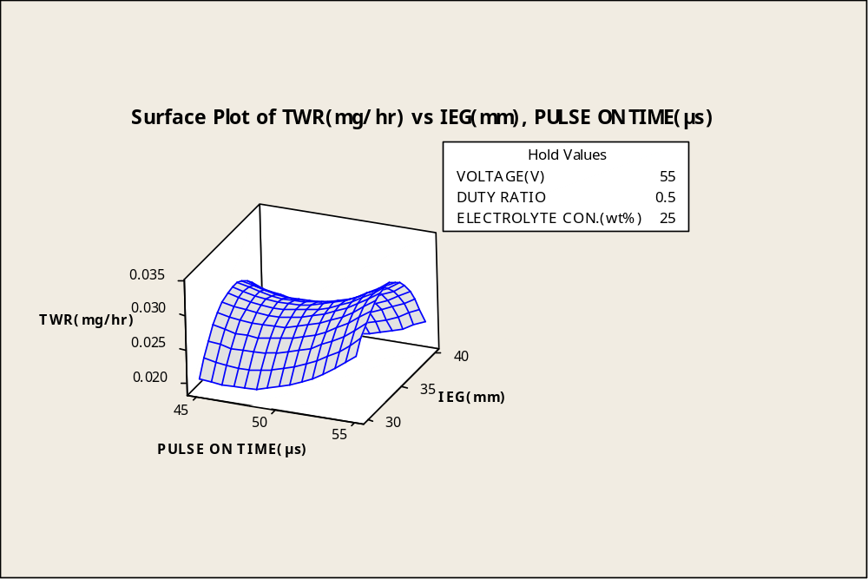
(d) Effect of Pulse-on time and IEG on TWR

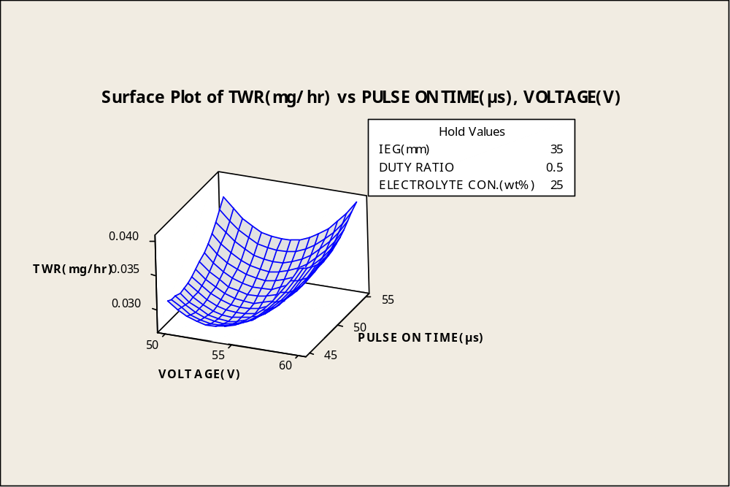
(e) Effect of Pulse-on time and applied Voltage on TWR
Fig. 3 (a) - (e) Effect of Electrolyte Concentration, Duty Ratio, Inter electrode gap (IEG) Applied Voltage, Pulse on time, and on TWR

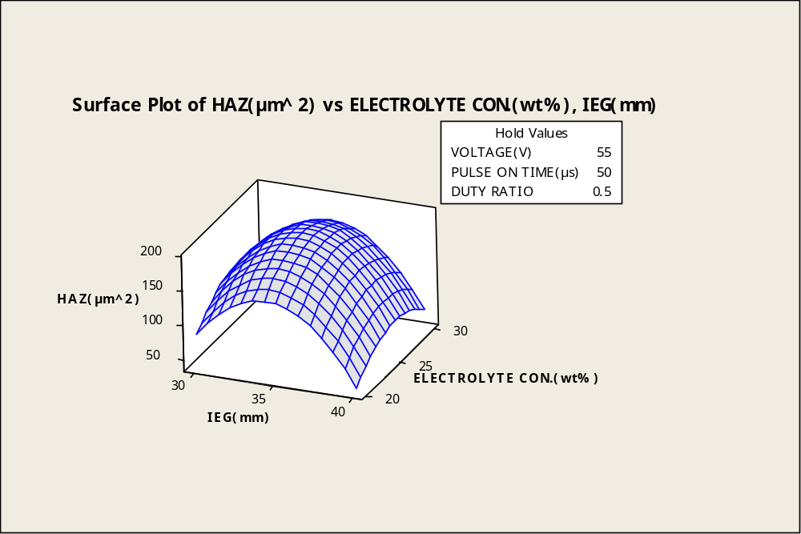
- Effect of pulse-on time and Applied voltage on HAZ
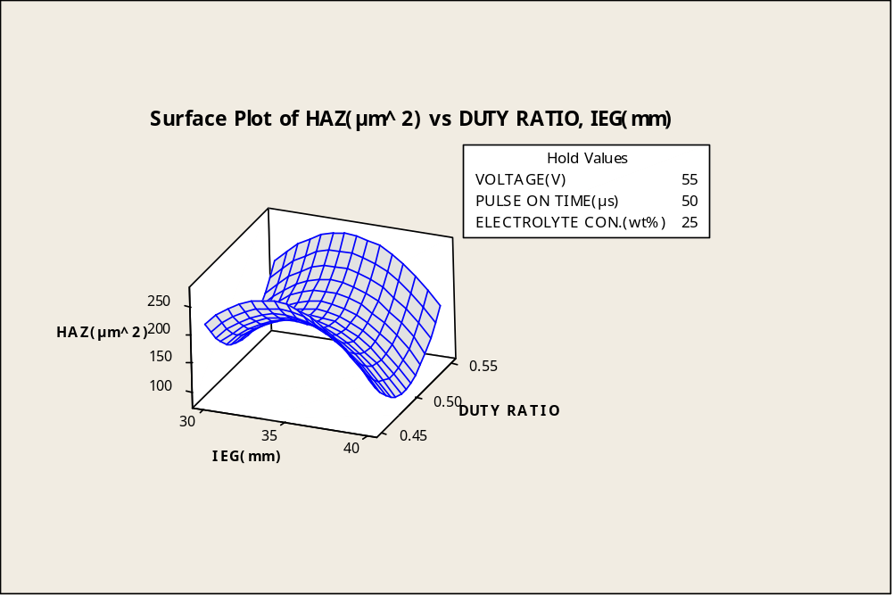
(b)Effect of Pulse-on time and IEG on HAZ

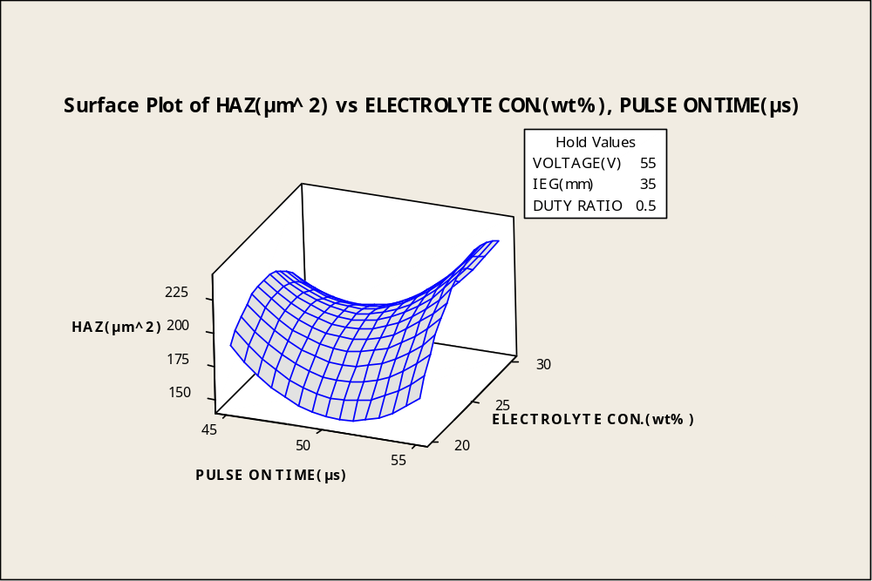
(c)Effect of duty ratio and applied voltage on HAZ
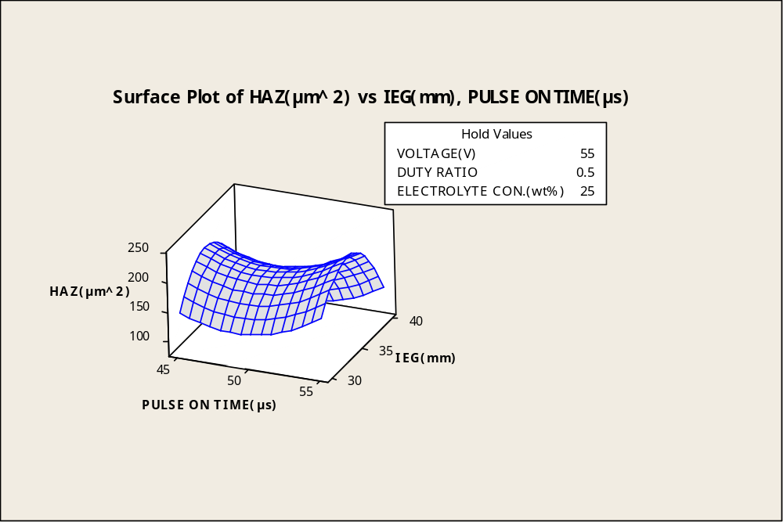
(d) Effect of Duty ratio and IEG on HAZ
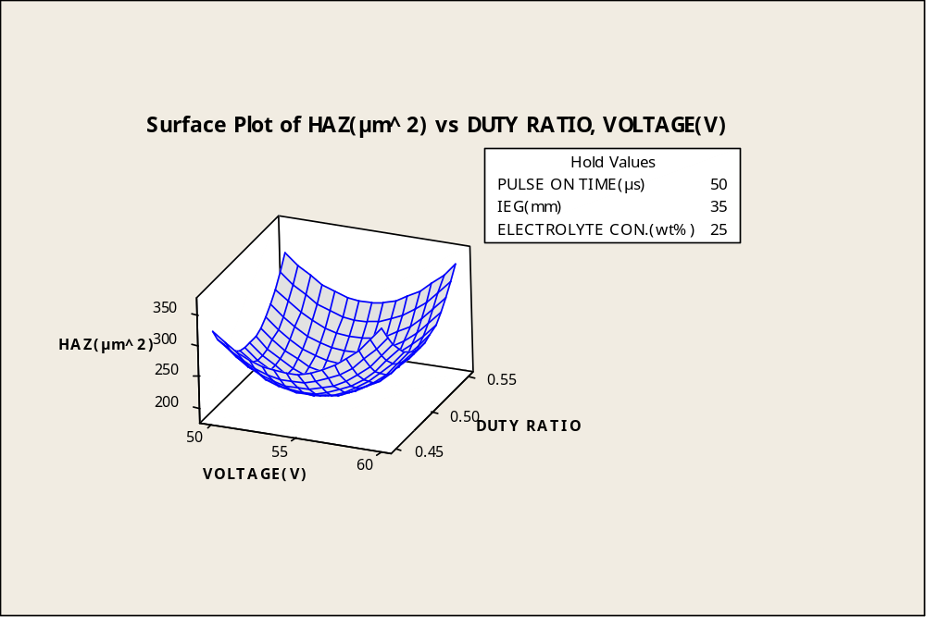
(e) Effect of Applied voltage and Electrolyte concentration (wt %) on HAZ
Fig. 4 (a) - (e)Effect of Pulse on time, Duty ratio Applied voltage, Electrolyte concentration, and Inter electrode gap (IEG) on HAZ
- Multi-Response Optimization Using Desirability Function Analysis

Figure 5 shows the minimization of multi-objectives plot of SR, TWR, and HAZ. It is found that if composite desirability level is 1or near about 0.95 indicates the validation of experimentations. Figure 5 shows the multi-criteria optimization plot with best possible condition of SR (1.039 µm), TWR (0.0184mg/hr) and HAZ (75.9188µm^2) at(50.70V/48.23 µs pulse on time/ 40 IEG/0.49 duty ratio/30 wt%). Figure 6 shows the silicon-wafer micro-channel at best possible conditions for validation of optimization conditions and the SEM shows the quality of micro-channel.
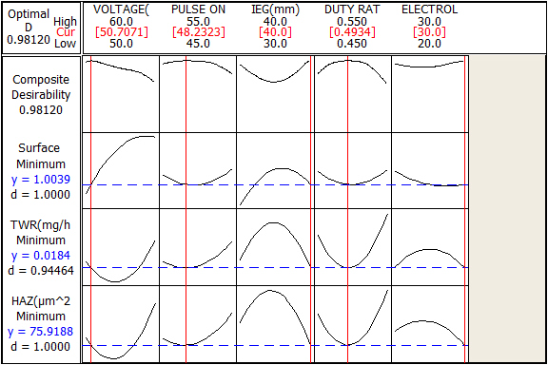
Fig.5 Multi-objective optimization for minimization of SR, TWR and HAZ

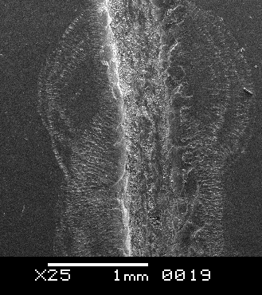
Fig.6 SEM Image of Silicon-wafer micro channel cutting by ECDM process at optimized conditions.

5. CONCLUSIONS

During the micro machining performances of semi-conducting silicon-wafer following conclusions drawn-out-
- HAZ, SR and TWR mostly influenced by duty ratio, applied voltage as well as pulse-on time by the enhancing of electrolyte concentration but IEG have less effect than domain parameters.
- It is found that best solution for this research, SR (1.039 µm), TWR (0.0184mg/hr) and HAZ (75.9188µm^2) is found at (50.70V/48.23 µs pulse on time/ 40 IEG/0.49 duty ratio/30 wt%).
- Tool should change frequently due to its thermal damage as tool tips damages.
- It is obviously observed by Scanning Electron Microscopy (SEM) analysis of silicon-wafer micro-channel, quality of micro-fluidic channel enhanced by the HAZ and surface quality also affected by violent sparking and side sparking.

Funding statement: (Not applicable)
Our research work is fully self-financed and is not funded by any of the government/private/organizations.
Conflict of interest: (Not applicable)
The authors do not have any conflicts of interest that may have a direct bearing on the subject matter of the article and it will not reflect any possible bias in either the exposition or the conclusions presented.
Availability of data and material:
The datasets generated during and/or analyzed during the current study are available with authors and would be provided to the journal if required.
Compliance with ethical standards: (Not applicable)
This article does not contain any studies with human participants or animals performed by any of the authors.
Consent to participate:
The authors are free to contact any of the people involved in the research to seek further clarification and information.
Consent for Publication:
The authors give their consent for the publication of identifiable details, which can include photograph(s) and/or details within the manuscript to be published in the esteemed Journal.
Acknowledgments:
The authors are thankful to Yenepoya Institute of Technology, Moodabidri, and Karnataka, India for permitting to conduct the experimentation work.
Authors' contributions:
All the authors are participated actively to experimental work as well as results analysis, also to write paper. All authors’ contribution is equal to all part of the paper.
REFERENCES
- G. Skrabalak, M. Z. Skrabalak and A. Ruszaj.Building of rules base for fuzzy-logic control of the ECDM process, Journal of Materials Processing Technology, 149, 530-535, 2004.
- W.Y. Peng, Y.S. Liao. Study of electrochemical discharge machining technology for slicing non-conductive brittle material, Journal of material processing technology,149, 343-369, 2004.
- R. Wüthrich, V. Fascio. Machining of non-conducting materials using electro-chemical discharge phenomenon—an overview. International Journal of Machine Tools & Manufacture. 45, 1095–1108, 2005.
- D. J. Kim, Y. Ahn, S. H. Lee, Y. K. Kim. Voltage pulse frequency and duty ratio effects in an electro-chemical discharge micro-drilling process of Pyrex glass. International Journal of Machine Tools & Manufacture.46, 1064–1067, 2006.
- C. T. Yang, S. L. Song, B. H. Yan, F. Y. Huang. Improving machining performance of wire electro-chemical discharge machining by adding SiC abrasive to electrolyte. International Journal of Machine Tools & Manufacture.46, 2044–2050, 2006.
- B. R. Sarkar. B. N. Doloi, B. Bhattachryya. Parametric analysis on electrochemical discharge machining of silicon nitride ceramics.International Journal of Advanced Manufacturing Technology.28, 827-881, 2006.
- K. L. Bhondwe, V. Yadava, G. Kathiresan. Finite element prediction of material removal rate due to electro-chemical spark machining. International Journal of Machine Tools & Manufacture.46, 1699–1706, 2006.
- M. S. Han, B. K. Min, S. J. Lee. Improvement of surface integrity of electro-chemical discharge machining process using powder-mixed electrolyte. Journal of Materials Processing Technology.191, 224–227, 2007.
- S. K. Chak, P. V. Rao. Trepanning of Al2O3 by electro-chemical discharge machining (ECDM) process using abrasive electrode with pulsed DC supply.International Journal of Machine Tools & Manufacture.47, 2061–2070, 2007.
- K. Furutani and H. Maeda.Machining a glass rod with a lathe-type electro-chemical discharge machine.Journal of micro mechanics and micro engineering, 18, 065006 (8pp), 2008.
- V.K. Jain, S. Adhikary. On the mechanism of material removal in electrochemical spark machining of quartz under different polarity conditions. Journal of material processing technology, 200, 460-470, 2008.
- R. Wuthrich, V. Fascio, H. Langen.Machining of non-conducting materials using electro-chemical discharge phenomena- an overview, International Journal of Machine Tools & Manufacture, 45, 1095–1108, 2005.
- J. W. Liu, T. M. Yue and Z. N. Guo. Wire Electrochemical Discharge Machining of Al₂O₃ Particle Reinforced Aluminum Alloy 6061. Materials and manufacturing process, 24, 446-453, 2009.
- X. D. Cao, B. H. Kim, C. N. Chu. Micro-structuring of glass with features less than 100 μ m by electrochemical discharge machining. Precision Engineering.33, 459–465, 2009.
- J. W. Liu, T. M Yue, Z. N. Guo. An analysis of the discharge mechanism in electro-chemical discharge machining of particulate reinforced metal matrix composites. International Journal of Machine Tools & Manufacture.50, 86–96, 2010.
- R. Wüthrich, A. Allagui. Building micro and nano-systems with electro-chemical discharges.ElectrochimicaActa.55, 8189–8196, 2010.
- C. K. Yang, C. P. Cheng, C. C. Mai, A. C. Wang, J. C. Hung, B. H. Yan. Effect of surface roughness of tool electrode materials in ECDM performance. International Journal of Machine Tools & Manufacture.50, 1088–1096, 2010.
- K. Khas, A. Manna. A study on MECD-machining during drilling of electrically non-conductive ceramic.National Conference on Advancements and Futuristic Trends in Mechanical and Materials Engineering. February 19-20, 2010.
- C. P. Cheng, K. L. Wu, C. C. Mai, C. K. Yang, Y. S. Hsu, B. H. Yan. Study of gas film quality in electro-chemical discharge machining.International Journal of Machine Tools & Manufacture.50, 689–697, 2010.
- C. Wei, D. Hu, K. Xu , J. Ni. Electro-chemical discharge dressing of metal bond micro-grinding tools.International Journal of Machine Tools & Manufacture.51, 165–168, 2011.
- C. K. Yang, K. L. Wu, J. C. Hung, S. M. Lee, J. C. Lin, B. H. Yan. Enhancement of ECDM efficiency and accuracy by spherical tool electrode.International Journal of Machine Tools & Manufacture.51, 528–535, 2011.
- Y. MOCHIMARU, M. OTA and K. YAMAGUCHI,Micro Hole Processing Using Electro-Chemical Discharge Machining, Journal of advanced mechanical design, systems and manufacturing.Vol. 6, No. 6, 949-957, 2012.
- C. S. Jawalkar, A. K. Sharma and P. Kumar, Micromachining with ECDM: Research Potentials and Experimental Investigations, World Academy of Science, Engineering and Technology, 61, 340-345, 2012.
- D. Jana. A. Ziki, T. F. Didar, R. Wuthrich, Micro-texturing channel surfaces on glass with spark assisted chemical engraving. International Journal of Machine Tools & Manufacture, 57, 66–72, 2012.
- B.Mallick, S.Biswas, B.R.Sarkar, B.Doloi and B.Bhattacharyya, “On Performances of Electrochemical Discharge Micro-Machining Process Using Different Electrolytes and Tool Shapes”. International Journal of Manufacturing, Materials, and Mechanical Engineering (IJMMME), 2019, Vol-10, Issue-2, Article-3. DOI: 10.4018/IJMMME.2020040103.
- B.Mallick, B.R.Sarkar, B.Doloi and B.Bhattacharyya, “Analysis on the effect of ECDM process parameters during micro-machining of glass using genetic algorithm”. Journal of Mechanical Engineering and Sciences, 2018, Vol. 12, (3), 3942-3960.
- B.Mallick, B.R.Sarkar, B.Doloi and B.Bhattacharyya “Analysis of Electrochemical Discharge Machining during Micro-Channel Cutting on Glass”. International Journal of Precision Technology, 2017, Vol.7, (1), 32– 50.
- B.Mallick, B.R.Sarkar, B.Doloi and B.Bhattacharyya, “Modelling and analysis on Performance of ECDM Process for the Fabrication of µ-Channels on Glass through Response Surface Methodology”. Manufacturing Technology Today (MTT), 2019, Vol.18, No 9 (2019).
- B.Mallick,B.R.Sarkar, B.Doloi and B.Bhattacharyya., "Multi Criteria Optimization of Electrochemical Discharge Micro-Machining Process during Micro-Channel Generation on Glass", Applied Mechanics and Materials, 2014,Vol. 592-594, 525-529.
- Mallick, B., A,S.Hameed, Sarkar, B. R., Doloi, B. and Bhattacharyya, B, “Experimental Investigation for Improvement of Micro-Machining Performances of µ-ECDM Process” Elsevier's Materials Today, 2019.
- Mallick, B.; Sarkar, B,R.; Doloi, B.; Bhattacharyya, B.;Improvement of Surface Quality and Machining Depth of μ-ECDM Performances Using Mixed Electrolyte at Different Polarity. Silicon 2022. https://doi.org/10.1007/s12633-021-01587-2.

