Short title: Relay Coordination on Motor Control Centre
Authors: Horsfall and Naanee
Intelligent Relay coordination on Motor Control Centre (MCC) (Case Study: Indorama Petrochemical Company)
D. Horsfall*, B. Naanee
Electrical and Electronics Engineering Department, Rivers State University, Nigeria
Abstract
The protection of motors in Motor Control Centres (MCCs) is of key importance in industries since motors play a vital role in production processes. Any damage to them as a result of fault can halt the production process. In order to protect the motors from these faults, relay coordination has to be performed so that protective devices can properly discriminate against fault current within the fastest possible time. For this undergraduate project, ETAP software was used to design the SLD of the MCC Network, specify equipment parameter, perform load flow, short circuit analysis and protection coordination study. Manual calculation of relay TDS and Pickup setting was done. The result of this calculation was inputted into the relay properties on ETAP. After fault insertion miscoordination was observed. Time-Current Curve, TCC fitting was resorted to, it was observed that the system became coordinated after fault insertion. The sequence of operation when using calculated values of TDS and pickup to perform relay coordination and TCC curve fitting was compared. In conclusion by using TCC fitting, relay coordination can be performed by varying only the TDS values while leaving the pickup values unchanged in order to avoid nuisance tripping.
Keywords: MCC, Relay Coordination, TCC fitting, ETAP
*Author for Correspondence E-mail: naaneebarinyima4@gmail.com, Tel: +2349053069214

INTRODUCTION
Electric motors have become so important, research estimate that it consumes over 50% of all electrical power in manufacturing plants, as manufacturing companies rely on motors to drive conveyors, compressors, cooling fans, pumps and machine control [1]. The amount of their power consumption shows that electric motors dominate manufacturing plants and industries especially in a petrochemical manufacturing company like Indorama, their use becomes endless. As a result of their importance, it becomes pertinent to properly control and protect them as any damage to these motors can lead to a halt in production.
Motor Control Centres (MCC) are metal enclosures used to effectively control these motors to optimize production plant operations from a central location. Since power distribution systems in industries are complex, a central system is needed to control the motors in a plant [2]. Before the introduction of MCC in production plants, it was necessary to control and perform preventive and corrective maintenance in a decentralised way. This led to a significant waste of time in the production process. In industries where MCC is installed a single push button can start and turn off motors thereby, reducing the time needed to start an operation [3]
The MCC consist of contactors, fuses, circuit breaker and overcurrent relays to protect and isolate motors from faults [4]. This means a protection scheme is integrated to the MCC. The major aim of a protection scheme is to effectively and quickly isolate the faulty part of a network to prevent further damage to the system and also maintain continuous flow of power to the healthy sections of the power system [5]. To ensure motor protection, overcurrent relays are used to protect motors from damages arising from prolonged overcurrent circuit conditions. This overcurrent relay in conjunction with circuit breakers trip and open circuit during overcurrent current conditions [6].
Overcurrent relays operate when the current flowing through them exceeds a pre-set value, when not set properly could cause incessant tripping leading to constant interruption of plant operation. Hence, the need for intelligent relay coordination in MCC.
Relay coordination is the intentional, careful arrangement and configuration of relays so they can trip in a particular order or sequence to isolate faulty part with minimized relay and circuit breaker operation [7]. For proper relay coordination the primary relay must operate before the backup relay, for this to happen the appropriate pickup and Time Dial Setting TDS values for each relay must be selected. The TDS and pickup values can be calculated or changed by adjusting the Time-Current Curve TCC.
Time-Current Curve, TCC is a graph that shows the operating time of the overcurrent relay based on a given current level [8]. As stated earlier, The TDS and pickup values can be adjusted through the TCC. The shifting or adjustment of these relay curves in order to change the Pickup or TMS values to ensure proper coordination of the relays is known as TCC fitting.
In this work TCC fitting is performed using Electrical Transient Analyser Program (ETAP) to achieve a coordinated system.

MATERIALS AND METHODS

Materials used
A Single Line Diagram, SLD showing the arrangement and interconnections between components in the MCC Network at Indorama is obtained and designed using AutoCAD. From the SLD in Fig1, a 5MW/11KV Generator (assumed) supplied power to a 300KVA 11/0.415KV distribution transformer (assumed), which supplies power to a 0.415KV busbar, Bus-2. Bus-2 then supplies power to both Bus-3 and Bus-4. Bus-3 and Bus-4 are interlocked using a Normally Open NO circuit breaker. Bus-3 feeds six 5.5KW, one spare 5.5KW motor, one 3KW, one spare 3kw and five 0.37kW three phase induction motors while Bus-4 feeds six 5.5kW, one spare 5.5kw, one 3kW and eight 0.37kW three phase motors.

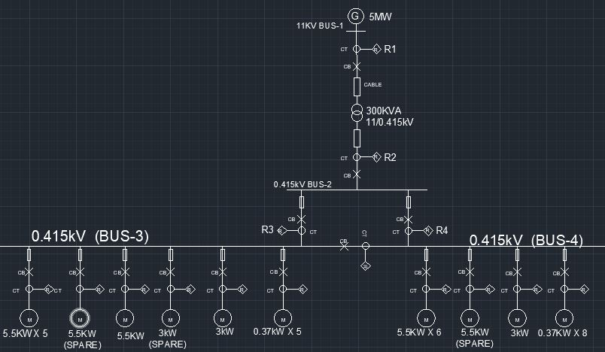
Figure 1 Simplified AutoCAD Presentation of the single line diagram of HRSG 1 & 2 MCC Panel Network at Indorama

Methods Used
Using ETAP software, Load flow analysis and short circuit analysis was conducted. Manual calculation of the relay settings (TDS and Pickup) was done from the data obtained. The following fomulars were used to calculate relay settings
$Pickup current=110\%×Full load current (FLA)$ [1]
$Pickup current in relay=\frac{110\%×FLA}{CT Ratio}$ [2]
$Relay operatime time, t=\frac{α×TDS}{{\left(PSM\right)}^{β}-1}$ [3]
$TDS=\frac{t×\left[{\left(PSM\right)}^{β}-1\right]}{α}$ [4]
$PSM=\frac{I_{F}}{I_{P}}=\frac{Fault current}{pick up current}$ [5]
From the equation [3] constant values α and β are seen. These constant values depend on the relay curve type. Different relay curve types are available on ETAP relay properties. The values for α and β are shown for different curve types on table 3.3. For the purpose of this work the very inverse relay curve type is used throughout. Hence values for α and β are 13.5 and 1.0 in this work.
Tables 1 IEC Constants Values for Relay Curve types
Curve Type | α | β
Standard Inverse | 0.14 | 0.02
Very Inverse | 13.5 | 1.0
Extremely Inverse | 80.0 | 2.0
Long-time Inverse | 120.0 | 1.0

Using the above stated formulars the relay setting values (pickup, PSM and TDS) were calculated and displayed in Table2 below. The values of CT ratio, operating time, t(s) were selected while fault current values were gotten from short circuit analysis. The Pickup in relay and TDS values were inserted in relay properties dialogue box on ETAP
Tables 2 Relay setting values
Relays | CT Ratio (A) | I_{F} (A) | I_{P} (A) | Pickup in relay (A) | PSM | t (s) | TDS
Relay1 | 50/1 | 390 | 17.33 | 0.35 | 22.50 | 2 | 3.185
Relay2 | 500/1 | 8741 | 459.14 | 0.92 | 19.04 | 1.5 | 2.000
Relay3 | 500/1 | 499 | 113.74 | 0.23 | 4.49 | 1 | 0.251
Relay4 | 500/1 | 518 | 109.90 | 0.22 | 4.71 | 1 | 0.275
Relays protecting 5.5KW motors | 50/1 | 72 | 13.21 | 0.26 | 5.45 | 0.5 | 0.165
Relays protecting 3KW motors | 10/1 | 42 | 7.59 | 0.76 | 5.53 | 0.5 | 0.168
Relays protecting 0.37KW motors | 10/1 | 7 | 1.21 | 0.12 | 5.79 | 0.5 | 0.177

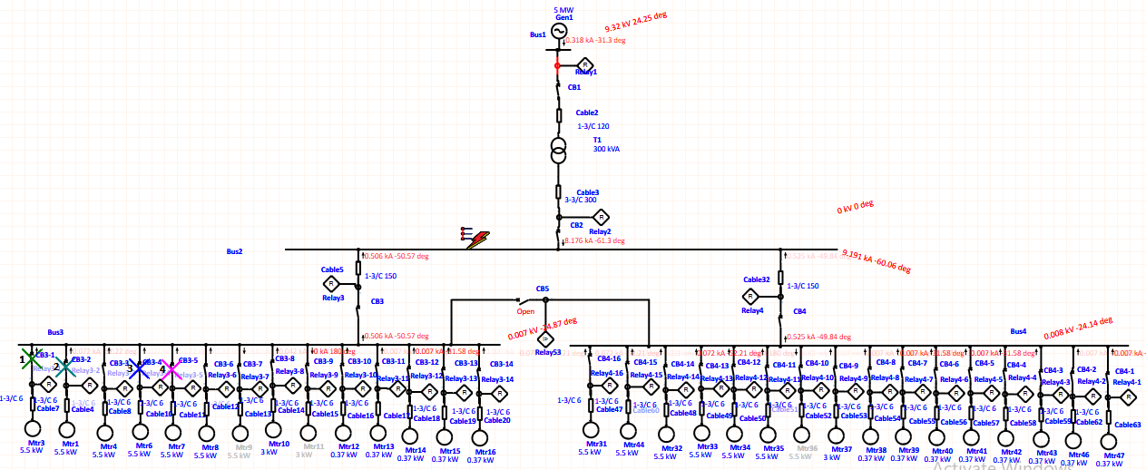
After calculated values of TDS and pickup in relay were inserted in the relay properties, fault was inserted on different locations of the MCC Network to see the relay sequence of operation.
Figure 2 Relay Sequence of Operation with fault insertion on Bus2 after inputting Calculated Pickup and TMS values
From Fig2 the relays are seen to be miscoordinated. This led to the use of TCC fitting to achieve proper coordination.
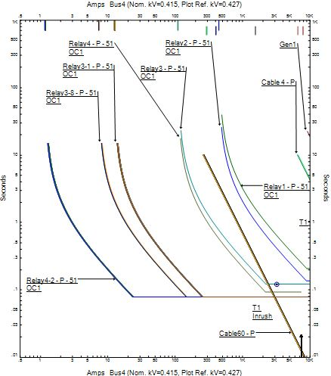
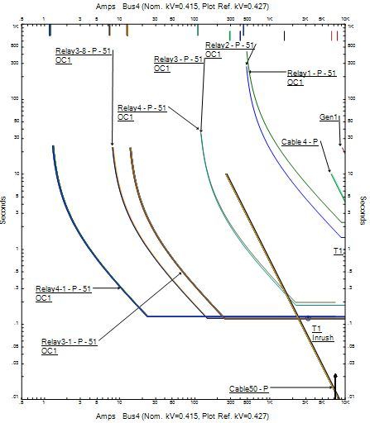
Figure 3 Time-Current Curve before TCC fitting (Left) and after TCC fitting (Right)
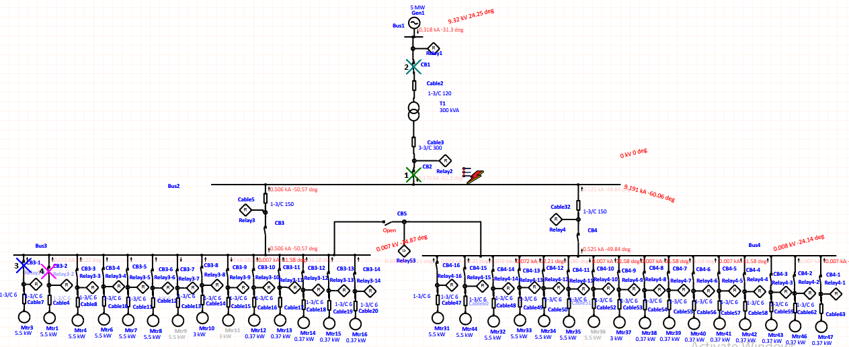
Figure 4 Relay Sequence of Operation with fault insertion on Bus2 after TCC fitting

RESULT AND DISCUSSION
Fault was inserted separately on each bus in the MCC Network and on one 5.5kw and 0.37kw motor. For fault insertion on Bus-1, 5.5kw and 0.37kw motor the relays were seen to be properly coordinated even before TCC fitting, but with a wide trip time interval between the primary and backup relays. After TCC fitting, the wide trip time interval between the primary and backup relays in the case was reduced.
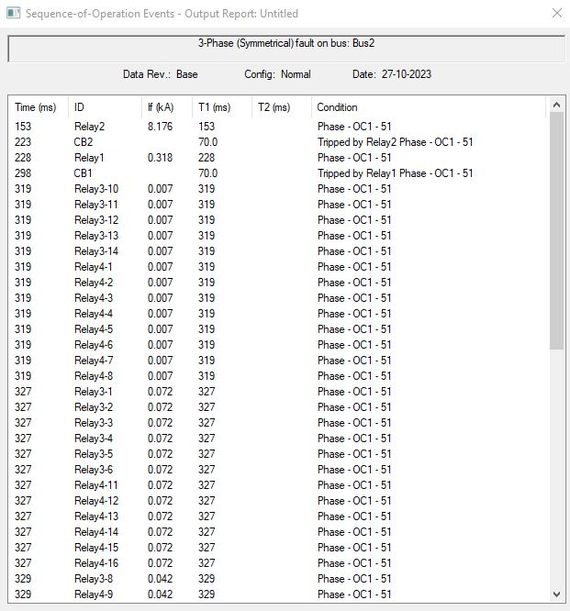
For fault insertion on Bus-2, Bus-3 and Bus-4 before TCC fitting as shown in Fig2 the relay sequence of operation is not coordinated but after TCC Curve fitting the relays become coordinated as shown in Figureure4. The sequence of operation for fault insertion on Bus-2 before and after TCC fitting are shown in the Figures below.
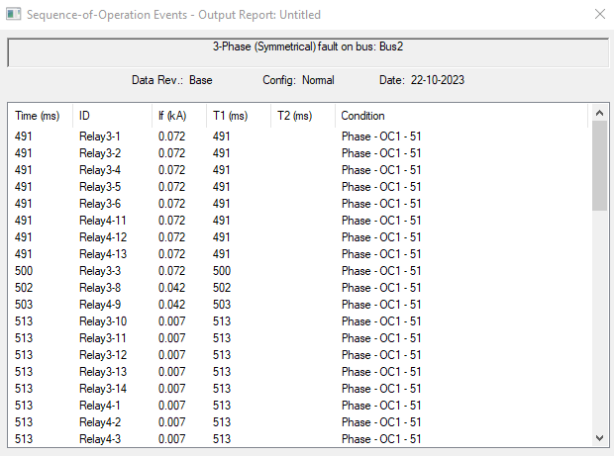

Figure 5 Sequence of Operation with fault on Bus2 before TCC curve fitting (left) and after (right) TCC curve fitting

Table 3 Pickup and TMS Values pf Relay Before and After TCC curve fitting
Relays | Pickup Before TCC Curve Fitting | Pickup After TCC Curve Fitting | TDS Before TCC Curve Fitting | TDS After TCC Curve Fitting
Relay1 | 0.35 | 0.35 | 3.185 | 0.29
Relay2 | 0.92 | 0.92 | 2.000 | 0.19
Relay3 | 0.23 | 0.23 | 0.250 | 0.17
Relay4 | 0.22 | 0.22 | 0.275 | 0.13
Relays protecting 5.5KW motors | 0.26 | 0.26 | 0.165 | 0.11
Relays protecting 0.37KW motors | 0.12 | 0.12 | 0.177 | 0.11

Comparing relay setting values before and after TCC fitting. Pickup settings before and after TCC fitting for all the relays remain the same. Meaning the adjustment of the TCC by dragging relay curves downwards does not affect the pickup values. The TDS values for all the relays are seen to have changed. A reduction in the TDS values was noticed, this resulted in the reduction of the relay operating time.

CONCLUSION
From the result obtained it is seen that in some cases, the use of calculated pickup and TDS values may not guarantee a perfect relay coordination hence, the reliance on TCC fitting. Even in cases where the relays are already operating sequentially TCC fitting can improve the effectiveness of the relays by reducing the trip time intervals between relays ensuring not just sequential but timely interruption of fault current.
From the results obtained after the TCC fitting it is seen that relay coordination can be achieved by changing only the TDS Values while the pickup values remain unchanged. This is to ensure the pickup is not too small resulting in tripping of the motors when they are operating at full load and not too large resulting in inability to trip during faults that are below the selected pickup.

ACKNOWLEDGEMENT
We are immensely grateful to God, our parents, siblings and friends for all their support during this undergraduate project work.

REFERENCE
- 999 Automation. The Importance of motor protection in modern industries [Internet]. 999 Automation; 2020, Sept, 15 [cited 2023 Nov 14]. Available from: https://blog.999automation.com/2020/09/15/motor-protection-modern-industry/#:~:text=Production%20and%20manufacturing%20companies%20depend,used%20in%20today’s%20manufacturing%20plants
- Csanyi E. The basics of motor control centres [Internet]. Electrical engineering portal; [cited 2023 Nov 14]. Available from: https://electrical-engineering-portal.com/download-center/books-and-guides/siemens-basics-of-energy/motor-control-centers#comments.
- Electrical Volt. Motor Control Centre- purpose, classification & advantages [Internet]. Electrical Volt; 2022 July [cited 2023 Nov 14]. Available from: https://www.electricalvolt.com/2022/07/motor-control-center-purpose-classification-advantages/#:~:text=Purpose%20of%20Motor%20Control%20Centers,the%20main%20components%20of%20control.
- Wikipedia. Motor Control Centre [Internet]. Wikipedia; 2021 Nov 29 [cited 2023 Nov 14]. Available from: https://en.wikipedia.org/wiki/Motor_control_center.
- Sowmiya T. and Dr. Sujatha B. Overcurrent Relay Coordination in Radial Distribution System. IJARSCT. 2021;12(1): 298-303.
- Atin C. Importance of motor protection in modern industries [Internet]. Schneider Electric; 2019 May 22 [cited 2023 Nov 14]. Available from: https://blog.se.com/industry/machine-and-process-management/2019/05/22/importance-of-motor-protection-in-modern-industries/.
- Electrical for U. Power System Relay Co-ordination [Internet]. Electrical for U; [cited 2023 Nov 14]. Available from: https://www.electrical4u.net/relay/power-system-relay-co-ordination/.
- Paul D. Understanding Time Current Curves [Internet]. Maverick Technologies; 2014 Jan 28 [cited 2023 Nov 14]. Available from: http://www.mavtechglogal.com/understanding-time-current-curves-part-3/

