Efficient Transmission Pricing using Power Flow Tracing

Ishaan Dubey^{#1} Ankit Singh^{#2} Sandeep Bhongade^{#3}

^{#1, #2, #3} Department of Electrical Engineering
Shri G S Institute of Technology & Science, Indore-03 M.P (INDIA)

Abstract - The evolution of transmission pricing philosophies in deregulated power markets has introduced various techniques for efficient and accurate cost estimation of power exchanges. Earlier methods of postage stamp cost estimation failed to provide accurate cost signals. Point of Connection (POC) method is a technique through which a considerable sunk cost can be recovered but is still inefficient if applied alone. In addition to this, the POC method along with the marginal cost method does not provide an accurate price signal. To overcome the above lacunae, the POC tariff method is employed with the recent Power tracing framework, employed for Active power flow methodologies.

Keywords – distributed energy resources(DER), point of connection, locational transmission pricing, tariff method, cost estimation, postage stamp methods, Load Flow Analysis(LFA)

- INTRODUCTION

A high voltage transmission network provides, a large number of routes through which transfer of electrical power can take place from source (commonly referred to as Generators) towards sinks (commonly referred to as Load side, or, grid supply points). Generally, a Load flow program is used for finding the different flows, in different lines when considering a complex mesh structure. However, it is difficult for the Load flow program, to trace the connections, ass any change in demand or generation at any node, will directly affect the generation coming from a marginal plant. Hence, conventional methodologies suggest that, it is unattainable to trace electricity from one particular generation point/bus, towards one particular supplier or demand side point/bus.

With conventional LFA, it is possible to determine a relation between generators and transmission line flows by the virtue of sensitivity analysis. While sensitivity analysis can determine a relation between generator and line flows, it is unable to determine how changing a nodal generation or demand can change line flows. In recent times, modern power systems are adapting to more and more Information and Communication Technologies (ICTs), along with the integration of Distributed Energy Resources (DERs) as they provide stability and reliability to the power system. Recent micro-grids that are being set up utilize a number of additional elements, hence, these provide a more reliable and uninterrupted power supply. Undoubtedly, a number of deregulation have been introduced which have pushed the advancement of the energy market.

In[1], author has proposed an innovative methodology for tracing of power from the generation side to the demand side. This work includes two algorithms based on matrices, which considers either the outflows from a node or inflows into a node, making it feasible for the tracing of Active power and to accurately assess the contribution of particular generators to particular loads. In[2][12], author has proposed a methodology of absorption of power at a particular load point and power utilization of the generation end. This topological based power flow tracing solves the problem with the counter flows. Also, in [3], the authors have incorporated both active and reactive powers into consideration while performing the power flow tracing. The advantage of this methodology is that it is unaffected by incremental changes. Many of the cost related problem and accurate analysis of transparency in a transmission network can be estimated by this method. The author in [4], transmission line power flow, in which real power flow is considered while analyzing the contribution of each generator unit is done by a new algorithm based method, i.e. by using VESPO algorithm. This method considers the contribution of particular generation units to particular load units, while taking the contribution of generator to line power injections into consideration. This method considers the not so popular constraints of the generator such as, thermal limits and prohibited operating zone. In[5], author conveys the idea of a bi-directional tracing method based on the separation of power supply paths in power grid. Under the premise of known power flow in an AC section and in consideration of the line-to-ground capacitance, this method conducts an equivalent conversion on the system’s intrinsic parameters, which cannot merely form the single-power multi-load networks, the single-power single-load networks and the single-load multi-power networks, and can further realize the bi-directional tracing in multi-power multi-load loop networks. Coordinating this method with economic accounting, the profit distribution of the power grid can be computed and revealed. In[6], the author presents a transmission pricing scheme using a power flow tracing method to determine the transmission service, congestion and loss cost. The goal is to trace the actual contributions of generators (loads) to each line flow and loss using tracing method, and then the transmission cost can be calculated and allocated based on these contributions.

- POWER FLOW TRACING AND LOCATIONAL TRANSMISSION PRICING

Some inventive work in the field of power tracing. Two versions of algorithms have been proposed to find out either the inflows or outflows of a node[1]. The main advantage of this is parting of transmission losses in to particular generator or load. This will always give the positive charges which always not possible with the traditional marginal cost-based methodology. By this method of power tracing the active and reactive power flow in each line due to each generator and each load can be find out. With the availability of modern tracing framework, we are able to find proper contributions of particular generators towards particular loads, resulting in an efficient manner of load flow allocation and which also becomes the foundation of our cost estimation methodology[13]. Power tracing based on the topological generation load flow remove the problem of counter flow occurs by another power flow tracing techniques. Tracing of electricity is basically a mathematical procedure of finding out the contribution of each generator towards each load, along with the path the electricity took while flowing from some Generator A to some Load A.

The fundamental principle behind the power flow tracing technique is the Proportional sharing principle. The basis of this can be explained through a simple junction diagram shown in Fig.1.
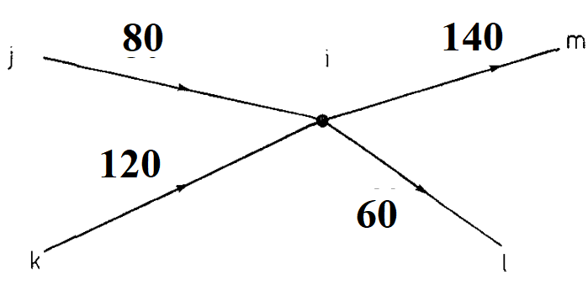

Fig.1. Proportional sharing principle

The figure shows that the line j-i is carrying power 80W, thus, it can be depicted as, P_{j-i} = 80MW ; P_{k-i}= 120MW ; P_{i-m} = 140MW ; P_{i-l} = 60MW. Now, incoming power to i^{th} node will be, P_{i} = 80 + 120 = 200 MW, the contribution of line j-i to the node i^{th} contribution is 40% and the contribution of k-i line to node i^{th} is 60%, which is visible from the simple concept of proportional sharing. Now, the outflows from node i, is independent of voltage gradient and impedance of line[14]. Thus, the outflow of line i-m 140MW will consist the contribution from the lines, j-i and k-i in the same proportionality, which is,

Contribution of line j-i to line i-m = 140(80/200) = 56MW
Contribution of line k-i to line i-m = 140(120/200) = 84MW

Similarly, the contribution of line i-l will be due to lines, j-i and k-i in the same proportion, which is,

Contribution of line j-i to line i-l = 60(80/200) = 24MW
Contribution of line k-i to line i-l = 60(120/200) = 36MW

The concept of locational transmission pricing (LTP), comes from the core of Point of Connection (POC) tariff scheme. POC scheme provides the operators access to whole energy system network, at one point, that is, the entire market place is accessible through one point of connection[15]. The main advantage of 24 using this pricing scheme is that, the charges applied or recovered from the users is done through a MW proportional injection or demands, which is independent of path followed and thus pancaking of costs doesn’t takes place, as a result of which, both power exchange and bilateral trades can be employed.

Let us define some variables as,
Name of Line = L_{m}
Cost of line per MW per unit = c_{lm}
Length of line = L_{lm}
Thus C`_{lm} = c_{lm} . L_{lm} Now, a load is using P_{lm} power from the corresponding line, thus, the total network usage cost for that particular line will be[9],

Total Cost = Σ∀ l_{m} C`_{lm}. P_{lm}

By the virtue of real power tracing it is possible to assign this cost accurately among different participants of the network[10]. Thus, P_{lm} = Σ_{i=1to n} (y^{i} _{lm} . P_{li}) Here, y ^{i} _{lm} is the fraction of load the line lm is carrying towards the fulfillment of load i Now, the final expression for LTP is given by,

LTP_{i} = Σ∀ lm(y^{i} _{lm} . C`_{lm}) Rs/MW

The result of the above equation when applied, is expected to show higher cost for farther loads[11].

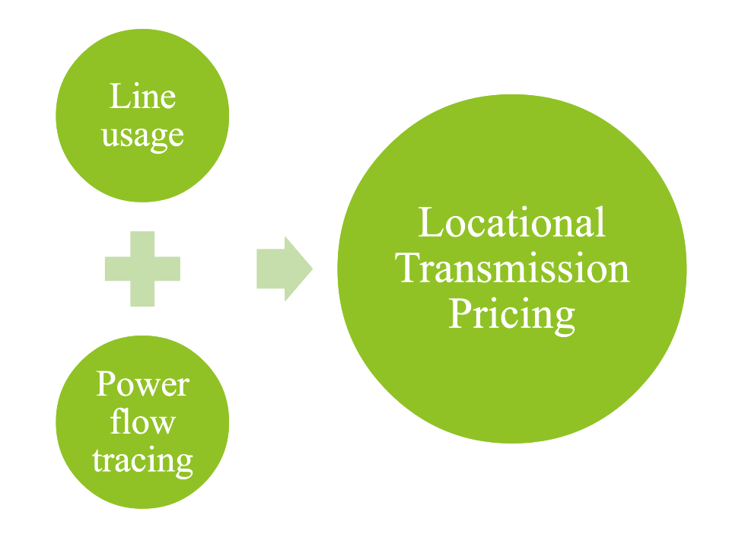

Fig. 2. Locational Transmission Pricing

- METHODOLOGY

In this paper, we have used a 4-Bus system for the execution of our code and to tally the results so as to check the authenticity of the code, so that, implementation on a 13-Bus system and 30-Bus system could be done. First, the implementation on the 4-Bus system is done. The 4-Bus system is shown.
There are two forms of algorithms which can be used to find the tracing or flow of electricity from generator to load[7]. These two are namely, Upstream looking algorithm and Downstream looking algorithm. The upstream looking algorithm will focus on the nodal balance of the inflows, while the Downstream looking algorithm will focus on the nodal balance of the outflows.

Overall flow P_{i} through the node i can be expressed as sum of all the inflows as,

P_{i} = Σ_{j ϵ ɑ(u)i} |P_{i-j}| + P_{Gi} for, i = 1, 2 ,…...k (1)

Here, ɑ(u) is a set of all nodes supplying node numbered i , since, line is lossless, thus,
|P_{j-i}| = |P_{i-j}|

Also, the nodal power P_{i} can be expressed as,

P_{i} = (Σ_{jϵ ɑ(u)i} c_{ji} .P_{j})+ P_{Gi} (2)

Now, rearranging the above equations, this will lead to a new expression namely,

P_{i} – (Σ_{jϵɑ(u)i} c_{ji} . P_{j} ) = P_{Gi} (3i)

Alternatively, Eqn. (3) can be written in the form of matrice notation as, A_{u} . P = P_{G} (3ii)
Here, A_{u} is a distribution matrix of order (n x n), also known as, Upstream Distribution Matrix, P in the Eqn. (3ii) depicts a nodal-through flows, while, P_{G} is the vector of nodal 22 generations. Any element of the matrix A_{u} with position indices as (i, j) is estimated via the below given conditions into consideration.

$\left\{\begin{aligned}\left[Au\right]ij=1;fori=j \\ -cji={-\left(Pj-i\right)}/{Pj};forjϵɑ\left(u\right)j\end{aligned}\right\}$ (4)

Pi = Σ_{q=1 to n} [A_{u}⁻¹]_{iq} . P_{Gq} for i = 1, 2, ……. k (5)

The above mentioned set of equations depicts the offering of a q ^{th} generator to i ^{th} node power equal to the expression [A_{u}⁻¹ ]_{iq} . P_{G} [8].
It should be noted that this same P_{i} is equal to summation of the load demands corresponding to the note i . The estimation of Load Demand P_{Li} , is depicted as, as function of P_{i} ,

P_{Li} = (P_{Li} / P_{i}) (Σ_{q=1 to n} [A_{u}] ⁻¹ _{iq} . P_{Gq}) for i = 1,2,3,4,5………..n (6)

The above equation depicts the contribution of q ^{th} generator unit towards the i ^{th} load unit. Thus, the expression,
(P_{Li} / P_{i} ) (Σ_{q=1 to n} [A_{u}] ⁻¹ _{iq} . P_{gq})
is used to trace the power from a generator to a load unit.

According to the above mentioned conditions and equations, we obtain A_{u} , Upstream Distribution Matrix as,
Au =$\begin{matrix}1 & 0 & 0 & 0 \\ -0.1508 & 1 & 0 & 0 \\ -0.5614 & 0 & 1 & 0.2889 \\ -0.2877 & -1 & 0 & 1\end{matrix}$
Similarly, [Au]⁻¹ = $\begin{matrix}1 & 0 & 0 & 0 \\ 0.1508 & 1 & 0 & 0 \\ 0.6882 & 0.289 & 1 & 0.289 \\ 0.4385 & 1 & 0 & 1\end{matrix}$

TABLE 1. GENERATOR TO LOAD CONTRIBUTION IN 4-BUS SYSTEM

LOAD | Generator 1 | Generator 2 | Total
Load3 | 271.5 | 32.5 | 304
Load4 | 123 | 80 | 203
Total | 394.5 | 112.5 | 507

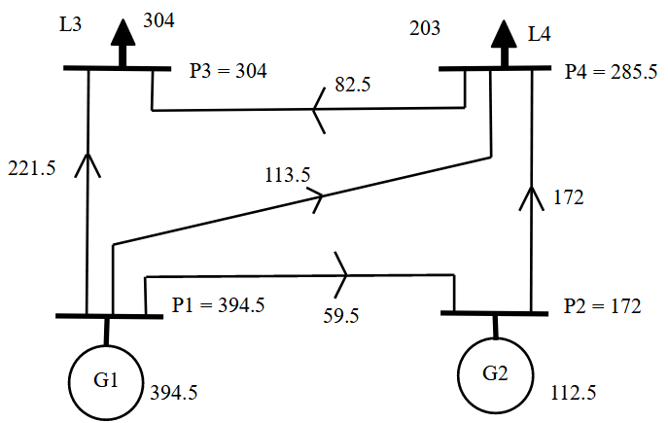
Fig. 2. 4-Bus lossless system

We have considered Cost per unit length, c_{lm} to be 100 units. Now, applying the concept of LTP in this 4-Bus system, we get the following result,

TABLE 2. COST OF LOADS BY USING LTP

LOAD NO. | COSTING(Rs/MW)
1 | 0
2 | 0
3 | 6150
4 | 12709

- RESULTS AND OBSERVATION

Now, the analysis is done on a 13-Bus system as well as on a 30-Bus system. The 13-Bus system consists of two generator buses, namely, Bus no. 4 and Bus no. 10, while two other buses are redundant buses namely Bus no. 2 and Bus no. 5. Now, Applying the concept of power tracing and LTP to 13 Bus system, we get results as,

TABLE 3. LINE FLOWS OF 13-BUS SYSTEM

From Bus | To Bus | Flow | Line No.
1 | 3 | 0.1429 | 1
2 | 5 | 0.0811 | 2
3 | 5 | 0.0949 | 3
3 | 6 | 0.2288 | 4
3 | 11 | 0.0564 | 5
3 | 12 | 0.0329 | 6
4 | 1 | 0.1657 | 7
5 | 2 | 0.0819 | 8
5 | 11 | 0.0114 | 9
7 | 9 | 0.0104 | 10
9 | 11 | 0.0314 | 11
10 | 7 | 0.0406 | 12
10 | 8 | 0.1527 | 13
10 | 9 | 0.0512 | 14
12 | 13 | 0.0225 | 15
13 | 11 | 0.0025 | 16

TABLE 4. POWER TRACING FOR 13-BUS SYSTEM

LOAD | GENERATOR
 | GENERATOR 4 | GENERATOR 10
Load 1 | 0.2 | 0
Load 3 | 0.0134 | 0.0314
Load 6 | 0.0718 | 0.2389
Load 7 | 0.0023 | 0.0279
Load 8 | 0.01159 | 0.1411
Load 9 | 0.0023 | 0.0279
Load 11 | 0.0743 | 0.0290
Load 12 | 0.00326 | 0.00714
Load 13 | 0.00628 | 0.01372

The LTP result for the 13-Bus system is given below. Since, there is no load attached to the Bus no. 2 and 5, thus, there is no cost bearing value obtained for the same buses.

TABLE 5. LTP FOR 13-BUS SYSTEM

LOAD BUS No. | COSTING(Rs/MW)
Load 1 | 1429
Load 3 | 3140
Load 6 | 7389
Load 7 | 2413
Load 8 | 11599
Load 9 | 2793
Load 11 | 1678
Load 12 | 1298
Load 13 | 3045

For a 30-Bus system, there are two generator buses, namely, Bus no. 1 and Bus no. 2, while others being the load buses. Since, we are performing Active Power analysis for this system, we have some buses which are not involved in power flow analysis.

Bus no. 9, 11 and 13 do not contribute towards the Active power flow tracing of the Bus system, hence, Generator contribution is zero for them.

TABLE 6. POWER TRACING FOR 30-BUS SYSTEM

LOAD | GENERATOR
 | GENERATOR 1 | GENERATOR 2
LOAD 3 | 3.985 | 0
LOAD 4 | 9.1321 | 0.1229
LOAD 5 | 92.0974 | 3.4626
LOAD 6 | 1.5264 | 0.0386
LOAD 7 | 22.7008 | 0.5742
LOAD 8 | 29.3135 | 0.7415
LOAD 9 | 0 | 0
LOAD 10 | 5.9739 | 0.1511
LOAD 11 | 0 | 0
LOAD 12 | 11.0217 | 0.1483
LOAD 13 | 0 | 0
LOAD 14 | 5.9598 | 0.0802
LOAD 15 | 8.0418 | 0.1082
LOAD 16 | 3.9765 | 0.0535
LOAD 17 | 8.8299 | 0.1801
LOAD 18 | 2.9799 | 0.0401
LOAD 19 | 8.8180 | 0.1920
LOAD 20 | 1.9891 | 0.0503
LOAD 21 | 16.6342 | 0.4208
LOAD 22 | 0.0488 | 0.0012
LOAD 23 | 2.9799 | 0.0401
LOAD 24 | 8.8334 | 0.2016
LOAD 25 | 0.0341 | 0.0009
LOAD 26 | 3.9208 | 0.0992
LOAD 27 | 0.1317 | 0.0033
LOAD 28 | 0.0293 | 0.0007
LOAD 29 | 2.0093 | 0.0508
LOAD 30 | 10.8213 | 0.2737

The power flow through each line is known through the N-R method, but, through power tracing we know the contribution of each generator to the line flows, thus, making it more efficient for the production of pricing signals.

TABLE 7. GENERATOR CONTRIBUTION TOWARDS LINE FLOWS

LINE | GENERATOR
 | GENERATOR 1 | GENERATOR 2
LINE 1 | 173.2 | 0
LINE 2 | 87.7 | 0
LINE 3 | 41.9296 | 1.6704
LINE 4 | 79.2431 | 3.1569
LINE 5 | 57.9898 | 2.3102
LINE 6 | 82.2 | 0
LINE 7 | 71.2413 | 0.9587
LINE 8 | 43.6131 | 0.5869
LINE 9 | 37.16 | 0.94
LINE 10 | 28.8697 | 0.7303
LINE 11 | 27.0166 | 0.6834
LINE 12 | 15.4102 | 0.3898
LINE 13 | 18.2387 | 0.4613
LINE 14 | 14.4349 | 0.3651
LINE 15 | 0.4877 | 0.0123
LINE 16 | 27.0166 | 0.6834
LINE 17 | 0 | 0
LINE 18 | 5.1692 | 0.1308
LINE 19 | 8.7780 | 0.2220
LINE 20 | 15.4102 | 0.3898
LINE 21 | 7.4125 | 0.1875
LINE 22 | 0 | 0
LINE 23 | 7.7951 | 0.1049
LINE 24 | 17.6623 | 0.2377
LINE 25 | 7.1044 | 0.0956
LINE 26 | 1.5788 | 0.0212
LINE 27 | 5.9203 | 0.0797
LINE 28 | 4.9336 | 0.0664
LINE 29 | 3.6509 | 0.0491
LINE 30 | 2.7628 | 0.0372
LINE 31 | 6.5345 | 0.1653
LINE 32 | 1.7556 | 0.0444
LINE 33 | 5.5594 | 0.1406
LINE 34 | 1.7761 | 0.0239
LINE 35 | 1.1704 | 0.0296
LINE 36 | 3.4137 | 0.0863
LINE 37 | 4.6816 | 0.1184
LINE 38 | 17.6535 | 0.4465
LINE 39 | 6.047 | 0.1530
LINE 40 | 6.9248 | 0.1752
LINE 41 | 3.6087 | 0.0913

The overall cost estimation of the load is mentioned, here, we can observe that bus no. 22 and 17 do not participate in the Active power flow tracing of the 30-Bus system, hence, the LTP result would also show zero values for the same.

TABLE 8. LTP RESULT FOR 30-BUS
LOAD | COST(Rs / MW)(x10⁶)
LOAD 3 | 0.1291
LOAD 4 | 0.0309
LOAD 5 | 0.7321
LOAD 6 | 0.3135
LOAD 7 | 0.7981
LOAD 8 | 0.0886
LOAD 9 | 0.0354
LOAD 10 | 0.2286
LOAD 11 | 0.0356
LOAD 12 | 0.0070
LOAD 13 | 1.1843
LOAD 14 | 0.0035
LOAD 15 | 0.0070
LOAD 16 | 0.0448
LOAD 17 | 0
LOAD 18 | 0.0022
LOAD 19 | 0.1840
LOAD 20 | 0.0060
LOAD 21 | 4.3624
LOAD 22 | 0
LOAD 23 | 0.0177
LOAD 24 | 0.0418
LOAD 25 | 0.0023
LOAD 26 | 0.0381
LOAD 27 | 0.0273
LOAD 28 | 0.0098
LOAD 29 | 0.0085
LOAD 30 | 0.0096

- CONCLUSION

The results obtained through the application of the above methodologies, can be summarized as,
- The power tracing result confirms the establishment of tracing technique being adopted for the Active power analysis.
- The farther load utilizes more transmission line and hence, the LTP for the same is taken into consideration.
- It is not necessary that the LTP of farther load will always be more, the costing depends upon the power consumed and also the length of transmission line being used.
- The costing results shown are thus, accurate as well as adequate for the pricing scheme to be setup. • In comparison of other methods for transmission pricing the LTP method gave a more detailed result, thus helps in establishing better and efficient pricing signals.
- Further, comparison of results suggest that, ethically, the costing should be distributed equally among the Generator and Demand side, but, since the sunk cost contribution of generator has already been invested, thus, one half of the costing can be charged to the demand side. This will allow for a lesser burden on the consumer side, when rural areas are to be considered.
REFERENCES

- J.Bialek, “Tracing the flow of electricity,” IEEE Proc.-Gener. Transm. Distrih., vol. 143, no. 4, pp. 313-320, July 1996.
- J.Bialek, “Topological generation and load distribution factors for supplement charge allocation in transmission open access,” IEEE Transactions on Power Systems, vol. 12, no. 3, pp.1185-1193, , Aug. 1997.
- Kirschen, D., Allan, R., & Strbac, G. (1997). “Contributions of individual generators to loads and flows”. IEEE Transactions on power systems, 12(1), 52-60.
- Vlachogiannis, J. G., & Lee, K. Y. (2005). “Determining generator contributions to transmission system using parallel vector evaluated particle swarm optimization”. IEEE Transactions on Power Systems, 20(4), 1765-1774.
- Abhyankar, A. R., Soman, S. A., & Khaparde, S. A. (2006). Optimization approach to real power tracing: an application to transmission fixed cost allocation. IEEE transactions on power systems, 21(3), 1350-1361.
- Kakoti, R. K., & Paul, M. (2016). Transmission Cost Allocation using Power flow Tracing. System, 3(9).
- A. Singh, S. Saha, P. Das, S. Chatterjee, P. Chandrakar and S. Debbarrna, (2018)"Power Tracing in Distribution Network in Deregulated Power Environment," International Conference on Computation of Power, Energy, Information and Communication (ICCPEIC), Chennai, India, 442-448.
- Leal P, Castro R, Lopes F. (2023), “Influence of Increasing Renewable Power Penetration on the Long-Term Iberian Electricity Market Prices”, Energies, 16(3).
- K.H. Cao, H.S. Qi, R. Li, C.K. Woo, A. Tishler, J. Zarnikau (2023), “An experiment in own-price elasticity estimation for non-residential electricity demand in the U.S.”, Utilities Policy, Vol. 81.
- Goran Durakovic, Pedro Crespo del Granado, Asgeir Tomasgard (2023), “Powering Europe with North Sea offshore wind: The impact of hydrogen investments on grid infrastructure and power prices”, Energy, 263(A).
- José E. Castro Pérez, Daniel Flores (2023), The effect of retail price regulation on the wholesale price of electricity, Energy Policy, 173.
- Quentin Lété, Yves Smeers, Anthony Papavasiliou (2022) “An analysis of zonal electricity pricing from a long-term perspective”, Energy Economics, Volume 107.
- Bojnec Š. (2023), “Electricity Markets, Electricity Prices and Green Energy Transition”. Energies.; 16(2).
- Bhowmik, D., & Sinha, A. K. (2017). Impact Valuation of all Connected Generators Separately by Power Sharing Approach in the Wind Incorporated System. International Journal of Renewable Energy Research (IJRER), 7(2), 489-495.
- Mohammad Hasan Nikkhah, Mahdi Samadi, (2023) “An analytical approach for evaluating the collusion possibility between generation companies and transmission companies”,Electric Power Systems, 217.

