PHARMACOLOGICAL REVIEW ON ENZALUTAMIDE
SREELATHA GANGU*, MAHABOOBI, SRUTHI KATTA, MEGAVATH SUBHASH, RAMA RAO TADIKONDA, NARENDER BOGGULA
CMR College of Pharmacy, Kandlakoya, Medchal, Hyderabad, Telangana, India.

Corresponding author:
SREELATHA GANGU
Assistant Professor,
Department of Pharmaceutical Analysis,
CMR College of Pharmacy, Kandlakoya,
Medchal, Hyderabad, Telangana, India – 501 401.
E-Mail: sreelatha1801@gmail.com
Mob: +91 80192 31952
ABSTRACT
A key therapeutic option in the treatment of prostate cancer, especially metastatic castration-resistant prostate cancer (mCRPC), is Enzalutamide, a second-generation anti androgen drug. Enzalutamide was developed and approved by the FDA in 2012 following its discovery by Charles Sawyer and Michael Jung at the University of California, Los Angeles. Its therapeutic value has further cemented with later extensions in indications to include metastatic castration-sensitive prostate cancer and non-metastatic castration-resistant prostate cancer. Enzalutamide’s crystalline structure and restricted water solubility are two of its physical and chemical characteristics that highlight its formulation and pharmacological implications. Enzalutamide pharmacologically inhibits the binding of dihydro testosterone to the androgen receptor in a competitive manner, hence hindering the progression of cancer. It is mostly metabolized in the liver, where it produces active metabolites that are mainly excreted in faces. Its effectiveness in improving overall survival, especially in high-risk patients, has been demonstrated in clinical trials. Although Enzalutamide has many therapeutic advantages, it also has several noticeable side effects, such as gynecomastia, exhaustion, and seizures. In addition, there are very few cases of CNS adverse effects, such as posterior reversible encephalopathy syndrome (PRES). As a result, close observation is necessary, particularly in those who already have seizure disorders. All things considered, Enzalutamide is a mainstay of the treatment of prostate cancer, providing patients with better results and a higher quality of life at different stages of the disease.
Key words: Enzalutamide, prostate cancer, androgens, gynecomastia, metabolites.

INTRODUCTION
Enzalutamide is a competitive inhibitor of dihydro testosterone, the active metabolite of testosterone, and an inhibitor of the androgen-receptor signaling pathway¹.Clinical studies in phase III have shown that Enzalutamide improves mCRPC patients' quality of life and contributes to their overall survival^{2,3}. Currently licensed for use both pre and post chemotherapy in men with metastatic castration-resistant prostate cancer (mCRPC).
It is uncertain how bio available Enzalutamide is orally. Cytochrome P450 (CYP) 2C8 metabolizes Enzalutamide primarily to produce the active metabolite N-desmethyl Enzalutamide, which binds to androgen receptors with a comparable affinity and strength of inhibition as the original molecule⁴. It is a second-generation anti androgen agent that the FDA approved on August 31, 2012⁵. It is more efficacious due to a higher affinity to AR and no partial agonist activity compared to bicalutamide. Although androgen deprivation therapy (ADT) is the first-line treatment of prostate cancer and remission can be achieved, arising resistance is inevitable, becoming castration-resistant prostate cancer. Until recently, docetaxel is the only treatment available for metastatic CRPC; however, AR inhibitors have been developed for more targeted therapy, although first-generation AR inhibitors like bicalutamide did not substantially increase the survival rate⁶.
Due to a favourable pharmacological profile, a phase 1 study of Enzalutamide was initiated in July 2007. Compared to the average time of 10 to 15 years for a drug to go from pre-clinical to clinical studies, Enzalutamide was developed relatively rapidly⁷. Prostate cancer is treated with Enzalutamide, a non steroidal anti androgen (NSAA) drug marketed under the trade name Xtandi⁸. When treating metastatic castration-resistant prostate cancer (mCRPC), it can be used in combination with castration⁹.
History
Enzalutamide was discovery Charles Sewyer and Michael Jung at the University of California, Los Angeles. They and their colleagues synthesized and evaluated nearly 200 thiohydantoin derivatives of RU-59063, an analogue of nilutamide, for AR antagonism in human prostate cancer cells, and identified Enzalutamide and RD-162 as lead compounds¹⁰⁻¹³. These compounds were patented in 2006 and described in 2007¹⁴. Enzalutamide was developed and marketed by medication for the treatment of prostate cancer¹⁵. It was approved by the US Food and Drug Administration (FDA) for the treatment of mCRPC in the United States in August 2012, and for the treatment of non metastatic castration-resistant prostate cancer in July 2018^{16,17}. Enzalutamide was the first new AR antagonist to be approved for the treatment of prostate cancer in over 15 years, following the introduction of the first-generation NSAA bicalutamide in 1995.
In July 2018, the FDA approved Enzalutamide for the treatment of people with castration-resistant prostate cancer. The approval broadens the indication to include people with both non-metastatic castration-resistant prostate cancer and metastatic castration-resistant prostate cancer. Enzalutamide was previously approved for the treatment of people with metastatic castration-resistant prostate cancer¹⁸.
In December 2019, the FDA approved Enzalutamide for the treatment of people with metastatic castration-sensitive prostate cancer (mCSPC).Enzalutamide was previously approved for the treatment of people with castration-resistant prostate cancer¹⁹.
In June 2023, the FDA approved talazoparib, in combination with Enzalutamide, for the treatment of people with homologous recombination repair (HRR) gene-mutated metastatic castration-resistant prostate cancer (mCRPC) ²⁰.
In November 2023, the FDA approved Enzalutamide for the treatment of people with non-metastatic castration-sensitive prostate cancer with biochemical recurrence at high risk for metastasis (high-risk BCR). Efficacy was evaluated in EMBARK (NCT02319837), a randomized, controlled clinical trial of 1068 patients with nmCSPC with high-risk BCR. All patients had prior definitive therapy with radical prostatectomy and/or radiotherapy with curative intent, had PSA doubling time ≤ 9 months, and was not candidates for salvage radiotherapy at enrollment. Patients were randomized 1:1:1 to receive blinded Enzalutamide 160 mg once daily plus leuprolide, open-label single- agent Enzalutamide 160 mg once daily, or blinded placebo once daily plus leuprolide. The application was granted priority review and fast track designations²¹.
Physical properties
These physical properties of Enzalutamide play a crucial role in its formulation, stability, and effectiveness as a therapeutic agent for prostate cancer. Understanding and optimizing these properties are essential for ensuring its safety, efficacy, and patient adherence to treatment regimens.
Appearance: Enzalutamide is commonly observed as a white to off-white crystalline powder, facilitating its identification and handling during manufacturing processes.
Solubility: Enzalutamide demonstrates limited aqueous solubility, with solubility in water of approximately 0.08mg/mL. This characteristic can impact its dissolution rate and bioavailability, necessitating appropriate formulation strategies to enhance its solubility and absorption.
Melting point: The melting point of Enzalutamide ranges from 196 to 198⁰C, ensuring its thermal stability during storage and manufacturing processes.
Hygroscopicity: Enzalutamide exhibits minimal hygroscopicity, indicating that it does not readily absorb moisture from the atmosphere under typical storage conditions. This property contributes to its stability and ease of handling.
Stability: Enzalutamide demonstrates stability under recommended storage conditions, typically at room temperature and protected from moisture and light. Stability studies are conducted to evaluate its shelf-life and storage requirements, ensuring product quality throughout its lifespan.
Particle size and morphology: Particle size distribution analysis is crucial during formulation development to optimize the particle size and morphology of Enzalutamide. These characteristics influence its dissolution kinetics, bioavailability, and manufacturability²².
Density: Enzalutamide has a density of approximately 1.36 g/cm³, providing essential information for dosage calculation and ensuring uniformity in pharmaceutical preparations.
Crystallinity: Enzalutamide exists in a crystalline form, which is critical for its chemical stability and physical properties. The crystalline structure affects its dissolution behavior and solid-state characteristics.
pH: While Enzalutamide itself is not characterized by a specific pH; the pH of its pharmaceutical formulations may vary depending on excipients used. pH can influence drug stability, compatibility, and absorption.
Chemical properties
Chemical modifications: Researchers may explore chemical modifications of the Enzalutamide molecule to optimize its pharmacological properties, improve metabolic stability, or enhance selectivity for the androgen receptor. Structure-activity relationship studies aid in the design of novel Enzalutamide derivatives with improved efficacy and safety profiles.
Chemical structure: Enzalutamide has a complex chemical structure characterized by a core bicyclic imidazolidin-2-one ring system with various functional groups attached. IUPAC name of enzalutamide is 4-(3-(4-cyano-3-(trifluoromethyl) phenyl)-5,5-dimethyl-4-oxo-2-thioxoimidazolidin-1-yl)-2-fluoro-N-methyl benzamide.
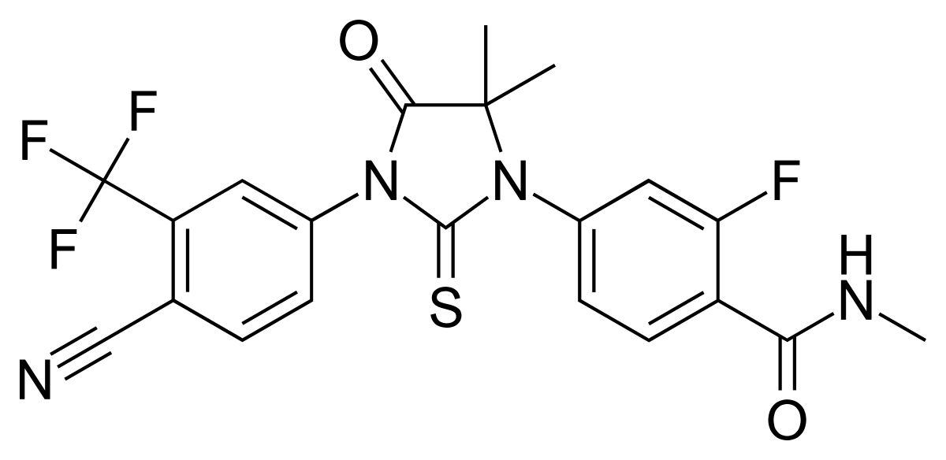
Figure 1: Structure of enzalutamide
Androgen receptor binding: Enzalutamide functions as a potent and selective antagonist of the androgen receptor (AR). It competitively inhibits the binding of androgens, such as testosterone and dihydrotestosterone (DHT), to the AR, thereby blocking AR-mediated signaling pathways involved in prostate cancer growth and progression.
Cytochrome P450 metabolism: Enzalutamide undergoes extensive hepatic metabolism primarily via the cytochrome P450 (CYP) enzyme system, particularly CYP2C8 and CYP3A4. Metabolites of Enzalutamide are pharmacologically active and contribute to its overall effects.
Metabolites: The major metabolites of Enzalutamide include N-desmethyl Enzalutamide, which retains significant pharmacological activity similar to the parent compound. These metabolites are further conjugated to form glucuronide and sulfate conjugates before excretion.
Chemical stability: Enzalutamide exhibits stability under recommended storage conditions, typically at room temperature and protected from light and moisture. Stability studies are conducted to assess its shelf-life and storage requirements to ensure drug quality over time²³.
Chemical reactivity: Enzalutamide is chemically reactive due to the presence of functional groups such as cyano, fluorine, and carbonyl moieties in its structure. These functional groups can participate in various chemical reactions, including metabolic transformations and interactions with other molecules.
Hydrophobicity: Enzalutamide is moderately hydrophobic, which influences its distribution and partitioning in biological fluids and tissues. Its hydrophobic nature contributes to its ability to cross cellular membranes and access intracellular targets such as the androgen receptor.
Chemical synthesis: Enzalutamide is synthesized through multistep organic synthesis routes involving the coupling of various intermediates and functional group transformations. The synthesis process is carefully optimized to ensure high yield, purity, and reproducibility of the final product.
Chemical interactions: Enzalutamide may interact with other drugs or chemicals that affect its metabolism, binding to plasma proteins, or elimination. Drug interaction studies are conducted to evaluate the potential for clinically significant interactions and guide dosing recommendations²⁴.
Pharmacodynamics
The androgen receptor (AR), the biological target of androgens such as testosterone and dihydrotestosterone (DHT), is selectively silently antagonistic to Enzalutamide. Enzalutamide, in contrast to bicalutamide, the first-generation NSAA, does not facilitate the translocation of AR to the cell nucleus and also inhibits the binding of AR to coactivator proteins and deoxyribonucleic acid (DNA)²⁵. As such, it has been called both an antagonist and an inhibitor of AR signaling. The medication is referred to as a "second-generation" NSAA due to its significantly higher anti androgen effectiveness when compared to "first-generation" NSAAs such as bicalutamide and flutamide. Compared to DHT, the natural ligand of the AR in the prostate gland, the drug's affinity for the AR is just two times lower²⁶.
Prostate cancer resistance mechanisms
Enzalutamide is only effective for a limited amount of time; beyond that, this anti androgen does not stop the cancer from growing. Extensive research is being done on the processes underlying Enzalutamide resistance²⁷.Currently, several mechanisms have been found:
- AR mutations^{28,29}
- AR splice variants³⁰
- Glucocorticoid receptor bypass³¹
- Increase in flux of glycolysis³²
- Autophagy mediated resistance³³
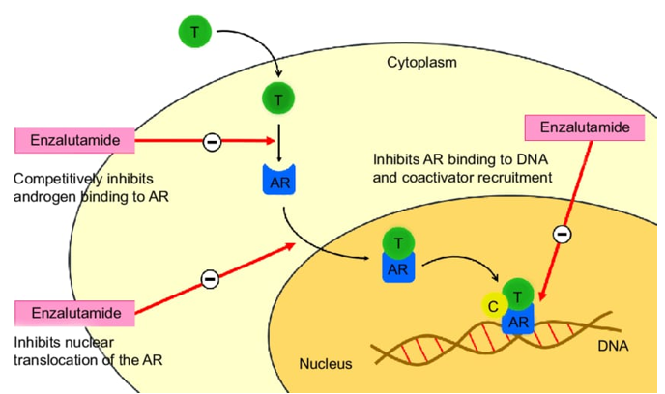
Figure 2: Enzalutamide in androgen receptor
Pharmacokinetics
Absorption: When Enzalutamide is taken orally, eating does not have a major impact on how well it is absorbed. That being said, it is advised to take it consistently with or without meals. About 84% of Enzalutamide is available in the body in its absolute form.
Distribution: Enzalutamide is mostly (more than 97%) attached to albumin, a highly protein-bound substance. Given its strong protein binding, Enzalutamide's tissue distribution may be restricted. The wide tissue distribution of Enzalutamide is shown by its enormous volume of distribution.
Metabolism: The liver is the primary site of Enzalutamide metabolism. Here, the hepatic cytochrome P450 (CYP) enzymes, namely CYP2C8 and CYP3A4, oxidize the drug. N-desmethyl Enzalutamide is the principal metabolite that is produced and possesses pharmacological action. Some CYP enzymes also metabolize ezetimibe to a lower degree.
Excretion: Roughly 71% of Enzalutamide and its metabolites are excreted in faces, while roughly 14% are excreted in urine. Enzalutamide is removed from the body slowly, as seen by its elimination half-life of around 5.8 days.
Interactions with drugs: Enzalutamide is a moderate inducer of CYP2C9 and CYP2C19 and a significant inducer of CYP3A4. Consequently, it may enhance the metabolism of substances that act as substrates for these enzymes, which may result in a decrease in the effectiveness of concurrently delivered pharmaceuticals. On the other hand, Enzalutamide and its active metabolites may be exposed to higher levels when these enzymes are inhibited³⁴.
Prostate cancer:
Enzalutamide has been shown to be a useful treatment for raising overall survival in patients with high-risk, non-metastatic castration-resistant prostate cancer, especially in those whose PSA doubling time is less than six months³⁵.
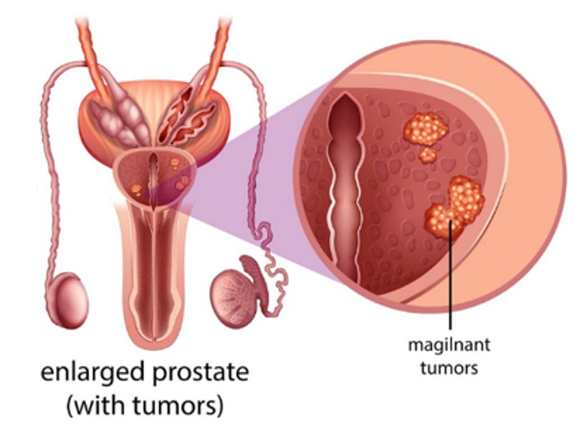
Figure 3: Prostate cancer
Medicinal uses
Patients with castration-resistant prostate cancer, metastatic castration-sensitive prostate cancer, and non-metastatic castration-sensitive prostate cancer with a biochemical recurrence and a high risk of metastasis should be treated with Enzalutamide.
Over dose
Enzalutamide overdose may lead to seizures.
Available Dosage Forms
Enzalutamide is provided as a capsule or tablet³⁶.
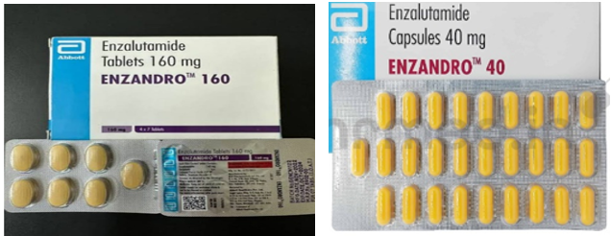
Figure 4: Enzalutamide tablets & capsules

Side effects
Notable side effects of Enzalutamide seen in clinical trials have included gynecomastia, breast pain/tenderness, fatigue, diarrhea, hot flashes, headache, sexual dysfunction, and, less commonly, seizures³⁷.Other "common" side effects reported in clinical trials have included neutropenia, visual hallucinations, anxiety, cognitive disorder, memory impairment, hypertension, dry skin, and pruritus (itching)³⁸. Enzalutamide monotherapy is regarded as having a moderate negative effect on sexual function and activity, significantly less than that of GnRH analogues but similar to that of other NSAAs such as bicalutamide³⁹.
Central adverse effects
Seizures have occurred in approximately 1% of patients treated with Enzalutamide in clinical trials. This is thought to be due to Enzalutamide crossing the blood–brain barrier and exerting off-target binding to and inhibition of the GABA_{A} receptor in the central nervous system (it has been found to inhibit the GABA_{A} receptor in vitro (IC₅₀Tooltip half-maximal inhibitory concentration = 3.6 μM) and induces convulsions in animals at high doses)⁴⁰. In addition to seizures, other potentially GABA_{A} receptor-related side effects observed with Enzalutamide treatment in clinical trials have included anxiety, insomnia, vertigo, paresthesia, and headache⁴¹. Due to its ability to lower the seizure threshold, patients with known seizure disorders or brain injury should be closely monitored during Enzalutamide treatment⁴². NSAA-induced seizures are responsive to benzodiazepine treatment, and it has been suggested that GABA_{A} receptor inhibition by Enzalutamide could be treated with these drugs⁴³. In dose-ranging studies, severe fatigue was observed with Enzalutamide at doses of 240 mg/day and above.
Rare adverse effects
There is a single case report of posterior reversible encephalopathy syndrome (PRES) with Enzalutamide treatment. The mechanism of action of the side effect is unknown, but it was proposed to a consequence of inhibition of the GABA_{A} receptor by enzalutamide⁴⁴.
CONCLUSION
One essential treatment option for prostate cancer, especially metastatic castration-resistant prostate cancer (mCRPC), is Enzalutamide. With its discovery, medical science made tremendous progress in treating patients and improving their quality of life and length of survival. Even with its remarkable effectiveness, Enzalutamide’s pharmacological properties and formulation call for careful thought in order to achieve the best possible dose and administration. Although Enzalutamide has great therapeutic advantages, it also has a number of tolerable adverse effects, such as gynecomastia, lethargy, and, very seldom, seizures. Significantly, its link to central side effects like seizures emphasizes how crucial it is to closely monitor patients, particularly those who already have seizure disorders. Furthermore, more research into the underlying processes of the uncommon incidence of adverse effects such posterior reversible encephalopathy syndrome (PRES) is necessary. Enzalutamide's contribution to the treatment of prostate cancer represents a noteworthy advancement overall, providing patients with better results and optimism at different phases of the illness.
REFERENCES
- Tran C, Ouk S, Clegg NJ, Chen Y, Watson PA, Arora V, Wongvipat J, Smith-Jones PM, Yoo D, Kwon A, Wasielewska T, Welsbie D, Chen CD, Higano CS, Beer TM, Hung DT, Scher HI, Jung ME, Sawyers CL. Development of a second-generation antiandrogen for treatment of advanced prostate cancer. Science. 2009; 324(5928):787-790.
- Beer TM, Armstrong AJ, Rathkopf DE, Loriot Y, Sternberg CN, Higano CS, Iversen P, Bhattacharya S, Carles J, Chowdhury S, Davis ID, de Bono JS, Evans CP, Fizazi K, Joshua AM, Kim CS, Kimura G, Mainwaring P, Mansbach H, Miller K, Noonberg SB, Perabo F, Phung D, Saad F, Scher HI, Taplin ME, Venner PM, Tombal B; PREVAIL Investigators. Enzalutamide in metastatic prostate cancer before chemotherapy. N Engl J Med. 2014; 371(5):424-433.
- Scher HI, Fizazi K, Saad F, Taplin ME, Sternberg CN, Miller K, de Wit R, Mulders P, Chi KN, Shore ND, Armstrong AJ, Flaig TW, Fléchon A, Mainwaring P, Fleming M, Hainsworth JD, Hirmand M, Selby B, Seely L, de Bono JS; AFFIRM Investigators. Increased survival with enzalutamide in prostate cancer after chemotherapy. N Engl J Med. 2012; 367(13):1187-1197.
- Benoist GE, Hendriks RJ, Mulders PF, Gerritsen WR, Somford DM, Schalken JA, van Oort IM, Burger DM, van Erp NP. Pharmacokinetic Aspects of the Two Novel Oral Drugs Used for Metastatic Castration-Resistant Prostate Cancer: Abiraterone Acetate and Enzalutamide. Clin Pharmacokinet. 2016; 55(11):1369-1380.
- Fujita K, Nonomura N. Role of Androgen Receptor in Prostate Cancer: A Review. World J Mens Health. 2019; 37(3):288-295.
- Schalken J, Fitzpatrick JM. Enzalutamide: targeting the androgen signalling pathway in metastatic castration-resistant prostate cancer. BJU Int. 2016; 117(2):215-225.
- Menon MP, Higano CS. Enzalutamide, a secondgeneration androgen receptor antagonist: development and clinical applications in prostate cancer. Curr Oncol Rep. 2013; 15(2):69-75.
- Foster WR, Car BD, Shi H, Levesque PC, Obermeier MT, Gan J, Arezzo JC, Powlin SS, Dinchuk JE, Balog A, Salvati ME, Attar RM, Gottardis MM. Drug safety is a barrier to the discovery and development of new androgen receptor antagonists. Prostate. 2011; 71(5):480-488.
- Keating GM. Enzalutamide: a review of its use in chemotherapy-naïve metastatic castration-resistant prostate cancer. Drugs & Aging. 2015; 32(3):243–249.
- Weber GF. (2015b). Molecular therapies of cancer. In Springer eBooks, USA.
- Borman S. New prostate cancer agent class. Chemical & Engineering News. 2008; 86(38):84–87.
- Jung ME, Ouk S, Yoo D, Sawyers CL, Chen C, Tran C, Wongvipat J. Structure-activity relationship for thiohydantoin androgen receptor antagonists for castration-resistant prostate cancer (CRPC). J Med Chem. 2010; 53(7):2779-2796.
- Narayanan R, Coss CC, Dalton JT. Development of selective androgen receptor modulators (SARMs). Mol Cell Endocrinol. 2018; 465:134-142.
- FDA approves Enzalutamide for metastatic castration-sensitive prostate cancer. U.S. Food and Drug Administration (FDA). 17 December 2019.
- Liu B, Su L, Geng J, Liu J, Zhao G. Developments in nonsteroidal antiandrogens targeting the androgen receptor. Chem Med Chem. 2010; 5(10): 1651–1661.
- Swe NC, Ahmed S, Eid M, Poretsky L, Gianos E, Cusano NE. The effects of gender-affirming hormone therapy on cardiovascular and skeletal health: a literature review. Metabolism Open. 2022; 13:100173.
- Tyler Marciniak. Enzalutamide Phase 2 terrain trial demonstrated statistically significant increase in PFS As Compared to Bicalutamide in Metastatic Prostate Cancer. 2015; (847) 736-7145.
- Pan F, Reifsnider O, Zheng Y, Proskorovsky I, Li T, He J, et al. Modeling Clinical Outcomes in Prostate Cancer: Application and Validation of the Discrete Event Simulation Approach. Value in Health. 2018; 21(4):416–22.
- Medivation’s MDV3100 shown to be effective in a preclinical model of hormone-refractory prostate cancer. Reuters, 2007.
- Research C for DE and. FDA approves enzalutamide for castration-resistant prostate cancer. FDA. 2018.
- Research C for DE and. FDA approves talazoparib with enzalutamide for HRR gene-mutated metastatic castration-resistant prostate cancer. FDA. 2023.
- Scher HI, Beer TM, Higano CS, et al. Antitumour activity of MDV3100 in castration-resistant prostate cancer: a phase 1–2 study. Lancet, 2010; 375:1437–1446.
- Gibbons JA, Ouatas T, Krauwinkel W, Ohtsu Y, van der Walt JS, Beddo V, de Vries M, Mordenti J. Clinical Pharmacokinetic Studies of Enzalutamide. Clin Pharmacokinet. 2015; 54(10):1043-1055.
- Sadar MD. Advances in small molecule inhibitors of androgen receptor for the treatment of advanced prostate cancer. World J Urol. 2012; 30(3):311–318
- Li JJ, Johnson DS (14 December 2015). Chapter 6: Enzalutamide. Innovative Drug Synthesis. John Wiley & Sons. p.103.
- Ricci F, Buzzatti G, Rubagotti A, Boccardo F (November 2014). Safety of antiandrogen therapy for treating prostate cancer. Expert Opinion on Drug Safety. 13 (11): 1483–1499.
- Claessens F, Helsen C, Prekovic S, Van den Broeck T, Spans L, Van Poppel H, et al. (December 2014). Emerging mechanisms of enzalutamide resistance in prostate cancer. Nature Reviews Urology. 11 (12): 712–716.
- Balbas MD, Evans MJ, Hosfield DJ, Wongvipat J, Arora VK, Watson PA, Chen Y, Greene GL, Shen Y, Sawyers CL. Overcoming mutation-based resistance to antiandrogens with rational drug design. Elife. 2013 Apr 9; 2:e00499.
- Pekovic S, van Royen ME, Voet AR, Geverts B, Houtman R, Melchers D, et al. (May 2016). The effect of F877L and T878A mutations on androgen receptor response to Enzalutamide. Molecular Cancer Therapeutics. 15 (7): 1702–12.
- Antonarakis ES, Lu C, Wang H, Luber B, Nakazawa M, Roeser JC, et al. (September 2014). AR-V7 and resistance to enzalutamide and abiraterone in prostate cancer. New EnglandJournalof Medicine. 371 (11): 1028–1038.
- Arora VK, Schenkein E, Murali R, Subudhi SK, Wongvipat J, Balbas MD, et al. (December 2013). Glucocorticoid receptor confers resistance to antiandrogens by bypassing androgen receptorblockade. Cell. 155 (6):130922.
- Cui Y, Nadiminty N, Liu C, Lou W, Schwartz CT, Gao AC (June 2014). Upregulation of glucose metabolism by NF-B2/p52 mediates Enzalutamide resistance in castration-resistant prostate cancer cells. Endocrine-Related Cancer. 21 (3): 435–442.
- Nguyen HG, Yang JC, Kung HJ, Shi XB, Tilki D, Lara PN, et al. (September 2014). Targeting autophagy overcomes Enzalutamide resistance in castration-resistant prostate cancer cells and improves therapeutic response in a xenograft model. Oncogene. 33 (36): 4521–4530.
- Kim TH, Jeong JW, Song JH, Lee KR, Ahn S, Ahn SH, et al. (November 2015). Pharmacokinetics of Enzalutamide, an anti-prostate cancer drug, in rats. Archives of Pharmacal Research. 38 (11): 2076–2082
- Wenzel M, Nocera L, Collà Ruvolo C, Würnschimmel C, Tian Z, Shariat SF, et al. (May 2021). "Overall survival and adverse events after treatment with darolutamide vs. apalutamide vs. enzalutamide for high-risk non-metastatic castration-resistant prostate cancer: a systematic review and network meta-analysis". Prostate Cancer Prostatic Dis (Systematic review). 25 (2): 139–148.
- Advanced Prostate Cancer Treatment | XTANDI® (enzalutamide) Safety Info Available from: https://www.xtandi.com/
- Antonarakis ES (June 2013). "Enzalutamide: The emperor of all anti-androgens". Translational Andrology and Urology. 2 (2): 119–120.
- Tombal B, Borre M, Rathenborg P, Werbrouck P, Van Poppel H, Heidenreich A, Iversen P, Braeckman J, Heracek J, Baskin-Bey E, Ouatas T. Long-term efficacy and safety of enzalutamide monotherapy in hormone-naïve prostate cancer: 1-and 2-year open-label follow-up results. European urology. 2015 1; 68(5):787-94.
- Desai C. Meyler's side effects of drugs: The international encyclopedia of adverse drug reactions and interactions. Indian J Pharmacol. 2016; 48(2):224.
- Alex AB, Pal SK, Agarwal N. CYP17 inhibitors in prostate cancer: latest evidence and clinical potential. Ther Adv Med Oncol. 2016; 8(4):267-275.
- Rathkopf D, Scher HI. Androgen receptor antagonists in castration-resistant prostate cancer. Cancer J. 2013; 19(1):43-49.
- Litt JZ. Comprar Litt's Drug Eruptions and Reactions Manual, | Jerome Z. Litt| 9781842145982| Informa Healthcare. Litt's Drug Eruptions and Reactions Manual, 19th edn, 2013.
- Tan PS, Haaland B, Montero AJ, Kyriakopoulos CE, Lopes G. Hormonal Therapeutics Enzalutamide and Abiraterone Acetate in the Treatment of Metastatic Castration-Resistant Prostate Cancer (mCRPC) Post-docetaxel-an Indirect Comparison. Clin Med Insights Oncol. 2014; 8:29-36
- Bonder, B., & De Lima, M. (2019). Posterior reversible encephalopathy syndrome (PRES) in cancer patients. In Springer eBooks (pp. 353–365).

