The use of remotely sensed parameters as preliminary tools to map leachate plumes around selected solid waste dumpsites in Abuja North central Nigeria
Owolabi J.A¹ Arogundade J.T² Omali A.O³
Department of Earth Sciences, Faculty of Natural Sciences
Prince Abubakar Audu University Anyigba, Nigeria
E-mail: arogundadejt@ksu.edu.ng; phone number: 07034759504
Abstract
Leachates around a few chosen dumpsites in the federal capital territory of Abuja, North central Nigeria, were mapped using freely acquired remote sensing parameters, including land surface temperature and digital elevation model. The digital elevation model represents the relief of the bare earth's surface while the land surface temperature measures the temperature of the air at the planet's surface. These variables were chosen because research has shown that digital elevation models can be used to define the spatial extent of the leachate and identify potential migration routes, while land surface temperatures can be used to map leachate plumes in a variety of settings, such as mining and landfill sites. The study area's land surface temperature and digital elevation model maps, respectively, showed the predominant migration path of the surface runoff, and consequently of the leachates, is northeast to southwest. The outcomes of Land Surface Temperature and Digital Elevation Model must be integrated with other techniques like electrical resistivity tomography and groundwater modeling to ensure effective mapping and delineation of the spatial extent of the leachates around dumpsites
Keywords: Land Surface Temperature; Digital Elevation Model; Leachates; Migration Routes; Air surface temperature,

- Introduction

The potential of Land Surface Temperature (LST) mapping for locating and mapping leachate plumes around solid waste dumpsites has been demonstrated in a number of studies [1, 2, and 3]. Leachate plumes can be mapped using land surface temperature in a variety of environments, such as mining regions and landfills. These studies' findings also imply that leachate plumes can be identified and monitored using remote sensing data, particularly thermal infrared imagery, in order to safeguard both human health and the environment. It is important to keep in mind, however, that a variety of factors, such as atmospheric conditions and land cover, can affect how accurate LST mapping is. LST mapping should be used in conjunction with other data sources and validation techniques to ensure accurate and reliable results.
Leachate plumes, which are areas of contaminated groundwater, can seriously harm the environment in the area. One technique for mapping these plumes is the measurement of the land surface temperature (LST), which can be used to locate areas with unusual heat signatures that might indicate the presence of leachate plumes and reveal information about the thermal properties of the land surface
As was already mentioned, several studies have used LST to map leachate plumes. For instance, [4] used Landsat 8 thermal infrared imagery to map the LST in a region affected by landfill leachate. Because the LST is higher where there are high contaminant concentrations, the study concluded that a leachate plume was present. Other studies have also used LST in conjunction with additional data sources, such as groundwater monitoring data, to map leachate plumes. For instance, [5] used groundwater monitoring data and LST derived from Landsat 7 thermal infrared imagery to map a leachate plume in a landfill-affected area. Similar to this, [6] used thermal infrared remote sensing data to map the LST in a region affected by coal mine drainage. The study found that areas with high LST values also had high levels of contaminants, which suggested that a leachate plume may have existed.
In a similar vein, digital elevation models (DEMs) have been extensively used to map leachate plumes. DEMs provide an accurate and detailed representation of the terrain for use in mapping the pathways of leachate migration and calculating the spatial extent of the plume. A leachate plume at a landfill site was mapped using DEMs in one study by [7]. The researchers combined ground-based and airborne LiDAR (Light Detection and Ranging) surveys to produce a high-resolution DEM. The size of the plume was then determined and potential leachate pathways were located using this DEM. In a different study, [8] used a DEM and groundwater modeling to map the geographic extent of a leachate plume at a landfill site. . The study demonstrates how DEMs, in conjunction with other methods like electrical resistivity tomography and groundwater modeling, can be used to map the spatial extent of leachate plumes and identify potential migration routes. The studies also highlight the importance of accurately calculating soil properties such as hydraulic conductivity, which can be achieved by combining DEMs and other geo-statistical methods. Because studies have shown that these methods have a lot of potential as a tool for locating and mapping leachate plumes, the purpose of this study is to use LST and DEMs of the area for that purpose.

- Materials and Methods
Site Description
According to Figure 1 [9], the study area is situated in the geographic center of Nigeria. 900,000 of its estimated 6 million residents live and work within the municipality [10 and 11]. The study area, which spans a portion of FCT Abuja, is roughly 120 km2 in size and lies between Latitudes N8°10' and N9°45' and Longitudes E6°30' and E7°45'E. Six local councils make up the Federal Capital Territory of Nigeria: Abuja Municipal, Abaji, Bwari, Gwagwalada, Kuje, and Kwali (Ezeah et al., 2009a). Investigations are being conducted at the following dumpsites: Gosa, Gwagwalada, Kuje, Kubwa, Bwari, Karshi, and Azhata.
.
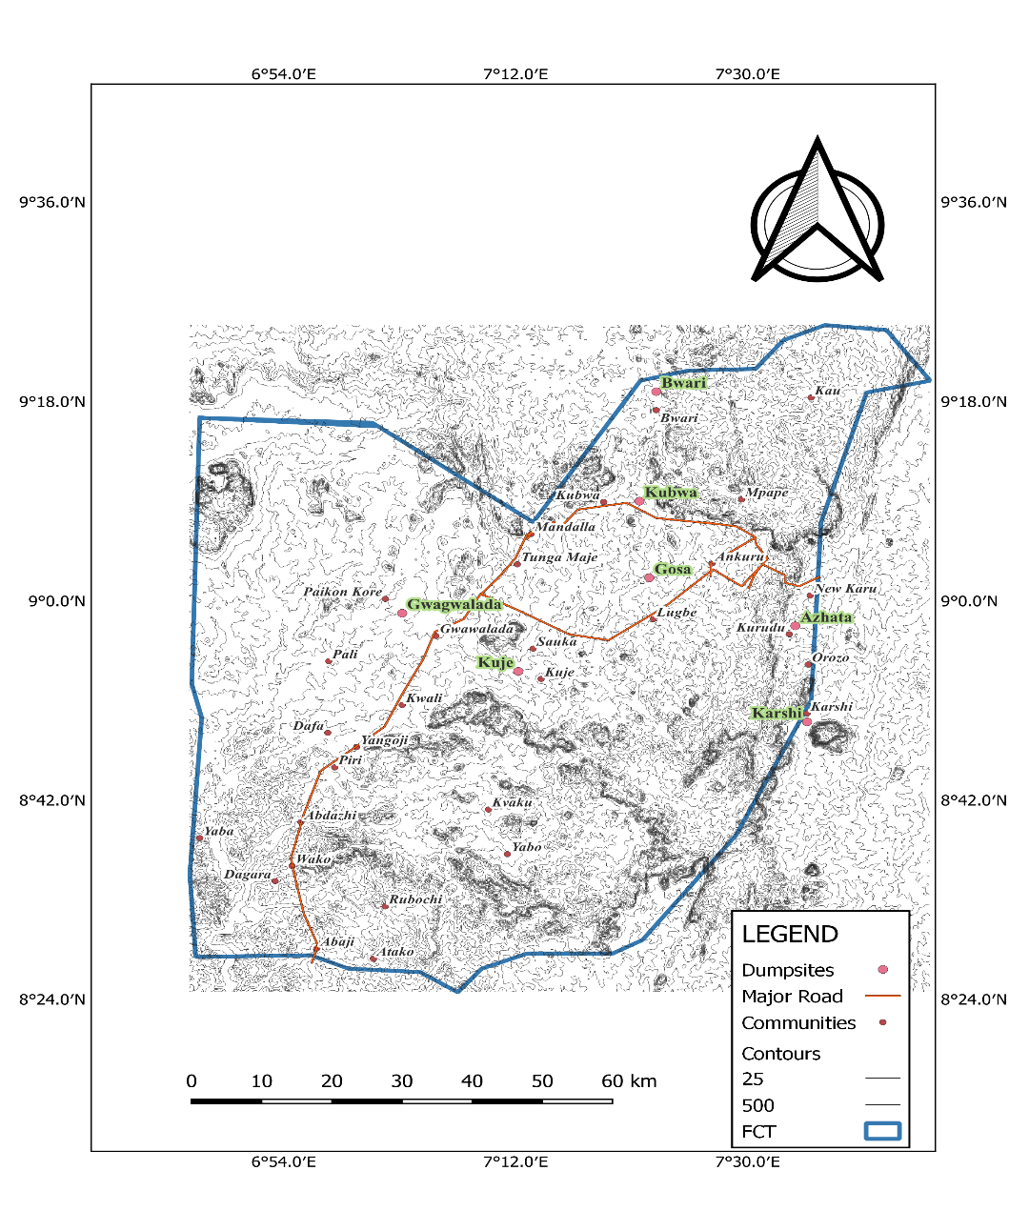

Figure 1. Map of the study area showing the dumpsites (source: This work)
Geology of the study area
Basement Complex, which dates from the Precambrian to the Lower Paleozoic, lies beneath the area. Precambrian-age igneous rocks and high-grade metamorphic rocks are the most common types of rocks [12, 13, and 14]. Granite Gneiss, Schist, and Migmatite make up the majority of it (Figure 2). Geologic characteristics like the intensity of fracturing and the depth of weathering (thickness and continuity of the regolith) affect the presence of groundwater in this region.
.
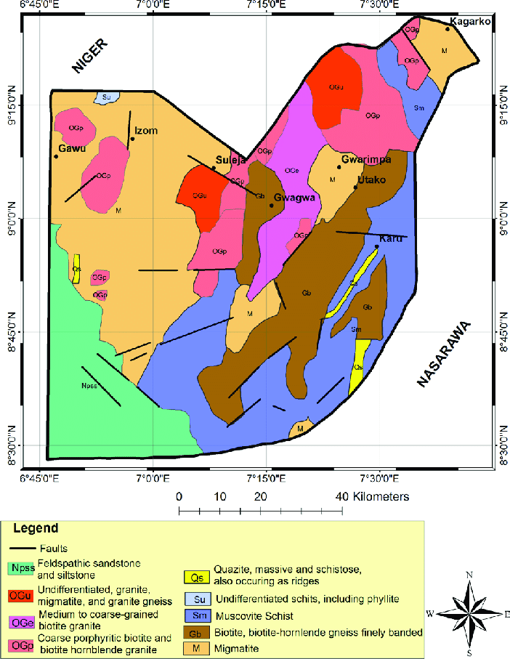
Figure 2 Geological Map of the study area

Digital Elevation Model
The bare earth surface, devoid of vegetation and topographic features, is represented by a digital elevation model (DEM). DEM, or digital elevation models, refer to the topographic surface of the Earth, excluding trees, structures, and any other objects on the surface. It is available from a variety of sources. The raster layer sources used for the DEM include;
- United State Geological Survey earth explorer (Shuttle Radar Topography Mission)
- Open topography.org
- Diva GIS etc
The raster layer used for this study was obtained from USGS earth explorer (SRTM). It was then processed through open sourced QGIS (3.26 version) to produce the DEM of the study area.
Land Surface Temperature (LST)
The skin temperature of the land is determined by solar radiation, and is known as the Land Surface Temperature (LST). It can also be described as the temperature at which the Earth's "surface" would feel hot to the touch in a specific location, depending on land use activities like burning, deforestation, and mining [3]. The Landsat Enhanced Thermal Mapper plus (ETM+) Thermal bands were used to estimate the land surface temperature of the study area. The following formula was used to process the Landsat 8 band 10 raster layer obtained from USGS Earth Explorer in QGIS (3.26 version) [2].
Land Surface Temperature (LST) of Landsat 8
- Convert Thermal Infra-Red Digital Numbers to Top of Atmospheric (TOA) spectral radiance using the radiance rescaling factor
L$λ=ML×Q_{cal}+AL-O_{i}$
L$λ=0.0003342×Band10+0.10000-0.29$
Where:
L$λ=TOA spectral radiance$
$$ML=Radiance multiplicative Band$$

$$AL=Radiance Add Band (No.)$$

$$Q_{cal}=Quantized and calibrated standard product pixel values$$
$$O_{i}=Correction value for band 10 is 0.29$$
- Convert spectral radiance data to top of atmosphere brightness temperature using the thermal constant values in the Meta data file.
$$Kelvin \left(K\right) to Celcius \left(°C\right) Degrees BT={K2}/{In\left(K1/Lλ+1\right)-273.15}$$
$$BT={(1321.0789}/{Ln(774.8853/TOA+1))-273.15}$$
Where:
$$BT=Top of atmosphere brightness temperature (°C)$$
L$λ=TOA spectral radiance$
$$K1=K1 Constant Band(No.)$$
$$K2=K2 Constant Band(No.)$$
- Calculate Normalized Difference Vegetation Index (NDVI)
The normalized differential vegetation index (NDVI) is a standardized vegetation index which is calculated using Near Infra-red (Band 5) and Red (Band 4) bands.
$$NDVI=(NIR-RED)/(NIR+RED)$$
$$NDVI=(Band 5-Band 4)/(Band 5-Band 4)$$
Where:
$$RED=DN values from the RED band$$
$$NIR=DN values from Near-Infrared band$$
- Calculate Land Surface Emissivity (LSE)
Land surface emissivity (LSE) is the average emissivity of an element of the surface of the Earth calculated from NDVI values.
$$PV={((NDVI-{NDVI}_{min})/({NDVI}_{max}-{NDVI}_{min}))}^{2}$$
Where:
$$PV=Proportion of Vegetation$$
$$NDVI=DN values from NDVI Image$$
$${NDVI}_{min}=Minimum DN values from NDVI image$$
$${NDVI}_{max}=Maximum DN values from NDVI image$$
$$E=0.004×PV+0.986$$
Where:
$$E=Land Surface Emissivity$$
$$PV=Proportion of Vegetation$$
$$0.986 corresponds to a correction value of the equation$$
- Calculate Land Surface Temperature (LST)
The Land Surface Temperature (LST) is the radiative temperature which is calculated using Top of atmosphere brightness temperature, wavelength of emitted radiance, Land Surface Emissivity.
$$LST=BT/(1+(λ×BT/c2)×In(E))$$
Here, $c2=14388µm K$
The values of $λ$ for Landsat 8: for Band 10 is 10.8 and for Band 11 is 12.0
Where
$$BT=Top of atmosphere brightness temperature \left(°C\right)$$
$$λ=Wavelength of emitted radiance$$
$$E=Land Surface Emissivity$$
$$c2=h×c/s=14388 mk$$
$$h=Planck^{'}s Constant=6.626×{10}^{-34}js$$
$$s=Botzmann constant=1.38×{10}^{-23}jk$$
$$c=velocity of light=2.998×{10}^{8}m/s$$

- Results and Interpretation

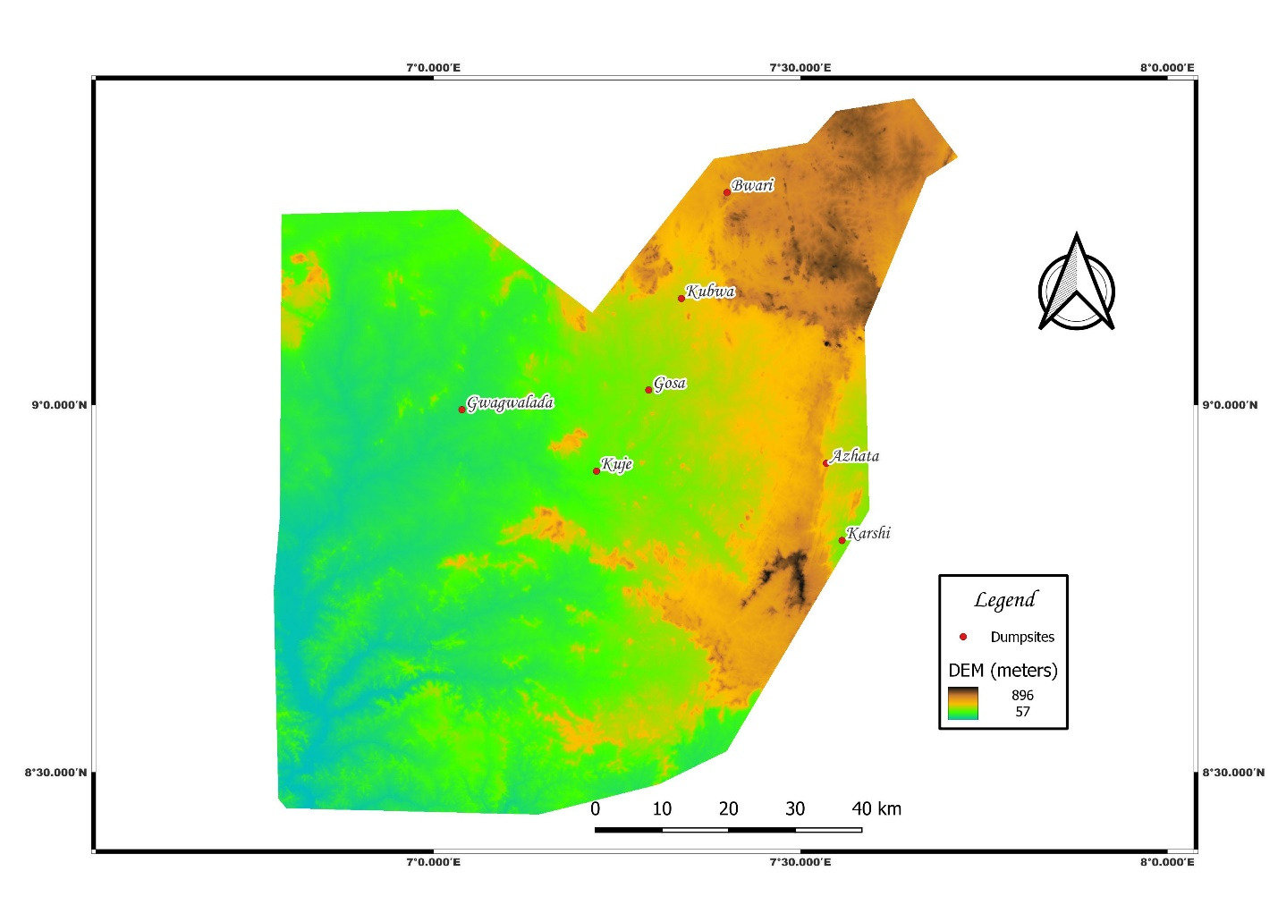
Figure 3. Digital elevation map of the study area

Digital Elevation Model of the study area
In response to the prevailing geology and topography, the products of waste decomposition rarely remain at the point of discharge instead being transported by infiltrating water and surface runoff. As a result, groundwater flow rate and direction, which serve as a conduit for the transmission of leachates from one point to another, are greatly influenced by the relief and or the topography of an area.
According to Figure 3, the elevation of the area captured with deep brown color ranges from 600 to 895 meters, that of the area captured with yellow color from 450 to 595 meters, that of the area captured with green from 190 to 400 meters, and that of the area captured with blue color from 50 to 180 meters. The general flow direction of the groundwater and surface runoff will likely be northeast to southwest, which is quite consistent with the local digital elevation model.
Given the foregoing, it was assumed that the leachates produced in all dumpsites—aside from Azhata and Karshi—would flow in a northeast-southwest direction (NE-SW). Based on the findings, geo-electric profiles for geophysical evaluation along NE-SW for the dumpsites at Gosa, Kubwa, Bwari, Gwagwalada, and Kuje can be taken in order to identify potential migration pathways and map the geographic extent of the leachates. This outcome is consistent with [15 and 16].

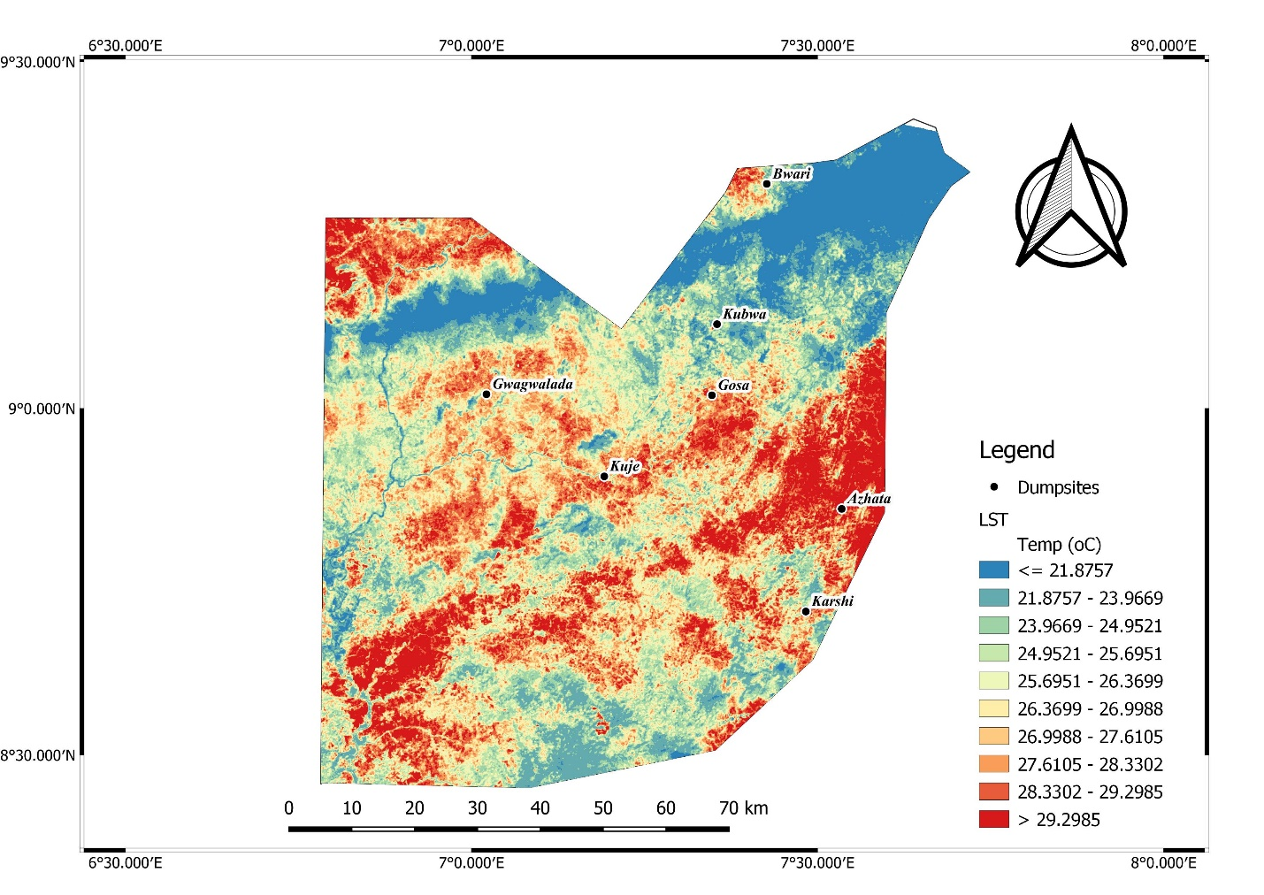
Figure 4. Land Surface Temperature Map of the study area
Land surface Temperature of the study area
According to Figure 4, regions on the map highlighted in red denote those with high air temperatures (roughly 30°C), while regions highlighted in green denote those with low air temperatures (roughly 20°C). The change in air temperature in and around the dumpsite brought on by the biodegradation of organic wastes, chemical reactions involving inorganic wastes, and perhaps human-based activities like waste burning are captured by land surface temperature (LST) [2]. The organic wastes' rapid aerobic and anaerobic breakdown into methane gas (CH4), carbon monoxide (CO), hydrogen sulfide (H2S), and other gases is to blame for some of the high temperatures in the dumpsite vicinity.
Red areas denote regions where burning, biodegradation of organic waste, spontaneous reaction of inorganic waste, and release of gaseous materials like methane (CH4), carbon monoxide (CO), and hydrogen sulfide (H2S) into the atmosphere are occurring. The areas that are depicted in green are those where there are fewer anthropogenic activities, such as burning and the emission of greenhouse gases like carbon monoxide into the atmosphere. [17] It was noted that the distribution of heavy metal concentrate and the mapping of dumpsites can both benefit from the correlation between temperature, topography, and resistivity response. Land surface temperature around the dumpsites was therefore used as a criterion in choosing the geo-electric profiles around the investigated dumpsites, in addition to the area's geology and digital elevation model.This result agrees with [18, 19. 20 and 21]

- Conclusion
Because they provide precise and thorough representations of the terrain that can be used to identify potential migration routes and estimate the spatial extent of the leachate plume, DEMs and LST are efficient mapping tools for leachate plumes. According to the map of LST and DEMs for the study area, the leachates (decomposition byproducts) of waste in the investigated disposal facilities flow primarily in a northeasterly to southwesterly direction. If the DEMs and LST results are combined with other methods, such as electrical resistivity tomography and groundwater modeling, the mapping of the leachate can be done more successfully.
- Acknowledgement
The authors sincerely want to thank Prof. C.C Eze of the Department of Physics, Enugu State University of Science and Technology, Agbani, Nigeria for his technical supports before and during the production of this manuscript

- References
1 Ngie A, Abutaleb K, Ahmed F, Taiwo J.O, Darwish A.A, Ahmed M Using Landsat ETM+ images, an estimate of the land surface temperature for Durban, South Africa, Rwanda Journal, http://dx.doi.org/10.4314/rj.v1i1S.2D, (2016) series D, Volume (1) pp. 1-17
2 Ekeu-wei1, I.T, Azuma K.I and Ogunmuyiwa F.B.B, Evaluation of the environmental impact of solid waste dumpsites Using remote sensing, Nigerian Journal of Technology (NIJOTECH), (2018) Vol. 37, No. 1, January 2018, pp. 275 – 285
3 Zhang, Y., Kusch-Brandt, S., Gu, S., & Sonia Heaven, S. Particle size distribution in municipal solid waste pre-treated for bioprocessing, Resources, (2019). 8, 166, 3-4
4 Al-Rawabdeh, A.M., Al-Ansari, N., Knutsson, S. The use of thermal infrared imagery to map landfill leachate plume. Environmental Earth Sciences, (2017)76(4), 147.
5 Kim, K., Chun, J., Kim, Y. Mapping landfill leachate plume with the aid of Landsat TM and ETM+ thermal infrared data. Environmental Earth Sciences, (2015). 73(10), 6427-6439
6 Chen, J., Zhang, Z., Jia, Y. The use of remote sensing thermal infrared data mapping coal mine drainage leachate plume. Environmental Science and Pollution Research, (2019)26(2), 1895-1908.
7 Kavazanjian, E., Johnson, E., Hanson, J., & Evanko, C. The use of digital elevation model to map leachate plumes at a landfill. Journal of Waste Management, (2015) 39, 123-129.
8 Al-Rawabdeh, A.M., Al-Ansari, N., Knutsson, S Mapping groundwater contamination from landfill leachate using thermal infrared imagery: a case study in the Amman-Zarqa Basin, Jordan. Environmental Earth Sciences, (2018). 77(3), 97.
9 Adama, O. Governing from above: Solid waste management in Nigeria's new capital city of Abuja. Ph.D. Thesis, Stockholm University, Sweden (2007)
10 NPC. National Population Commission of Nigeria Website (2012). Available @ www.population.gov.ng
11 Olanrewaju O, Ilemobade A. Waste to wealth: A case study of the Ondo State integrated wastes recycling and treatment project. Nigerian, European Journal of Social Sciences. (2009) 8(1):7-16.
12 Oyawoye, M.O. The geology of the basement complex. Journal of Nigeria Mining, Geology and Metallurgy. (1964).Volume 1, pp. 87-102.
13 Rahaman, M. A.and Lancelot, J. R. Continental crustal evolution in S.W.Nigeria: constraints from U-Pb dating of Pre Pan African gneisses. Report de Centre geophysique de Montepellier (1984)
14 Dada, S. S. Proterozoic evolution of Nigeria. In: Oshin, O. (ed.). The Basement Complex of Nigeria and its mineral resources. Ibadan, Nigeria, Akin Jinad & Co. (2006).
15 Xu, Q., Qian, J., Yang, C., & Huang, Y. Spatial variability of hydraulic conductivity for mapping landfill leachate plume simulation based on digital elevation model and geostatistics. Journal of Environmental Management, (2021) 278, 111542.
16 Xu, Q., Yang, C., Qian, J., & Lin, C. Groundwater flow and contaminant transport simulation for landfill leachate plume with the aid of digital elevation model and finite element method. Journal of Environmental Management, (2020) 259, 110-119.
17 Grellier S. Robain H. Bellier G. and Skhiri N. Influence of temperature on the electrical conductivity of leachate from municipal solid waste, Journal of Hazardous Materials (2006) 137(1): 612-7
18 Ruan, G., Zhou, J., Chen, X. . Mapping landfill leachate plumes using thermal infrared remote sensing: a case study in Fuzhou, China. Environmental Science and Pollution Research, (2020) 27(2), 1304-1314
19 Wang, Y., Li, P., Hu, B. Mapping leachate plumes using high-resolution thermal infrared imagery: a case study in the Tianjin landfill, China. Journal of Environmental Management, (2020). 268, 110677
20 Yu, X., Yang, Y., & Zhang, Y. Mapping of landfill leachate plume with the aid of electrical resistivity tomography and digital elevation model. Environmental Science and Pollution Research, (2017) 24(4), 3455-3464.
21 Du, Y., Wu, J., Shi, H Mapping and prediction of leachate plumes direction using high-resolution thermal infrared imagery: a case study in Shenzhen, China. Environmental Science and Pollution Research, (2019). 26(20), 20927-20938

