**Short Title :**Assessment of impact of Health Education Package on screening of TB and IPT among family members of TB patients.

**Authors :** Thakur M, Bamania S.K., Sharma B., Kaur J, Singla M, Priya and Mann S.K.

A Study To Assess The Impact Of Health Education Package On Screening Of TB And IPT Among Family Members Of TB Patients Registered In DOTS Centre PGIMER, Chandigarh, 2019-2020.

## Thakur M, Bamania S.K., Sharma B., Kaur J, Singla M, Priya and Mann S.K.

Nursing Department, National Institute of Nursing Education, Chandigarh, India

# ABSTRACT

**Background:** Tuberculosis (TB) is a chronic infectious disease caused by mycobacterium tuberculosis (MTB). Worldwide it is considered among the top ten infectious diseases. Though it is preventable and curable, it is still a major public health concern in India. The present study was carried out to assess the status of screening for TB in the family members and Isoniazid Prophylaxis Therapy (IPT) provided to under 6 years of age among the family of TB patients registered in DOTS Centre, PGIMER, Chandigarh during 2019-20 and to assess the impact of Health Education Package among non-screened family members of registered TBpatients.

**Methods:** After obtaining ethical clearance from the ethical committee, 80 registered PTB patients taking treatment or completed during July 2019-July 2020 at DOTS Centre, PGIMER, and Chandigarh were identified by employing survey performa and 50 registered TB patients fulfilling the criteria were enrolled by purposive sampling technique. 240 family members of 50 registered pulmonary Tuberculosis patients were interviewed telephonically after obtaining written consent via Google form. Semi structured interview schedule was used to collect socio demographic data and checklist to assess the screening status of Tuberculosis for adults and IPT status for less than 6 years of children. Health Education Package was also developed and for missing cases 3 follow ups were done and in each follow up Health Education package was imparted telephonically to symptomatic, non- screened family members to motivate them for screening and for initiation of IPT to children below 6 years ofage.

**Results:** The findings showed that all registered TB patients took treatment. . Majority (98%) of family members were not having any signs and symptoms of PTB and 5(2%) were symptomatic and undergone screening. 3(60%) of the symptomatic family members were found sputum smear positive on screening and started with DOTS therapy. In all 19 less than 6 years of age children eligible for IPT, 14(73%) of them had taken IPT and 5 (27%) didn’t initiated with IPT .The parents were motivated via Health Education Package for risk evaluation of children to initiate IPT at nearbyDOTScentre.However,theresultsforrisk assessment were minimal as the patients in these 5 families had already completed treatment with sputum smear negative result & hence there was no need for IPT.

**Conclusion:** Screening and IPT services for family members of patients with TB registered under DOTS are functioning well. Health Education Package developed in the study had got impact for motivating people for screening and initiation of IPT to under 6 years of age children.

# *Keywords:*TB, Screening, IPT, Health Education

# *\*Author for Correspondence* E-mail:muskansingla496@gmail.com, Tel: +91-798-6453248

# INTRODUCTION

Worldwide tuberculosis is considered among the top ten infectious diseases. It is prevalent in every part of the world. Globally TB incidence is reducing at the rate of 2% per annum [1]. In India, 2.5 lakh is the total incidence of new TB cases. 89% of TB cases come from the age group of 15 to 69 years [2]. In 2019 estimated incidence of 24 lakh cases makes India one of the highest TB burden country globally. 2019 is a milestone year of TB surveillance of India as there is increase of 12% cases as compared to last year 2018[3].The goal of NTEP is to eliminate TB by 2025 in INDIA. The requirement of TB elimination has been integrated into source strategic pillars of “detect –treat-prevent-build” (DTPB). The most crucial activity of case finding strategy under NSP is early identification of high risk people (presumptive TB). Under contact screening as component of NSP, all contacts, especially household contacts will be screened for TB.NSP includes IPT to children under the age of 5 as these children are more susceptible to TBinfection [4].The mode of infection is droplet infection through droplet nuclei generated by sputum smear positive pulmonary TB cases [5].Contact investigation is very crucial part to break the chain of disease transmission and to successfully stop TB transmission and emergence of future cases and outbreak of the disease. Present study was planned as perWHO 1+1 initiative program with goal of each one reach one, each one teach on and each one each one, and as per NTEP guidelines to bring down the morbidity due to TB and MDR-TB and screening for the entire household and IPT for children less than 6 years of age. As greatest challenge faced by NTEP is non- Compliance and latent cases of tuberculosis, Ignorance of family in non-Compliance of IPT. Keeping the guidelines in mind the present study was aimed so as to identify the missing cases by making use of Health Education Package to motivate the non-screened family members and children less than 6 years of age of registered TB for initiation ofIPT [6].

# Review of literature

A study was conducted in 2001 on total 659 patients with sputum smear positive PTB were identified. 267 had 365 children aged 5 and less living at their home. 33 under 5 children were screened for TB and 23 received IPT and 6 under5 children received anti tuberculosis therapy[7].Mary R. Reichler, et al. studied on risk and timing of tuberculosis among close contacts of persons with infectious TB in US and CanadaStates[8]. TB cases are at high risk for getting TB infection, therefore there is a need for prompt and thorough contact investigation of smear positive TB patients for control of TB[9]. Screening of young children living in the households of smear positive PTB cases has identified active TB disease in 22- 34% and contribute a significant proportion of the trial number of registered childhood cases of TB. Therefore, all the children <6years of age of smear positive PTB patients should be screened for TB[10]. A study on evaluation of TB case finding through systematic contact investigation, Chhattisgarh, India conducted from 2010-2011 by Kashitijkhapaede, et al in rural and socioeconomically depressed districts of Rajnandgaon, Chhattisgarh state, India. Study concluded that 63% TB cases were contributed by household visits as compared to passive case detection[11]. PothukuchiM,Nagaraja SB, et al. on TB contact screening and IPT in a south Indian District in 2011 concluded that the contact screening andIPTimplementation under routine programmatic condition was found sub-optimal[12]. A prospective cohort study was conducted by Singh J, et al identifies that the active household contact screening is a powerful tool to detect and treat tuberculosis at early stages and the only method to control TB in high TB burden countries[13]. Gomes VF,Wejse C, et al concluded that overall adherence to IPT was better than previously reported from YB endemic areas, with 76% of the children completing at least 6 months of treatment, with more than 80% adherence[14]. Fox GJ, et al findings suggest higher prevalence of TB among child contacts compared with adults, and a higher prevalence of TB among contacts in low middle income countries compared with high income countries. The substantial incidence of TB disease during 5 years after exposure, and particularly within the first 12 months, highlights the potential importance of serial screening for TB in contacts that don’t receive treatment for latent TB infection [15]. A quasi experimental study model observed that there was a significant relationship between knowledge, HBM constructs and self-care promoting behaviors. It was concluded that TB patients still need education about self-care behaviors, timely medications and adherence to health workers instructions [16]. Strengthening contact tracing capacity of pulmonary tuberculosis patients in Enugu, Southeast Nigeria, a targeted and focused health education intervention study in 2014 concluded that the planned health education improved contact tracing skills of the TB center in Enugu state, Nigeria[17]. A quasi- randomized interventional study from January 2014- June 2015 by Ghulam Hassan Khatana, et al. concluded that ‘home based interventional model’ was found effective in tracing contacts for TB[18]. A mixed method study was conducted from January 2015- March 2015 in Bhopal, India by AakashRanjansingh, et al. concluded that awareness is lacking among parents of infected children[19]. Laghari, et al. (2019) conducted a cross sectional study in Hyderabad which showed that only symptomatic cases in contactwithactive TB cases were screened under NTP and the rest contacts were left unscreened[20].

**Need of Study**

In India TB is reported as one of the killer disease.Present study was planned as per WHO 1+1 initiative program with goal of each one reach one, each one teach on and each one each one, and as per NTEP guidelines to bring down the morbidity due to TB and MDR-TB and screening for the entire household and IPT for children less than 6 years ofage.

As greatest challenge faced by NTEP is non- Compliance and latent cases of tuberculosis, Ignorance of family in non-Compliance of IPT. Keeping the guidelines in mind the present study was aimed so as to identify the missing cases by making use of Health Education Package to motivate the non-screened family members and children less than 6 years of age of registered TB for initiation of IPT.

Present study was previously being conducted for the DMC and Dhanas research setting, it has been the areas to gain community experience. The areas are rehabilitation colonies, mainly of low socioeconomic status, majority are daily wage workers, during our posting we found that many patients were coming for DOTStherapy.

But before we started the data collection COVID 19 was declared pandemic, so we had to change the research setting. As advised by guide, co- guide and ethical committee research setting was changed from community to hospital setting with same objectives.

## RESEARCH METHODS

## The study setting was conducted at DOTS Centre under RNTCP in PGIMER Chandigarh. The study design was pre-experimental. The study period was from July 2019 to July 2020. The study population was family members of registered TB patients. We included all the household contacts of registered PTB patient who were willing to participate and able to under Hindi or English after taking their consent. A tool was designed keeping in view the desired information needed from the subjects which included survey performa, socio demographic data of registered TB patient,Family members and household screening Performa, Screening Performa for less than 6 years of age children, Health Education package, Telephonic follow up Performa. Structured interview was carried out to collect data. Due to COVID 19 pandemic face to face interview was not possible so interview was conducted telephonically. The socio- demographic data for identification of PTB cases and family members, smoking, alcohol, relation with patient, checklist regarding TB sign and symptoms, duration of sign and symptoms if any, screening and treatment status and IPT to under 6 yrs of age was collected. Intervention was done by motivating non-screened family members and parents of under 6 yrs of age not taking IPT via Health Education Package.The impact of Health Education Package on screening of non-screened family members and IPT status of under 6 yrs of age children was observed by doing three follow ups at 3rd 5th and 7th days after motivating via Health Education Package.

## Sample Size

Sample size was estimated to be 85 patients, but as per the availability of patients due to COVID 19 only 50 registered patients were selected as sample and interviewed. The non-screened family members of these 50 patients were motivated via Health EducationPackage.

## Method Of Data Collection

Data collection was carried out at DOTS Centre, PGIMER, Chandigarh from 24th July - 31th July.

A total of 83 registered TB patients were enrolled in the study using purposive sampling technique, only 50 out of them were selected as sample and others were rejected due to non-availability. Consent was taken from the participants via goggle forms. The anonymity and confidentiality of the subjects were maintained. They were given adequate time to respond to the questions and their privacy was ensured to prevent any unbiased answers from participants. A semi structured validated interview schedule was used in local language. As governmentimposedrestrictions and social distancing so family members were not accompanying the patients at DOTS Centre. So Data was collected by telephonic interview method and conditions were not possible to deliver health educational package at health center so it was delivered via communication application on their phones. An average 15-20 minutes were spent on each subject on the day of telephonic interviews.

## Data Analysis

Data was analysed using SPSS version 20.0(statistical package for the social sciences). Descriptive and Inferential statistical method were used to analyse the data. The results were grouped into tables to interpret the data.

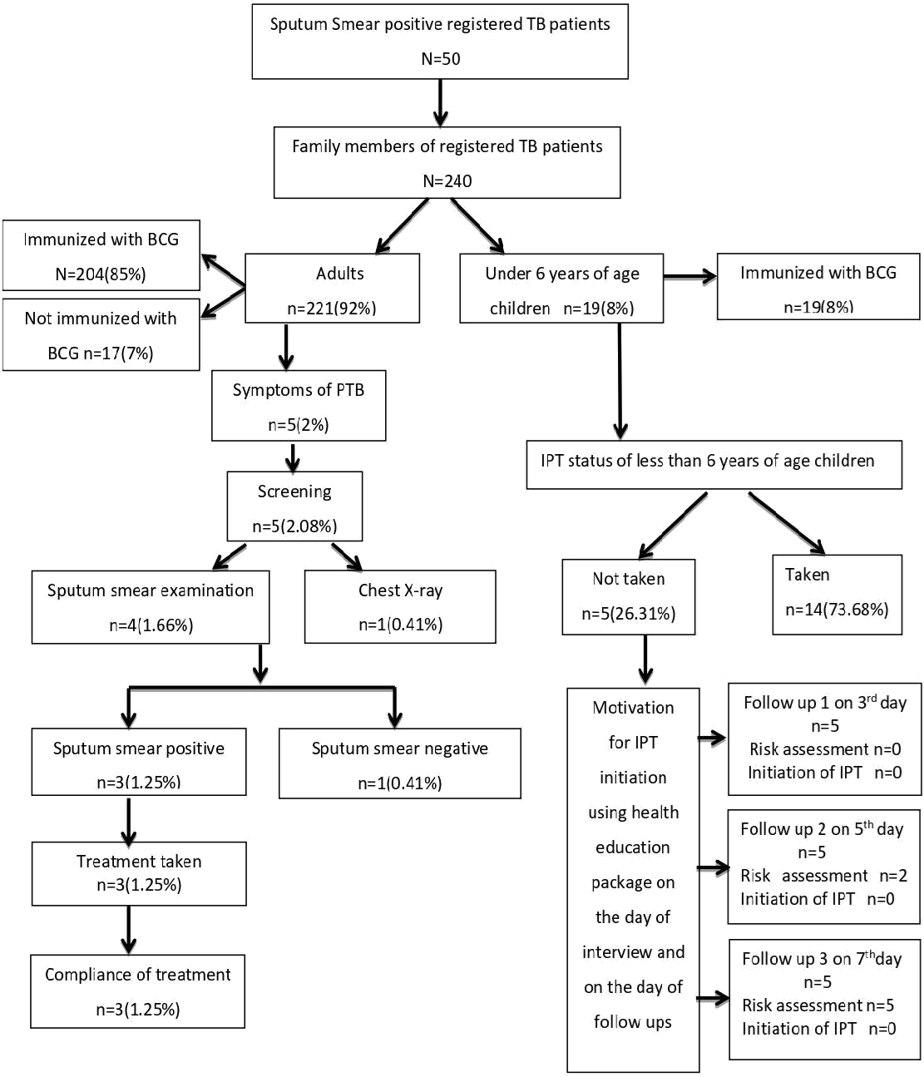

**Figure 1: Flow Diagram Depicting the Screening and IPT Status of Family Members of Registered Patients at DOTS Centre, PGIMER, Chandigarh from July 2019-2020.**

**Table 1: Socio Demographic Characteristics of Registered TB Patients.**

**Table 2: Behavioural Characteristics of Registered TB Patients.**

|  |  |
| --- | --- |
| Range(years)=15-70 Mean±SD=33.3±13 | **N=50** |
| **Socio demographic Variables** | **n(%)** |
| **Age(in years)** |  |
| 15-25 | 19(38) |
| 26-35 | 12(24) |
| 36-45 | 9(18) |
| 46-55 | 8(16) |
| >65 | 2(4) |
| **Gender** |  |
| Male | 35(70) |
| Female | 15(30) |
| **Religion** |  |
| Hindu | 41(82) |
| Sikh | 9(18) |
| **Educational status** |  |
| Illiterate | 5(10) |
| Primary | 9(18) |
| Secondary | 23(46) |
| Graduate | 13(26) |
| **Occupation** |  |
| Government job | 7(14) |
| Private job | 12(24) |
| Daily wage worker | 8(16) |
| Housewife | 6(12) |
| Not working | 9(18) |
| Students | 8(16) |
| **Type of Family** |  |
| Nuclear | 41(82) |
| Joint | 9(18) |
| **Family members** |  |
| 1-3 | 25(50) |
| 4-6 | 21(42) |
| 7-9 | 4(8) |
| **Children under 6 years of age** |  |
| No child | 36(72) |
| 1 | 9(18) |
| 2 | 5(10) |
| **Monthly family income (**Rs.**)** |  |
| 5000-10000 | 3(6) |
| 10100-20000 | 17(34) |
| 20100-30000 | 30(60) |
| **Mean**±SD=20550±4565.20 |  |

|  |  |
| --- | --- |
| **N=50** | |
| **Behavioural variables** | n(%) |
| **Smoking** | 4(8) |
| **Duration of smoking** |  |
| 2-3 years | 1(2) |
| >3years | 3(6) |
| **Type of smoking** |  |
| Bidi | 3(6) |
| Cigarette | 1(2) |
| **Alcohol** | 6(12) |
| **Duration of alcohol intake** |  |
| 1-2 years | 2(4) |
| 2-3 years | 1(2) |
| >3 years | 4(8) |
| **Table 3: Health Profile of Registered TB Patient.** | |
| **N=50** | |
| **Health Variables** | **n(%)** |
| **Type of TB Case** |  |
| New Case | 46(92) |
| Relapse Case | 4(8) |
| **Treatment Completed** | 26(52) |
| **Treatment ongoing** | 24(48) |
| <1 Month | 3(6) |
| 1-3Months | 7(14) |
| 3-6Months | 13(26) |
| >6Months | 1(2) |
| **Drug Compliance** | 50(100) |

**Table 4: Screening Status of Family Members.**

|  |  |
| --- | --- |
| **N=240** | |
| **Family members** | **n(%)** |
| Adults | 221(92) |
| Under 6 age of children | 19(8) |
| **Family members Immunized with BCG** | 223 |
| Adults | 204(92) |
| Under 6 years of age children | 19(100) |
| **Screening status** |  |
| Symptomatic family members screened | 5(2) |
| for TB |  |
| Chest X-Ray | 1(20) |
| Sputum smear examination | 4(80) |
| TB positive result | 3(60) |
| Treatment status | 3(60) |
| TB Drug compliance of positive family | 3(60) |
| Members |  |

**Table 5: IPT Status of Under 6 Years of Children.**

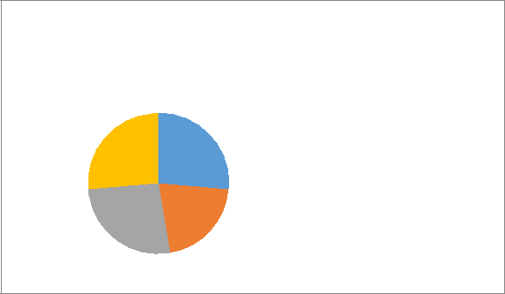

**IPT Status**

IPT completed

26% 27%

IPT for <3 months

26%

21%

months

IPT for

>3months

**Table 6: Follow Up Results for Impact of Health Educational Package among<6Years of Age Children for Initiation of IPT.**

|  |  |  |  |
| --- | --- | --- | --- |
| **Follow ups** | **1 (day 3 )** | **2 (day 5 )** | **3 (day 7 )** |
|  | n=5 | n=5 | n=3 |
| IPT Initiated | 0 | 0 | 0 |
| IPT notInitiated | 5(100) | 3+2* | 5* |

*Risk assessment was minimal. So, no IPT required as per authorities.

# CONCLUSION

Screening of all symptomatic family members was done under RNTCP and IPT was given to most of the children under 6 years of age in the family of registered TB patients. Health Education could improve the results but due to pandemic crisis, it was implemented telephonically and was not much successful in terms of the outcome. RNTCP program in Chandigarh branch runs very well because they screened each symptomatic household contact of registered TB patients. Nonetheless, the study showed considerable evidence that the active cases of TB can serve as a key to control additional cases in thecontacts.

# IMPLICATIONS

Nursing research: Findings of this study can serve as the baseline data for conducting studies on largescale.

1. Nursing research: Findings of this study can serve as the baseline data for conducting studies on largescale.
2. Nursing practices: Health care personnel can be used to motivate the registered TB patients to get their family members screened and initiate IPT if there is any under 6 years of age child infamily.

# ACKNOWLEDGEMENT

We are highly grateful to “almighty”for blessing us at every stage of work.We convey our sincere thanks to guide Mrs.Manjula Thakur and co guide Mr Suresh Kumar Bahamania for their valuable advice, help and availability. We are grateful to the college for providing the opportunity and our principal Dr.Karobi Das for providing us the facility to carry out the research. We sincerely acknowledge the patients and their family members for their invaluable time and immense cooperation.

**REFERENCE**

1. Global Tuberculosis report 2019 [Internet]. Geneva: World Health Organization 2019; 2019 p. 40 - 81. Available from: https://www. who.int/tb/ publications/ global_report/ en/. Accessed on 15 Jauary2020.
2. India TB report 2019 [Internet]. New Delhi: Central TB division; 2019 p. 9-10. Available from: [https://tbcindia.gov.in/index1.php?lang=1&level=1&sublinkid=5365&lid=3450Accessed](https://tbcindia.gov.in/index1.php?lang=1&amp%3Blevel=1&amp%3Bsublinkid=5365&amp%3Blid=3450) on 15 Jauary 2020.
3. India TB report [Internet]. New Delhi: Ministry of health and family welfare; 2020 p. 11. Available from: [https://tbcindia.gov.in/index1.php?lang=1&level=1&sublinkid=4160&lid=2807](https://tbcindia.gov.in/index1.php?lang=1&amp%3Blevel=1&amp%3Bsublinkid=4160&amp%3Blid=2807) accessed on 20 August 2020.
4. Park, K. Parks Textbook Of Preventive And Social Medicine. 23th ed., BanarsidasBhanot, 2015, pp. 176-202. Accessed on January 15 2020 RNTCP. Directorate general of health services, governmentof

India.[cited2020Feb2].Accessed on 02 February 2020.

1. World health organisation. Implementing the WHO Stop TB Strategy: A Handbook for National Tuberculosis Control Programmes. [Online]. Available from:[https://www.ncbi.nlm.nih.gov/books/NBK310766/](http://www.ncbi.nlm.nih.gov/books/NBK310766/) [Accessed 3 February2020]
2. Claessens NJ, Gausi FF, Meijnen S, et al. Screening childhood contacts of patients with smear-positive pulmonary tuberculosis in Malawi. Int J Tuberc Lung Dis. 2002;6(4):362-364.
3. Reichler MR, Khan A, Sterling TR, et al. Risk and Timing of Tuberculosis Among Close Contacts of Persons with Infectious Tuberculosis. J Infect Dis. 2018;218(6):1000-1008.doi:10.1093/infdis/jiy265
4. Tornee S, Kaewkungwal J, Fungladda W, et al. Factors associated with the household contact screening adherence of tuberculosis patients. Southeast Asian Journal of Tropical Medicine & Public Health. 2005 Mar 1;36(2):331-40.Accessed on November20,2019.
5. BanuRekha VV, Jagarajamma K, Wares F, et al. Contact screening and chemoprophylaxis in India's Revised Tuberculosis Control Programme: a situational analysis. The International journal of tuberculosis and lung disease. 2009 Dec 1;13(12):1507-12.Accessed on November20,2019.
6. KshitijKhaparde, PawanJethani, Puneet K,et al. "Evaluation of TB Case Finding through Systematic Contact Investigation, Chhattisgarh, India", Tuberculosis Research and Treatment, vol. 2015, Article ID 670167, 5 pages, 2015.https://doi.org/10.1155/2015/670167
7. Pothukuchi M, Nagaraja SB, Kelamane S, et al. Tuberculosis contact screening and isoniazid preventive therapy in a South Indian district: operational issues for programmatic consideration. PLoS One. 2011 Jul 22;6(7):e22500.Accessed on 22 November,2019.
8. Singh J, Sankar MM, Kumar S, et al. Incidence and prevalence of tuberculosis among household contacts of pulmonary tuberculosis patients in a peri-urban population of South Delhi, India. PloS one. 2013;8(7). Accessed on 22 November2019.
9. Gomes VF, Wejse C, Oliveira I, et al. Adherence to isoniazid preventive therapy in children exposed to tuberculosis: a prospective study from Guinea-Bissau. The International journal of tuberculosis and lung disease. 2011 Dec 1;15(12):1637-43. Accessed on 22 November2019.
10. FoxGJ,BarrySE, BrittonWJ,MarksGB.Contactinvestigationfortuberculosis:asystematicreviewand meta-analysis. European Respiratory Journal. 2013 Jan 1;41(1):140-56.. Accessed on 28 January2020.
11. Jadgal KM, Nakhaei-Moghadam T, Alizadeh-Seiouki H, et al. Impact of educational intervention on patients behavior with smear-positive pulmonary tuberculosis: a study using the health belief model. Materia socio-medica. 2015Aug;27(4):229.
12. Ekwueme OE, Omotowo BI, Agwuna KK. Strengthening contact tracing capacity of pulmonary tuberculosis patients in Enugu, southeast Nigeria: a targeted and focused health education intervention study. BMC public health. 2014 Dec1;14(1):1175.
13. Khatana GH, Haq I, Khan SS. Effectiveness, acceptance and feasibility of home-based intervention model for tuberculosis contact tracing in Kashmir. Journal of clinical tuberculosis and other mycobacterial diseases. 2019 Feb 1;14:19-25.
14. Fox GJ, Sy DN, Nhung NV, et al. Active Case-Finding OfTuberculosis Among Household Contacts In Hanoi, Vietnam-A 12 Month Prospective Study. InB54. Tuberculosis in special populations 2012 May (pp. A3248-A3248). American ThoracicSociety.
15. Laghari M, Sulaiman SA, Khan AH, et al. Contact screening and risk factors for TB among the household contact of children with active TB: a way to find source case and new TB cases. BMC public health. 2019 Dec1;19(1):1274.