SMART INCUBATOR FOR PREMATURE BABY IN AN IoT APPLICATIONS
Athimoolam S^{1,} Dr.Karuppasamy .P^{,2}
athimoolam@psr.edu.in^{1 ,} pkaruppasamy96@gmail.com
Abstract:
The neonatal incubator is an apparatus that provides a closed and controlled environment for the sustenance of premature babies. But recently, many premature babies have lost their lives due to lack of proper monitoring of the incubator that leads to accidents. This project deals with the design of an embedded device that monitors certain parameters such as pulse rate of the baby, temperature, air quality inside the incubator. The details are updated on the android app or web page of the hospital through IOT, so that proper actions can be taken in advance, to maintain the environment inside the incubator and ensure safety to the infant's life. So, the objective of this project is to overcome the above-mentioned drawbacks and provide a safe and affordable mechanism for monitoring the incubator.
INTRODUCTION:
New-born babies take time to accustom to the external environment specially if they one premature and Low Birth Weight. As they are on risk to develop hypoxia, hypothermia and other many associated adverse conditions, who needs special care and attention. The most advanced, user-friendly and developmentally supportive microenvironment available today; combining state of the art technology, innovative design and exceptional thermal performance to create an unsurpassed healing environment for intensively ill infants. Whatever the level of care required, all new born infants need to be primarily kept warm, receive fluid & nutrition. Keeping the baby warm may be done by wrapping the infant in a blanket, or by placing it under an overhead warmer, or by placing it in an incubator. The term incubator has derived from a Latin word Incubate that means lie on. Incubator is an apparatus used to care the premature, law birth weight, and very sick babies in thermos neutral environment.
The modern incubator available in most specialized Nurseries is an excellent device to maintain the temperature and humidity according to babies’ requirement. The recommended Nursery temperature is around 300C. Incubator enables accurate observation of infants’ general condition, colour, respiration, etc.
A new born non-electric transport incubator has been developed for transferring babies between health facilities in developing countries. The temperature performance of this prototype was compared with commercial electric incubator. 45 non-distressed premature babies, aged 24-72hours with a gestational age of less than 37 weeks, were continuously evaluated for a 2 hour period .25 babies with a mean weight of 2,073g (range 1,500-2,500g) were studied in the prototype and 20 babies with a mean weight of 2076g(range 1,550-2500g), were studied in the electrical incubator. The rectal and abdominal skin temperature, heart rate, oxygen saturation and respiratory rate of the babies were recorded. The temperature, oxygen and humidity level of the canopy and the room temperature were also measured. The saturated oxygen, heart rate and respiratory rate were within normal range, (in the prototype 96.5%,13.05beats/ minutes and 43breaths/minute) respectively and in the electric incubator 96.5%, 128.5 beats/minutes and 40breaths/minutes respectively. The mean rectal temperature for both groups was within range 36.50C-37.50 C. The level of oxygen inside the canopy was 21%. So, the conclusion of the study was the new non-electric transport incubator confirmed its safety and efficiency in providing warm environment for non-distressed premature babies over 2 hours.
Keeping premature new-borns warm is crucial for their survival. Their ability to prevent excessive heat loss to the environment and to control their body temperature is limited, so a study was performed to assess the body heat loss difference between small and large body-size premature new-borns using two anthropomorphic thermal manikins of premature new-borns of 900g and 1,800g and the body surface area of 0.086 and 0.150m2 respectively. The two manikins were exposed to 5 different environmental temperatures ranging between 290C and 350C in a single walled, air heated closed incubator. The result obtained from the comparison of the heat loss measures from the two manikins confirm the fact that 3 the heat loss increases to an increase in the ratio of the body surface the heat loss increases to an increase in the ratio of the body surface area to body mass11.
Studies have shown improved survival of new-born infants maintained in the thermo neutral range. The concept of incubator with additional insulation, double Plexiglas wall, is appealing for very low-birth weight infants as it may help to provide a thermo neutral environment to assess the effect of double wall incubator on insensible water loss, rate of oxygen consumption, episodes of hypothermia, time to regain birth weight, duration of hospitalization and mortality in premature infants. Only studies using random or quasi random methods of allocation were considered for the review data was analysed by using generic inverse variance methodology and weighted mean different, results were presented with 95% confidence interval. Double wall incubator have the advantage of decreasing heat loss, heat production and radiant heat loss compared to single wall incubator. And reduced oxygen consumption although it appears that caring for extremely small infants in double wall incubator may theoretically result in shorter hospitalization and may have metabolic advantages, this review was unable to find any data in the literature to support or refuse this hypothesis.
INTERNET OF THINGS(IOT)
The Internet of Things is nothing but "A network of Internet connected objects that is able to collect and exchange data. The input device that is sensors sense the external environment collects data and provides them as signals to the controller. The actuators connected to the controller operate as per the command of the controller. Thus objects are connected to internet. The data obtained could also be stored in internet in form of a cloud. IoT based smart incubator for premature baby with the design goal of monitoring temperature, humidity and gas leakage detection is prominently needed. Since there are many disadvantages in using PIC, Arduino nano is used as microcontroller in this proposed system. It is our control unit. The temperature, humidity, gas leakage and pulse rate of the baby are simultaneously monitored. These sensors are connected to the Arduino Nano which is already programmed by Arduino IDE software. For the output side LCD and buzzer are connected. When the gas sensor detect the harmful gases inside the incubator it will alert the user by means of buzzer. And all input parameters will shown in the LCD. For the communication, Node MCU which is inbuild with a Wi-Fi Module will be used. When the internet is connected with Node MCU it will send all the datas to the cloud. The Doctor or Nurse can view the details from their Mobile Phone or Laptop using the login credential.
IOT BASED SMART INCUBATOR FOR PREMATURE BABY:
This paper covers the basics of Internet of Things (IOT), and describes in detail about the block diagram of this smart system with its working principle. The power unit to operate the entire system is discussed briefly. The components of the power supply unit including the transformer, rectifier and regulator with their interior working phenomena are included under this chapter. Circuit diagram of this smart incubator is also discussed with clear knowledge of its operation. This is followed by the hardware and software details of the automated system. The overview of the microcontroller that is Arduino Nano is elaborately discussed with the explanations provided to the pin configuration of Arduino. Memory capacity, input and output of the Nano controller is provided for knowing purpose. The transfer of data via the communication module ie, NodeMCU is discussed with the UART dataflow and the pin configuration. The pulse sensor, gas sensor, DHT11 sensor being employed in this system for measuring external factors are explained deeply with their pin configuration, and working. The outputs such as , Buzzer and LCD (Liquid Crystal Display) are provided with explanation of their working. The software being employed to design this smart system is discussed elaborately. An important note to Arduino IDE and IoT cloud Data Log is provided with the explanations.
BLOCK DIAGRAM OF IOT BASED SMART INCUBATOR FOR PREMATURE BABY:

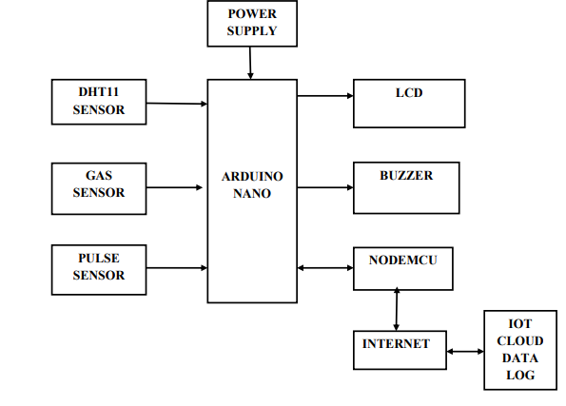
Fig..1 IoT based smart incubator for premature baby

The arduino is primarily provided with the input from sensors that includes pulse senfsor, DHT11 sensor, gas sensor. The input signal obtained from these sensors is processed in such a way to control the output devices that is LCD, buzzer and NodeMCU. The NodeMCU that receive command from the arduino include LCD and buzzer. This system uses cloud storage to collect the sensed data and send emergency notifications to the doctor or nurse when there exists any variation in specified condition. The readings of the sensor are continuously ARDUINO NANO POWER SUPPLY DHT11 SENSOR GAS SENSOR LCD PULSE SENSOR BUZZER NODEMCU INTERNET IOT CLOUD DATA LOG 11 monitored with help of IoT and can be controlled, thereby providing efficient and safe working of an incubator. This is sent to the controller end and further actions are done there which is shown in Fig.1

CIRCUIT DIAGRAM OF IOT BASED SMART INCUBATOR FOR PREMATURE BABY
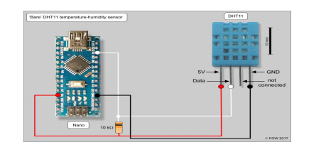
Fig. 2: connection of Arduino Nano with DHT11 sensor
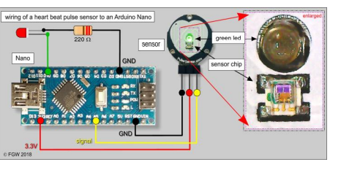
Fig. 3 pulse sensor and its wiring to an Arduino Nano
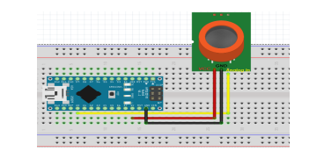
Fig.4 MQ-135 sensor connection with Arduino Nano
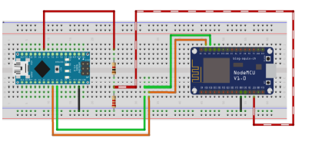
Fig..5: Connection of Arduino nano with NodeMCU
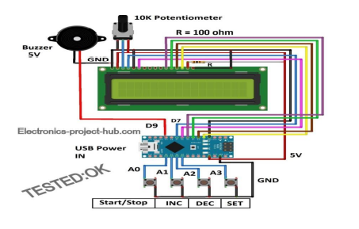
Fig..6: Connection of Arduino Nano with buzzer and LCD
When an alternative current (AC) is applied to the primary winding of the power transformer it can either be stepped down or up based on the value of DC (Direct Current) needed. Here, the transformer of 230v/15v is used to perform the step down operation where a 230V AC appears as 15V AC across the secondary winding of the transformer. In the power supply unit, the rectification is normally achieved using a solid-state diode. Diode has the property which will let the electron flow easily in one direction at proper biasing condition. As alternative current is applied to the diode, electrons only flow when the anode and cathode is negative. Reversing the polarity of voltage won't permit electron flow. The circuit used for supplying large amounts of DC power is the bridge rectifier which is shown in Fig.2. A bridge rectifier of 4 diodes (4*IN4007) is employed to realize full wave rectification. Two diodes will conduct during the negative cycle and therefore the other two will conduct during the positive half cycle. The DC voltage appearing across the output terminals of the bridge rectifier are going to be somewhat but 90% of the applied RMS (Root Mean Square) value. Filter circuits, where the capacitor is acting as a surge arrester always follow the rectifier unit. This capacitor is additionally called as a decoupling capacitor or a bypassing capacitor, is employed not only to ‘short’ the ripple with frequency of 120Hz to ground but also to leave the frequency of the DC to seem at the output. The voltage regulators play a crucial role in any power supply unit. The primary purpose of a regulator is to assist the rectifier and filter circuit in providing a continuing DC voltage to the device. Power supplies without regulators have an inherent problem of adjusting DC voltage values thanks to variations within the load or thanks to fluctuations within the AC liner voltage. With a regulator connected to the DC output, the voltages are often maintained within an in-depth tolerant region of the specified output shown in Fig.3. The regulators IC7812 and 7805 are used to provide the +12v and +5v to the circuit. 14 A 10 kΩ resistor must be mounted between the Data pin and Vcc pin to keep the signal level high during operation of the DHT11. Some breakout boards already contain a 10 kΩ resistor which makes wiring to the Arduino extremely easy. A 10 kΩ pull up resistor is incorporated in the wiring scheme of Fig. 4. Connection wiring scheme of a DHT11 and an Arduino, in this example a Nano. The Data pin of the DHT11 is here connected with pin 10 of the Arduino but any of the other pins D1-D12 or A0-A5 of the microcontroller board may be used. As pin 13 of the Arduino contains a built-in pull up resistor, problems may arise using this pin. Wiring to the Arduino is for that matter very simple: power (best is to use the 3.3V pin on the Arduino), GND and a signal wire to one of the analogous pins A0 through A5 on the Arduino. Most common is to connect the signal wire of the sensor with pin A0. However, because the TFT display we are planning to use needs pin A0 we further use pin A5 as signal pin for the pulse sensor. MQ-135 gas sensor is a hazardous gas detection apparatus for the family, the environment, suitable for ammonia, aromatic compounds, sulfur, benzene vapor, smoke and other gases harmful gas detection, gas-sensitive element test concentration. Air quality sensor is for detecting a wide range of gases, including NH3, NOx, alcohol, benzene, smoke and CO2. Ideal for use in office or factory, simple drive and monitoring circuit. The sensitivity of the sensor can be adjusted by using the potentiometer. Connect the RX pin of NodeMCU to the TX pin of Arduino. Also, connect the TX pin of NodeMCU to the RX pin of Arduino. Common both Grounds of NodeMCU and Arduino as per the Fig 4. Connect the components as shown in the circuit diagram Fig.5. For backlighting a 100 ohm current limiting resistor is connected to +Ve of the backlight terminal on the LCD. The 10K variable resistor can be a potentiometer or a preset or a trimmer potentiometer. The 4 buttons are momentary push buttons where it conducts when you press the button and stops conducting when you release the button. You can utilize any arduino board not just limited to arduino nano as shown in the above circuit and you may power the arduino via USB. If you could not recognize the correct arduino pins on 15 the schematic, please download the high resolution image and you can zoom in to the circuit extensively.
RESULTS AND DISCUSSION
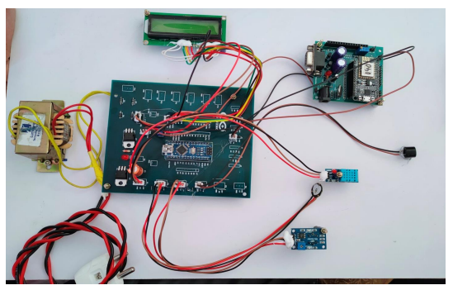
Figure .7 Experimental Setup
The fig 4.1 shows experimental setup of the project. Here as mentioned in the methodology all input devices were connected to Arduino microcontroller. The Arduino Nano and Node MCU is programmed to obtain the readings of these sensors and display it thus enabling in the monitoring of the readings. The values of these sensors are updated in the cloud platform. The temperature and humidity sensor senses the temperature of the surroundings and the humidity present in the surrounding environment of the neonate.
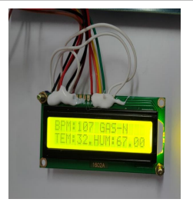 | 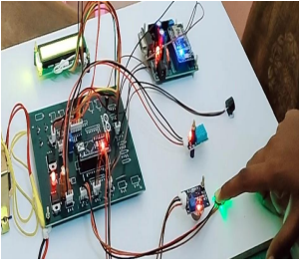
Fig.:8 value of pulse sensor in LCD | Fig.9 Working of Pulse sensor

Similarly, pulse sensor detects pulse rate of the baby. Fig. 9 Shows the Working of pulse sensor when the infant hand is placed on the pulse sensor it will detect the pulse rate of the baby which shown in the Fig.8. Then the gas sensor detects the presence of any gas in the incubator, it will alert the user by Buzzer and it is also stored in a cloud. If any gas detected it shows like GAS-Y in the cloud which is shown in Fig.10.
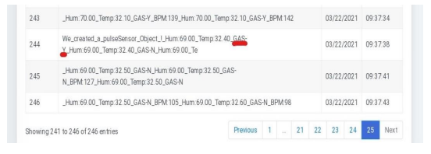
Fig.10 gas detection stored in cloud
If the temperature and humidity values exceed the specified range (36.5-37.2°C) or when the presence of gas is detected by the respective sensors monitored by a Arduino then, the values are stored in a cloud when connecting a internet to the wifi module. The input parameters are shown in Fig.12.
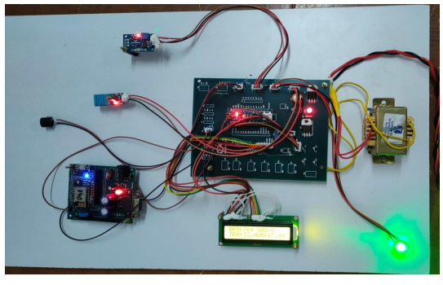
Fig.:11 working of Smart incubator
That will be monitored by baby’s doctor and nurse with the help of the cloud storage. The Node MCU is also programmed to get the analog readings from the pulse sensor (M212) to monitor the heartbeat of the infant. The continuous readings of these parameters such as temperature, humidity, gas, and pulse can be monitored on the cloud storage. Also, the values of these parameters can be altered immediately if any parameter exceeds their reference values, by the doctor or nurse viewing it at that moment. This ensures the ambient atmosphere being maintained for the neonates. Moreover, any variation in the parameters is intimated in order to help the hospital staff to take immediate action and thereby, save an infant from an imminent danger. The input parameters are shown in Fig.12. Sensor data Analysis in cloud is shown in Table 1
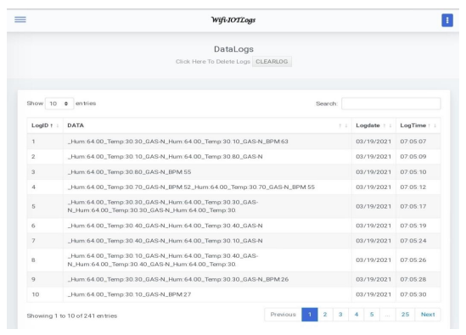
Fig. 12. Input parameters in Data Log website

DATA ANALYSIS:

S. No | Log Date | Log Time | Hum % | Temp ℃ | Gas (N/Y) | Pulse in BPM
1 | 03/19/2021 | 07:05:47 | 64.00 | 30.10 | N | 78
2 | 03/19/2021 | 12:33:48 | 76.00 | 32.70 | Y | 59
3 | 03/22/2021 | 16:16:44 | 59.00 | 33 | N | 58
4 | 03/22/2021 | 16:16:54 | 60.00 | 33.30 | Y | 54
Table. 1: Sensor data Analysis in cloud
CONCLUSION
When the sensors are used such that, they supplement the IoT in the necessary application, the technology becomes an illustration of the more general class of cyber-physical systems, which also comprises of technologies such as smart grids, virtual power plants, smart homes, intelligent transportation and smart cities. Thus, IoT helps in sensing various objects, remote controlling of those objects and creates an ease in directly integrating the physical world into computer-based systems. This results not only in improved efficiency and accuracy but also in economic benefit and reduced human intervention. Fig.12 The ease of access to data is ensured by the use of the cloud storage which is a means of data analytics in IoT. Also, the sensors used in this project are affordable and can be easily obtained if replacement is necessary as a part of periodic maintenance.

REFERENCES
1. Ashish.B,“Temperature monitored IoT based smart incubator”,Feb2017, Volume 6 ,Issue 11.
2. SarfrazFayaz Khan, “Health care monitoring system in internet of things (loT) by Using RFID”,May2017, volume: 23, Issue: 9.
3. Andreas Tobola, Heike Leutheuser, Markus Pollak, Peter Spies, Christian Hofmann, Christian Weigand, Bjoern M. Eskofier, and Georg Fischer, “SelfPowered Multiparameter Health Sensor”,Aug.2017, volume: 7, Issue: 5
4. G.S.Mudur “Rise in premature baby deaths”, Sept.21 2017, volume: 20, Issue: 2.
5. Stephanie Baker, Wei Xiang and Ian Atkinson, “Internet of Things for Smart Healthcare: Technologies, challenges and opportunities”, Nov2017, volume:54, Issue: 3.
6. Alexandru Archip, Nicolae Botezatu, Elena Serban, Paul Corneliu Herghelegiu and Andrei Zala, “An IoT based system for remote patient monitoring”, 10.1109/CarpathianCC.2016.7501056,Jun2016, Volume: 2, Issue: 5.
7. KannanShilpa “low cost technologies saving premature babies’ lives” ,Oct 13., volume: 7, Issue: 1.
8. L. Nachabe, M. Girod-Genet, B. ElHassan, and J. Jammas, “M-health application for neonatal incubator signals monitoring through a CoAP-based multi-agent system”, 2015, Volume: 3, Issue: 2.
9. Mustafa A. Al-Saffar, Esam H. Ismail, Ahmad J. Sabzali and Abbas A.Fardoun (2008) ‘wireless transmission of health parameters in baby incubator, IEEE Transactions on modern technology Volume: 23, Issue 5

