Medicinal properties of Chakramarda – A review article

Dr. Ganpat Lal Kumawat¹ Dr. Ashish Pareek² Prof. A. Ramamurthy³ Dr. Tarun Sharma⁴

1. P.G. Scholar, Dept. of Dravyaguna Vigyana, NIA, Jaipur
2. H.O.D. Shalya tantra, S.S.S.B. Ayurveda college, K. Renwal, Jaipur
3. Guide and H.O.D. Dept. of Dravyaguna Vigyana, NIA, Jaipur
4. Assistant professor, Dept. of Dravyaguna Vigyana, NIA, Jaipur

Corresponding author Email ID: glkumawat12345@gmail.com

ABSTRACT

Chakramarda (English - Ring worm plant, Cassio tora Linn) is used for the management of numerous skin disorders i.e., ringworm, eczema, psoriasis etc. Cassio tora is a very popular and common plant widely distributed in India. It is an annual shrub and grows everywhere in India. Numerous medicinal properties have been attributed to this plant in Ayurveda (traditional system of Indian medicine). Various parts of this plant i.e., leaves, seeds, root etc. possess medicinal properties. It has katu rasa, katu vipaka and ushna virya. This plant is laghu, ruksha in guna and kapha-vatshamaka. The present article is an effort to gain and explore the information about the plant chakramarda from various Ayurveda texts like Samhitas, Ras Granthas and Nighantus. This article concludes various synonyms, morphological properties, pharmacological properties, ethnomedical properties and medicinal as well as clinical uses.
Keywords: Chakramarda, Cassio tora, Ring worm plant, skin disorders etc.

INTRODUCTION
Chakramarda is a famous medicinal plant frequently found in India and other tropical countries. Numerous medicinal properties have been attributed to this plant in Ayurveda (traditional system of Indian medicine). The plant of Chakramarda is available in all regions of India especially during rainy seasons and it grows commonly roadsides. It has katu rasa, katu vipaka and ushna virya. This plant is laghu, ruksha in guna and kapha-vatshamaka¹. In Ayurveda Samhitas, Chakramarda is said to be very useful in many disease especially in skinn disorders like Kushta, Dadru etc.
Various anthraquinones have been isolated from the seeds of chakramarda. Sennosides, Naphthopyrone etc. are have been isolated from the leaves of the chakramarda. The extracts of the plant is used as a remedy for several skin diseases, rheumatic disorders and as laxatives. It also shows hepato-protective activity and anti-inflammatory activity.
The present article summarizes the most standard information of chakramarda regarding its identification, medicinal use, pharmacological properties,chemical composition, ethanomedical uses, etc. A balanced correlation between Ayurveda and modern views has been tried.
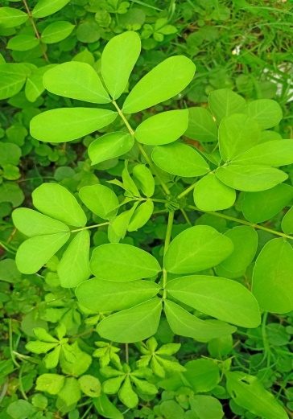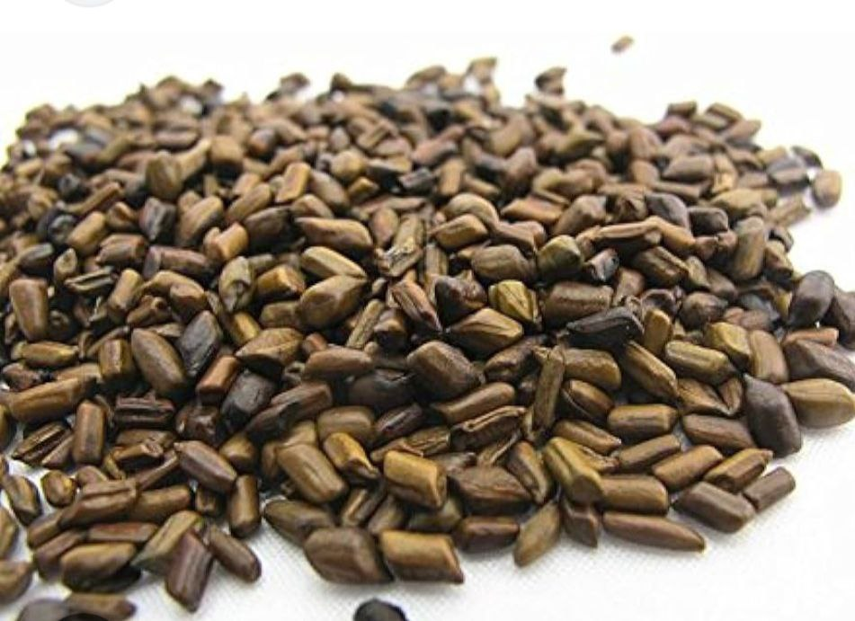
Fig. Plant and seeds of Chakramarda
Cassia tora linn. has following taxonomical classification² –

1. Kingdom | :- | Plantae
2. Class | :- | Dicotyledons
3. Subclass | :- | Polypetalae
4. Series | :- | Thalamiflorae
6. Order | :- | Parietalas
7. Family | :- | Ceasalpinaceae
8. Genus | :- | Cassia
9. Species | :- | Tora

MATERIALS AND METHODS
The essential part to elaborate the properties of chakramarda is review of literature. Various Ayurveda classical texts i.e. Samhitas, Nighnatus and books related medicinal plants various journals, research articles etc. were studied in order to understand the chakramarda. The internet media was also used to gain the knowledge of the subject.

Table 1:- Synonyms attributed to chakramarda by different classical texts of Ayurveda³

Pharmacognostical characters
Meshlochan | Leaf resembles of eyes of mesha (sheep)
Uranakhya | The seeds are similar to sambar’s eye
Dadrubeej | Seeds are rough in nature
Synonyms based on pharmacological actions
Edgaj | Its leaves and flowers resemble sheep’s eye
Dadrughna | It cures dadru
Chakri | It grows gregariously
Kharjughna | It cures kandu (itching)
Kushtaghna | It is used in treatment of kushta
Pamagati | It is used in treatment of pama
Chakramarda | It cures ringworm
Prapunnat | It causes adverse effect on virility
Padmat | It blossoms during time period of sunrise

CLASSIFICATION:-
In Charak Samhita, chakramarda mentioned in shakavarga, it is edible as a vegetable⁴.
In Sushrut Samhita, it is mentioned in urdhvabhagahara gana.
In Ashtanga Hridaya, chakramarda is described by its synonyms like edgaja
and prapunnada. It is mentioned in treatment of shiroroga.

PHARMACOLOGICAL PROPERTIES
Table 3:- Pharmacological properties of chakramarda according to various nighantus^{5,6,7,8,9,10}

Nighantu | Rasa | Vipaka | Virya | Guna | Doshghnata | Rogaghanta
Ashtanga nighnatu | - | - | - | - | - | -
Dhanawanatari nighantu | Katu | - | Ushna | - | Vatakaphaghna | Kandu, dadru
Madanpalnighnatu | - | - | - | - | Vatapittaghna | -
Shodhala nighnatu | - | - | - | - | - | -
Kaidev nighnatu | Madhura and lavana | - | Sheeta | Laghu, guru, ruksha | Vatakaphaghna | Kandu,gulma, kas
Bhavprakash nighantu | Katu | - | Ushna | - | - | -
Raj nighantu | - | - | - | - | - | -
Nighnatu ratnakar | Madhura | - | - | Laghu, Ruksha | Pittavataghna
Shaligram nighnatu | Katu | - | - | Sheet | Vatapittaghna | Kushta,kandu, krumighna
Priya nighantu | - | - | - | - | - | Kandu, dadru
Nighnatu adarsh | Madhura and Katu | Katu | Ushna | - | Vatakaphaghna

CHEMICAL COMPOSITION
Table 5:- Chemical composition of chakramarda

SN | Plant parts | Chemical composition
1 | Leaves | 1)Anthraquinone glycosides 2)Flavonoids  - Sennosides  - Kaempferol-3-diglucoside
2 | Seeds | 1)Anthraquinone 2)Naphthopyrone  3)Three naphthopyrone glucoside 4)Cassiaside  5)Chrysophanic acid-9-anthone
3 | Seed oil | 1)Oleic 2)Linoleic 3)Palmitic 4)Stearic  5)Lignoceric acids
4 | Panwar gum  (obtained from seeds of cassia tora) | 1)Neutral of heteropolysaccharide of galactose 2)Mannose
5 | Pods | 1)Sennoides
6 | Flowers | - Kaemferol  - Leucopelargonidine
7 | Stem | 1)Arachidic acid 2)Isostearic acid 3)Palmitic acid 4)Marginic acid  5)Behenic acid
8 | Roots | - Leucopelargonidine  - β-Sitosterol

SUBSTITUTION & ADULTERATION OF CHAKRAMARDA:-
- Cassia tora seeds are sometimes used as substitute for coffee.
- Sometimes leaves of Cassia tora are sold by the name of leaves of Senna, and sometimes the true senna is adulterated with the leaves of chakarmarda due to its cost effectiveness.

CLASSICAL USES OF CHAKRAMARDA:-

Table 6:- Uses of chakramarda according to Ayurveda texts¹¹

1 | Sidhma kushta | External application - The root of chakramarda mixed with kanji
2 | Shiroroga | External application - The seeds of chakramarda mixed with amla dravya.
3 | Dadru | External application - Seeds of chakramarda with leaves of radish
4 | Gandamala | Chakramarda taila
5 | Vatavyadhi | Chakramarda leaves
6 | Pama | External application - Chakramarda seeds pounded with takra
7 | Teething time | chakramarda leaves kwath
8 | Kushta | Formulation of chakramarda is excellent for eradicating kushta
9 | Shoth and visphota | Chakramarda juice in shotha and visphota caused by bhallataka
10 | Difficult labour | The powdered root of chakramarda is placed into the vagina.

ETHANOMEDICAL USES12:-
Table 7:- Uses of chakramarda

1) | Eczema | External application – The Root of chakramarda
2) | Ringworm | External application - Mixed swaras of chakramarda leaves with lemon juice
3) | Warts | External application - paste of chakramarda leaves for 7 days
4) | vaginal discharge | Chakramarda root ground with rice water
5) | Migraine | External application - Seeds of chakramarda mixed with kanji

PHARMACOLOGICAL ACTIVITIES¹³

Antifungal activity:- The extract of leves revelas significant antifungal property.

Anti-inflammatory effect:- Extract of leaves shows anti-inflammatory activity against histamine and serotonin.

Anti-microbial activity:- Extracts of leaves shows antimicrobial property.

Antitumor Activity:- Extracts of leaves shows anti tumor activity.

Purgative effect:- Extract of leaves has mild purgative action, probably due to the presence of emodine, aloe-emodine and anthraquinone glycosides.
- Antifertility activity:- Extract of shows oestrogenic activity.

Antihelmintic Activity:- Extracts of leaves shows anti helmintic activity.

- Antioxidant activity:- Extract of seed of chakramarda has stronger anti-oxidant activity.

DISCUSSION
The references of medicinal use of chakramarda are available in various Ayurveda texts.
The role of Paryaya (synonyms) of a plant (like chakramarda) is to describe morphological description, its habitat and pharmacological characters.
The chakramarda seeds have katu rasa, katu vipaka and ushna virya.

CONCLUSION

The present article is based on to enlighten the properties and formulation of chakramarda that are used in various conditions like kushta, fungal infection, vatavyadhi etc. Lot of studies reveals that it possesses very useful medicinal properties due to presence of chemical constituents effective against a large number of ailments. There is no doubt that chakramarda is a reservoir of various active components which work on various systems in the body. The further clinical and pharmacological studies should be done to investigate unexploited potential of this plant.

REFERENCES
- Professor Priyavrat Sharma edited Dravyaguna vijnana volume II; edition 2006; page no.186
- Dr. Prakash L. Hegde, Dravyaguna vigyana Volume 3 revised edition, page no. 95
- Bapalal G. Vaidya; Nighantu Adarsa Vol.I; Published By Chaukhambha Bharati Academy, Varanasi; Reprint 2018; Page No. 470.
- Dr. Kashinath pandey; Charak Samhita Vol I; Published By Chaukhamba Prakashan Varanasi; Sutrasthan Adhyaya 27
- Nripa madanpalvirchit Madanpalnighantu; Madanpal Nighantu; Khemraj Shrikrushnadas Prakshan; Mumbai; Reprint 1998; Page No.42.
- Aacharya Priyavrat Sharma; Interpreter Dr. Guruprasad Sharma; Kaidev Nighantu; Chaukhambha Orientalia; Reprint 1979; Page No. 130.
- Commentary By Dr. K. C. Chunekar; Edited By Dr. G. S. Pandey; Bhavprakash Nighantu: Published By Chaukhambha Bharati Academy; Reprint 2004; Page No. 125.
- Dr. Indradeo Tripathi And Pandit Narahari Edited With Dravyaguna Prakasika; Rajnighantu; Published By Chukhambha Krishnadas Academy; Reprint 2003; Page No.102.
- Gangavishnu SD, Nighantu Ratnakar, 1st Edition, Nirnayasagar Publication, Mumbai. Reprint 2001.

- Shaligram Nighantubhushanam Arthat Bruhatrinighantu ratnakarantargati Saptamashtamabhagi: Shaligram Nighantu; Published By Khemraj Shrikrushnadas Prakshan Mumbai; Reprint 2002; Page No. 163.
- Bapalal G. Vaidya; Nighantu Adarsa Vol.I; Published By Chaukhambha Bharati Academy, Varanasi; Reprint 2018
- Ayurved Mahopadhyaya Shankar Dajishri Pade; Vanoushadhi Gunadarsha.(Part I-IV); Page No. 179

- Professor Priyavrat Sharma Edited Classical Uses Of Medicinal Plants; Chaukhambha Vishwabharati.

